OUM
CM.060 Environment and Patch Management Plan
<Company Long Name>
<Subject>

When this template is completed, delete all the yellow notes as follows:
1. With your document open, open the Find and Replace window.
2. Expand the Find and Replace window using the More>> button.
3. Place the cursor in the Find what: field.
4. Choose Format > Style.
5. When the Find Style box opens, scroll through the list and select Note and click OK.
6. Leave the Replace with: field blank.
7. Select Replace, Replace All or Find Next to remove the yellow notes.
8. Repeat using the Note Wide style if there are any landscape sections that contain wide yellow notes.
Please refer to the OUM Template User’s Guide for detailed instructions for working with OUM templates.

Author: <Author>
Creation Date: May 8, 2014
Last Updated: August 30, 2016
Document Ref: <Document Reference Number>
Version: DRAFT 1A

Title, Subject, Last Updated Date, Reference Number, and Version are marked by a Word Bookmark so that they can be easily reproduced in the header and footer of documents. When you change any of these values, be careful not to accidentally delete the bookmark. You can make bookmarks visible by selecting the Office Button>Word Options>Advanced> and checking the Show bookmarks option in the Show document content region.

Approvals:
<Approver 1>
<Approver 2>
To add additional approval lines, press [Tab] from the last cell in the table above.
You can delete any elements of this cover page that you do not need for your document.

Document Control

Change Record
5
Date | Author | Version | Change Reference
8-May-14 | <Author> | Draft 1a | No Previous Document

Reviewers

Name | Position

Contents
1 Document Control iii
1.1 Change Record iii
1.2 Reviewers iii
2 Strategy 1
2.1 Objective 1
2.2 Key Principles 1
3 Project Environments 3
3.1 Basic Environment Sizes 3
3.2 Project Environment Schematic 3
3.3 Environment Descriptions 5
4 Access Policies 7
5 Environment Procedures 8
5.1 Creation Procedures 8
5.2 Cloning Procedures 8
5.3 Maintenance Procedures 8
5.4 Backup Procedures 8
6 Implementation Environment Hardware Requirements 9
6.1 Capacity Requirements 9
6.2 Project Environment to Server Mapping 9
7 Environment Tools and Techniques 11
8 Patch Management Procedures Tools and Techniques 12
8.1 Identification and Request for Patches 12
9 Patch Tools and Techniques 14
10 Roles and Responsibilities 15
11 Open and Closed Issues 16
11.1 Open Issues 16
11.2 Closed Issues 16

To update the table of contents, put the cursor anywhere in the table and press [F9]. To change the number of levels displayed, select the menu option Insert->Index and Tables, make sure the Table of Contents tab is active, and change the Number of Levels to a new value.

Strategy
This document summarizes the project environment planning and patch management strategy. It describes the systems needed by the project team to carry out project activities, but does not define the technical architecture of the production system. This document serves as a planning tool to define the required environments at each stage of the implementation. As such, it should be viewed as an iterative document that may be updated to reflect new requirements or constraints.

Objective
The purpose of this Plan is to provide a structured approach to installing and maintaining the environments necessary to support implementation. The Environment and Patch Management Plan is designed to meet the following goals:
- Ensure all development is done using the appropriate setups. This minimizes the risk of build components not fitting together with the overall solution.
- Mitigate the risk of lost time and effort due to the corruption or loss of a development instance. The risk is mitigated by a timely refresh from an instance with current setup data.
- Enforce a discipline of using approved, current setups for all development activities.
- Allow differentiation between setup, manual conversion, or automated conversion. For each business object, define which instance it initially goes in, and how the data enters the instance.
The plan will answer the following key questions:
- What type and size of project environments will be needed?
- What data will be used to populated each environment?
- What is the source of the setups for each environment?
- When should the environments be ready for use?
- When can the environments be decommissioned?
- How will each environment be used?
- Who is the owner of each environment?
- What access controls apply to each environment?
- What is the strategy to manage and apply patches to each environment?
- What configuration management processes apply to each environment?
- What are the required procedures to manage project environments?
- What is the mapping between project environments and servers?
- Any other topics you may find relevant for your project

Key Principles
- Total separation of all environments – environments will not share code or databases
- Support for Configuration Management procedures by taking baseline ‘Images” at certain point of the project.
- Compliance to Configuration Management procedures related to installation and promotion of code
- Compliance to Software Release requirements
- Clearly defined “stages” within the project when environment re-configuration will take place. These stages can then be built into the project plan so that functional consultants are aware of these “mission critical” activities.

Project Environments
Document the various environments that will be used on the project (for example, production, test, training, etc.).

Basic Environment Sizes
The following diagrams describe the three project environment sizes that will be required to support the project and their anticipated method of data population.
Remove or update the table for your project.

 | Application Tier | Database and CP Tier | Database files | Comment
Size 1 | 20 GB | 20GB | ?? GB | Initial install with set-up data only, or small amount of master and transactional test data entered manually
Size 2 | 20 GB | 20 GB | ??GB | Complete Master data and subset of historical transactions, populated via conversion process
Size 3 | 20 GB | 20 GB | TBD GB | Full sized production data base with all Master Data and all historical transactions, populated via conversion process

Project Environment Schematic
The following diagram illustrated the environment that will be required to support the project as it progresses through the phases of implementation, Definition, Elaboration, Build/Test, Transition and Production.

Diagram is an example only, and should be replaced by a diagram specific to your project.

Diagram Conventions
In the diagram, each environment is represented with the familiar drum symbol:
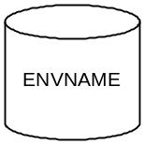
ENVNAME is the name of the application environment and not the database instance (referenced by the environment variable ORACLE_SID).
The ‘Applications environment’ denotes the combination of Applications software (APPLICATION TOP), Oracle RDBMS software (ORACLE HOME), Oracle iAS software and database itself.
The size of the drum symbol denotes the size of the environment. Large environments contain more data, and are populated by data conversions or cloning from converted environments or production.
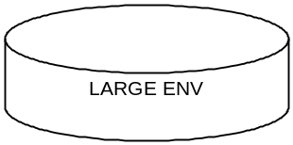

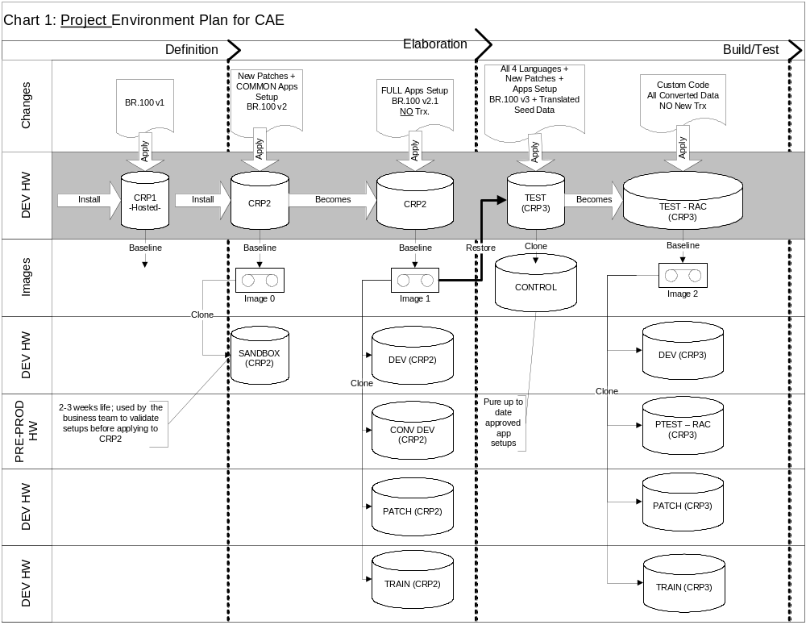

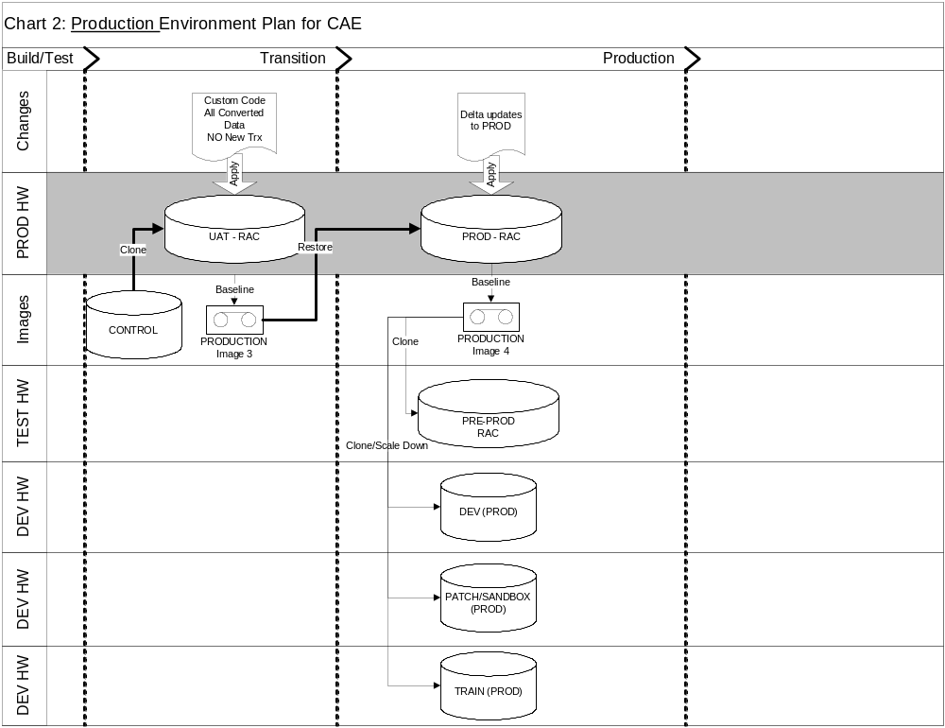

Environment Descriptions

<Environment Name>

Name
Purpose
Owner
Creation Strategy
Date Required
Decommission Date
Data Population Strategy
Backup Requirement
CM Requirement
Access Rights

<Environment Name>

Name
Purpose
Owner
Creation Strategy
Date Required
Decommission Date
Data Population Strategy
Backup Requirement
CM Requirement
Access Rights

<Environment Name>

Name
Purpose
Owner
Creation Strategy
Date Required
Decommission Date
Data Population Strategy
Backup Requirement
CM Requirement
Access Rights

Access Policies
Document the access policies related to each environment.

Environment Procedures
Document any necessary procedures to create, clone, maintain and backup environments.

Creation Procedures

Cloning Procedures

Maintenance Procedures
The following environment management procedures will be documented by the DBA team and used consistently during the implementation.
- Installation – Original Oracle EBS and other supporting software installation from DVD media Oracle supported tools and procedures.
- Cloning – Procedure to copy one environment (e.g. CRP1) into another (e.g. DEV) using Oracle supported tools and procedures.
- Scaling Down – Procedure to decrease the size of production support environments by purging data. Also includes scrambling sensitive data.
- Backup/Recovery – Procedure to take full backup of the system and restore at will.

Environment Maintenance Service Levels

It is very important to established expected service levels for the environments at the start of the project, particularly if customer or third party has responsibility for environment maintenance activities. Often there is an “expectation” built into the project plan timeline, and the service levels need to accommodate the project’s requirements. Use a table similar to the one below to structure the conversation and avoid issues that might arise when discussion is not explicitly held.

Environment | Maintenance Activity | Lead Time for Request | Outage Time
All | Installation | 2 weeks, per project plan
All | Decommission | Per project plan
 | Clone | 2 days | 12 hours
 | Backup | Scheduled (hot backup nightly, cold backup weekly | 12 hours
 | Recovery | As needed, request via DBA mgr | 6 hours
This might vary by environment type | Response to unplanned outage | 1 hour | As required

Backup Procedures

Implementation Environment Hardware Requirements
Document any implementation environment hardware requirements. The following information should be updated for your project or removed.
The following requirements are for the servers supporting implementation effort and are not meant to size target production system. See Technical Architecture for a discussion of the production hardware sizing and supporting requirements.

Capacity Requirements
Capacity plan for the project environments will be done utilising ‘rule of thumb’ approach, since the size of implementation project and target user population ( approx. ?? named users) does not justify investment into full capacity study for the project environments. Here are some assumptions used to derive server capacity:
Adjust assumptions for the specific project requirements.

- The project team will consist of maximum ?? named users.
- Each environment has it’s own ORACLE_HOME (Technology Stack), APPL_TOP (Applications code) and database instance.
- All environments will be installed as “multi-node”
- There will be at least 2 RAC environments in test
- There will be 2 sizes of databases supporting the implementation: 20 GB and 40 GB. These sizes correspond to different sizes of environments as depicted on charts in previous section.
- There will be no more than 6 Application environments at any given time (see plan for each phase above). However, server and storage capacity should be sufficient to hold 8 environments as some will overlap during phase transition periods.

Server Class and CPUs
Minimum requirements are:<adjust for Project specific requirements>
- Two RISC servers with single CPU to support at most 3-4 Applications environments at the same time, one server for Application Tier and another server for CP and Database tier.
- Two RISC servers with single CPU to support CRP -> TEST -> PREPROD environments, one server for Application Tier and another server for CP and Database tier.

Memory
Minimum requirements are: <adjust for Project specific requirements, examples below are likely much too small >
- 528 MB of RAM per server, per one project environment.
- 1GB Minimum for per server, per CRP -> TEST -> PREPROD environments

Network
Detailed network capacity is out of scope of this document. However, LAN segments at <Customer Name> should be able to support 10 additional users requiring 6 kbit/s each, with latency less than 10ms.

Project Environment to Server Mapping

Server Name | Environment | # 1 GHz RISC CPUs | RAM (MB) | Disk Size (GB) | Estimated Number of Concurrent Users
XX Server/LPAR | CRP1 -> CRP2 -> CRP3 ->TEST -> PRE-PROD | 1 X 2 SERVERS | 1GB x 2 Servers | 20 GB Apps Tier  100 GB DB/CP Tier | 10
YY Server/LPAR | DEV  CDEV  PATCH  TRAIN | 1 X 2 SERVERS | 2GB x 2 Servers | 80 GB Apps Tier  240 GB DB/CP Tier | 3 each

Project Environment Time Schedule
The source of the timing schedule for project environments is the baseline version of the implementation project plan. This table should be filled out and owned by infrastructure (DBA) manager. Changes to the time below are approved <describe project process here>
Environment | Start Date | End Date | Installed /Cloned By | Managed by | SysAdmin
CRP1 |  |  | Oracle Remote DBA | Oracle Remote DBA | Oracle Remote DBA
CRP2 |  |  | Oracle Onsite DBA | Oracle Remote DBA | Customer DBA
DEV (CRP2) |  |  | Oracle Remote DBA | Oracle Remote DBA
CDEV (CRP2) |  |  | Oracle Remote DBA | Customer DBA
PATCH (CRP2) |  |  | Oracle Remote DBA | Customer DBA
TRAIN (CRP2) |  |  | Oracle Remote DBA | Customer DBA
CRP3 , RAC Install |  |  | Oracle Remote DBA | Oracle Remote DBA
CONTROL |  |  | Customer DBA | Customer DBA
PTEST (CRP3), RAC Install |  |  | Customer DBA
DEV (CRP3)
PATCH (CRP3)
TRAIN (CRP3)
UAT
PROD
PRE PROD
DEV (PROD)
PATCH (PROD)

Environment Tools and Techniques
Document any tools and techniques for managing and monitoring environments.

Patch Management Procedures Tools and Techniques
Application code enhancements and patches (subsequently referred to as Patches) play a very crucial role in the deployment of Oracle Applications. The patches may include mandatory security updates or other critical updates, bug fixes and product enhancements. Regardless of the reason for applying a patch, management and application of patches must follow a standard process.
Document any policies and procedures for managing patches.

Identification and Request for Patches
It is primarily the responsibility of the functional team to identify patches that should be applied. Exceptions would be patches that are on the recommended or required by the patch notes published via Metalink or patches identified by support to correct defects.

Approval Process for Patches
The program manager must approve identified patches, before patch application is requested.
This may vary from project to project, update for your project – could be a change control board, etc. Should always be a functional, not a technical responsibility.

Patch Application Flow

Alter as appropriate for your project, or replace with a diagram.
Approved patches will initially applied by DBA team to the Sandbox instance. The patch will be technically evaluated for successful completion and impact by the DBA who applied the patch. Patch application information will be recorded in the patch log. After the patch is technically evaluated, the environment will be released to the functional team for regression testing. Once the function team passes the patch, it will be applied to the appropriate CRP environment as indicated in the diagram below:
Insert project specific diagram here.
For each patch applications, the DBA’s will conduct a validation of successful patch application, and update the patch log. It is the responsibility of the Functional leads to conduct functional testing of the patch to validate that expected results have been achieved before promoting the patch to additional environments.

Patch Installation Flow
The patch installation process consists of the following steps:
- Schedule the patch application window with the project team <add project specific info>
- Download patch from Oracle or other vendor. Typically this is done via Oracle support web site, http://metalink.oracle.com/ or Oracle’s ftp site, ftp://oracle-ftp.oracle.com. For non-Oracle patches, like Vertex this is provided on a floppy disk. At this time, the patch readme and documentation is reviewed for pre-requisites and known issues.
- Transfer patch via FTP to the appropriate Oracle Applications server. This is done with either GUI or command line FTP, either way the transfer should be completed in binary mode. In the current configuration, the location of the patches is on <project specific location>
- Unzip or untar the downloaded file. Typically, Oracle will zip the files of a patch. There a unzip is required. Other vendors such as Vertex ship self-extracting zip files.
- Post the patch readme to the documentation directory of<appropriate iProjects or other location>
- Bring down the Forms server, Web listener and Concurrent Manager as appropriate for patch
- Apply the patch using adpatch (Oracle) or provided program
- Restart the Forms server, Web listener and Concurrent Manager as appropriate for patch
- Conduct technical validation
- Update patch spreadsheet and notify functional testers that patch is available for validation.

Patch Tools and Techniques
Document any tools and techniques for managing and monitoring patches.

Roles and Responsibilities

Use the following table to document roles involved and describe the responsibilities.

Role | Responsibility | Assignment

Open and Closed Issues
Add open issues that you identify while writing or reviewing this document to the open issues section. As you resolve issues, move them to the closed issues section and keep the issue ID the same. Include an explanation of the resolution.
When this work product is complete, any open issues should be transferred to the project- or process-level Issue Log (Manage Focus Area) and managed using a project level Issue Form (Manage Focus Area). In addition, the open items should remain in the open issues section of this work product, but flagged in the resolution column as being transferred.

Open Issues

ID | Issue | Resolution | Responsibility | Target Date | Impact Date

Closed Issues

ID | Issue | Resolution | Responsibility | Target Date | Impact Date

