OUM
IFM.030 Physical Resource Plan
<Company Long Name>
<Subject>

When this template is completed, delete all the yellow notes as follows:
1. With your document open, open the Find and Replace window.
2. Expand the Find and Replace window using the More>> button.
3. Place the cursor in the Find what: field.
4. Choose Format > Style.
5. When the Find Style box opens, scroll through the list and select Note and click OK.
6. Leave the Replace with: field blank.
7. Select Replace, Replace All or Find Next to remove the yellow notes.
8. Repeat using the Note Wide style if there are any landscape sections that contain wide yellow notes.
Please refer to the OUM Template User’s Guide for detailed instructions for working with OUM templates.

Author: <Author>
Creation Date: May 9, 2014
Last Updated: January 11, 2016
Document Ref: <Document Reference Number>
Version: DRAFT 1A

Title, Subject, Last Updated Date, Reference Number, and Version are marked by a Word Bookmark so that they can be easily reproduced in the header and footer of documents. When you change any of these values, be careful not to accidentally delete the bookmark. You can make bookmarks visible by selecting the Office Button>Word Options>Advanced> and checking the Show bookmarks option in the Show document content region.

Approvals:
<Approver 1>
<Approver 2>
To add additional approval lines, press [Tab] from the last cell in the table above.
You can delete any elements of this cover page that you do not need for your document.

Document Control

Change Record
5
Date | Author | Version | Change Reference
9-May-14 | <Author> | Draft 1a | No Previous Document

Reviewers

Name | Position

Contents
1 Document Control iii
1.1 Change Record iii
1.2 Reviewers iii
2 Introduction 1
3 Environment Requirements 2
3.1 Support Tools Required 2
4 Application/Development Environments 3
5 High-Level Database Topology 4
6 Sizing Summary 5
7 Instance Synchronization Approach 6
8 Legacy Systems and Support 7
9 Infrastructure Plan 8
9.1 Physical Resources 8
9.2 Planned Changes to Resources 8
9.3 Test and Porting Environments 8
9.4 Network Setup 8
9.5 System Administration 8
10 Procurement Plan 9
11 Hardware Support Policy 10
12 Service Definition 11
12.1 Services 11
12.2 Areas of Responsibility 11
12.3 Availability and Notification Periods 11
12.4 Reporting Arrangements 11
13 Customer Responsibilities 12
13.1 Customer Responsibilities 12
13.2 Computer Access and Security 12
13.3 Site Access 12
14 Procedures 13
14.1 Service Loss Procedure 13
14.2 Service Incident Procedure 13
14.3 Service Change Procedure 13

To update the table of contents, put the cursor anywhere in the table and press [F9]. To change the number of levels displayed, select the menu option Insert->Index and Tables, make sure the Table of Contents tab is active, and change the Number of Levels to a new value.

Introduction
This document summarizes the hardware and software required by <Project Name> at <Company Long Name>. It describes systems needed by the project team to carry out project activities, but does not attempt to define the technical architecture of the production system. This document serves as a planning document during the initial stages of the project to ensure that the required environment is in place as each stage of the project commences.
This document will be succeeded by the following additional documents that will describe related requirements in more detail:
- Project Infrastructure
- Application Sizing spreadsheets
- Installation planning worksheets
- Application Architecture (high-level and detail)
- Technical Architecture (high-level and detail)
- Backup and Recovery Plan
- Design and Development Standards

Environment Requirements
Special computer hardware and software is required to support <Project Phase> of the <Company Short Name> project <Project Name>. At a minimum, this includes

Support Tools Required
The table below summarizes the tool requirements of significant tasks throughout the project:
Milestone Task | Applications | Word Processing | Diagramming | Design Tools | Source Control
Assess Current Business |  | ? | ? | ?
Define Future Business | ? | ? | ? | ?
Propose Technical Architecture |  | ? | ?
Train Project Team | ? | ?
Map Business Requirements | ? | ?
Define Business Solution | ? | ? | ? | ?
Design Custom Modules | ? | ? | ? | ? | ?
Design Technical Architecture | ? | ? | ?
Construct Programs | ? | ? |  | ? | ?
Perform Business System Test | ? | ? |  |  | ?
Convert Data | ? | ? |  | ? | ?
Train Users | ?
Implement Production Environment | ? | ? |  |  | ?
Accept System | ? | ?
Commence Production | ?
Support Production System | ? | ? |  |  | ?
Monitor Performance | ? | ? | ?
Refine System | ? | ? | ? | ? | ?
The software selected for each of the above is as follows:
Applications | XXXX
Word Processing | Microsoft Word for Windows
Diagramming | Visio  Microsoft Powerpoint
(Tool dependent on type of diagram) | XXXX
Design Tools
Configuration Management | <Configuration Mgmt System>

Application/Development Environments
The table below summarizes the application/development environments required to support the project team during the project:

Milestone Task | Demo Database  DEMO | Test Install  TEST | Develop-ment  APPDEV | Conversion  CONVTEST | Production  FINPROD  MFGPROD
Assess Current Business
Define Future Business | ?
Propose Technical Architecture
Train Project Team | ?
Map Business Requirements |  | ?
Define Business Solution |  | ?
Design Custom Modules |  | ? | ?
Design Technical Architecture |  | ?
Construct Programs |  |  | ? | ?
Perform Business System Test |  | ? | ? | ?
Perform Performance Assurance Test |  |  |  |  | ?
Convert Data |  |  | ? | ? | ?
Train Users |  | ?
Implement Production Environment |  |  |  |  | ?
Accept System |  |  |  |  | ?
Commence Production |  |  |  |  | ?
Support Production System |  | ? | ? |  | ?
Monitor Performance |  |  |  |  | ?
Refine System |  | ? | ? |  | ?

High-Level Database Topology
<Company Short Name> will initially have a single system for training, mapping, and development tasks. A second production system will be installed after detailed requirements analysis. The planned location of the various project databases on each system is shown below.

Diagram Conventions
In the diagram below, a shaded box that represents the physical machine represents each server. Databases on the machine are represented with the familiar drum symbol:
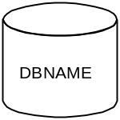
DBNAME is the name of the database instance (referenced by the environment variable ORACLE_SID). Databases that share the same set of application executables are grouped together within a box that resembles a building:
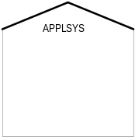
The name at the top identifies the application environment file that sets the environment variables to product directories (i.e., APPLSYS.env). Each application environment may be a different version of applications. This allows us to test and migrate customizations to the next release of applications while the users continue to run against the prior version.
Databases that are independent of applications are not contained within an environment box (in this example, CASE).
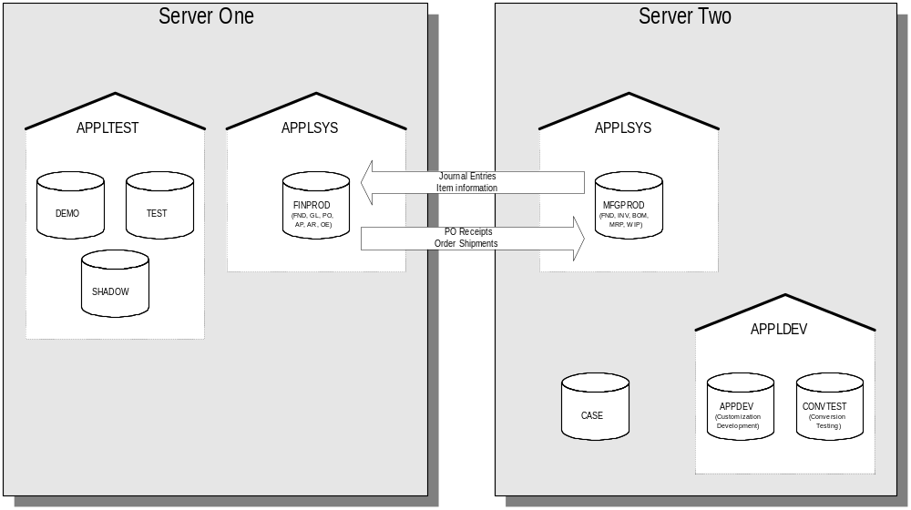

Sizing Summary
Preliminary database sizing has been performed for the project databases using the Oracle Applications Sizing Spreadsheet. The results are summarized below with additional requirements for operating system and software tools.

Component | Server One (Mb) | Server Two (Mb)
Operating System | 0 | 0
Swap Space | 0 | 0
User Directories | 0 | 0
Documentation Repository | 0 | 0
Oracle Executables | 0 | 0
Application Executables | 0 | 0
SYSTEM Tablespaces | 0 | 0
Rollback Segments | 0 | 0
Archiving Files | 0 | 0
Temp Space | 0 | 0
Total Applications Data | 0 | 0
Total Applications Indexes | 0 | 0
Design Tool database | 0 | 0
Oracle Bookviewer Files | 0 | 0
Space for Export files | 0 | 0
 | 0 | 0
TOTAL DISK SPACE | 0 | 0

Instance Synchronization Approach
Since separate instances will be set up for training, mapping, development, testing, and production, a mechanism is required to migrate setups established during mapping to the subsequent environments. This process is referred to as instance synchronization.
The first two Applications Instances are the demo database (DEMO) and a test instance (TEST). The first contains setup data that is seeded from Oracle. The second will be used during mapping to prototype business solutions and make configuration decisions. Therefore, neither of these environments is suitable as the source of setup information.

Target Live Setup
To support instance synchronization, a third instance (SHADOW) will be established to hold the target live setup (TLS). When configuration decisions are finalized, the project team will perform the required configuration in the SHADOW environment. At the end of the Solution Design stage, this environment will contain all the setup information required for the Business Systems Test, Performance Assurance Testing, End-User Training, and Production environments. Refinements to the target live setup may be made as the result of each of these activities.
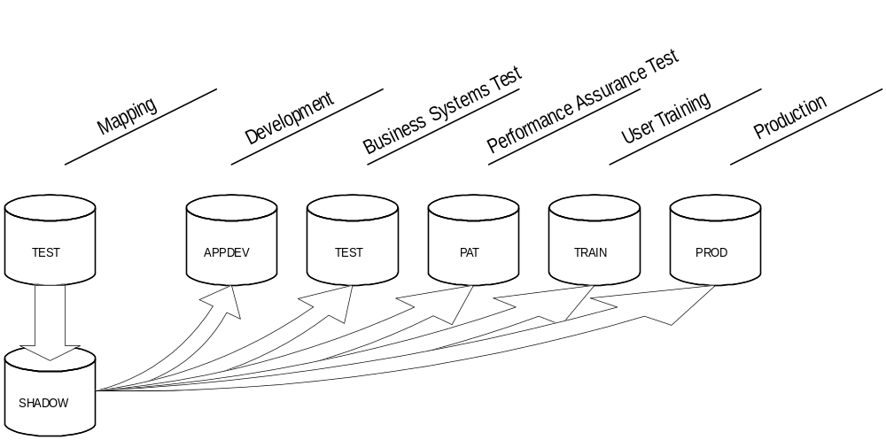

Legacy Systems and Support
<Company Short Name> currently has the following internal systems running on various hardware platforms:
Application | Purpose | System Name | Hardware Type | Operating System | Database Type | Retain?
Acme GL | General Ledger | ALPHA1 | IBM 4341 | MVS | DB2 | No
Systems with “Yes” in the Retain? column will be retained after the project. Interfaces between these systems and the Oracle Software will be required. The specific interfaces will be defined in the Application Architecture document (created during Analysis and Design stages).

Infrastructure Plan

Physical Resources

Planned Changes to Resources

Test and Porting Environments

Network Setup

System Administration

Procurement Plan
New hardware and software to support the project will be procured according to the following schedule:

Vendor | Model/ Package | Description | Purpose | Scheduled Delivery | Delivered?
Sequent | S99-001 | 32 Processor Sequent Symmetry | Training |  | Yes
 |  |  | Evaluation |  | No
 |  |  | Production
Procurement will be made using the customer/Oracle purchasing arrangements.

Hardware Support Policy
The hardware support policy for this project is:

Service Definition

Services

Areas of Responsibility

Availability and Notification Periods

Reporting Arrangements

Customer Responsibilities

Customer Responsibilities

Computer Access and Security

Site Access

Procedures

Service Loss Procedure

Service Incident Procedure

Service Change Procedure

