OUM
QM.020 Quality Review Report for Technology/Custom Development Projects
<Company Long Name>
<Subject>

When this template is completed, delete all the yellow notes as follows:
1. With your document open, open the Find and Replace window.
2. Expand the Find and Replace window using the More>> button.
3. Place the cursor in the Find what: field.
4. Choose Format > Style.
5. When the Find Style box opens, scroll through the list and select Note and click OK.
6. Leave the Replace with: field blank.
7. Select Replace, Replace All or Find Next to remove the yellow notes.
8. Repeat using the Note Wide style if there are any landscape sections that contain wide yellow notes.
Please refer to the OUM Template User’s Guide for detailed instructions for working with OUM templates.

Author: <Author>
Creation Date: May 13, 2014
Last Updated: November 12, 2014
Document Ref: <Document Reference Number>
Version: DRAFT 1A

Title, Subject, Last Updated Date, Reference Number, and Version are marked by a Word Bookmark so that they can be easily reproduced in the header and footer of documents. When you change any of these values, be careful not to accidentally delete the bookmark. You can make bookmarks visible by selecting the Office Button>Word Options>Advanced> and checking the Show bookmarks option in the Show document content region.

Approvals:
<Approver 1>
<Approver 2>
To add additional approval lines, Press [Tab] from the last cell in the table above.
You can delete any elements of this cover page that you do not need for your document.

Document Control

Change Record
3
Date | Author | Version | Change Reference
31-Oct-14 | <Author> | Draft 1a | No Previous Document

Reviewers

Name | Position

Contents
1 Document Control ii
1.1 Change Record ii
1.2 Reviewers ii
2 Quality Review Report 1
3 Overview 2
3.1 Review Results 2
3.2 Code Review 2
3.3 OO Design Quality Review 3
4 References 13
5 Example of Calculating the Metrics 14
5.1 Example of Class-Attribute (CA) interaction 14
5.2 Example of Class-Method (CM) interaction 14
5.3 Example of Inheritance Metrics: 14

To update the table of contents, put the cursor anywhere in the table and press [F9]. To change the number of levels displayed, select the menu option Insert->Index and Tables, make sure the Table of Contents tab is active, and change the Number of Levels to a new value.

Quality Review Report

Business Unit:

Project:

Reviewer:

Date of Review:

Reason for Review: <End of a phase>

Follow-Up Date: <To be defined>

Overview
This document provides a quality review report for the <Project Name>. The following work products have been provided for review:

- Source Code

Review Results

Code Review

Quality Attribute: Self- Descriptiveness.
Software is self-descriptive if a reader of the design or source code can easily understand how a function has been implemented.
Importance: This attribute is strongly related to the following external software quality attributes:
- Expandability
- Flexibility
- Maintainability
- Portability
- Reusability
- Verifiability
Analysis: Evaluating the provided source code, it is easy to verify that it does not have this important internal software quality attribute. There is almost no documentation at all. The JavaDoc standard, which is considered as minimum, was not provided. Therefore, we can also conclude that the external software quality attributes described above are also jeopardized. Code with no self-descriptiveness is hard to maintain, reuse, expand (code new functionalities), etc.
Conclusion: The provided source code should be documented before production. At least, JavaDoc should be provided. The high-risk classes (see quantitative evaluation in the next section) must use assertions on their methods (pre-/postconditions) to mitigate the risk of failures and improve testing.

Quality Attribute: Consistency.
Software is consistent when the same standards are used throughout the design and implementation to achieve uniformity.
Importance: This attribute is strongly related to the following external quality attributes
- Correctness
- Maintainability
Analysis: The coding standard used in this project, was not provided to the reviewer. Supposing that the coding standard used was either the Sun or Oracle coding standard, some points can be raised:
- Most of the attribute names use underscore. Normally, this should not be done.
- Some constants name are lowercase (CampaignDataLoader,CONSTANT s_threadName). Normally, all the constants should be UPPERCASE.
- Most of the method names use underscore and upper case letter (getRES_TAC_FIELD). Normally, method names should not use underscore, e.g., getResTacField.
Conclusion: The project manager must provide the coding standards used in the project and all the source code must follow this standard. Ideally, the standard should be the Oracle Java Coding Standard.

OO Design Quality Review
In this section, we provide the analysis results of the OO design quality. To do so, we have used a set of well establish OO design metrics [1] [3] [4] [5] [6]. These metrics are used to evaluate the class structure (use of information hiding, inheritance, and class association) as well as the dynamic aspects of class message exchange. The analysis does not take into account the actual object message exchange, but only the potential object message exchange. The metrics were calculated using JMETRICS [2], which allows us, extract OO design metrics directly from the .class files.

Information Hiding: MOOD
In order to evaluate information hiding and use of inheritance in the class design, we have used the MOOD set of metrics (Metrics for Object Oriented Designs) [5]. MOOD is a collection of metrics that must be seen as probabilities, since its values range from 0 to 1, and aim at quantifying the presence or absence of a certain property or attribute.
Information hiding is a key concept in an OO project. Software with a lower rate of information hiding will be hard to maintain, reuse and extend. The use of inheritance is also a key concept in an OO project. Well-structured class hierarchies can make the software more reusable. However, inheritance increases coupling.
Not all the MOOD metrics were analyzed. The ones used here gauge encapsulation as well as inheritance.
MOOD metrics analyzed:

Metric | Definition
AHF | Attribute hiding factor
MHF | Method hiding factor
MIF | Method inheritance factor

The following attribute scores should be entered as percentages for your OUM engagement, based on your project calculation.

AHF (Attribute hiding factor)
This metric calculates the number of hidden attributes (defined as private, in Java) divided by the number of visible attributes (in Java, defined as protected, public or the default, package), for the project being analyzed.
AHF Score: %
This result indicates that in average % of the project’s attributes are private, which shows that the encapsulation concept was used in the definition of methods. Some authors argue that this factor should be even higher. According to JavaBeans design standards the ideal value of information hiding would be 100%, i.e., the attributes can be only accessed via its getter and setter methods. However, according to the literature, 70% is still an acceptable value.
The following attribute scores should be entered as percentages for your OUM engagement, based on your project calculation.

MHF (Method hiding factor)
This metric calculates the number of hidden methods (defined as private, in Java) divided by the number of visible methods (in Java, defined as protected, public or the default, package), for the project being analyzed.
MHF Score: %
Shows that most of the methods are accessible to other classes. Represents a percentage of approximately 20% of private methods in relation to the project’s total number of methods.
The following attribute scores should be entered as percentages for your OUM engagement, based on your project calculation.

MIF (Method inheritance factor)
This metric calculates the number of methods inherited in a class divided by the number of methods available in this same class. The value returned is for the project, as a whole.
MIF Score: %
Indicates that the inheritance concept was not used very much. (It is important to point out here that we have not analyzed the imported Java libraries).

The following conclusions are SAMPLE ONLY, please update with your project findings accordingly
Conclusion: Information hiding can be improved by fostering the use of getter and setter methods. Currently the information hiding level is 70%. The goal should be 90%-100% to comply with Java beans standards.

OO Design Complexity: CK Metrics
In order to evaluate the OO design complexity, we have also analyzed the OO metrics knew as CK metrics [1] [6]. Three CK metrics were used:
- WMC (Weight Method Count). The rationale underlying this metric is the following: the more methods a class has, the more responsibilities the class has, by consequence more error-prone the class is.
- NOC (Number of Children). The rationale of this metrics is the following: the more subclasses a class has, the more error-prone it is since a modification in the class can affect all its subclasses.
- DIT (Deep in the Inheritance Tree). The rationale of this metric is the following: the deeper a class is in the inheritance tree, the more error-prone the class is since it will import all the definitions of its super classes.
The following figure shows the NOC distribution on the analyzed classes. As you can see, the code is quite flat, i.e., the great majority of class has no children at all. However, a class has 5 children. This class should be tested with more care and be better documented.
Analyzing the source code of this class, oracle.apps.ieu.server.mediaExtensions.davox.davoxProxy.proxyFramework.ProxyException, we do not find any extra documentation. Also, evaluating the test scripts, we were not able to find any information that makes us think that this care has received any special care during testing and/or inspection.
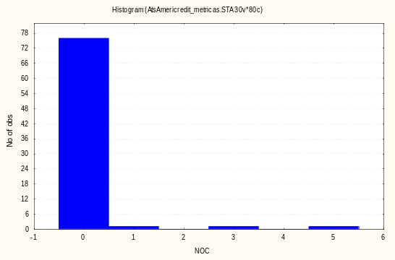
The following figure shows the results for the DIT metric. As you can see most of the classes have no super classes (or the super classes have not been provided for analysis). However, a small number of classes are one level deep in the class inheritance tree (DIT =1). These few classes should be better documented and tested, since a modification on its super-classes can affect them. Again, studying the documentation and test scripts we did not find any documentation or any specific testing for them. Normally, specific testing scripts should be provided in order to test the methods imported via inheritance.

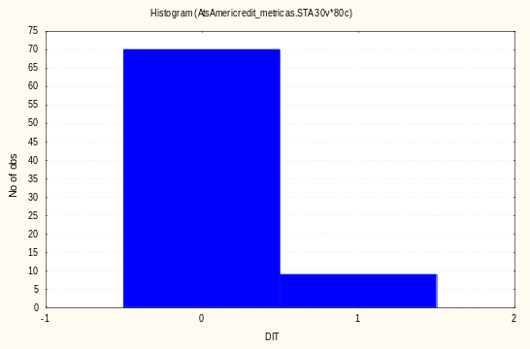
The following figure shows the results for the WMC metric. As you can seen there is a large distribution of value. The average of methods for class is equal to approximately 7.(i.e., 7 methods per class). However, the standard deviation is quite large, about 9. The median is equal to 2.(i.e., 50% of class has less than 3 methods). However, as shown in the following figure, 7 classes have more than 20 methods. The oracle.apps.ieu.server.mediaExtensions.davox.davoxProxy.listPredictive.ListCustomer class has 47 methods!
Classes that deviate far way from the average or median should be documented and tested with more care since they, from a statistical point of view, are more error-prone. However, after studying the documentation and test scripts, we do not find any information that lets us believe that this class had special care. We cannot conclude if they have been tested with more care or better documented.

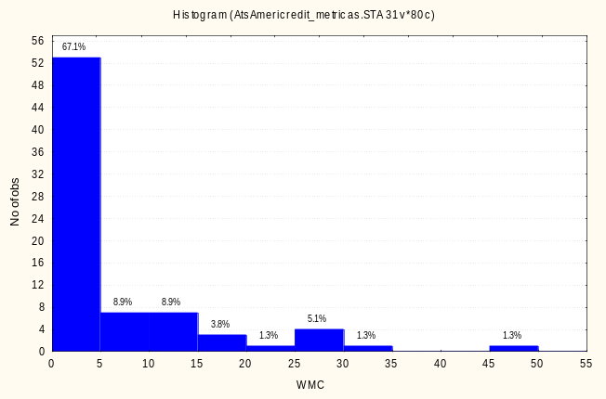
Remarks: The analyzed CK metrics can help identify spots that need special attention since the highlighted classes are more error-prone. We strongly recommend that these classes have to be better tested and better documented. Some design principles, as design-by-contract, should also be used in order to reduce risk of failures during software operation.

Conclusion: The highly complex classes (classes with an WMC higher than 16 as calculated by mean + standard deviation) must be further inspected. Probably the design of these classes should be re-done in order to reduce their complexity.
The following conclusions are SAMPLE ONLY, please update with your project findings accordingly

OO Design Coupling: C-FOOD Metrics
Modularity is one of most important internal software quality attributes. Modularity has a strong impact on several external software quality attributes such as reusability, maintainability and expandability.. Modularity can be measured from two points of view: coupling and cohesion. Well-designed software should present a lower coupling between its classes and each class should have a higher cohesion.
In order to evaluate modularity, we have used C-FOOD [3][4], a set of metrics that allows us to measure coupling in the OO design. C-FOOD takes into consideration the three modalities through which coupling may appear in OO projects:
- Relationship: refers to the type of relationship (inheritance or non-inheritance (“others”)).
- Locus: refers to the expected impact of localization For instance whether the change impacts flows towards a class (import) or away from a class (export).
- Type: refers to the type of interaction between classes (or their elements). Two types will be taken into consideration for the metrics implemented: Class-Attribute (CA) and Class-Method (CM).
All the metrics presented below correspond to particular interaction counting:

Metrics | Description
ACAIC | Ancestors Class-Attribute Import Coupling
OCAIC | Others Class-Attribute Import Coupling
DCAEC | Descendant Class-Attribute Export Coupling
OCAEC | Others Class-Attribute Export Coupling
ACMIC | Ancestors Class-Method Import Coupling
OCMIC | Others Class-Method Import Coupling
DCMEC | Descendant Class-Method Export Coupling
OCMEC | Others Class-Method Export Coupling

ACAIC (Ancestors CA import coupling)
This metrics counts the number of Actual Class-Attribute interactions that are present among the attribute declarations of the class from which the metrics are being calculated and the classes with which it have an ancestral relationship.
In this case, all the 89 analyzed classes have ACAIC is equal to zero: there is no coupling related to importing attribute definitions from ancestors. This is, in part, due to the fact the analyzed classes did not use inheritance (DIT = 0).

DCAEC (Descendant CA export coupling)
What this metric does is count the number of actual Class-Attribute interactions that are present among the attribute declarations of the classes which have a descendant relationship with the class from which the metric is being calculated and the class itself.
All classes have this metric equal to zero: no exporting coupling due to the use of object references. This is due to the flat way inheritance was used: DIT = 0.

ACMIC (Ancestors CM import coupling)
The objective of this metric is to count the number of Actual Class-Method interactions between the methods of the class from which the metrics are being calculated and the classes with which it have an ancestral relationship.
Most of the analyzed classes have this metric equal to zero: no importing coupling on method signature with ancestors. Again, this stems from the fact that the inheritance was almost not used in the design.

DCMEC (Descendant CM export coupling)
The result of this metric is the number of Actual Class-Method interactions between the methods of the classes which have a descendant relationship with the class from which the metric is being calculated and the class itself.
Except one class that has this metric equal to 3, all the other metrics have this metric equal to zero. Therefore, based on these criteria, the level of coupling is low. This stems from the fact that inheritance was almost not used.

OCAIC (Others CA import coupling)
The intention of this metric is to count the number of actual Class-Attribute interactions that are present among the attribute declarations of the class from which the metrics are being calculated and the classes with which it does not has any inheritance relationship.
As we can see in the following figure, most of the classes have this metric equal to zero: no coupling due to attribute importing. Only three classes have this metric value greater than 3. However, it is recommended that these 3 classes are better tested and documented due to this characteristic.

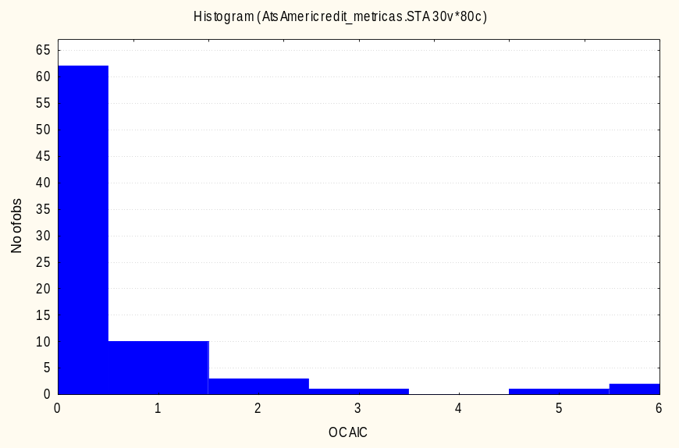

OCAEC (Others CA export coupling)
This metric counts the number of actual Class-Attribute interactions that are present among the attribute declarations of the classes which do not have any inheritance relationship with the class from which the metric is being calculated and the class itself.
Most of the analyzed classes have this metric equal to zero: no relationship with other classes due to association, aggregation or composition. Only a couple of classes have this value greater than zero.

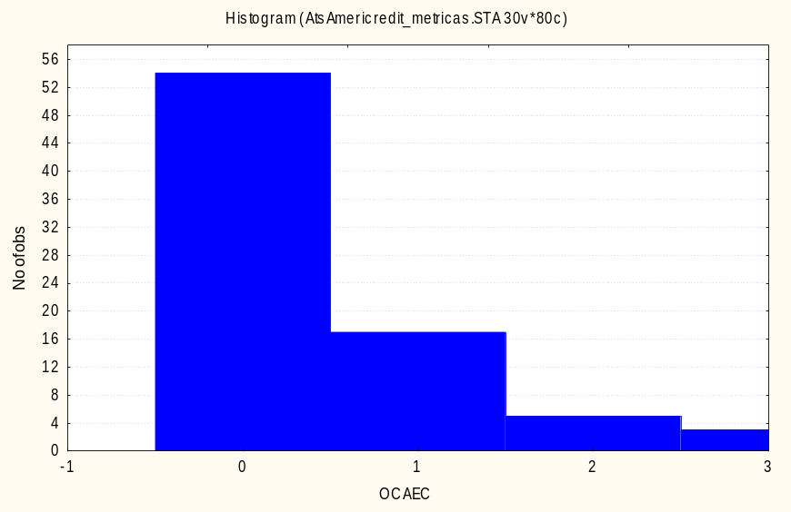

OCMIC (Others CM import Coupling)
This metric counts the number of Actual Class-Method interactions between the methods of the class from which the metrics are being calculated and the classes with which it have no inheritance relationship.
As you can see by the following figure, most of the classes have this metric equal to zero. However, some classes are far way from the average that is 2. Some classes have OCMIC equal to 12 or even 14!
Given the high values of OCMIC on these classes, they are considered more error-prone than to the others and should be tested and documented with care. Probably, such classes also need to be re-designed in order to reduce the amount of coupling.
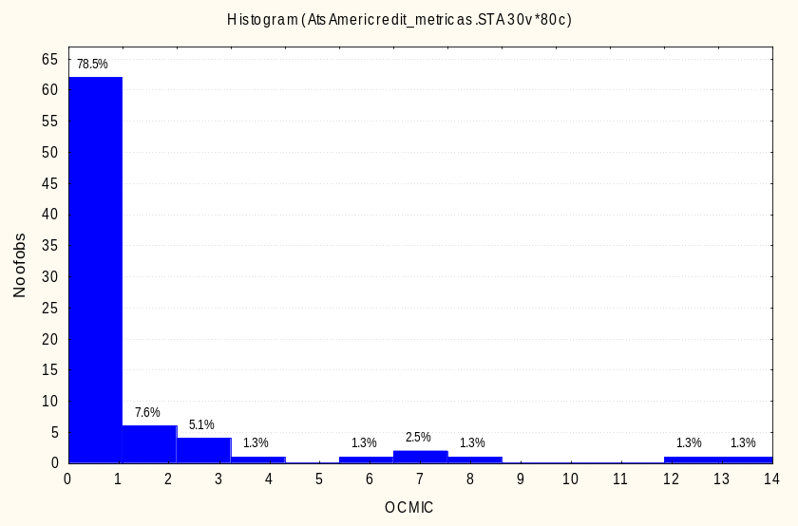

OCMEC (Others CM export coupling)
This metric counts the number of Actual Class-Method interactions between the methods of the classes which do not have any relationship with the class from which the metric is being calculated and the class itself.
As we can see in the following figure, there is a small amount of classes that have a very high level of coupling to usage, i.e., their are used in the method signatures of other classes. We consider the classes that the OCMEC higher than 4 (mean + standard deviation) as more error-prone.

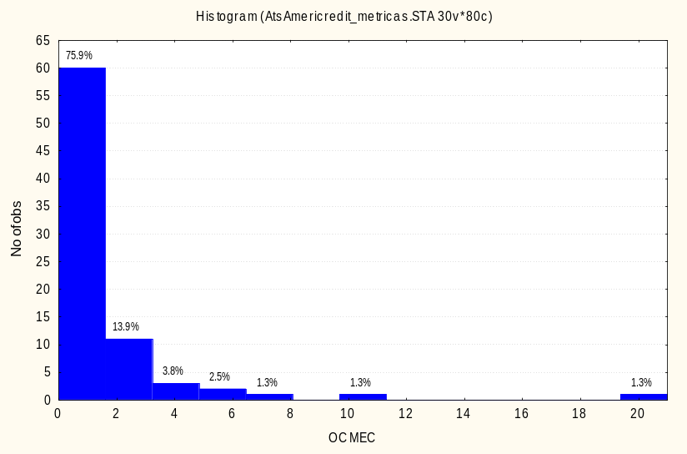

Conclusion. Given the fact that in this project the use of inheritance is almost not used, we have also analyzed the design coupling by adding up all the coupling measures except the inheritance ones. The result is the following:
The average of design coupling is not high: 3.5
10% classes that have presented a high design coupling. These classes are considered more error-prone than the other classes.
One class alone is responsible for 2.5% of the system coupling. This class is a potential risk. Probably, this class should be documented and tested better. Maybe its design should also be re-done in order to reduce its coupling and complexity.
All classes that are considered high risk due to design coupling (C-FOOD greater than 9, i.e., mean + standard deviation), must be better documented; their methods should have assertions (pre-/postconditions) in order to mitigate risk of failures.
The classes that are considered very high risk due to design coupling (C-FOOD greater than 14 (mean + standard deviation*1.96) should have their design re-done in order to reduce coupling.
The following figures show the results of the coupling analysis when we add up all the design coupling measures due to potential message exchanges. It is important to point out here that this analysis is done using the OO design. At run time, the coupling among classes can be quite different of the results discussed here.
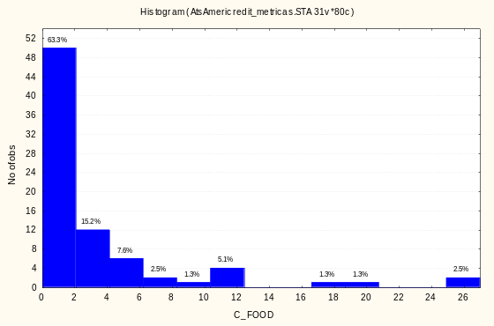 | 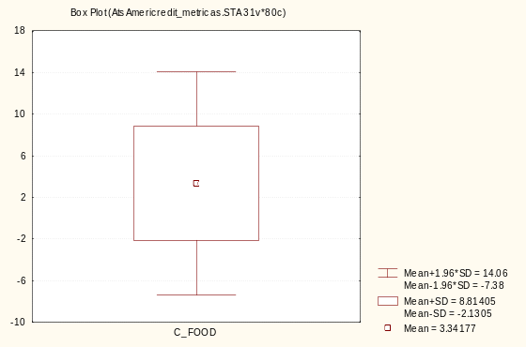

Use this only if you do not use an automated tool for recording review comments.

REVIEW COMMENTS LIST
Ref: ___/___/ RCL/ ___
Use this Review Comment List only if you do not use an automated tool for recording review comments

 | Item Under Review  Version: Review Date: |  |  |  |  | Author:
Reviewers Names OR Associated Review Leader Form Reference: ___/___ RLF/ ___

Outcome: (Circle One)
ACCEPTED (Once comments have been actioned) NOT ACCEPTED (Wish to re-review once comments have been actioned)

No |  | Reference | Comment | Cat | Pt | ACTION |  | CL
Categories (Cat): MA - MAJOR MI - MINOR I - INFORMATION O - OBSERVATION
Problem Types (Pt): M - MISSING W - WRONG E - EXTRA/SUPERFLUOUS
CL - CLEARED (or tick)
Page __ of ___

References
Basili, L. Briand and W. Melo: “A Validation of Object-Oriented Design Metrics as Quality Indicators”. In IEEE Transactions on Software Engineering, 22(10):751-761, 1996.
Barbosa da Veiga, R. Farnese W. Melo, “JMetrics Java Metrics Extractor: An Overview”, University of Brasilia, Dep. of Computer Science, Under-Graduating Final Project, Brasilia, DF, Brazil, 1999.
Briand, P. Devanbu, and W. Melo: “An Investigation into Coupling Measures for C++”. In Proceedings of the 19th International Conference on Software Engineering, Boston, MA, 1997.
Briand, P. Devanbu, and W. Melo. Quality Modeling based on Coupling Measures in a Commercial Object-Oriented System. IESE Technical Report 001.98/E - ISERN Technical Report 98-01
Brito e Abreu and W. Melo: “Evaluating the Impact of Object-Oriented Design on Software Quality”. In Proceedings of the 3rd International Software Metrics Symposium, pages 90-99, Berlin, Germany, 1996.
S. Chidamber and C. Kemerer: "A Metrics Suite for Object-Oriented Design". In IEEE Transactions on Software Engineering, 20(6):476-493, 1994.

Example of Calculating the Metrics
In this subsection we present a simple Java example of calculating the metrics used in this evaluation. The examples should clarify exactly what is counted when computing the inheritance and coupling metrics.
We suppose that classes A and B are descendents of class D and that between the classes A, B and C and between C and D there is an “Other” type of relationship (i.e. other than Ascendant or Descendent).

Example of Class-Attribute (CA) interaction
From the Figure 1 we can notice the CA interaction between classes A and B through the attribute public_ab1. This attribute is of type of class A and is declared in class B, such as, if class A is changed, class B will be changed via the public attribute of class B.
This means that OCAIC (B) = 1 (Class B has an attribute of type A, public_ab1, while classes A and B have a relationship of type “Other”).
In a similar way we can measure the following CA metrics:
ACAIC(B) = 1 (class B has an attribute of type D, public_ab2, while class D is an ancestor of class B).
OCAIC (C) = 2 (Class C has an attribute of type of class A, public_ab3, and one of type of class D, public_ab4, and A and D are in a relationship of type “Other” with class C).
OCAEC(D)=1 (class C has an attribute of type D, while C has a relationship of type “Other” with class D).
DCAEC(D) = 1 (class B, which is a descendant of class D, has an attribute of type of class D).
OCAEC(A) = 2 ( two classes, B and C, have attributes of type A, and they have a relationship with A of type “Other”).

Example of Class-Method (CM) interaction
There is a Class-Method interaction between class A and mb1, a method of class B, and between class A and mb2, a method of class C.
OCMIC(B) = 1 ( class B has a method, mb1, which has a parameter of type of class A, and between B and A there is a relationship of type “Other”)
OCMIC(C) =1 (class C has a method, mb2, which has a parameter of type of class A, and between C and A there is a relationship of type “Other”)
OCMEC(A) = 2 (2 classes, B and C, have methods with parameters of type of class A)

Example of Inheritance Metrics:
DIT(A) and DIT(B) are equal to 1, because they are descendents of class D.
All the other classes have a DIT= 0.
Class D has two descendents, A and B, such that NOC(D) = 2. All the other classes in the example have NOC=0.

Class D
{
public int x;
public int y;
….
}
class A extends D
{
public int aa;
public void ma1()
{ ...
}
}
class B extends D
{
public A public_ab1;
public D public_ab2;
private int i;
private float r;
…
private void mb1(A a1)
{
A a2;
C a3; ...
a2=a3.mb2(a1);
}
}
Class C
{
public A public_ab3;
public D public_ab4;
………
private A mb2(A a)
{ ……..
a.ma1();
return a;
}
}

Example of calculating the metrics for sample Java code.
Summarize the audit findings in terms of scope and objectives together with overall impression of the audit and number of actions (major/minor) raised.

