OUM
STM.010 Project Team Organization Chart
<Company Long Name>
<Subject>

When this template is completed, delete all the yellow notes as follows:
1. With your document open, open the Find and Replace window.
2. Expand the Find and Replace window using the More>> button.
3. Place the cursor in the Find what: field.
4. Choose Format > Style.
5. When the Find Style box opens, scroll through the list and select Note and click OK.
6. Leave the Replace with: field blank.
7. Select Replace, Replace All or Find Next to remove the yellow notes.
8. Repeat using the Note Wide style if there are any landscape sections that contain wide yellow notes.
Please refer to the OUM Template User’s Guide for detailed instructions for working with OUM templates.

Author: <Author>
Creation Date: May 9, 2014
Last Updated: September 13, 2016
Document Ref: <Document Reference Number>
Version: DRAFT 1A

Title, Subject, Last Updated Date, Reference Number, and Version are marked by a Word Bookmark so that they can be easily reproduced in the header and footer of documents. When you change any of these values, be careful not to accidentally delete the bookmark. You can make bookmarks visible by selecting the Office Button>Word Options>Advanced> and checking the Show bookmarks option in the Show document content region.

Approvals:
<Approver 1>
<Approver 2>
To add additional approval lines, press [Tab] from the last cell in the table above.
You can delete any elements of this cover page that you do not need for your document.

Document Control

Change Record
4
Date | Author | Version | Change Reference
9-May-14 | <Author> | Draft 1a | No Previous Document

Reviewers

Name | Position

Contents
1 Document Control iii
1.1 Change Record iii
1.2 Reviewers iii
2 Project Organization Chart 1
3 Roles and Responsibilities 2
3.1 Project Steering Group 2
3.2 Customer Project Manager 2
3.3 <Consultant> Project Manager 2
4 Open and Closed Issues 3
4.1 Open Issues 3
4.2 Closed Issues 3

To update the table of contents, put the cursor anywhere in the table and press [F9]. To change the number of levels displayed, select the menu option Insert->Index and Tables, make sure the Table of Contents tab is active, and change the Number of Levels to a new value.

Project Organization Chart
Replace this organization chart with the organization chart for the project.

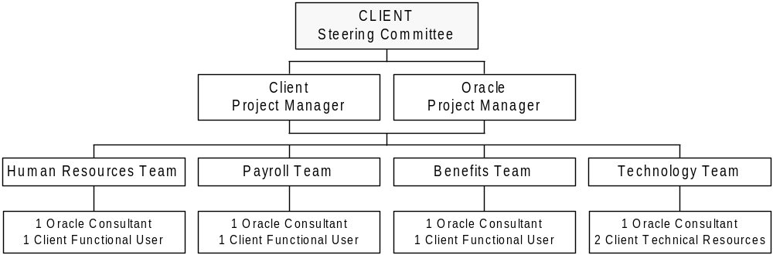

Roles and Responsibilities

Project Steering Group
This consists of:

Customer Project Manager

<Consultant> Project Manager

Open and Closed Issues
Add open issues that you identify while writing or reviewing this document to the open issues section. As you resolve issues, move them to the closed issues section and keep the issue ID the same. Include an explanation of the resolution.
When this work product is complete, any open issues should be transferred to the project- or process-level Issue Log (Manage Focus Area) and managed using a project level Issue Form (Manage Focus Area). In addition, the open items should remain in the open issues section of this work product, but flagged in the resolution column as being transferred.

Open Issues

ID | Issue | Resolution | Responsibility | Target Date | Impact Date

Closed Issues

ID | Issue | Resolution | Responsibility | Target Date | Impact Date

