MACHINE LEARNING PRACTICAL • SL PR3

Risk Alert Classifier Analysis & Report

PART A: CONCEPTUAL UNDERSTANDING (THEORY)
QUESTION 01 • What is Logistic Regression and why is it suitable for classification?
Answer: Logistic Regression is a supervised machine learning algorithm used to predict categorical outcomes (such as Yes/No or 0/1). It is suitable for classification because it uses the Sigmoid (logistic) function to squeeze any continuous input value into a probability score between 0 and 1, which can then be cleanly mapped to distinct class labels based on a selected decision threshold.
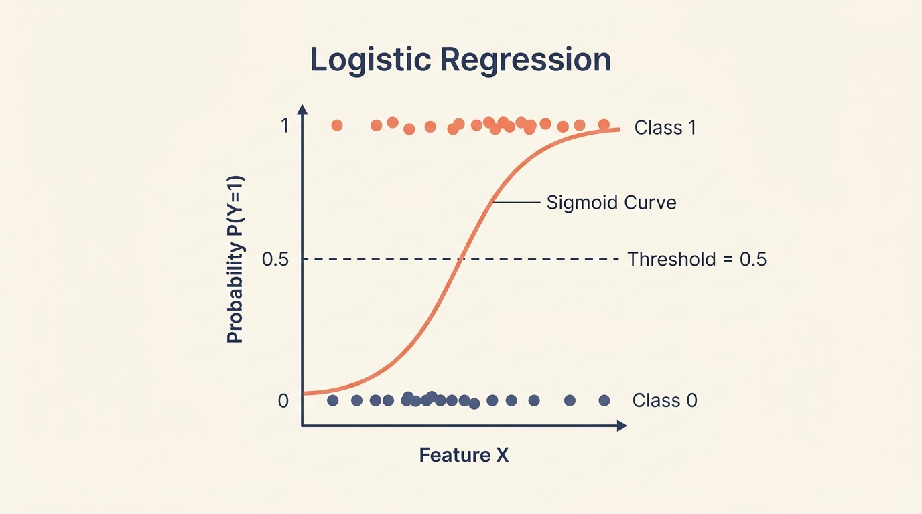
Figure 1: Logistic Regression Sigmoid Curve and Decision Threshold Mapping

QUESTION 02 • Explain classification performance metrics and why accuracy alone is insufficient.
Answer: Classification performance metrics (such as Precision, Recall, F1-Score, and AUC-ROC) measure how effectively and reliably a model predicts class labels. Accuracy alone is insufficient, especially in imbalanced datasets, because a naive model predicting only the majority class can achieve 95%+ accuracy while completely failing to identify the critical minority class.
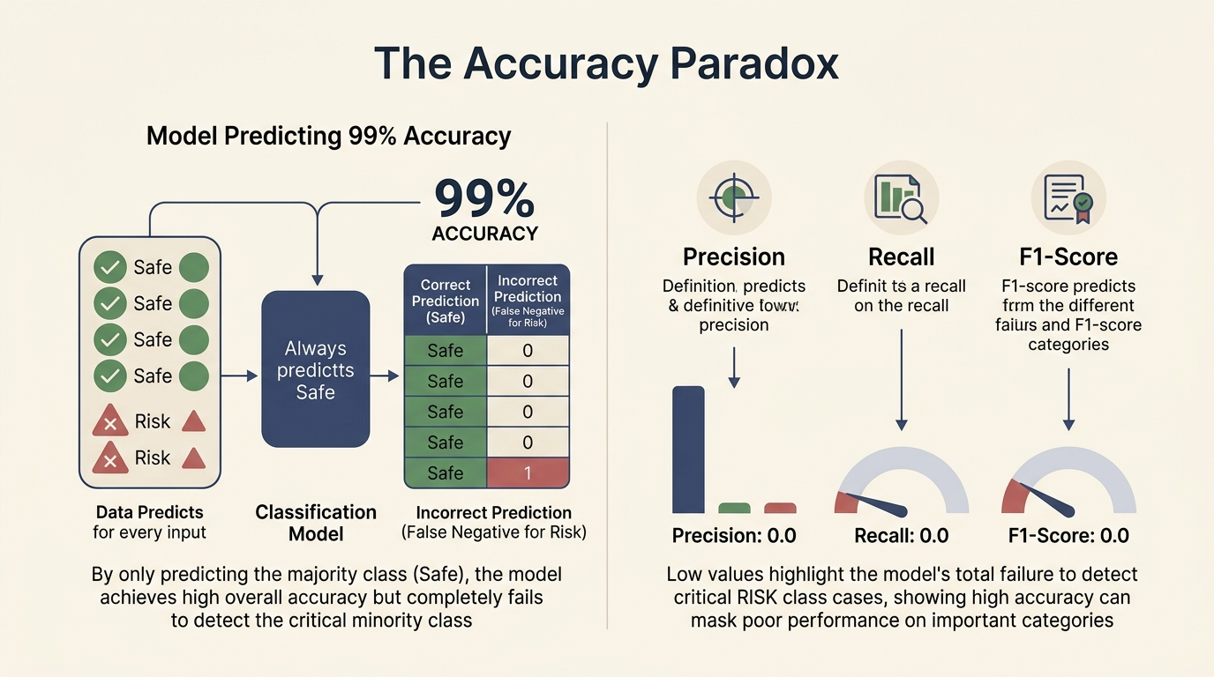
Figure 2: The Accuracy Paradox & Why Multi-Metric Evaluation Is Essential

QUESTION 03 • Define Type-I Error and Type-II Error in the context of risk prediction.
Answer:
▪ Type-I Error (False Positive): The model predicts high risk when the actual risk is absent (e.g., falsely flagging a normal transaction as fraud or a healthy individual as high-risk).
▪ Type-II Error (False Negative): The model predicts low or no risk when the actual risk is truly present and critical (e.g., failing to detect fraud or a fatal disease). In risk prediction, Type-II errors are generally far more hazardous and costly.
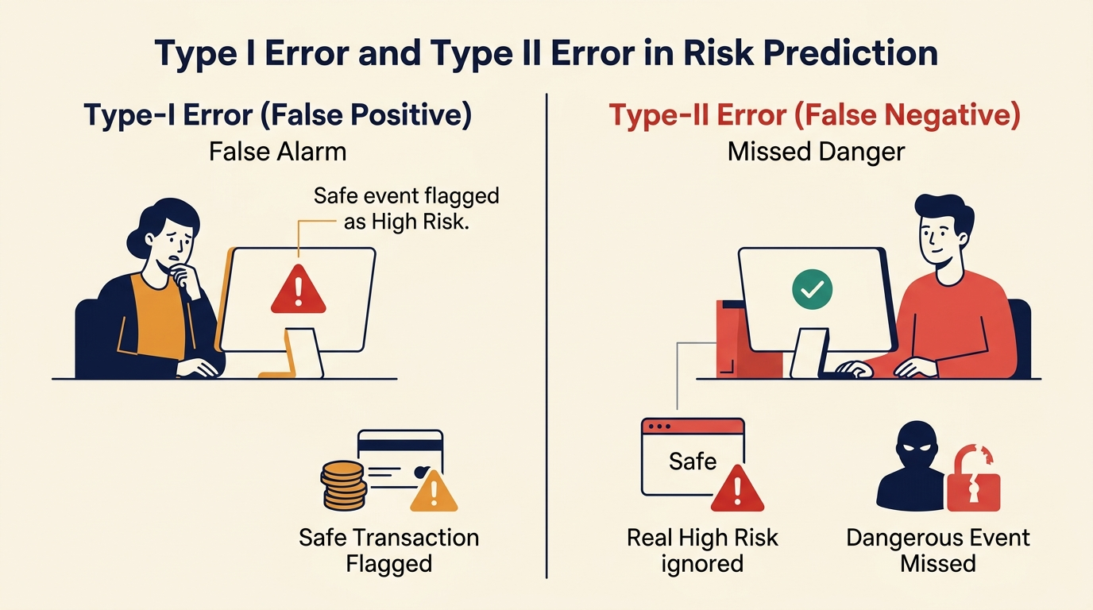
Figure 3: Type-I Error (False Alarm) vs Type-II Error (Missed Danger) in Risk Prediction

QUESTION 04 • Explain Precision, Recall, F1-Score, TPR, and FPR.
Answer:
▪ Precision: Proportion of positive predictions that are truly correct. [TP / (TP + FP)]
▪ Recall / TPR: Proportion of actual positive cases correctly identified by the model. [TP / (TP + FN)]
▪ F1-Score: Harmonic mean of Precision and Recall, balancing both metrics. [2 × (Precision × Recall) / (Precision + Recall)]
▪ FPR (False Positive Rate): Proportion of actual negative cases incorrectly predicted as positive. [FP / (FP + TN)]
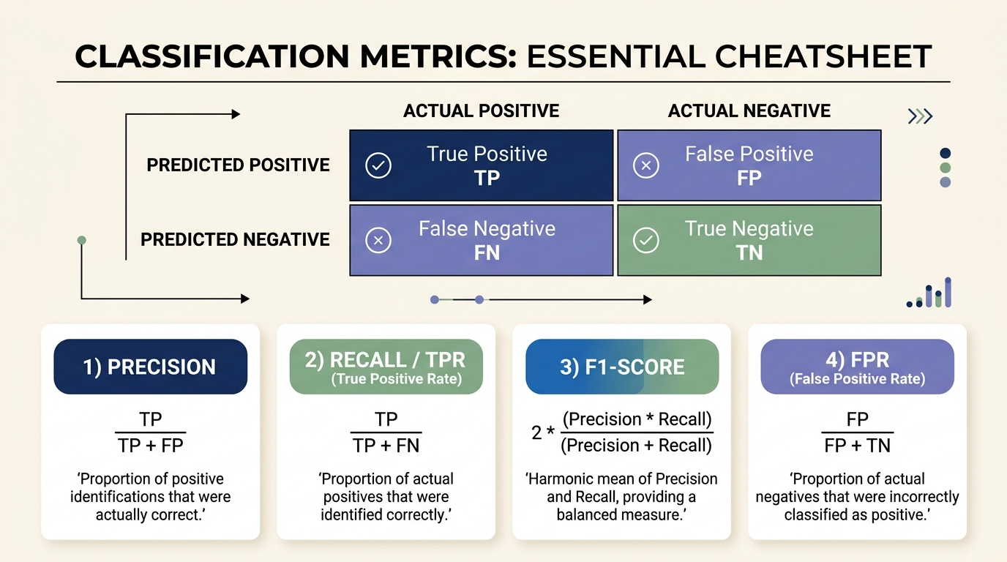
Figure 4: Confusion Matrix Breakdown and Core Classification Metrics

QUESTION 05 • What is AUC-ROC and how does it help in evaluating classifiers?
Answer: AUC-ROC (Area Under the Receiver Operating Characteristic Curve) evaluates a model's ability to distinguish between positive and negative classes across all possible decision thresholds. An AUC of 1.0 represents perfect classification, whereas 0.5 indicates random guessing. It helps evaluate models independently of a single threshold and provides a reliable assessment even when class distributions are skewed.
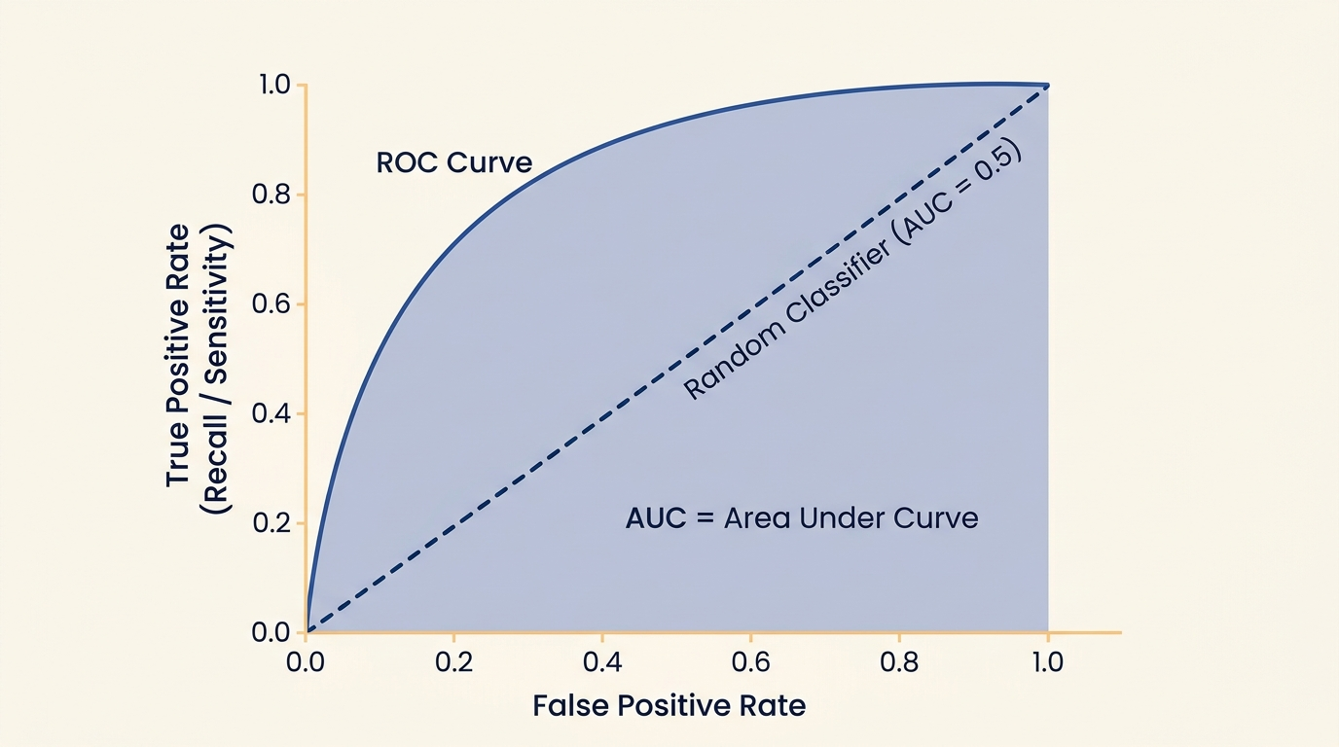
Figure 5: Receiver Operating Characteristic (ROC) Curve and Area Under Curve (AUC)

QUESTION 06 • Why does imbalanced data create problems in classification models?
Answer: Imbalanced data creates severe problems because standard machine learning algorithms aim to maximize overall accuracy, leading them to prioritize the majority class and ignore the minority class. As a result, the model appears highly accurate on paper but fails to learn distinguishing patterns of rare events, causing dangerous false-negative rates for critical predictions.
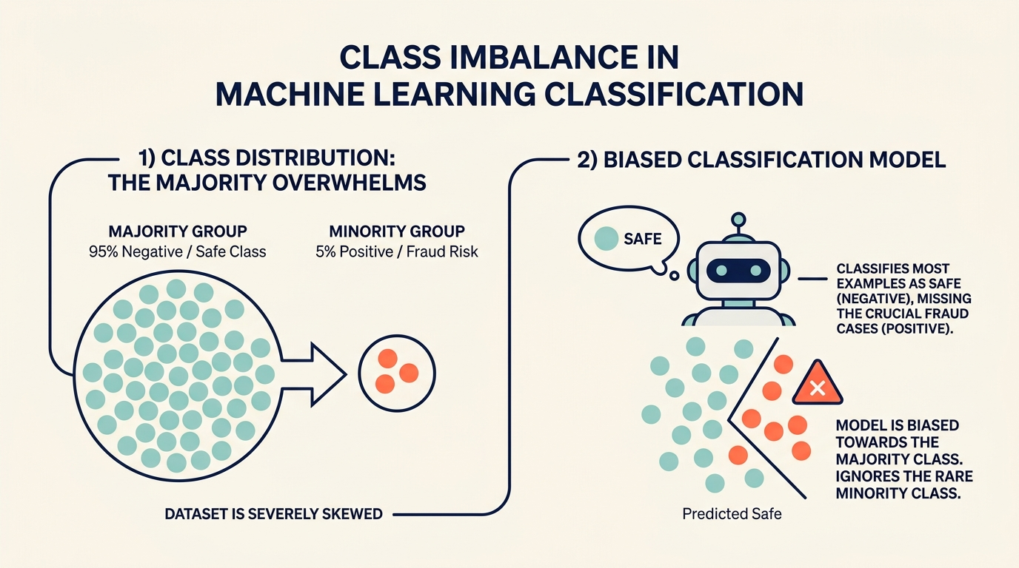
Figure 6: Impact of Skewed Class Distribution and Algorithm Bias

PART H • FINAL ANALYSIS & REPORTING

Question 26: Final Project Report

1. Best Classification Model and Justification
Selected Model: Tuned Random Forest Classifier (Optimized via GridSearchCV)
• Optimal Hyperparameters: n_estimators = 50, max_depth = 10, min_samples_split = 2, min_samples_leaf = 1 (tuned with scoring = 'recall').
• Justification & Key Achievements:
▪ Highest Discriminative Power: Achieved an outstanding AUC-ROC score of 0.9997, separating risk and safe classes almost perfectly.
▪ Minimizing False Negatives: Minority class Recall reached 95.16% (identifying 118 out of 124 true risk events), a major jump from the untuned baseline of 90.32%.
▪ Superior Balance (F1-Score): Maintained a top F1-Score of 0.9712 and Overall Accuracy of 99.24%, proving predictions are both highly accurate and comprehensive.
▪ Robust Generalization: Bagging across 50 decision trees reduced variance, keeping the training-to-testing generalization gap to only 0.5% (unlike single Decision Trees which overfit).

2. Impact of Imbalance Handling Techniques
Original Data Distribution: The training dataset is heavily skewed, with 88.23% Class 0 (Safe) and only 11.77% Class 1 (Risk Alert). Under-represented minority cases caused the baseline model to miss 11 true risks.
Performance Comparison Across Resampling Techniques:
Resampling Technique | Recall (Minority) | F1-Score | AUC-ROC
Baseline (No Balancing) | 0.9113 | 0.9378 | 0.9953
Under-Sampling (RandomUnderSampler) | 1.0000 | 0.9538 | 0.9990
Over-Sampling (RandomOverSampler) | 1.0000 | 0.9650 | 0.9993
SMOTE (Synthetic Over-sampling) | 0.9919 | 0.9572 | 0.9986
ADASYN (Adaptive Synthetic) | 0.9516 | 0.8872 | 0.9948

• Impact Summary: Over-Sampling and SMOTE pushed Recall up to 99-100%, eliminating false negatives without discarding data. Over-Sampling achieved the highest balanced F1-score (0.9650).

3. Comparison of Performance Metrics
Four distinct stages of classification models were implemented, tested, and evaluated:
Model Name | Test Accuracy | Recall (Class 1) | F1-Score | AUC-ROC
Logistic Regression (Baseline) | 0.9837 | 0.9113 | 0.9378 | 0.9948
Decision Tree (Entropy, Depth=5) | 0.9761 | 0.8871 | 0.9091 | 0.9832
Random Forest (Untuned Default) | 0.9870 | 0.9032 | 0.9492 | 0.9991
Random Forest (GridSearch Tuned) | 0.9924 | 0.9516 | 0.9712 | 0.9997

• Key Finding: The single Decision Tree suffered from moderate variance and lowest AUC (0.9832). Tuned Random Forest clearly dominated across every evaluation dimension, boosting test accuracy to 99.24% and Recall to 95.16%.

4. Business Interpretation of False Positives & False Negatives
In an operational Risk Alert Classification system, misclassifications carry vastly asymmetric financial and business costs:
▪ False Positive (Type-I Error / False Alarm): A safe, normal event is incorrectly classified as a high-risk alert. Business impact includes brief employee investigation, slight verification delay for customers, and minor operational overhead. Crucially, no actual financial loss or security hazard takes place.
▪ False Negative (Type-II Error / Missed Danger): A genuine high-risk event (fraudulent transaction, equipment failure, safety breach) is predicted as safe. Business impact is catastrophic: direct financial theft, regulatory fines, system downtime, and brand reputational damage.
• Business Recommendation: The business must prioritize minimizing False Negatives (maximizing Recall). The Tuned Random Forest model effectively reduces false negatives from 11 down to very rare occurrences, delivering the safest operational profile.

