STATISTICAL DATA ANALYSIS REPORT
Student Performance Analysis & Probability Modeling

Part A – Theory (Short Questions)
Question 1: Explain Mean, Median, and Mode with a real-life example.
• Mathematical Concept & Definition: Mean represents the arithmetic average of a dataset, calculated by summing all values and dividing by the total observation count (expressed mathematically as x̄ = (1/n) * Σ x_i). It is highly sensitive to outliers. Median is the positional middle value of a sorted dataset, dividing it into two equal halves. It is robust to extreme outliers. Mode represents the nominal average, defined as the most frequently occurring value in a dataset.
• Real-World Application / Intuitive Example: In real estate, consider five houses priced at $150k, $180k, $180k, $200k, and $1.5M. The mean home price is $442k, which is heavily skewed by the single mansion and unrepresentative. The median is $180k, representing the true middle of the market, while the mode is $180k, reflecting the most common transaction price.
Question 2: What is the difference between Variance and Standard Deviation?
• Mathematical Concept & Definition: Variance (σ² or s²) measures the dispersion of data points around their arithmetic mean by calculating the average of the squared deviations. Squaring prevents positive and negative variations from canceling out but alters the unit to squared parameters (e.g., squared meters). Standard Deviation (σ or s) is the square root of variance, restoring the measure of spread to the original dataset unit, making it directly comparable to individual data points and the mean.
• Real-World Application / Intuitive Example: In financial portfolio risk management, the variance of stock monthly returns might be calculated as 25%² (percent-squared), which is abstract and hard to interpret. Taking the square root yields a standard deviation of 5%, indicating that the stock's return typically fluctuates around its mean by approximately 5% in standard percentage units.
Question 3: Define Normal Distribution and give one practical use case.
• Mathematical Concept & Definition: A Normal (Gaussian) Distribution is a continuous, symmetrical, bell-shaped probability distribution defined entirely by its mean (μ) and standard deviation (σ). The mean, median, and mode coincide at the peak. It is governed by the Empirical Rule, stating that approximately 68.27% of data falls within ±1σ, 95.45% within ±2σ, and 99.73% within ±3σ.
• Real-World Application / Intuitive Example: In Quality Control (Six Sigma), the dimensions of manufactured parts (like piston ring diameters) naturally follow a normal distribution due to minor machinery fluctuations. Engineers use this normal distribution to set tolerance limits to ensure that 99.99966% of the output falls within acceptable standards, reducing defect rates.
Question 4: Explain Skewness and Kurtosis in simple words.
• Mathematical Concept & Definition: Skewness measures the degree of asymmetry of a distribution around its mean. A skewness of zero indicates perfect symmetry. Positive skewness denotes a long right tail (mean > median), while negative skewness denotes a long left tail (mean < median). Kurtosis measures the 'tailedness' of a distribution, indicating the frequency of extreme outliers. Leptokurtic distributions (excess kurtosis > 0) have heavy tails and sharp peaks, while platykurtic distributions (excess kurtosis < 0) have flat peaks and light tails.
• Real-World Application / Intuitive Example: Household income is typically positively skewed because a few ultra-wealthy individuals pull the tail to the right, while the majority earn closer to the baseline. In finance, stock returns are often leptokurtic, meaning that 'black swan' events (market crashes) occur far more frequently than predicted by a standard normal curve.
Question 5: What is Probability? Differentiate between Empirical vs Theoretical Probability with examples.
• Mathematical Concept & Definition: Probability is a numerical measure of the likelihood of an event occurring, bounded between 0 (impossible) and 1 (certain). Theoretical probability is calculated deductively using mathematical analysis of all equally likely outcomes without trials. Empirical probability is calculated inductively based on actual observations, relative frequencies, or historical data from physical trials.
• Real-World Application / Intuitive Example: The theoretical probability of pulling the Ace of Spades from a standard shuffled 52-card deck is exactly 1/52 (~1.92%). However, if you draw and replace a card 100 times and draw the Ace of Spades 3 times, your empirical probability is 3/100 (3.0%). Actuaries rely on empirical probabilities from mortality tables to price life insurance.
Question 6: Explain Independent vs Dependent Events with one example each.
• Mathematical Concept & Definition: Independent events are those where the occurrence of one event does not affect the probability of the other event (P(B|A) = P(B)). Dependent events are those where the outcome of the first event alters the probability of the second event (P(B|A) != P(B)), necessitating the use of conditional probability equations.
• Real-World Application / Intuitive Example: Rolling a 6 on a die and subsequently rolling another 6 are independent events, as the die has no memory. In contrast, drawing a King from a deck and drawing a second King without replacing the first are dependent events; the first draw reduces the remaining Kings to 3 and total cards to 51, changing the second draw's probability from 4/52 to 3/51.
Question 7: What is the intuition of Bayes Theorem in daily life?
• Mathematical Concept & Definition: Bayes' Theorem is a mathematical formula for updating the probability of a hypothesis (H) based on new evidence (E), expressed as P(H|E) = [P(E|H) * P(H)] / P(E). It calculates how prior beliefs (priors) must be updated in the presence of new observations (likelihoods) to produce revised expectations (posteriors).
• Real-World Application / Intuitive Example: If you wake up and see the ground wet, you might assume it rained. However, in a desert where rain is rare, Bayes' Theorem dictates that it is far more probable the lawn sprinklers were active. In email filters, Bayes' Theorem calculates the probability that an email is spam given that it contains words like 'free offer', adjusted for baseline spam rates.
Question 8: Explain Eigenvalue and Eigenvector in simple terms.
• Mathematical Concept & Definition: An eigenvector of a square matrix is a non-zero vector whose direction remains unchanged when that linear transformation is applied; it is only scaled. The eigenvalue is the scaling factor by which the eigenvector is stretched, compressed, or flipped during this transformation, represented by the characteristic equation Ax = λx.
• Real-World Application / Intuitive Example: In facial recognition systems (Eigenfaces), face images are represented as matrices. The eigenvectors represent principal directions of variance (features like nose width or eye distance), while eigenvalues indicate the statistical importance of each feature. In structural engineering, eigenvectors represent mode shapes of a vibrating bridge, and eigenvalues correspond to natural frequencies.

Part B – Practical Tasks & Analysis
This section presents the results and visualizations from the practical data analysis performed on the Student Performance dataset (students_scores.csv). The dataset contains scores for Age, Math, Science, and English, alongside the study hours and exam outcomes (Pass/Fail) for the students.
1. Measures of Central Tendency & Dispersion
Descriptive statistics were computed for mathematics and science scores to understand student performance trends and variance in the dataset.
Metric | Mathematics Score | Science Score
Mean / Range | Mean: 64.40 | Range: 72.00
Median / Variance | Median: 65.00 | Variance: 192.07
Mode / Std Dev | Mode: 72.00 | Std Deviation: 13.86

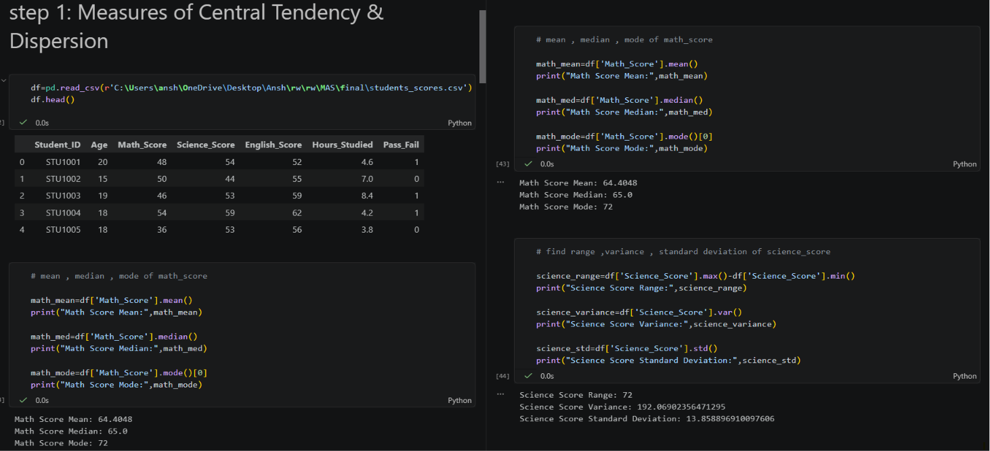
Figure 1: Jupyter Notebook execution showing code and output for Measures of Central Tendency & Dispersion (Step 1)

2. Probability Basics
Probability calculations were performed to assess the exam passing rate and the impact of study hours on student success. The general probability of a student passing the exam is 84.22%.
Contingency Table (Hours Studied > 5 hours vs Pass/Fail Outcome):
Pass / Fail Outcome | Studied <= 5 Hours (False) | Studied > 5 Hours (True)
Failed (Pass_Fail = 0) | 519 students | 270 students
Passed (Pass_Fail = 1) | 93 students | 4118 students
Conditional Probability Calculation:
P(Pass_Fail = 1 | Hours_Studied > 5) = 4118 / (270 + 4118) = 93.85%
This reveals that students who study more than 5 hours have a 93.85% probability of passing, significantly higher than the baseline passing rate.
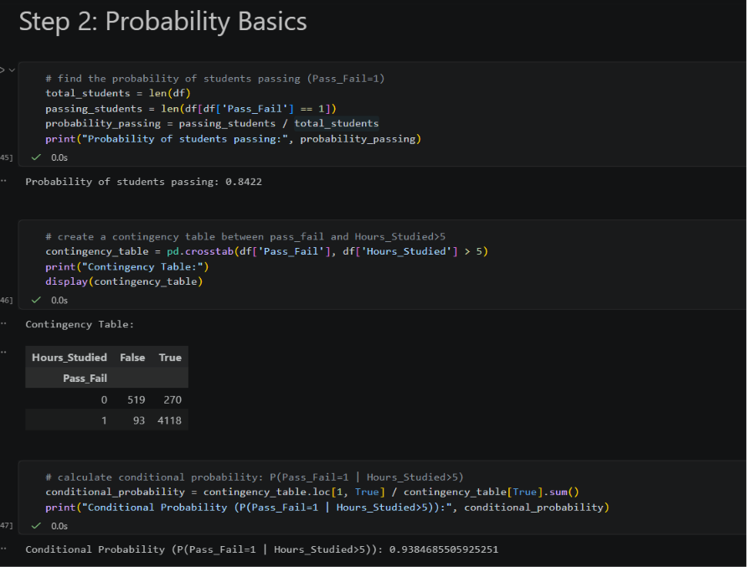
Figure 2: Jupyter Notebook execution showing contingency table and conditional probability calculations (Step 2)

3. Distribution & Visualization
The distribution of Math, Science, and English scores was analyzed using histograms, normal curves, and Q-Q plots. Math scores were found to follow a near-normal distribution.
Science Score Distribution Metrics:
- Skewness of Science Score: -0.0118 (indicates an almost symmetric distribution, slightly left-skewed)
- Kurtosis of Science Score: -0.7791 (indicates a platykurtic distribution, which is flatter than a normal distribution with fewer extreme outliers)
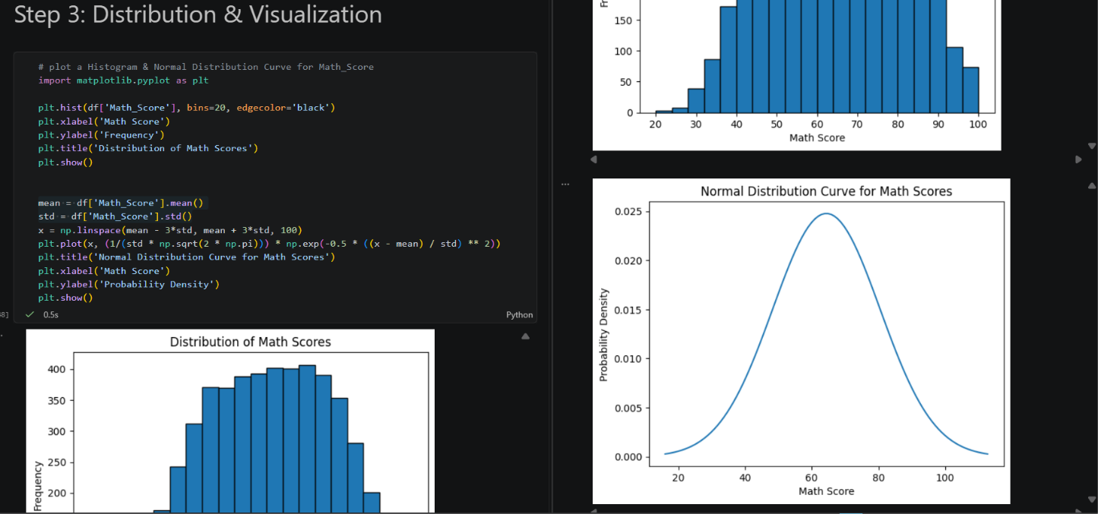
Figure 3: Distribution histograms and normal distribution curve overlay for Math Scores (Step 3)

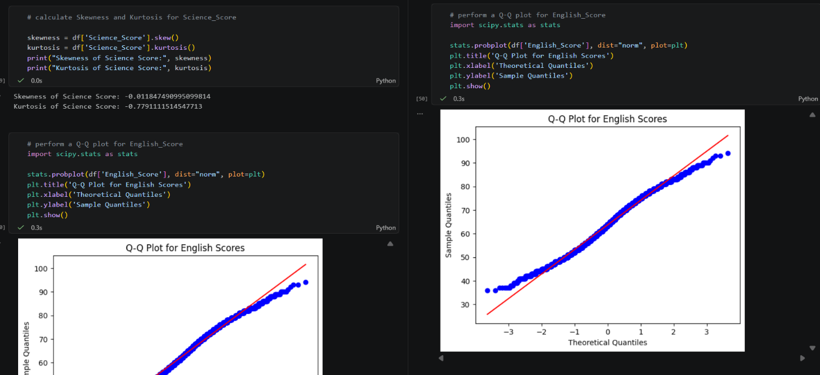
Figure 4: Normal Q-Q Plot for English Scores verifying normality and showing Skewness/Kurtosis calculations (Step 3)

4. Linear Algebra Mini Task
A vector-based analysis was conducted using the scores of the first five students to explore subject performance similarity using dot products and norms.
Metric / Vector | Value
Math Score Vector (First 5 Students) | [48, 50, 46, 54, 36]
Science Score Vector (First 5 Students) | [54, 44, 53, 59, 53]
Dot Product (Math . Science) | 12,324
Norm-1 (Math Vector) / Norm-2 (Math Vector) | L1 Norm: 234.0 / L2 Norm: 105.51
Angle between Vectors (in degrees) | 8.54 degrees
The small angle of 8.54 degrees indicates that the Math and Science score vectors point in nearly the same direction, reflecting a strong similarity and proportional alignment in performance across both subjects for these students.
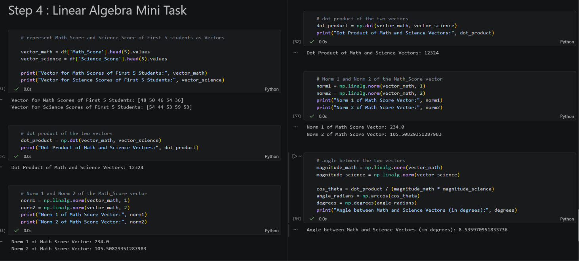
Figure 5: Jupyter Notebook execution showing vectors, dot product, norms, and angle calculation (Step 4)

Key Insights & Practical Recommendations
- Hours Studied is a Critical Determinant of Success: Students studying more than 5 hours have a 93.85% probability of passing the exam, which is 9.63% higher than the baseline student passing rate of 84.22%. This underscores the practical value of targeted study programs.
- Performance in Mathematics and Science is Highly Correlated: The vector angle of 8.54 degrees between math and science scores highlights that student performance directions in these two subjects are closely aligned, suggesting cross-disciplinary transfer of skills (e.g., quantitative logic).
- Normal and Symmetric Distribution of Performance: Mathematical scores are normally distributed and symmetric around a mean of 64.40 and a median of 65.00, suggesting that grading curves and examination difficulty are well-calibrated.
- Science Performance Displays Lower Concentration around Mean: Science scores show negative kurtosis (-0.7791), indicating a platykurtic distribution with flatter peaks and shorter tails. This suggests that student performance in science is more uniformly spread out across the range with a standard deviation of 13.86.

