Umetna inteligenca 2021-2022

Seminarska naloga 2

Jan Vovk, Aljaž Hribar

December 2021

# Naloga

Namen seminarske naloge je implementacija in uporaba preiskovalnih algoritmov na domeni iskanja poti

v labirintu. Vsak vhodni labirint vsebuje eno začetno in eno ciljno polje. Prav tako, vsak labirint vsebuje

vsaj eno polje z zakladom. Želimo poiskati čim cenejšo pot od začetnega do enega izmed ciljnih polj tako,

da na poti poberemo vse zaklade. Premiki skozi steno (polja z oznako -1) niso dovoljeni. Pozitivne

vrednosti v polju predstavljajo ceno prehoda preko tega polja. Prehodi skozi specialna polja (začetno,

ciljno, ter polja z zakladom) imajo ceno 0.

Za iskanje poti iz labirinta sva implementirala 3 algoritme. BFS(best first search), DFS(depth first search) in A*.Dobila sva naslednje rezultate

# Labirint

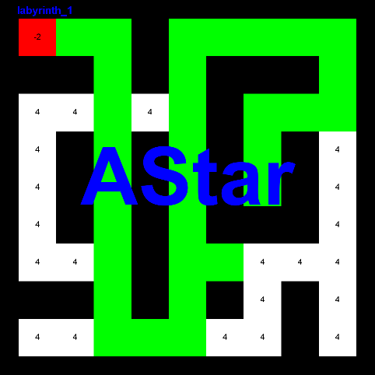DFS

dolzina poti: 54

cena poti: 184

število obiskanih vozlišč: 122

največja globina: 39

[[1,2], [1,3], [2,3], [3,3], [4,3], [5,3], [6,3], [7,3], [8,3], [9,3], [8,3], [7,3], [6,3], [5,3], [4,3], [3,3], [3,4], [3,5], [2,5], [1,5], [1,6], [1,7], [1,6], [1,5], [2,5], [3,5], [4,5], [5,5], [6,5], [7,5], [8,5], [9,5], [9,6], [9,7], [8,7], [7,7], [7,6], [7,5], [6,5], [5,5], [4,5], [3,5], [2,5], [1,5], [1,6], [1,7], [1,8], [1,9], [2,9], [3,9], [3,8], [3,7], [4,7], [5,7], ]

BFS

dolzina poti: 32

cena poti: 103

število obiskanih vozlišč: 108

največja globina: 10

[[1,2], [1,3], [2,3], [3,3], [4,3], [5,3], [6,3], [7,3], [8,3], [9,3], [9,4], [9,5], [8,5], [7,5], [7,6], [7,5], [6,5], [5,5], [4,5], [3,5], [2,5], [1,5], [1,6], [1,7], [1,8], [1,9], [2,9], [3,9], [3,8], [3,7], [4,7], [5,7], ]

AStar

dolzina poti: 32

cena poti: 103

število obiskanih vozlišč: 67

največja globina: 10

[[1,2], [1,3], [2,3], [3,3], [4,3], [5,3], [6,3], [7,3], [8,3], [9,3], [9,4], [9,5], [8,5], [7,5], [7,6], [7,5], [6,5], [5,5], [4,5], [3,5], [2,5], [1,5], [1,6], [1,7], [1,8], [1,9], [2,9], [3,9], [3,8], [3,7], [4,7], [5,7], ]

Opazke:

Zaradi velikosti in oblike labirinta je BFS uspel najti z manjšim številom obiskani oblišč kot DFS.

AStar se je odrezal boljše od obeh

# Labirint

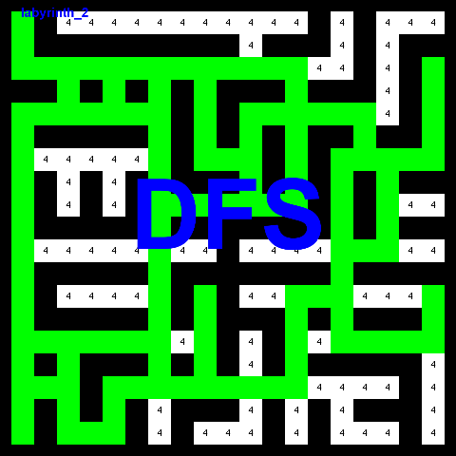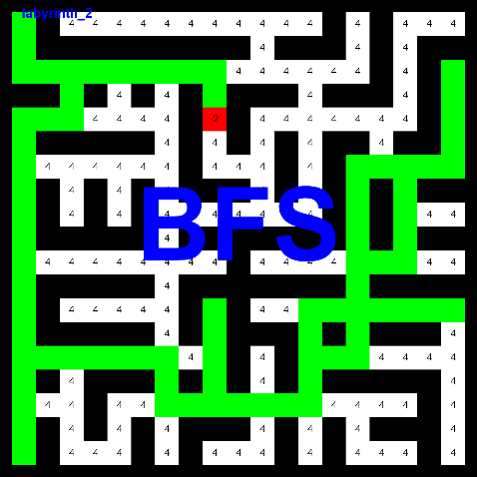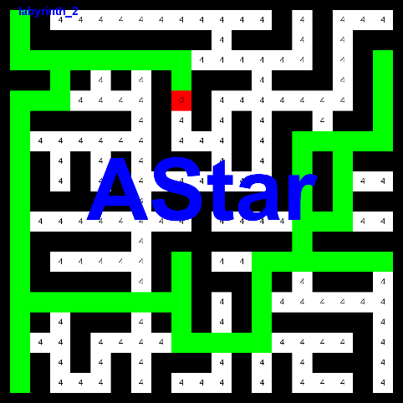

DFS

dolzina poti: 328

cena poti: 1268

število obiskanih vozlišč: 539

največja globina: 82

[[4,9], [3,9], [3,8], [3,7], [4,7], [5,7], [6,7], [7,7], [8,7], [9,7], [10,7], [11,7], [12,7], [13,7], [14,7], [15,7], [16,7], [17,7], [17,6], [17,5], [18,5], [19,5], [19,4], [19,3], [18,3], [17,3], [16,3], [15,3], [15,2], [15,1], [14,1], [13,1], [12,1], [11,1], [10,1], [9,1], [8,1], [7,1], [6,1], [5,1], [5,2], [5,3], [4,3], [3,3], [3,2], [3,1], [2,1], [1,1], [2,1], [3,1], [3,2], [3,3], [4,3], [5,3], [5,2], [5,1], [6,1], [7,1], [8,1], [9,1], [10,1], [11,1], [12,1], [13,1], [14,1], [15,1], [16,1], [17,1], [18,1], [19,1], [18,1], [17,1], [16,1], [15,1], [14,1], [13,1], [12,1], [11,1], [10,1], [9,1], [8,1], [7,1], [6,1], [5,1], [5,2], [5,3], [4,3], [3,3], [3,4], [3,5], [4,5], [5,5], [5,6], [5,7], [4,7], [3,7], [3,8], [3,9], [4,9], [5,9], [6,9], [7,9], [7,10], [7,11], [6,11], [5,11], [5,12], [5,13], [6,13], [7,13], [8,13], [9,13], [9,12], [9,11], [9,10], [9,9], [9,8], [9,7], [10,7], [11,7], [12,7], [13,7], [14,7], [15,7], [16,7], [17,7], [17,8], [17,9], [17,10], [17,11], [17,12], [17,13], [16,13], [15,13], [14,13], [13,13], [13,14], [13,15], [12,15], [11,15], [10,15], [9,15], [8,15], [7,15], [7,16], [7,17], [7,18], [7,19], [6,19], [5,19], [4,19], [3,19], [4,19], [5,19], [6,19], [7,19], [7,18], [7,17], [8,17], [9,17], [10,17], [11,17], [11,16], [11,15], [10,15], [9,15], [8,15], [7,15], [7,16], [6,16], [5,16], [5,15], [5,14], [5,13], [4,13], [3,13], [3,12], [3,11], [3,10], [3,9], [4,9], [5,9], [6,9], [7,9], [7,10], [7,11], [8,11], [9,11], [9,10], [9,9], [9,8], [9,7], [8,7], [7,7], [6,7], [5,7], [4,7], [3,7], [3,6], [3,5], [4,5], [5,5], [5,4], [5,3], [5,2], [5,1], [6,1], [7,1], [8,1], [9,1], [10,1], [11,1], [12,1], [13,1], [14,1], [15,1], [16,1], [17,1], [17,2], [17,3], [16,3], [15,3], [15,4], [15,5], [15,6], [15,7], [16,7], [17,7], [17,8], [17,9], [17,10], [17,11], [17,12], [17,13], [16,13], [15,13], [14,13], [13,13], [13,14], [13,15], [14,15], [15,15], [15,16], [15,17], [15,18], [15,19], [14,19], [13,19], [14,19], [15,19], [15,18], [15,17], [15,16], [15,15], [14,15], [13,15], [12,15], [11,15], [10,15], [9,15], [8,15], [7,15], [7,16], [6,16], [5,16], [5,15], [5,14], [5,13], [4,13], [3,13], [3,12], [3,11], [3,10], [3,9], [4,9], [5,9], [6,9], [7,9], [7,10], [7,11], [8,11], [9,11], [9,10], [9,9], [9,8], [9,7], [8,7], [7,7], [6,7], [5,7], [4,7], [3,7], [3,6], [3,5], [4,5], [5,5], [5,4], [5,3], [5,2], [5,1], [6,1], [7,1], [8,1], [9,1], [10,1], [11,1], [12,1], [13,1], [14,1], [15,1], [16,1], [17,1], [17,2], [17,3], [16,3], [15,3], [15,4], [15,5], [15,6], [15,7], [16,7], [17,7], [17,8], [17,9], [16,9], [15,9], [14,9], [13,9], ]

BFS

dolzina poti: 108

cena poti: 400

število obiskanih vozlišč: 630

največja globina: 28

[[4,9], [3,9], [3,8], [3,7], [3,6], [3,5], [3,4], [3,3], [3,2], [3,1], [2,1], [1,1], [2,1], [3,1], [3,2], [3,3], [4,3], [5,3], [5,2], [5,1], [6,1], [7,1], [8,1], [9,1], [10,1], [11,1], [12,1], [13,1], [14,1], [15,1], [16,1], [17,1], [18,1], [19,1], [18,1], [17,1], [16,1], [15,1], [15,2], [15,3], [15,4], [15,5], [15,6], [15,7], [16,7], [17,7], [17,8], [17,9], [17,10], [17,11], [17,12], [17,13], [16,13], [15,13], [14,13], [13,13], [13,14], [13,15], [13,16], [13,17], [13,18], [13,19], [13,18], [13,17], [13,16], [13,15], [12,15], [11,15], [10,15], [9,15], [8,15], [7,15], [7,16], [7,17], [7,18], [7,19], [6,19], [5,19], [4,19], [3,19], [4,19], [5,19], [6,19], [7,19], [7,18], [7,17], [8,17], [9,17], [10,17], [11,17], [11,16], [11,15], [12,15], [13,15], [14,15], [15,15], [15,14], [15,13], [16,13], [17,13], [17,12], [17,11], [17,10], [17,9], [16,9], [15,9], [14,9], [13,9], ]

AStar

dolzina poti: 108

cena poti: 400

število obiskanih vozlišč: 316

največja globina: 28

[[4,9], [3,9], [3,8], [3,7], [3,6], [3,5], [3,4], [3,3], [3,2], [3,1], [2,1], [1,1], [2,1], [3,1], [3,2], [3,3], [4,3], [5,3], [5,2], [5,1], [6,1], [7,1], [8,1], [9,1], [10,1], [11,1], [12,1], [13,1], [14,1], [15,1], [16,1], [17,1], [18,1], [19,1], [18,1], [17,1], [16,1], [15,1], [15,2], [15,3], [15,4], [15,5], [15,6], [15,7], [15,8], [15,9], [16,9], [17,9], [17,10], [17,11], [17,12], [17,13], [16,13], [15,13], [14,13], [13,13], [13,14], [13,15], [13,16], [13,17], [13,18], [13,19], [13,18], [13,17], [13,16], [13,15], [12,15], [11,15], [10,15], [9,15], [8,15], [7,15], [7,16], [7,17], [7,18], [7,19], [6,19], [5,19], [4,19], [3,19], [4,19], [5,19], [6,19], [7,19], [7,18], [7,17], [8,17], [9,17], [10,17], [11,17], [11,16], [11,15], [12,15], [13,15], [13,14], [13,13], [14,13], [15,13], [16,13], [17,13], [17,12], [17,11], [17,10], [17,9], [16,9], [15,9], [14,9], [13,9], ]

Opazke:

DFS je našev rešitev pred BFS, ampak rešitev BFS je boljša.

AStar se je odrezal boljše od obeh

# Labirint

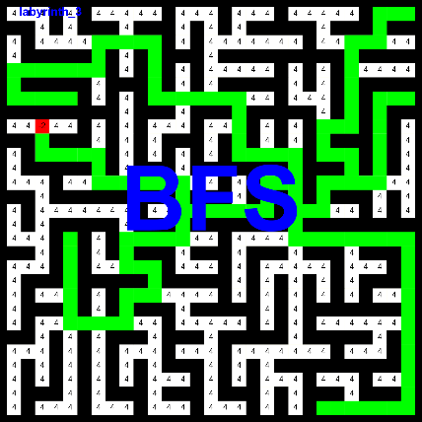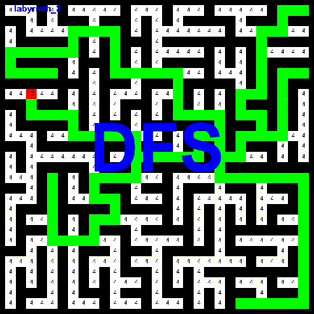

DFS

dolzina poti: 268

cena poti: 1040

število obiskanih vozlišč: 1282

največja globina: 69

[[10,3], [11,3], [11,4], [11,5], [11,6], [11,7], [12,7], [13,7], [13,8], [13,9], [13,10], [13,11], [13,12], [13,13], [14,13], [15,13], [16,13], [17,13], [17,12], [17,11], [17,10], [17,9], [18,9], [19,9], [19,10], [19,11], [20,11], [21,11], [21,10], [21,9], [22,9], [23,9], [23,8], [23,7], [23,6], [23,5], [22,5], [21,5], [20,5], [19,5], [18,5], [17,5], [18,5], [19,5], [20,5], [21,5], [22,5], [23,5], [23,6], [23,7], [23,8], [23,9], [22,9], [21,9], [21,10], [21,11], [20,11], [19,11], [19,10], [19,9], [18,9], [17,9], [17,10], [17,11], [17,12], [17,13], [16,13], [15,13], [15,14], [15,15], [15,16], [15,17], [15,18], [15,19], [14,19], [13,19], [13,20], [13,21], [12,21], [11,21], [11,20], [11,19], [11,18], [11,17], [10,17], [9,17], [8,17], [7,17], [7,16], [7,15], [7,14], [7,13], [7,12], [7,11], [6,11], [5,11], [4,11], [3,11], [3,10], [3,9], [3,8], [3,7], [4,7], [5,7], [5,6], [5,5], [5,4], [5,3], [5,2], [5,1], [6,1], [7,1], [7,2], [7,3], [7,4], [7,5], [7,4], [7,3], [7,2], [7,1], [6,1], [5,1], [5,2], [5,3], [5,4], [5,5], [5,6], [5,7], [4,7], [3,7], [3,8], [3,9], [3,10], [3,11], [4,11], [5,11], [6,11], [7,11], [7,12], [7,13], [7,14], [7,15], [7,16], [7,17], [8,17], [9,17], [10,17], [11,17], [11,18], [11,19], [11,20], [11,21], [12,21], [13,21], [14,21], [15,21], [16,21], [17,21], [17,22], [17,23], [17,24], [17,25], [17,26], [17,27], [17,28], [17,29], [18,29], [19,29], [20,29], [21,29], [22,29], [23,29], [24,29], [25,29], [26,29], [27,29], [28,29], [29,29], [29,28], [29,27], [29,26], [29,25], [29,24], [29,23], [29,24], [29,25], [29,26], [29,27], [29,28], [29,29], [28,29], [27,29], [26,29], [25,29], [24,29], [23,29], [22,29], [21,29], [20,29], [19,29], [18,29], [17,29], [17,28], [17,27], [17,26], [17,25], [17,24], [17,23], [17,22], [17,21], [16,21], [15,21], [15,22], [15,23], [14,23], [13,23], [13,24], [13,25], [12,25], [11,25], [11,24], [11,23], [10,23], [9,23], [9,24], [9,25], [8,25], [7,25], [6,25], [5,25], [4,25], [3,25], [3,26], [3,27], [2,27], [1,27], [1,28], [1,29], [1,28], [1,27], [2,27], [3,27], [3,26], [3,25], [4,25], [5,25], [6,25], [7,25], [8,25], [9,25], [9,24], [9,23], [10,23], [11,23], [11,24], [11,25], [12,25], [13,25], [13,26], [13,27], [12,27], [11,27], [10,27], [9,27], [8,27], [7,27], [7,28], [7,29], ]

BFS

dolzina poti: 284

cena poti: 1104

število obiskanih vozlišč: 1737

največja globina: 68

[[10,3], [11,3], [11,4], [11,5], [11,6], [11,7], [12,7], [13,7], [13,8], [13,9], [13,10], [13,11], [13,12], [13,13], [14,13], [15,13], [16,13], [17,13], [17,12], [17,11], [17,10], [17,9], [18,9], [19,9], [19,10], [19,11], [20,11], [21,11], [21,10], [21,9], [22,9], [23,9], [23,8], [23,7], [23,6], [23,5], [22,5], [21,5], [20,5], [19,5], [18,5], [17,5], [18,5], [19,5], [20,5], [21,5], [22,5], [23,5], [23,6], [23,7], [23,8], [23,9], [22,9], [21,9], [21,10], [21,11], [20,11], [19,11], [19,10], [19,9], [18,9], [17,9], [17,10], [17,11], [17,12], [17,13], [16,13], [15,13], [15,14], [15,15], [15,16], [15,17], [15,18], [15,19], [14,19], [13,19], [13,20], [13,21], [14,21], [15,21], [15,22], [15,23], [14,23], [13,23], [13,24], [13,25], [12,25], [11,25], [11,24], [11,23], [10,23], [9,23], [9,24], [9,25], [8,25], [7,25], [6,25], [5,25], [4,25], [3,25], [3,26], [3,27], [2,27], [1,27], [1,28], [1,29], [1,28], [1,27], [2,27], [3,27], [3,26], [3,25], [4,25], [5,25], [6,25], [7,25], [8,25], [9,25], [9,24], [9,23], [10,23], [11,23], [11,24], [11,25], [12,25], [13,25], [13,24], [13,23], [14,23], [15,23], [15,22], [15,21], [16,21], [17,21], [17,22], [17,23], [17,24], [17,25], [17,26], [17,27], [17,28], [17,29], [18,29], [19,29], [20,29], [21,29], [22,29], [23,29], [24,29], [25,29], [26,29], [27,29], [28,29], [29,29], [29,28], [29,27], [29,26], [29,25], [29,24], [29,23], [29,24], [29,25], [29,26], [29,27], [29,28], [29,29], [28,29], [27,29], [26,29], [25,29], [24,29], [23,29], [22,29], [21,29], [20,29], [19,29], [18,29], [17,29], [17,28], [17,27], [17,26], [17,25], [17,24], [17,23], [17,22], [17,21], [16,21], [15,21], [14,21], [13,21], [12,21], [11,21], [11,20], [11,19], [11,18], [11,17], [10,17], [9,17], [8,17], [7,17], [7,16], [7,15], [7,14], [7,13], [7,12], [7,11], [6,11], [5,11], [4,11], [3,11], [3,10], [3,9], [3,8], [3,7], [4,7], [5,7], [5,6], [5,5], [5,4], [5,3], [5,2], [5,1], [6,1], [7,1], [7,2], [7,3], [7,4], [7,5], [7,4], [7,3], [7,2], [7,1], [6,1], [5,1], [5,2], [5,3], [5,4], [5,5], [5,6], [5,7], [4,7], [3,7], [3,8], [3,9], [3,10], [3,11], [4,11], [5,11], [6,11], [7,11], [7,12], [7,13], [7,14], [7,15], [7,16], [7,17], [8,17], [9,17], [10,17], [11,17], [11,18], [11,19], [11,20], [11,21], [12,21], [13,21], [14,21], [15,21], [15,22], [15,23], [14,23], [13,23], [13,24], [13,25], [13,26], [13,27], [12,27], [11,27], [10,27], [9,27], [8,27], [7,27], [7,28], [7,29], ]

AStar

dolzina poti: 284

cena poti: 1104

število obiskanih vozlišč: 1165

največja globina: 68

[[10,3], [11,3], [11,4], [11,5], [11,6], [11,7], [12,7], [13,7], [13,8], [13,9], [13,10], [13,11], [13,12], [13,13], [14,13], [15,13], [16,13], [17,13], [17,12], [17,11], [17,10], [17,9], [18,9], [19,9], [19,10], [19,11], [20,11], [21,11], [21,10], [21,9], [22,9], [23,9], [23,8], [23,7], [23,6], [23,5], [22,5], [21,5], [20,5], [19,5], [18,5], [17,5], [18,5], [19,5], [20,5], [21,5], [22,5], [23,5], [23,6], [23,7], [23,8], [23,9], [22,9], [21,9], [21,10], [21,11], [20,11], [19,11], [19,10], [19,9], [18,9], [17,9], [17,10], [17,11], [17,12], [17,13], [16,13], [15,13], [15,14], [15,15], [15,16], [15,17], [15,18], [15,19], [14,19], [13,19], [13,20], [13,21], [14,21], [15,21], [15,22], [15,23], [14,23], [13,23], [13,24], [13,25], [12,25], [11,25], [11,24], [11,23], [10,23], [9,23], [9,24], [9,25], [8,25], [7,25], [6,25], [5,25], [4,25], [3,25], [3,26], [3,27], [2,27], [1,27], [1,28], [1,29], [1,28], [1,27], [2,27], [3,27], [3,26], [3,25], [4,25], [5,25], [6,25], [7,25], [8,25], [9,25], [9,24], [9,23], [10,23], [11,23], [11,24], [11,25], [12,25], [13,25], [13,24], [13,23], [14,23], [15,23], [15,22], [15,21], [16,21], [17,21], [17,22], [17,23], [17,24], [17,25], [17,26], [17,27], [17,28], [17,29], [18,29], [19,29], [20,29], [21,29], [22,29], [23,29], [24,29], [25,29], [26,29], [27,29], [28,29], [29,29], [29,28], [29,27], [29,26], [29,25], [29,24], [29,23], [29,24], [29,25], [29,26], [29,27], [29,28], [29,29], [28,29], [27,29], [26,29], [25,29], [24,29], [23,29], [22,29], [21,29], [20,29], [19,29], [18,29], [17,29], [17,28], [17,27], [17,26], [17,25], [17,24], [17,23], [17,22], [17,21], [16,21], [15,21], [14,21], [13,21], [12,21], [11,21], [11,20], [11,19], [11,18], [11,17], [10,17], [9,17], [8,17], [7,17], [7,16], [7,15], [7,14], [7,13], [7,12], [7,11], [6,11], [5,11], [4,11], [3,11], [3,10], [3,9], [3,8], [3,7], [4,7], [5,7], [5,6], [5,5], [5,4], [5,3], [5,2], [5,1], [6,1], [7,1], [7,2], [7,3], [7,4], [7,5], [7,4], [7,3], [7,2], [7,1], [6,1], [5,1], [5,2], [5,3], [5,4], [5,5], [5,6], [5,7], [4,7], [3,7], [3,8], [3,9], [3,10], [3,11], [4,11], [5,11], [6,11], [7,11], [7,12], [7,13], [7,14], [7,15], [7,16], [7,17], [8,17], [9,17], [10,17], [11,17], [11,18], [11,19], [11,20], [11,21], [12,21], [13,21], [14,21], [15,21], [15,22], [15,23], [14,23], [13,23], [13,24], [13,25], [13,26], [13,27], [12,27], [11,27], [10,27], [9,27], [8,27], [7,27], [7,28], [7,29], ]

Opazke:

DFS je našel bolj optimalno rešitev kot BFS in AStar in ob enem imel tudi skoraj najbanjše število pregledanih vozlišč. Verjetno zato, ker oba BFS in AStar iščeta pot do najbljižjega zaklada/cilja, DFS pa naključno preiskuje prostor in v tem primeru najprej obiskati najbližje zaklade ni najbolj optimalna rešitev

# Labirint

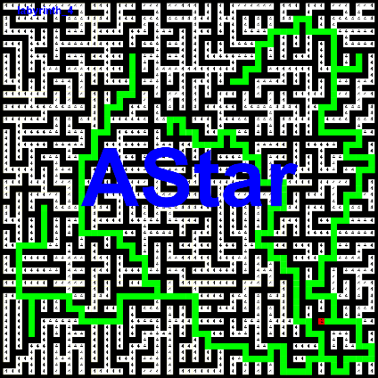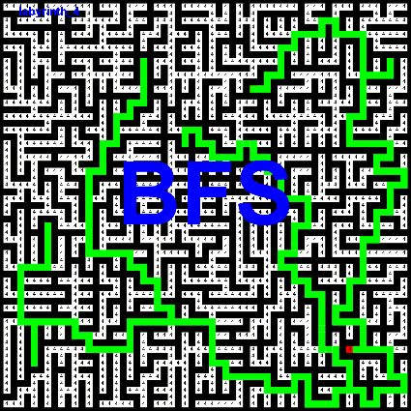

DFS

dolzina poti: 814

cena poti: 3217

število obiskanih vozlišč: 3496

največja globina: 175

[[51,52], [51,53], [50,53], [49,53], [48,53], [47,53], [47,52], [47,51], [47,50], [47,49], [46,49], [45,49], [45,50], [45,51], [44,51], [43,51], [42,51], [41,51], [41,52], [41,53], [40,53], [39,53], [38,53], [37,53], [36,53], [35,53], [35,54], [35,55], [34,55], [33,55], [32,55], [31,55], [31,56], [31,57], [30,57], [29,57], [28,57], [27,57], [27,58], [27,59], [26,59], [25,59], [25,58], [25,57], [25,56], [25,55], [24,55], [23,55], [23,56], [23,57], [22,57], [21,57], [21,56], [21,55], [21,54], [21,53], [21,52], [21,51], [20,51], [19,51], [18,51], [17,51], [17,52], [17,53], [16,53], [15,53], [14,53], [13,53], [12,53], [11,53], [10,53], [9,53], [8,53], [7,53], [6,53], [5,53], [5,52], [5,51], [5,50], [5,49], [4,49], [3,49], [3,48], [3,47], [4,47], [5,47], [5,46], [5,45], [5,44], [5,43], [6,43], [7,43], [7,42], [7,41], [8,41], [9,41], [10,41], [11,41], [11,40], [11,39], [12,39], [13,39], [13,38], [13,37], [13,38], [13,39], [12,39], [11,39], [11,40], [11,41], [10,41], [9,41], [8,41], [7,41], [7,42], [7,43], [6,43], [5,43], [5,44], [5,45], [5,46], [5,47], [4,47], [3,47], [3,48], [3,49], [4,49], [5,49], [5,50], [5,51], [5,52], [5,53], [6,53], [7,53], [8,53], [9,53], [10,53], [11,53], [12,53], [13,53], [14,53], [15,53], [16,53], [17,53], [17,52], [17,51], [18,51], [19,51], [20,51], [21,51], [21,52], [21,53], [21,54], [21,55], [21,56], [21,57], [22,57], [23,57], [23,56], [23,55], [24,55], [25,55], [25,56], [25,57], [25,58], [25,59], [26,59], [27,59], [27,58], [27,57], [28,57], [29,57], [30,57], [31,57], [31,56], [31,55], [32,55], [33,55], [34,55], [35,55], [35,54], [35,53], [36,53], [37,53], [38,53], [39,53], [40,53], [41,53], [41,52], [41,51], [42,51], [43,51], [44,51], [45,51], [45,50], [45,49], [46,49], [47,49], [47,50], [47,51], [47,52], [47,53], [48,53], [49,53], [50,53], [51,53], [51,54], [51,55], [51,56], [51,57], [52,57], [53,57], [54,57], [55,57], [55,58], [55,59], [56,59], [57,59], [57,58], [57,57], [57,56], [57,55], [58,55], [59,55], [59,54], [59,53], [58,53], [57,53], [57,52], [57,51], [57,50], [57,49], [58,49], [59,49], [59,48], [59,47], [59,46], [59,45], [58,45], [57,45], [56,45], [55,45], [55,44], [55,43], [56,43], [57,43], [57,42], [57,41], [57,40], [57,39], [56,39], [55,39], [55,38], [55,37], [55,36], [55,35], [55,34], [55,33], [54,33], [53,33], [53,32], [53,31], [52,31], [51,31], [50,31], [49,31], [48,31], [47,31], [47,30], [47,29], [47,28], [47,27], [47,26], [47,25], [46,25], [45,25], [45,24], [45,23], [44,23], [43,23], [42,23], [41,23], [41,22], [41,21], [40,21], [39,21], [39,20], [39,19], [38,19], [37,19], [37,18], [37,17], [37,16], [37,15], [37,14], [37,13], [36,13], [35,13], [34,13], [33,13], [32,13], [31,13], [30,13], [29,13], [28,13], [27,13], [26,13], [25,13], [25,14], [25,15], [24,15], [23,15], [22,15], [21,15], [21,16], [21,17], [20,17], [19,17], [18,17], [17,17], [17,18], [17,19], [16,19], [15,19], [15,20], [15,21], [14,21], [13,21], [12,21], [11,21], [10,21], [9,21], [10,21], [11,21], [12,21], [13,21], [14,21], [15,21], [15,20], [15,19], [16,19], [17,19], [17,18], [17,17], [18,17], [19,17], [20,17], [21,17], [21,16], [21,15], [22,15], [23,15], [24,15], [25,15], [25,14], [25,13], [26,13], [27,13], [28,13], [29,13], [30,13], [31,13], [32,13], [33,13], [34,13], [35,13], [36,13], [37,13], [37,14], [37,15], [37,16], [37,17], [37,18], [37,19], [38,19], [39,19], [39,20], [39,21], [40,21], [41,21], [41,22], [41,23], [42,23], [43,23], [44,23], [45,23], [45,24], [45,25], [46,25], [47,25], [47,24], [47,23], [47,22], [47,21], [47,20], [47,19], [48,19], [49,19], [50,19], [51,19], [51,18], [51,17], [51,16], [51,15], [51,14], [51,13], [50,13], [49,13], [49,12], [49,11], [48,11], [47,11], [47,10], [47,9], [47,8], [47,7], [47,6], [47,5], [48,5], [49,5], [50,5], [51,5], [52,5], [53,5], [52,5], [51,5], [50,5], [49,5], [48,5], [47,5], [47,4], [47,3], [46,3], [45,3], [44,3], [43,3], [42,3], [41,3], [40,3], [39,3], [39,4], [39,5], [39,6], [39,7], [38,7], [37,7], [36,7], [35,7], [34,7], [33,7], [34,7], [35,7], [36,7], [37,7], [38,7], [39,7], [39,6], [39,5], [39,4], [39,3], [40,3], [41,3], [42,3], [43,3], [44,3], [45,3], [46,3], [47,3], [47,4], [47,5], [47,6], [47,7], [47,8], [47,9], [47,10], [47,11], [48,11], [49,11], [49,12], [49,13], [50,13], [51,13], [51,14], [51,15], [51,16], [51,17], [51,18], [51,19], [50,19], [49,19], [48,19], [47,19], [47,20], [47,21], [47,22], [47,23], [47,24], [47,25], [47,26], [47,27], [47,28], [47,29], [47,30], [47,31], [48,31], [49,31], [50,31], [51,31], [52,31], [53,31], [53,32], [53,33], [54,33], [55,33], [55,34], [55,35], [55,36], [55,37], [55,38], [55,39], [56,39], [57,39], [57,40], [57,41], [57,42], [57,43], [56,43], [55,43], [55,44], [55,45], [56,45], [57,45], [58,45], [59,45], [59,46], [59,47], [59,48], [59,49], [58,49], [57,49], [57,50], [57,51], [57,52], [57,53], [58,53], [59,53], [59,54], [59,55], [58,55], [57,55], [57,56], [57,57], [57,58], [57,59], [56,59], [55,59], [55,58], [55,57], [54,57], [53,57], [52,57], [51,57], [51,56], [51,55], [51,54], [51,53], [50,53], [49,53], [48,53], [47,53], [47,52], [47,51], [47,50], [47,49], [46,49], [45,49], [45,50], [45,51], [44,51], [43,51], [42,51], [41,51], [41,52], [41,53], [40,53], [39,53], [38,53], [37,53], [36,53], [35,53], [35,54], [35,55], [34,55], [33,55], [32,55], [31,55], [31,56], [31,57], [30,57], [29,57], [28,57], [27,57], [27,58], [27,59], [26,59], [25,59], [25,58], [25,57], [25,56], [25,55], [24,55], [23,55], [23,56], [23,57], [22,57], [21,57], [21,56], [21,55], [21,54], [21,53], [21,52], [21,51], [20,51], [19,51], [18,51], [17,51], [17,52], [17,53], [16,53], [15,53], [14,53], [13,53], [12,53], [11,53], [11,54], [11,55], [11,56], [11,57], [10,57], [9,57], [10,57], [11,57], [11,56], [11,55], [11,54], [11,53], [12,53], [13,53], [14,53], [15,53], [16,53], [17,53], [17,52], [17,51], [18,51], [19,51], [20,51], [21,51], [21,52], [21,53], [21,54], [21,55], [21,56], [21,57], [22,57], [23,57], [23,56], [23,55], [24,55], [25,55], [25,56], [25,57], [25,58], [25,59], [26,59], [27,59], [27,58], [27,57], [28,57], [29,57], [30,57], [31,57], [31,56], [31,55], [32,55], [33,55], [34,55], [35,55], [35,54], [35,53], [36,53], [37,53], [38,53], [39,53], [40,53], [41,53], [41,52], [41,51], [42,51], [43,51], [44,51], [45,51], [45,50], [45,49], [46,49], [47,49], [47,50], [47,51], [47,52], [47,53], [48,53], [49,53], [50,53], [51,53], [51,54], [51,55], [51,56], [51,57], [52,57], [53,57], [54,57], [55,57], [55,58], [55,59], [56,59], [57,59], [57,58], [57,57], [57,56], [57,55], [58,55], [59,55], [59,54], [59,53], [58,53], [57,53], [57,52], [57,51], [56,51], [55,51], [54,51], [53,51], [53,50], [53,49], [52,49], [51,49], [51,48], [51,47], [50,47], [49,47], [48,47], [47,47], [46,47], [45,47], [44,47], [43,47], [43,46], [43,45], [42,45], [41,45], [41,44], [41,43], [40,43], [39,43], [39,42], [39,41], [38,41], [37,41], [37,42], [37,43], [36,43], [35,43], [34,43], [33,43], [33,44], [33,45], [32,45], [31,45], [30,45], [29,45], [29,44], [29,43], [29,42], [29,41], [28,41], [27,41], [26,41], [25,41], [25,40], [25,39], [24,39], [23,39], [23,38], [23,37], [22,37], [21,37], [21,36], [21,35], [22,35], [23,35], [23,34], [23,33], [23,32], [23,31], [22,31], [21,31], [21,30], [21,29], [20,29], [19,29], [19,28], [19,27], [20,27], [21,27], ]

BFS

dolzina poti: 630

cena poti: 2481

število obiskanih vozlišč: 4779

največja globina: 204

[[51,52], [51,53], [50,53], [49,53], [48,53], [47,53], [47,52], [47,51], [47,50], [47,49], [46,49], [45,49], [45,50], [45,51], [44,51], [43,51], [42,51], [41,51], [41,52], [41,53], [40,53], [39,53], [38,53], [37,53], [36,53], [35,53], [35,54], [35,55], [34,55], [33,55], [32,55], [31,55], [31,56], [31,57], [30,57], [29,57], [28,57], [27,57], [27,58], [27,59], [26,59], [25,59], [25,58], [25,57], [25,56], [25,55], [24,55], [23,55], [23,56], [23,57], [22,57], [21,57], [21,56], [21,55], [21,54], [21,53], [21,52], [21,51], [20,51], [19,51], [18,51], [17,51], [17,52], [17,53], [16,53], [15,53], [14,53], [13,53], [12,53], [11,53], [11,54], [11,55], [11,56], [11,57], [10,57], [9,57], [10,57], [11,57], [11,56], [11,55], [11,54], [11,53], [10,53], [9,53], [8,53], [7,53], [6,53], [5,53], [5,52], [5,51], [5,50], [5,49], [4,49], [3,49], [3,48], [3,47], [4,47], [5,47], [5,46], [5,45], [5,44], [5,43], [6,43], [7,43], [7,42], [7,41], [8,41], [9,41], [10,41], [11,41], [11,40], [11,39], [12,39], [13,39], [13,38], [13,37], [13,38], [13,39], [12,39], [11,39], [11,40], [11,41], [10,41], [9,41], [8,41], [7,41], [7,42], [7,43], [6,43], [5,43], [5,44], [5,45], [5,46], [5,47], [4,47], [3,47], [3,48], [3,49], [4,49], [5,49], [5,50], [5,51], [5,52], [5,53], [6,53], [7,53], [8,53], [9,53], [10,53], [11,53], [12,53], [13,53], [14,53], [15,53], [16,53], [17,53], [17,52], [17,51], [18,51], [19,51], [20,51], [21,51], [21,52], [21,53], [21,54], [21,55], [21,56], [21,57], [22,57], [23,57], [23,56], [23,55], [24,55], [25,55], [25,56], [25,57], [25,58], [25,59], [26,59], [27,59], [27,58], [27,57], [28,57], [29,57], [30,57], [31,57], [31,56], [31,55], [32,55], [33,55], [34,55], [35,55], [35,54], [35,53], [36,53], [37,53], [38,53], [39,53], [40,53], [41,53], [41,52], [41,51], [42,51], [43,51], [44,51], [45,51], [45,50], [45,49], [46,49], [47,49], [47,50], [47,51], [47,52], [47,53], [48,53], [49,53], [50,53], [51,53], [51,54], [51,55], [51,56], [51,57], [52,57], [53,57], [54,57], [55,57], [55,58], [55,59], [56,59], [57,59], [57,58], [57,57], [57,56], [57,55], [58,55], [59,55], [59,54], [59,53], [58,53], [57,53], [57,52], [57,51], [57,50], [57,49], [58,49], [59,49], [59,48], [59,47], [59,46], [59,45], [58,45], [57,45], [56,45], [55,45], [55,44], [55,43], [56,43], [57,43], [57,42], [57,41], [57,40], [57,39], [56,39], [55,39], [55,38], [55,37], [55,36], [55,35], [55,34], [55,33], [54,33], [53,33], [53,32], [53,31], [52,31], [51,31], [50,31], [49,31], [48,31], [47,31], [47,30], [47,29], [47,28], [47,27], [47,26], [47,25], [47,24], [47,23], [47,22], [47,21], [47,20], [47,19], [48,19], [49,19], [50,19], [51,19], [51,18], [51,17], [51,16], [51,15], [51,14], [51,13], [50,13], [49,13], [49,12], [49,11], [48,11], [47,11], [47,10], [47,9], [47,8], [47,7], [47,6], [47,5], [48,5], [49,5], [50,5], [51,5], [52,5], [53,5], [52,5], [51,5], [50,5], [49,5], [48,5], [47,5], [47,4], [47,3], [46,3], [45,3], [44,3], [43,3], [42,3], [41,3], [40,3], [39,3], [39,4], [39,5], [39,6], [39,7], [38,7], [37,7], [36,7], [35,7], [34,7], [33,7], [34,7], [35,7], [36,7], [37,7], [38,7], [39,7], [39,6], [39,5], [39,4], [39,3], [40,3], [41,3], [42,3], [43,3], [44,3], [45,3], [46,3], [47,3], [47,4], [47,5], [47,6], [47,7], [47,8], [47,9], [47,10], [47,11], [48,11], [49,11], [49,12], [49,13], [50,13], [51,13], [51,14], [51,15], [51,16], [51,17], [51,18], [51,19], [50,19], [49,19], [48,19], [47,19], [47,20], [47,21], [47,22], [47,23], [47,24], [47,25], [46,25], [45,25], [45,24], [45,23], [44,23], [43,23], [42,23], [41,23], [41,22], [41,21], [40,21], [39,21], [39,20], [39,19], [38,19], [37,19], [37,18], [37,17], [37,16], [37,15], [37,14], [37,13], [36,13], [35,13], [34,13], [33,13], [32,13], [31,13], [30,13], [29,13], [28,13], [27,13], [26,13], [25,13], [25,14], [25,15], [24,15], [23,15], [22,15], [21,15], [21,16], [21,17], [20,17], [19,17], [18,17], [17,17], [17,18], [17,19], [16,19], [15,19], [15,20], [15,21], [14,21], [13,21], [12,21], [11,21], [10,21], [9,21], [10,21], [11,21], [12,21], [13,21], [14,21], [15,21], [15,20], [15,19], [16,19], [17,19], [17,18], [17,17], [18,17], [19,17], [20,17], [21,17], [21,16], [21,15], [22,15], [23,15], [24,15], [25,15], [25,14], [25,13], [26,13], [27,13], [28,13], [29,13], [30,13], [31,13], [32,13], [33,13], [34,13], [35,13], [36,13], [37,13], [37,14], [37,15], [37,16], [37,17], [37,18], [37,19], [38,19], [39,19], [39,20], [39,21], [40,21], [41,21], [41,22], [41,23], [42,23], [43,23], [44,23], [45,23], [45,24], [45,25], [46,25], [47,25], [47,26], [47,27], [47,28], [47,29], [47,30], [47,31], [48,31], [49,31], [50,31], [51,31], [52,31], [53,31], [53,32], [53,33], [54,33], [55,33], [55,34], [55,35], [55,36], [55,37], [55,38], [55,39], [56,39], [57,39], [57,40], [57,41], [57,42], [57,43], [56,43], [55,43], [55,44], [55,45], [56,45], [57,45], [58,45], [59,45], [59,46], [59,47], [59,48], [59,49], [58,49], [57,49], [57,50], [57,51], [56,51], [55,51], [54,51], [53,51], [53,50], [53,49], [52,49], [51,49], [51,48], [51,47], [50,47], [49,47], [48,47], [47,47], [46,47], [45,47], [44,47], [43,47], [43,46], [43,45], [42,45], [41,45], [41,44], [41,43], [40,43], [39,43], [39,42], [39,41], [38,41], [37,41], [37,42], [37,43], [36,43], [35,43], [34,43], [33,43], [33,44], [33,45], [32,45], [31,45], [30,45], [29,45], [29,44], [29,43], [29,42], [29,41], [28,41], [27,41], [26,41], [25,41], [25,40], [25,39], [24,39], [23,39], [23,38], [23,37], [22,37], [21,37], [21,36], [21,35], [22,35], [23,35], [23,34], [23,33], [23,32], [23,31], [22,31], [21,31], [21,30], [21,29], [20,29], [19,29], [19,28], [19,27], [20,27], [21,27], ]

AStar

dolzina poti: 630

cena poti: 2481

število obiskanih vozlišč: 3332

največja globina: 204

[[51,52], [51,53], [50,53], [49,53], [48,53], [47,53], [47,52], [47,51], [47,50], [47,49], [46,49], [45,49], [45,50], [45,51], [44,51], [43,51], [42,51], [41,51], [41,52], [41,53], [40,53], [39,53], [38,53], [37,53], [36,53], [35,53], [35,54], [35,55], [34,55], [33,55], [32,55], [31,55], [31,56], [31,57], [30,57], [29,57], [28,57], [27,57], [27,58], [27,59], [26,59], [25,59], [25,58], [25,57], [25,56], [25,55], [24,55], [23,55], [23,56], [23,57], [22,57], [21,57], [21,56], [21,55], [21,54], [21,53], [21,52], [21,51], [20,51], [19,51], [18,51], [17,51], [17,52], [17,53], [16,53], [15,53], [14,53], [13,53], [12,53], [11,53], [11,54], [11,55], [11,56], [11,57], [10,57], [9,57], [10,57], [11,57], [11,56], [11,55], [11,54], [11,53], [10,53], [9,53], [8,53], [7,53], [6,53], [5,53], [5,52], [5,51], [5,50], [5,49], [4,49], [3,49], [3,48], [3,47], [4,47], [5,47], [5,46], [5,45], [5,44], [5,43], [6,43], [7,43], [7,42], [7,41], [8,41], [9,41], [10,41], [11,41], [11,40], [11,39], [12,39], [13,39], [13,38], [13,37], [13,38], [13,39], [12,39], [11,39], [11,40], [11,41], [10,41], [9,41], [8,41], [7,41], [7,42], [7,43], [6,43], [5,43], [5,44], [5,45], [5,46], [5,47], [4,47], [3,47], [3,48], [3,49], [4,49], [5,49], [5,50], [5,51], [5,52], [5,53], [6,53], [7,53], [8,53], [9,53], [10,53], [11,53], [12,53], [13,53], [14,53], [15,53], [16,53], [17,53], [17,52], [17,51], [18,51], [19,51], [20,51], [21,51], [21,52], [21,53], [21,54], [21,55], [21,56], [21,57], [22,57], [23,57], [23,56], [23,55], [24,55], [25,55], [25,56], [25,57], [25,58], [25,59], [26,59], [27,59], [27,58], [27,57], [28,57], [29,57], [30,57], [31,57], [31,56], [31,55], [32,55], [33,55], [34,55], [35,55], [35,54], [35,53], [36,53], [37,53], [38,53], [39,53], [40,53], [41,53], [41,52], [41,51], [42,51], [43,51], [44,51], [45,51], [45,50], [45,49], [46,49], [47,49], [47,50], [47,51], [47,52], [47,53], [48,53], [49,53], [50,53], [51,53], [51,54], [51,55], [51,56], [51,57], [52,57], [53,57], [54,57], [55,57], [55,58], [55,59], [56,59], [57,59], [57,58], [57,57], [57,56], [57,55], [58,55], [59,55], [59,54], [59,53], [58,53], [57,53], [57,52], [57,51], [57,50], [57,49], [58,49], [59,49], [59,48], [59,47], [59,46], [59,45], [58,45], [57,45], [56,45], [55,45], [55,44], [55,43], [56,43], [57,43], [57,42], [57,41], [57,40], [57,39], [56,39], [55,39], [55,38], [55,37], [55,36], [55,35], [55,34], [55,33], [54,33], [53,33], [53,32], [53,31], [52,31], [51,31], [50,31], [49,31], [48,31], [47,31], [47,30], [47,29], [47,28], [47,27], [47,26], [47,25], [47,24], [47,23], [47,22], [47,21], [47,20], [47,19], [48,19], [49,19], [50,19], [51,19], [51,18], [51,17], [51,16], [51,15], [51,14], [51,13], [50,13], [49,13], [49,12], [49,11], [48,11], [47,11], [47,10], [47,9], [47,8], [47,7], [47,6], [47,5], [48,5], [49,5], [50,5], [51,5], [52,5], [53,5], [52,5], [51,5], [50,5], [49,5], [48,5], [47,5], [47,4], [47,3], [46,3], [45,3], [44,3], [43,3], [42,3], [41,3], [40,3], [39,3], [39,4], [39,5], [39,6], [39,7], [38,7], [37,7], [36,7], [35,7], [34,7], [33,7], [34,7], [35,7], [36,7], [37,7], [38,7], [39,7], [39,6], [39,5], [39,4], [39,3], [40,3], [41,3], [42,3], [43,3], [44,3], [45,3], [46,3], [47,3], [47,4], [47,5], [47,6], [47,7], [47,8], [47,9], [47,10], [47,11], [48,11], [49,11], [49,12], [49,13], [50,13], [51,13], [51,14], [51,15], [51,16], [51,17], [51,18], [51,19], [50,19], [49,19], [48,19], [47,19], [47,20], [47,21], [47,22], [47,23], [47,24], [47,25], [46,25], [45,25], [45,24], [45,23], [44,23], [43,23], [42,23], [41,23], [41,22], [41,21], [40,21], [39,21], [39,20], [39,19], [38,19], [37,19], [37,18], [37,17], [37,16], [37,15], [37,14], [37,13], [36,13], [35,13], [34,13], [33,13], [32,13], [31,13], [30,13], [29,13], [28,13], [27,13], [26,13], [25,13], [25,14], [25,15], [24,15], [23,15], [22,15], [21,15], [21,16], [21,17], [20,17], [19,17], [18,17], [17,17], [17,18], [17,19], [16,19], [15,19], [15,20], [15,21], [14,21], [13,21], [12,21], [11,21], [10,21], [9,21], [10,21], [11,21], [12,21], [13,21], [14,21], [15,21], [15,20], [15,19], [16,19], [17,19], [17,18], [17,17], [18,17], [19,17], [20,17], [21,17], [21,16], [21,15], [22,15], [23,15], [24,15], [25,15], [25,14], [25,13], [26,13], [27,13], [28,13], [29,13], [30,13], [31,13], [32,13], [33,13], [34,13], [35,13], [36,13], [37,13], [37,14], [37,15], [37,16], [37,17], [37,18], [37,19], [38,19], [39,19], [39,20], [39,21], [40,21], [41,21], [41,22], [41,23], [42,23], [43,23], [44,23], [45,23], [45,24], [45,25], [46,25], [47,25], [47,26], [47,27], [47,28], [47,29], [47,30], [47,31], [48,31], [49,31], [50,31], [51,31], [52,31], [53,31], [53,32], [53,33], [54,33], [55,33], [55,34], [55,35], [55,36], [55,37], [55,38], [55,39], [56,39], [57,39], [57,40], [57,41], [57,42], [57,43], [56,43], [55,43], [55,44], [55,45], [56,45], [57,45], [58,45], [59,45], [59,46], [59,47], [59,48], [59,49], [58,49], [57,49], [57,50], [57,51], [56,51], [55,51], [54,51], [53,51], [53,50], [53,49], [52,49], [51,49], [51,48], [51,47], [50,47], [49,47], [48,47], [47,47], [46,47], [45,47], [44,47], [43,47], [43,46], [43,45], [42,45], [41,45], [41,44], [41,43], [40,43], [39,43], [39,42], [39,41], [38,41], [37,41], [37,42], [37,43], [36,43], [35,43], [34,43], [33,43], [33,44], [33,45], [32,45], [31,45], [30,45], [29,45], [29,44], [29,43], [29,42], [29,41], [28,41], [27,41], [26,41], [25,41], [25,40], [25,39], [24,39], [23,39], [23,38], [23,37], [22,37], [21,37], [21,36], [21,35], [22,35], [23,35], [23,34], [23,33], [23,32], [23,31], [22,31], [21,31], [21,30], [21,29], [20,29], [19,29], [19,28], [19,27], [20,27], [21,27], ]

Opazke:

Tukaj vidimo pričakovane vrednosti. DFS našev po hitreje od BFS ampak manj optimalno. AStar zaradi dodtnih informacij o lokaciji imel manjše število obishanih vozlišč in optimalno pot.

# Labirint

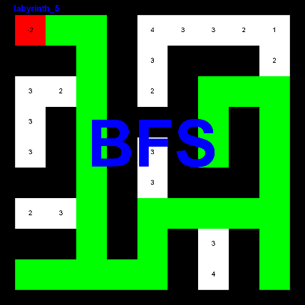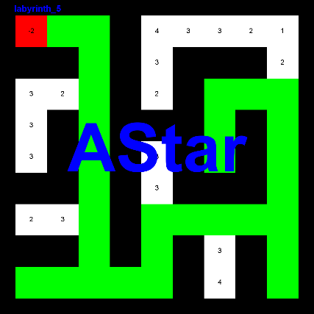

DFS

dolzina poti: 40

cena poti: 78

število obiskanih vozlišč: 76

največja globina: 13

[[1,2], [1,3], [2,3], [3,3], [4,3], [5,3], [6,3], [7,3], [8,3], [9,3], [9,2], [9,1], [9,2], [9,3], [9,4], [9,5], [8,5], [7,5], [7,6], [7,7], [7,8], [7,9], [6,9], [5,9], [4,9], [3,9], [3,8], [3,7], [4,7], [5,7], [4,7], [3,7], [3,8], [3,9], [4,9], [5,9], [6,9], [7,9], [8,9], [9,9], ]

BFS

dolzina poti: 40

cena poti: 78

število obiskanih vozlišč: 80

največja globina: 18

[[1,2], [1,3], [2,3], [3,3], [4,3], [5,3], [6,3], [7,3], [8,3], [9,3], [9,2], [9,1], [9,2], [9,3], [9,4], [9,5], [8,5], [7,5], [7,6], [7,7], [7,8], [7,9], [6,9], [5,9], [4,9], [3,9], [3,8], [3,7], [4,7], [5,7], [4,7], [3,7], [3,8], [3,9], [4,9], [5,9], [6,9], [7,9], [8,9], [9,9], ]

AStar

dolzina poti: 40

cena poti: 78

število obiskanih vozlišč: 71

največja globina: 18

[[1,2], [1,3], [2,3], [3,3], [4,3], [5,3], [6,3], [7,3], [8,3], [9,3], [9,2], [9,1], [9,2], [9,3], [9,4], [9,5], [8,5], [7,5], [7,6], [7,7], [7,8], [7,9], [6,9], [5,9], [4,9], [3,9], [3,8], [3,7], [4,7], [5,7], [4,7], [3,7], [3,8], [3,9], [4,9], [5,9], [6,9], [7,9], [8,9], [9,9], ]

Opazke:

DFS premagal BFS zaradi manjšega labirinta. AStar boljši od obeh.

# Labirint

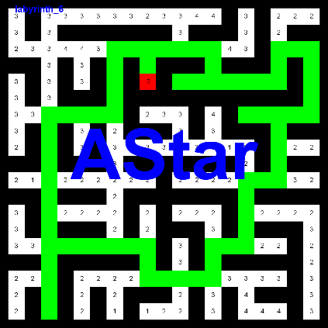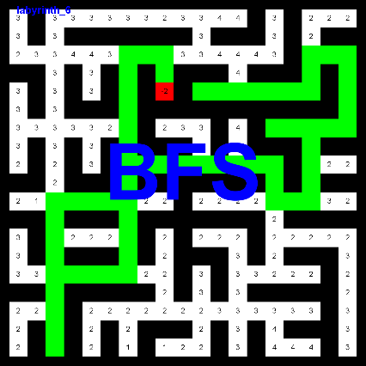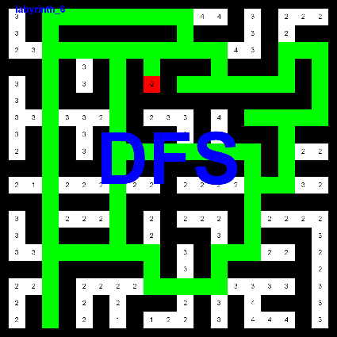

DFS

dolzina poti: 190

cena poti: 447

število obiskanih vozlišč: 394

največja globina: 87

[[4,9], [3,9], [3,8], [3,7], [4,7], [5,7], [6,7], [7,7], [8,7], [9,7], [10,7], [11,7], [12,7], [13,7], [14,7], [15,7], [15,6], [15,5], [15,4], [15,3], [14,3], [13,3], [12,3], [11,3], [10,3], [9,3], [8,3], [7,3], [6,3], [5,3], [4,3], [3,3], [2,3], [1,3], [1,4], [1,5], [1,6], [1,7], [1,8], [1,9], [1,10], [1,11], [2,11], [3,11], [3,12], [3,13], [4,13], [5,13], [5,14], [5,15], [5,16], [5,17], [4,17], [3,17], [3,18], [3,19], [4,19], [5,19], [6,19], [7,19], [7,18], [7,17], [7,16], [7,15], [7,16], [7,17], [8,17], [9,17], [10,17], [11,17], [11,16], [11,15], [10,15], [9,15], [9,14], [9,13], [9,12], [9,11], [9,10], [9,9], [9,8], [9,7], [8,7], [7,7], [6,7], [5,7], [4,7], [3,7], [3,6], [3,5], [3,4], [3,3], [4,3], [5,3], [6,3], [7,3], [8,3], [9,3], [10,3], [11,3], [12,3], [13,3], [14,3], [15,3], [16,3], [17,3], [18,3], [19,3], [18,3], [17,3], [16,3], [15,3], [14,3], [13,3], [12,3], [11,3], [10,3], [9,3], [8,3], [7,3], [6,3], [5,3], [4,3], [3,3], [2,3], [1,3], [1,4], [1,5], [1,6], [1,7], [1,8], [1,9], [1,10], [1,11], [2,11], [3,11], [3,10], [3,9], [3,8], [3,7], [4,7], [5,7], [6,7], [7,7], [8,7], [9,7], [10,7], [11,7], [12,7], [13,7], [14,7], [15,7], [15,8], [15,9], [16,9], [17,9], [17,10], [17,11], [17,12], [17,13], [16,13], [15,13], [15,14], [15,15], [14,15], [13,15], [12,15], [11,15], [11,16], [11,17], [10,17], [9,17], [8,17], [7,17], [7,18], [7,19], [6,19], [5,19], [4,19], [3,19], [3,18], [3,17], [4,17], [5,17], [5,16], [5,15], [5,14], [5,13], [5,12], [5,11], ]

BFS

dolzina poti: 74

cena poti: 153

število obiskanih vozlišč: 431

največja globina: 32

[[4,9], [3,9], [3,8], [3,7], [4,7], [5,7], [6,7], [7,7], [8,7], [9,7], [10,7], [11,7], [12,7], [13,7], [14,7], [15,7], [15,6], [15,5], [15,4], [15,3], [16,3], [17,3], [18,3], [19,3], [18,3], [17,3], [16,3], [15,3], [14,3], [13,3], [12,3], [11,3], [11,4], [11,5], [11,6], [11,7], [10,7], [9,7], [9,8], [9,9], [9,10], [9,11], [9,12], [9,13], [9,14], [9,15], [10,15], [11,15], [11,16], [11,17], [10,17], [9,17], [8,17], [7,17], [7,16], [7,15], [7,16], [7,17], [7,18], [7,19], [6,19], [5,19], [4,19], [3,19], [3,18], [3,17], [4,17], [5,17], [5,16], [5,15], [5,14], [5,13], [5,12], [5,11], ]

AStar

dolzina poti: 86

cena poti: 195

število obiskanih vozlišč: 350

največja globina: 32

[[4,9], [3,9], [3,10], [3,11], [3,12], [3,13], [4,13], [5,13], [5,14], [5,15], [5,16], [5,17], [4,17], [3,17], [3,18], [3,19], [4,19], [5,19], [6,19], [7,19], [7,18], [7,17], [7,16], [7,15], [7,16], [7,17], [8,17], [9,17], [10,17], [11,17], [11,16], [11,15], [12,15], [13,15], [14,15], [15,15], [15,14], [15,13], [16,13], [17,13], [17,12], [17,11], [17,10], [17,9], [16,9], [15,9], [15,8], [15,7], [15,6], [15,5], [15,4], [15,3], [16,3], [17,3], [18,3], [19,3], [18,3], [17,3], [16,3], [15,3], [14,3], [13,3], [12,3], [11,3], [10,3], [9,3], [8,3], [7,3], [7,4], [7,5], [7,6], [7,7], [6,7], [5,7], [4,7], [3,7], [3,8], [3,9], [3,10], [3,11], [3,12], [3,13], [4,13], [5,13], [5,12], [5,11], ]

Opazke:

Zaradi vrstnega reda pregledovanja vozlišč je BFS našel bolj optimalno pot kot AStar. DFS je imel manj preiskanih vozlišč kot BFS ampak zato tudi manj optimalno pot.

# Labirint

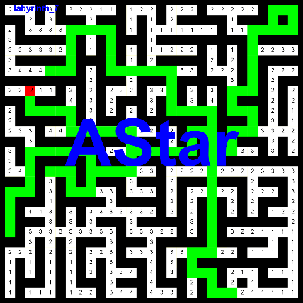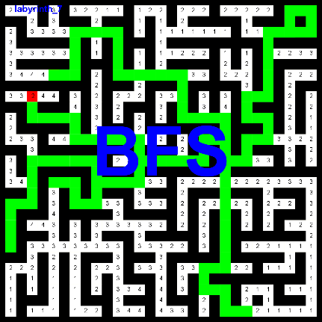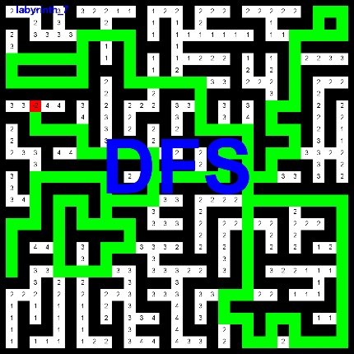

DFS

dolzina poti: 276

cena poti: 676

število obiskanih vozlišč: 987

največja globina: 70

[[10,3], [11,3], [11,4], [11,5], [11,6], [11,7], [12,7], [13,7], [13,8], [13,9], [13,10], [13,11], [13,12], [13,13], [14,13], [15,13], [16,13], [17,13], [17,12], [17,11], [17,10], [17,9], [18,9], [19,9], [19,8], [19,7], [18,7], [17,7], [17,6], [17,5], [18,5], [19,5], [20,5], [21,5], [22,5], [23,5], [23,6], [23,7], [23,8], [23,9], [22,9], [21,9], [21,10], [21,11], [20,11], [19,11], [19,10], [19,9], [18,9], [17,9], [17,10], [17,11], [17,12], [17,13], [16,13], [15,13], [15,14], [15,15], [15,16], [15,17], [15,18], [15,19], [14,19], [13,19], [13,20], [13,21], [12,21], [11,21], [11,20], [11,19], [11,18], [11,17], [10,17], [9,17], [8,17], [7,17], [7,16], [7,15], [7,14], [7,13], [7,12], [7,11], [6,11], [5,11], [4,11], [3,11], [3,10], [3,9], [3,8], [3,7], [4,7], [5,7], [6,7], [7,7], [7,6], [7,5], [7,4], [7,3], [7,2], [7,1], [6,1], [5,1], [5,2], [5,3], [5,4], [5,5], [5,6], [5,7], [4,7], [3,7], [3,8], [3,9], [3,10], [3,11], [4,11], [5,11], [6,11], [7,11], [7,12], [7,13], [7,14], [7,15], [7,16], [7,17], [8,17], [9,17], [10,17], [11,17], [11,18], [11,19], [11,20], [11,21], [12,21], [13,21], [14,21], [15,21], [16,21], [17,21], [18,21], [19,21], [20,21], [21,21], [22,21], [23,21], [24,21], [25,21], [25,20], [25,19], [26,19], [27,19], [27,20], [27,21], [28,21], [29,21], [29,22], [29,23], [28,23], [27,23], [27,24], [27,25], [28,25], [29,25], [29,26], [29,27], [29,28], [29,29], [28,29], [27,29], [26,29], [25,29], [24,29], [23,29], [22,29], [21,29], [20,29], [19,29], [18,29], [17,29], [17,28], [17,27], [17,26], [17,25], [17,24], [17,23], [17,22], [17,21], [16,21], [15,21], [15,22], [15,23], [14,23], [13,23], [13,24], [13,25], [12,25], [11,25], [11,24], [11,23], [10,23], [9,23], [9,24], [9,25], [8,25], [7,25], [6,25], [5,25], [4,25], [3,25], [3,26], [3,27], [2,27], [1,27], [1,28], [1,29], [2,29], [3,29], [3,28], [3,27], [3,26], [3,25], [4,25], [5,25], [6,25], [7,25], [8,25], [9,25], [9,24], [9,23], [10,23], [11,23], [11,24], [11,25], [12,25], [13,25], [13,24], [13,23], [14,23], [15,23], [15,22], [15,21], [14,21], [13,21], [13,20], [13,19], [14,19], [15,19], [15,18], [15,17], [15,16], [15,15], [15,14], [15,13], [16,13], [17,13], [17,12], [17,11], [17,10], [17,9], [16,9], [15,9], [15,8], [15,7], [15,6], [15,5], [15,4], [15,3], [16,3], [17,3], [18,3], [19,3], [19,2], [19,1], [20,1], [21,1], [22,1], [23,1], ]

BFS

dolzina poti: 244

cena poti: 600

število obiskanih vozlišč: 1587

največja globina: 64

[[10,3], [11,3], [11,4], [11,5], [11,6], [11,7], [12,7], [13,7], [13,8], [13,9], [13,10], [13,11], [13,12], [13,13], [14,13], [15,13], [16,13], [17,13], [17,12], [17,11], [17,10], [17,9], [18,9], [19,9], [19,8], [19,7], [18,7], [17,7], [17,6], [17,5], [17,6], [17,7], [18,7], [19,7], [19,8], [19,9], [18,9], [17,9], [17,10], [17,11], [17,12], [17,13], [16,13], [15,13], [15,14], [15,15], [15,16], [15,17], [15,18], [15,19], [14,19], [13,19], [13,20], [13,21], [14,21], [15,21], [16,21], [17,21], [18,21], [19,21], [20,21], [21,21], [22,21], [23,21], [24,21], [25,21], [25,20], [25,19], [26,19], [27,19], [27,20], [27,21], [28,21], [29,21], [29,22], [29,23], [29,22], [29,21], [28,21], [27,21], [27,20], [27,19], [26,19], [25,19], [25,20], [25,21], [24,21], [23,21], [22,21], [21,21], [20,21], [19,21], [18,21], [17,21], [16,21], [15,21], [15,22], [15,23], [14,23], [13,23], [13,24], [13,25], [12,25], [11,25], [11,24], [11,23], [10,23], [9,23], [9,24], [9,25], [8,25], [7,25], [6,25], [5,25], [4,25], [3,25], [3,26], [3,27], [2,27], [1,27], [1,28], [1,29], [2,29], [3,29], [3,28], [3,27], [3,26], [3,25], [4,25], [5,25], [6,25], [7,25], [8,25], [9,25], [9,24], [9,23], [10,23], [11,23], [11,24], [11,25], [12,25], [13,25], [13,24], [13,23], [14,23], [15,23], [15,22], [15,21], [14,21], [13,21], [12,21], [11,21], [11,20], [11,19], [11,18], [11,17], [10,17], [9,17], [8,17], [7,17], [7,16], [7,15], [7,14], [7,13], [7,12], [7,11], [6,11], [5,11], [4,11], [3,11], [3,10], [3,9], [3,8], [3,7], [4,7], [5,7], [6,7], [7,7], [7,6], [7,5], [7,6], [7,7], [6,7], [5,7], [4,7], [3,7], [3,8], [3,9], [3,10], [3,11], [4,11], [5,11], [6,11], [7,11], [7,12], [7,13], [7,14], [7,15], [7,16], [7,17], [8,17], [9,17], [10,17], [11,17], [11,18], [11,19], [11,20], [11,21], [12,21], [13,21], [13,20], [13,19], [14,19], [15,19], [15,18], [15,17], [15,16], [15,15], [15,14], [15,13], [16,13], [17,13], [17,12], [17,11], [17,10], [17,9], [16,9], [15,9], [15,8], [15,7], [15,6], [15,5], [15,4], [15,3], [16,3], [17,3], [18,3], [19,3], [19,2], [19,1], [20,1], [21,1], [22,1], [23,1], ]

AStar

dolzina poti: 244

cena poti: 600

število obiskanih vozlišč: 980

največja globina: 64

[[10,3], [11,3], [11,4], [11,5], [11,6], [11,7], [12,7], [13,7], [13,8], [13,9], [13,10], [13,11], [13,12], [13,13], [14,13], [15,13], [16,13], [17,13], [17,12], [17,11], [17,10], [17,9], [18,9], [19,9], [19,8], [19,7], [18,7], [17,7], [17,6], [17,5], [17,6], [17,7], [18,7], [19,7], [19,8], [19,9], [18,9], [17,9], [17,10], [17,11], [17,12], [17,13], [16,13], [15,13], [15,14], [15,15], [15,16], [15,17], [15,18], [15,19], [14,19], [13,19], [13,20], [13,21], [14,21], [15,21], [16,21], [17,21], [18,21], [19,21], [20,21], [21,21], [22,21], [23,21], [24,21], [25,21], [25,20], [25,19], [26,19], [27,19], [27,20], [27,21], [28,21], [29,21], [29,22], [29,23], [29,22], [29,21], [28,21], [27,21], [27,20], [27,19], [26,19], [25,19], [25,20], [25,21], [24,21], [23,21], [22,21], [21,21], [20,21], [19,21], [18,21], [17,21], [16,21], [15,21], [15,22], [15,23], [14,23], [13,23], [13,24], [13,25], [12,25], [11,25], [11,24], [11,23], [10,23], [9,23], [9,24], [9,25], [8,25], [7,25], [6,25], [5,25], [4,25], [3,25], [3,26], [3,27], [2,27], [1,27], [1,28], [1,29], [2,29], [3,29], [3,28], [3,27], [3,26], [3,25], [4,25], [5,25], [6,25], [7,25], [8,25], [9,25], [9,24], [9,23], [10,23], [11,23], [11,24], [11,25], [12,25], [13,25], [13,24], [13,23], [14,23], [15,23], [15,22], [15,21], [14,21], [13,21], [12,21], [11,21], [11,20], [11,19], [11,18], [11,17], [10,17], [9,17], [8,17], [7,17], [7,16], [7,15], [7,14], [7,13], [7,12], [7,11], [6,11], [5,11], [4,11], [3,11], [3,10], [3,9], [3,8], [3,7], [4,7], [5,7], [6,7], [7,7], [7,6], [7,5], [7,6], [7,7], [6,7], [5,7], [4,7], [3,7], [3,8], [3,9], [3,10], [3,11], [4,11], [5,11], [6,11], [7,11], [7,12], [7,13], [7,14], [7,15], [7,16], [7,17], [8,17], [9,17], [10,17], [11,17], [11,18], [11,19], [11,20], [11,21], [12,21], [13,21], [13,20], [13,19], [14,19], [15,19], [15,18], [15,17], [15,16], [15,15], [15,14], [15,13], [16,13], [17,13], [17,12], [17,11], [17,10], [17,9], [16,9], [15,9], [15,8], [15,7], [15,6], [15,5], [15,4], [15,3], [16,3], [17,3], [18,3], [19,3], [19,2], [19,1], [20,1], [21,1], [22,1], [23,1], ]

Opazke:

AStar boljši od obeh. V odvisnoti od števila pregledanih vozlišč je DFS našel bolj optimalno rešitev kot BFS.

# Labirint

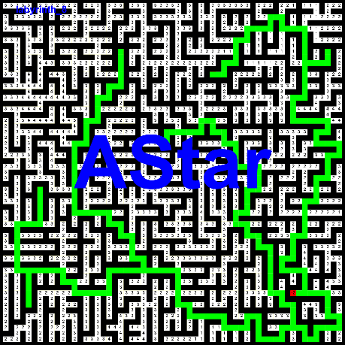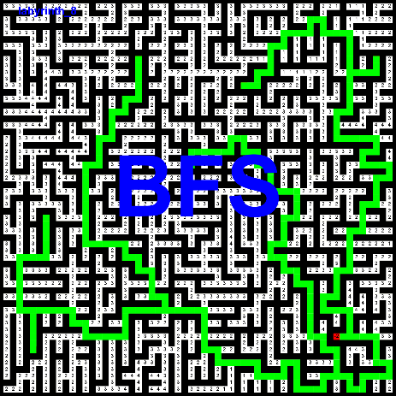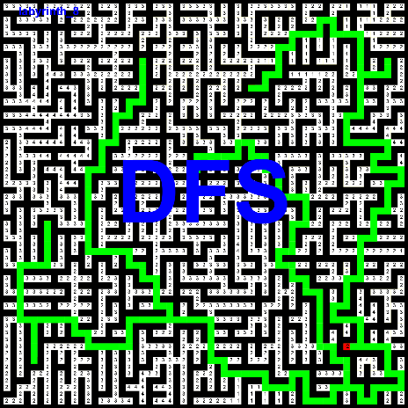

DFS

dolzina poti: 808

cena poti: 2116

število obiskanih vozlišč: 3506

največja globina: 177

[[51,52], [51,53], [50,53], [49,53], [48,53], [47,53], [47,52], [47,51], [47,50], [47,49], [46,49], [45,49], [45,50], [45,51], [44,51], [43,51], [42,51], [41,51], [41,52], [41,53], [40,53], [39,53], [38,53], [37,53], [36,53], [35,53], [35,54], [35,55], [34,55], [33,55], [32,55], [31,55], [31,56], [31,57], [30,57], [29,57], [28,57], [27,57], [27,58], [27,59], [26,59], [25,59], [25,58], [25,57], [25,56], [25,55], [24,55], [23,55], [23,56], [23,57], [22,57], [21,57], [21,56], [21,55], [21,54], [21,53], [21,52], [21,51], [20,51], [19,51], [18,51], [17,51], [17,52], [17,53], [16,53], [15,53], [14,53], [13,53], [12,53], [11,53], [10,53], [9,53], [8,53], [7,53], [6,53], [5,53], [5,52], [5,51], [5,50], [5,49], [4,49], [3,49], [3,48], [3,47], [4,47], [5,47], [5,46], [5,45], [5,44], [5,43], [6,43], [7,43], [7,42], [7,41], [8,41], [9,41], [10,41], [11,41], [11,40], [11,39], [12,39], [13,39], [13,38], [13,37], [13,38], [13,39], [12,39], [11,39], [11,40], [11,41], [10,41], [9,41], [8,41], [7,41], [7,42], [7,43], [6,43], [5,43], [5,44], [5,45], [5,46], [5,47], [4,47], [3,47], [3,48], [3,49], [4,49], [5,49], [5,50], [5,51], [5,52], [5,53], [6,53], [7,53], [8,53], [9,53], [10,53], [11,53], [12,53], [13,53], [14,53], [15,53], [16,53], [17,53], [17,52], [17,51], [18,51], [19,51], [20,51], [21,51], [21,52], [21,53], [21,54], [21,55], [21,56], [21,57], [22,57], [23,57], [23,56], [23,55], [24,55], [25,55], [25,56], [25,57], [25,58], [25,59], [26,59], [27,59], [27,58], [27,57], [28,57], [29,57], [30,57], [31,57], [31,56], [31,55], [32,55], [33,55], [34,55], [35,55], [35,54], [35,53], [36,53], [37,53], [38,53], [39,53], [40,53], [41,53], [41,52], [41,51], [42,51], [43,51], [44,51], [45,51], [45,50], [45,49], [46,49], [47,49], [47,50], [47,51], [47,52], [47,53], [48,53], [49,53], [50,53], [51,53], [51,54], [51,55], [51,56], [51,57], [52,57], [53,57], [54,57], [55,57], [55,58], [55,59], [56,59], [57,59], [57,58], [57,57], [57,56], [57,55], [58,55], [59,55], [59,54], [59,53], [58,53], [57,53], [57,52], [57,51], [57,50], [57,49], [58,49], [59,49], [59,48], [59,47], [59,46], [59,45], [58,45], [57,45], [56,45], [55,45], [55,44], [55,43], [56,43], [57,43], [57,42], [57,41], [57,40], [57,39], [56,39], [55,39], [55,38], [55,37], [55,36], [55,35], [55,34], [55,33], [54,33], [53,33], [53,32], [53,31], [52,31], [51,31], [50,31], [49,31], [48,31], [47,31], [47,30], [47,29], [47,28], [47,27], [47,26], [47,25], [46,25], [45,25], [45,24], [45,23], [44,23], [43,23], [42,23], [41,23], [41,22], [41,21], [40,21], [39,21], [39,20], [39,19], [38,19], [37,19], [37,18], [37,17], [37,16], [37,15], [37,14], [37,13], [36,13], [35,13], [34,13], [33,13], [32,13], [31,13], [30,13], [29,13], [28,13], [27,13], [26,13], [25,13], [25,14], [25,15], [24,15], [23,15], [22,15], [21,15], [21,16], [21,17], [20,17], [19,17], [18,17], [17,17], [17,18], [17,19], [16,19], [15,19], [15,20], [15,21], [14,21], [13,21], [12,21], [11,21], [10,21], [9,21], [10,21], [11,21], [12,21], [13,21], [14,21], [15,21], [15,20], [15,19], [16,19], [17,19], [17,18], [17,17], [18,17], [19,17], [20,17], [21,17], [21,16], [21,15], [22,15], [23,15], [24,15], [25,15], [25,14], [25,13], [26,13], [27,13], [28,13], [29,13], [30,13], [31,13], [32,13], [33,13], [34,13], [35,13], [36,13], [37,13], [37,14], [37,15], [37,16], [37,17], [37,18], [37,19], [38,19], [39,19], [39,20], [39,21], [40,21], [41,21], [41,22], [41,23], [42,23], [43,23], [44,23], [45,23], [45,24], [45,25], [46,25], [47,25], [47,24], [47,23], [47,22], [47,21], [47,20], [47,19], [48,19], [49,19], [50,19], [51,19], [51,18], [51,17], [51,16], [51,15], [51,14], [51,13], [50,13], [49,13], [49,12], [49,11], [48,11], [47,11], [47,10], [47,9], [47,8], [47,7], [47,6], [47,5], [48,5], [49,5], [50,5], [51,5], [52,5], [53,5], [52,5], [51,5], [50,5], [49,5], [48,5], [47,5], [47,4], [47,3], [46,3], [45,3], [44,3], [43,3], [42,3], [41,3], [40,3], [39,3], [39,4], [39,5], [39,6], [39,7], [38,7], [37,7], [36,7], [35,7], [34,7], [33,7], [34,7], [35,7], [36,7], [37,7], [38,7], [39,7], [39,6], [39,5], [39,4], [39,3], [40,3], [41,3], [42,3], [43,3], [44,3], [45,3], [46,3], [47,3], [47,4], [47,5], [47,6], [47,7], [47,8], [47,9], [47,10], [47,11], [48,11], [49,11], [49,12], [49,13], [50,13], [51,13], [51,14], [51,15], [51,16], [51,17], [51,18], [51,19], [50,19], [49,19], [48,19], [47,19], [47,20], [47,21], [47,22], [47,23], [47,24], [47,25], [47,26], [47,27], [47,28], [47,29], [47,30], [47,31], [48,31], [49,31], [50,31], [51,31], [52,31], [53,31], [53,32], [53,33], [54,33], [55,33], [55,34], [55,35], [55,36], [55,37], [55,38], [55,39], [56,39], [57,39], [57,40], [57,41], [57,42], [57,43], [56,43], [55,43], [55,44], [55,45], [56,45], [57,45], [58,45], [59,45], [59,46], [59,47], [59,48], [59,49], [58,49], [57,49], [57,50], [57,51], [57,52], [57,53], [58,53], [59,53], [59,54], [59,55], [58,55], [57,55], [57,56], [57,57], [57,58], [57,59], [56,59], [55,59], [55,58], [55,57], [54,57], [53,57], [52,57], [51,57], [51,56], [51,55], [51,54], [51,53], [50,53], [49,53], [48,53], [47,53], [47,52], [47,51], [47,50], [47,49], [46,49], [45,49], [45,50], [45,51], [44,51], [43,51], [42,51], [41,51], [41,52], [41,53], [40,53], [39,53], [38,53], [37,53], [36,53], [35,53], [35,54], [35,55], [34,55], [33,55], [32,55], [31,55], [31,56], [31,57], [30,57], [29,57], [28,57], [27,57], [27,58], [27,59], [26,59], [25,59], [25,58], [25,57], [25,56], [25,55], [24,55], [23,55], [23,56], [23,57], [22,57], [21,57], [21,56], [21,55], [21,54], [21,53], [21,52], [21,51], [20,51], [19,51], [18,51], [17,51], [17,52], [17,53], [16,53], [15,53], [14,53], [13,53], [12,53], [11,53], [11,54], [11,55], [11,56], [11,57], [10,57], [9,57], [10,57], [11,57], [11,56], [11,55], [11,54], [11,53], [12,53], [13,53], [14,53], [15,53], [16,53], [17,53], [17,52], [17,51], [18,51], [19,51], [20,51], [21,51], [21,52], [21,53], [21,54], [21,55], [21,56], [21,57], [22,57], [23,57], [23,56], [23,55], [24,55], [25,55], [25,56], [25,57], [25,58], [25,59], [26,59], [27,59], [27,58], [27,57], [28,57], [29,57], [30,57], [31,57], [31,56], [31,55], [32,55], [33,55], [34,55], [35,55], [35,54], [35,53], [36,53], [37,53], [38,53], [39,53], [40,53], [41,53], [41,52], [41,51], [42,51], [43,51], [44,51], [45,51], [45,50], [45,49], [46,49], [47,49], [47,50], [47,51], [47,52], [47,53], [48,53], [49,53], [50,53], [51,53], [51,54], [51,55], [51,56], [51,57], [52,57], [53,57], [54,57], [55,57], [55,58], [55,59], [56,59], [57,59], [57,58], [57,57], [57,56], [57,55], [58,55], [59,55], [59,54], [59,53], [58,53], [57,53], [57,52], [57,51], [56,51], [55,51], [54,51], [53,51], [53,50], [53,49], [52,49], [51,49], [51,48], [51,47], [50,47], [49,47], [48,47], [47,47], [46,47], [45,47], [44,47], [43,47], [43,46], [43,45], [42,45], [41,45], [41,44], [41,43], [40,43], [39,43], [39,42], [39,41], [38,41], [37,41], [37,42], [37,43], [36,43], [35,43], [34,43], [33,43], [33,44], [33,45], [32,45], [31,45], [30,45], [29,45], [29,44], [29,43], [29,42], [29,41], [28,41], [27,41], [26,41], [25,41], [25,40], [25,39], [24,39], [23,39], [23,38], [23,37], [22,37], [21,37], [21,36], [21,35], [22,35], [23,35], [23,34], [23,33], [23,32], [23,31], [23,30], [23,29], [24,29], [25,29], ]

BFS

dolzina poti: 624

cena poti: 1545

število obiskanih vozlišč: 4752

največja globina: 204

[[51,52], [51,53], [50,53], [49,53], [48,53], [47,53], [47,52], [47,51], [47,50], [47,49], [46,49], [45,49], [45,50], [45,51], [44,51], [43,51], [42,51], [41,51], [41,52], [41,53], [40,53], [39,53], [38,53], [37,53], [36,53], [35,53], [35,54], [35,55], [34,55], [33,55], [32,55], [31,55], [31,56], [31,57], [30,57], [29,57], [28,57], [27,57], [27,58], [27,59], [26,59], [25,59], [25,58], [25,57], [25,56], [25,55], [24,55], [23,55], [23,56], [23,57], [22,57], [21,57], [21,56], [21,55], [21,54], [21,53], [21,52], [21,51], [20,51], [19,51], [18,51], [17,51], [17,52], [17,53], [16,53], [15,53], [14,53], [13,53], [12,53], [11,53], [11,54], [11,55], [11,56], [11,57], [10,57], [9,57], [10,57], [11,57], [11,56], [11,55], [11,54], [11,53], [10,53], [9,53], [8,53], [7,53], [6,53], [5,53], [5,52], [5,51], [5,50], [5,49], [4,49], [3,49], [3,48], [3,47], [4,47], [5,47], [5,46], [5,45], [5,44], [5,43], [6,43], [7,43], [7,42], [7,41], [8,41], [9,41], [10,41], [11,41], [11,40], [11,39], [12,39], [13,39], [13,38], [13,37], [13,38], [13,39], [12,39], [11,39], [11,40], [11,41], [10,41], [9,41], [8,41], [7,41], [7,42], [7,43], [6,43], [5,43], [5,44], [5,45], [5,46], [5,47], [4,47], [3,47], [3,48], [3,49], [4,49], [5,49], [5,50], [5,51], [5,52], [5,53], [6,53], [7,53], [8,53], [9,53], [10,53], [11,53], [12,53], [13,53], [14,53], [15,53], [16,53], [17,53], [17,52], [17,51], [18,51], [19,51], [20,51], [21,51], [21,52], [21,53], [21,54], [21,55], [21,56], [21,57], [22,57], [23,57], [23,56], [23,55], [24,55], [25,55], [25,56], [25,57], [25,58], [25,59], [26,59], [27,59], [27,58], [27,57], [28,57], [29,57], [30,57], [31,57], [31,56], [31,55], [32,55], [33,55], [34,55], [35,55], [35,54], [35,53], [36,53], [37,53], [38,53], [39,53], [40,53], [41,53], [41,52], [41,51], [42,51], [43,51], [44,51], [45,51], [45,50], [45,49], [46,49], [47,49], [47,50], [47,51], [47,52], [47,53], [48,53], [49,53], [50,53], [51,53], [51,54], [51,55], [51,56], [51,57], [52,57], [53,57], [54,57], [55,57], [55,58], [55,59], [56,59], [57,59], [57,58], [57,57], [57,56], [57,55], [58,55], [59,55], [59,54], [59,53], [58,53], [57,53], [57,52], [57,51], [57,50], [57,49], [58,49], [59,49], [59,48], [59,47], [59,46], [59,45], [58,45], [57,45], [56,45], [55,45], [55,44], [55,43], [56,43], [57,43], [57,42], [57,41], [57,40], [57,39], [56,39], [55,39], [55,38], [55,37], [55,36], [55,35], [55,34], [55,33], [54,33], [53,33], [53,32], [53,31], [52,31], [51,31], [50,31], [49,31], [48,31], [47,31], [47,30], [47,29], [47,28], [47,27], [47,26], [47,25], [47,24], [47,23], [47,22], [47,21], [47,20], [47,19], [48,19], [49,19], [50,19], [51,19], [51,18], [51,17], [51,16], [51,15], [51,14], [51,13], [50,13], [49,13], [49,12], [49,11], [48,11], [47,11], [47,10], [47,9], [47,8], [47,7], [47,6], [47,5], [48,5], [49,5], [50,5], [51,5], [52,5], [53,5], [52,5], [51,5], [50,5], [49,5], [48,5], [47,5], [47,4], [47,3], [46,3], [45,3], [44,3], [43,3], [42,3], [41,3], [40,3], [39,3], [39,4], [39,5], [39,6], [39,7], [38,7], [37,7], [36,7], [35,7], [34,7], [33,7], [34,7], [35,7], [36,7], [37,7], [38,7], [39,7], [39,6], [39,5], [39,4], [39,3], [40,3], [41,3], [42,3], [43,3], [44,3], [45,3], [46,3], [47,3], [47,4], [47,5], [47,6], [47,7], [47,8], [47,9], [47,10], [47,11], [48,11], [49,11], [49,12], [49,13], [50,13], [51,13], [51,14], [51,15], [51,16], [51,17], [51,18], [51,19], [50,19], [49,19], [48,19], [47,19], [47,20], [47,21], [47,22], [47,23], [47,24], [47,25], [46,25], [45,25], [45,24], [45,23], [44,23], [43,23], [42,23], [41,23], [41,22], [41,21], [40,21], [39,21], [39,20], [39,19], [38,19], [37,19], [37,18], [37,17], [37,16], [37,15], [37,14], [37,13], [36,13], [35,13], [34,13], [33,13], [32,13], [31,13], [30,13], [29,13], [28,13], [27,13], [26,13], [25,13], [25,14], [25,15], [24,15], [23,15], [22,15], [21,15], [21,16], [21,17], [20,17], [19,17], [18,17], [17,17], [17,18], [17,19], [16,19], [15,19], [15,20], [15,21], [14,21], [13,21], [12,21], [11,21], [10,21], [9,21], [10,21], [11,21], [12,21], [13,21], [14,21], [15,21], [15,20], [15,19], [16,19], [17,19], [17,18], [17,17], [18,17], [19,17], [20,17], [21,17], [21,16], [21,15], [22,15], [23,15], [24,15], [25,15], [25,14], [25,13], [26,13], [27,13], [28,13], [29,13], [30,13], [31,13], [32,13], [33,13], [34,13], [35,13], [36,13], [37,13], [37,14], [37,15], [37,16], [37,17], [37,18], [37,19], [38,19], [39,19], [39,20], [39,21], [40,21], [41,21], [41,22], [41,23], [42,23], [43,23], [44,23], [45,23], [45,24], [45,25], [46,25], [47,25], [47,26], [47,27], [47,28], [47,29], [47,30], [47,31], [48,31], [49,31], [50,31], [51,31], [52,31], [53,31], [53,32], [53,33], [54,33], [55,33], [55,34], [55,35], [55,36], [55,37], [55,38], [55,39], [56,39], [57,39], [57,40], [57,41], [57,42], [57,43], [56,43], [55,43], [55,44], [55,45], [56,45], [57,45], [58,45], [59,45], [59,46], [59,47], [59,48], [59,49], [58,49], [57,49], [57,50], [57,51], [56,51], [55,51], [54,51], [53,51], [53,50], [53,49], [52,49], [51,49], [51,48], [51,47], [50,47], [49,47], [48,47], [47,47], [46,47], [45,47], [44,47], [43,47], [43,46], [43,45], [42,45], [41,45], [41,44], [41,43], [40,43], [39,43], [39,42], [39,41], [38,41], [37,41], [37,42], [37,43], [36,43], [35,43], [34,43], [33,43], [33,44], [33,45], [32,45], [31,45], [30,45], [29,45], [29,44], [29,43], [29,42], [29,41], [28,41], [27,41], [26,41], [25,41], [25,40], [25,39], [24,39], [23,39], [23,38], [23,37], [22,37], [21,37], [21,36], [21,35], [22,35], [23,35], [23,34], [23,33], [23,32], [23,31], [23,30], [23,29], [24,29], [25,29], ]

AStar

dolzina poti: 624

cena poti: 1545

število obiskanih vozlišč: 3304

največja globina: 204

[[51,52], [51,53], [50,53], [49,53], [48,53], [47,53], [47,52], [47,51], [47,50], [47,49], [46,49], [45,49], [45,50], [45,51], [44,51], [43,51], [42,51], [41,51], [41,52], [41,53], [40,53], [39,53], [38,53], [37,53], [36,53], [35,53], [35,54], [35,55], [34,55], [33,55], [32,55], [31,55], [31,56], [31,57], [30,57], [29,57], [28,57], [27,57], [27,58], [27,59], [26,59], [25,59], [25,58], [25,57], [25,56], [25,55], [24,55], [23,55], [23,56], [23,57], [22,57], [21,57], [21,56], [21,55], [21,54], [21,53], [21,52], [21,51], [20,51], [19,51], [18,51], [17,51], [17,52], [17,53], [16,53], [15,53], [14,53], [13,53], [12,53], [11,53], [11,54], [11,55], [11,56], [11,57], [10,57], [9,57], [10,57], [11,57], [11,56], [11,55], [11,54], [11,53], [10,53], [9,53], [8,53], [7,53], [6,53], [5,53], [5,52], [5,51], [5,50], [5,49], [4,49], [3,49], [3,48], [3,47], [4,47], [5,47], [5,46], [5,45], [5,44], [5,43], [6,43], [7,43], [7,42], [7,41], [8,41], [9,41], [10,41], [11,41], [11,40], [11,39], [12,39], [13,39], [13,38], [13,37], [13,38], [13,39], [12,39], [11,39], [11,40], [11,41], [10,41], [9,41], [8,41], [7,41], [7,42], [7,43], [6,43], [5,43], [5,44], [5,45], [5,46], [5,47], [4,47], [3,47], [3,48], [3,49], [4,49], [5,49], [5,50], [5,51], [5,52], [5,53], [6,53], [7,53], [8,53], [9,53], [10,53], [11,53], [12,53], [13,53], [14,53], [15,53], [16,53], [17,53], [17,52], [17,51], [18,51], [19,51], [20,51], [21,51], [21,52], [21,53], [21,54], [21,55], [21,56], [21,57], [22,57], [23,57], [23,56], [23,55], [24,55], [25,55], [25,56], [25,57], [25,58], [25,59], [26,59], [27,59], [27,58], [27,57], [28,57], [29,57], [30,57], [31,57], [31,56], [31,55], [32,55], [33,55], [34,55], [35,55], [35,54], [35,53], [36,53], [37,53], [38,53], [39,53], [40,53], [41,53], [41,52], [41,51], [42,51], [43,51], [44,51], [45,51], [45,50], [45,49], [46,49], [47,49], [47,50], [47,51], [47,52], [47,53], [48,53], [49,53], [50,53], [51,53], [51,54], [51,55], [51,56], [51,57], [52,57], [53,57], [54,57], [55,57], [55,58], [55,59], [56,59], [57,59], [57,58], [57,57], [57,56], [57,55], [58,55], [59,55], [59,54], [59,53], [58,53], [57,53], [57,52], [57,51], [57,50], [57,49], [58,49], [59,49], [59,48], [59,47], [59,46], [59,45], [58,45], [57,45], [56,45], [55,45], [55,44], [55,43], [56,43], [57,43], [57,42], [57,41], [57,40], [57,39], [56,39], [55,39], [55,38], [55,37], [55,36], [55,35], [55,34], [55,33], [54,33], [53,33], [53,32], [53,31], [52,31], [51,31], [50,31], [49,31], [48,31], [47,31], [47,30], [47,29], [47,28], [47,27], [47,26], [47,25], [47,24], [47,23], [47,22], [47,21], [47,20], [47,19], [48,19], [49,19], [50,19], [51,19], [51,18], [51,17], [51,16], [51,15], [51,14], [51,13], [50,13], [49,13], [49,12], [49,11], [48,11], [47,11], [47,10], [47,9], [47,8], [47,7], [47,6], [47,5], [48,5], [49,5], [50,5], [51,5], [52,5], [53,5], [52,5], [51,5], [50,5], [49,5], [48,5], [47,5], [47,4], [47,3], [46,3], [45,3], [44,3], [43,3], [42,3], [41,3], [40,3], [39,3], [39,4], [39,5], [39,6], [39,7], [38,7], [37,7], [36,7], [35,7], [34,7], [33,7], [34,7], [35,7], [36,7], [37,7], [38,7], [39,7], [39,6], [39,5], [39,4], [39,3], [40,3], [41,3], [42,3], [43,3], [44,3], [45,3], [46,3], [47,3], [47,4], [47,5], [47,6], [47,7], [47,8], [47,9], [47,10], [47,11], [48,11], [49,11], [49,12], [49,13], [50,13], [51,13], [51,14], [51,15], [51,16], [51,17], [51,18], [51,19], [50,19], [49,19], [48,19], [47,19], [47,20], [47,21], [47,22], [47,23], [47,24], [47,25], [46,25], [45,25], [45,24], [45,23], [44,23], [43,23], [42,23], [41,23], [41,22], [41,21], [40,21], [39,21], [39,20], [39,19], [38,19], [37,19], [37,18], [37,17], [37,16], [37,15], [37,14], [37,13], [36,13], [35,13], [34,13], [33,13], [32,13], [31,13], [30,13], [29,13], [28,13], [27,13], [26,13], [25,13], [25,14], [25,15], [24,15], [23,15], [22,15], [21,15], [21,16], [21,17], [20,17], [19,17], [18,17], [17,17], [17,18], [17,19], [16,19], [15,19], [15,20], [15,21], [14,21], [13,21], [12,21], [11,21], [10,21], [9,21], [10,21], [11,21], [12,21], [13,21], [14,21], [15,21], [15,20], [15,19], [16,19], [17,19], [17,18], [17,17], [18,17], [19,17], [20,17], [21,17], [21,16], [21,15], [22,15], [23,15], [24,15], [25,15], [25,14], [25,13], [26,13], [27,13], [28,13], [29,13], [30,13], [31,13], [32,13], [33,13], [34,13], [35,13], [36,13], [37,13], [37,14], [37,15], [37,16], [37,17], [37,18], [37,19], [38,19], [39,19], [39,20], [39,21], [40,21], [41,21], [41,22], [41,23], [42,23], [43,23], [44,23], [45,23], [45,24], [45,25], [46,25], [47,25], [47,26], [47,27], [47,28], [47,29], [47,30], [47,31], [48,31], [49,31], [50,31], [51,31], [52,31], [53,31], [53,32], [53,33], [54,33], [55,33], [55,34], [55,35], [55,36], [55,37], [55,38], [55,39], [56,39], [57,39], [57,40], [57,41], [57,42], [57,43], [56,43], [55,43], [55,44], [55,45], [56,45], [57,45], [58,45], [59,45], [59,46], [59,47], [59,48], [59,49], [58,49], [57,49], [57,50], [57,51], [56,51], [55,51], [54,51], [53,51], [53,50], [53,49], [52,49], [51,49], [51,48], [51,47], [50,47], [49,47], [48,47], [47,47], [46,47], [45,47], [44,47], [43,47], [43,46], [43,45], [42,45], [41,45], [41,44], [41,43], [40,43], [39,43], [39,42], [39,41], [38,41], [37,41], [37,42], [37,43], [36,43], [35,43], [34,43], [33,43], [33,44], [33,45], [32,45], [31,45], [30,45], [29,45], [29,44], [29,43], [29,42], [29,41], [28,41], [27,41], [26,41], [25,41], [25,40], [25,39], [24,39], [23,39], [23,38], [23,37], [22,37], [21,37], [21,36], [21,35], [22,35], [23,35], [23,34], [23,33], [23,32], [23,31], [23,30], [23,29], [24,29], [25,29], ]

Opazke:

AStar se je odrezal boljše od obeh.

# Labirint

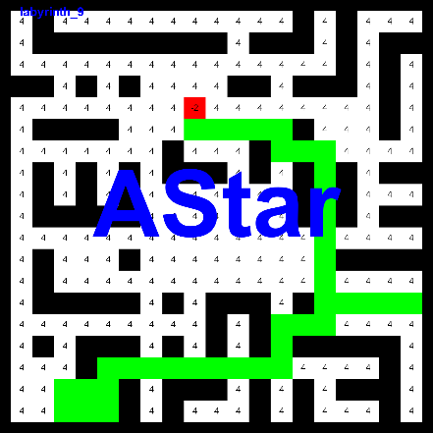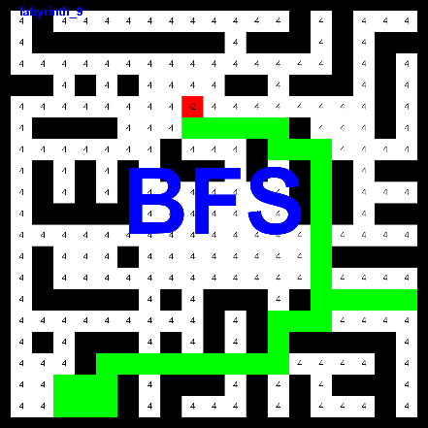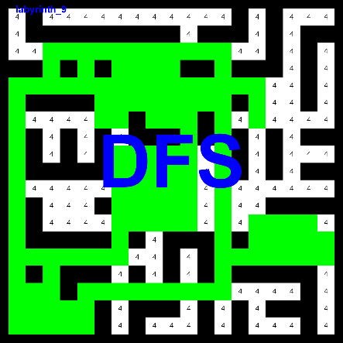

DFS

dolzina poti: 277

cena poti: 1082

število obiskanih vozlišč: 467

največja globina: 121

[[4,9], [3,9], [3,8], [4,8], [5,8], [6,8], [6,7], [5,7], [4,7], [3,7], [3,6], [3,5], [4,5], [5,5], [5,4], [5,3], [5,2], [5,1], [6,1], [7,1], [8,1], [9,1], [10,1], [11,1], [12,1], [13,1], [14,1], [15,1], [16,1], [17,1], [18,1], [19,1], [19,2], [18,2], [17,2], [17,3], [16,3], [15,3], [15,4], [15,5], [15,6], [15,7], [14,7], [13,7], [12,7], [11,7], [10,7], [9,7], [9,8], [10,8], [11,8], [12,8], [13,8], [13,9], [12,9], [11,9], [10,9], [9,9], [9,10], [10,10], [11,10], [12,10], [13,10], [13,11], [12,11], [11,11], [10,11], [9,11], [8,11], [7,11], [6,11], [5,11], [5,10], [4,10], [3,10], [3,11], [3,12], [3,13], [4,13], [5,13], [6,13], [7,13], [8,13], [9,13], [10,13], [11,13], [12,13], [13,13], [14,13], [15,13], [16,13], [17,13], [17,12], [17,11], [17,10], [17,9], [17,8], [17,7], [17,6], [17,5], [18,5], [19,5], [19,4], [18,4], [18,3], [19,3], [18,3], [17,3], [16,3], [15,3], [15,2], [15,1], [14,1], [13,1], [12,1], [11,1], [10,1], [9,1], [8,1], [7,1], [6,1], [5,1], [5,2], [5,3], [4,3], [3,3], [3,4], [3,5], [4,5], [5,5], [5,6], [6,6], [7,6], [7,7], [6,7], [5,7], [4,7], [3,7], [3,8], [4,8], [5,8], [6,8], [6,9], [5,9], [4,9], [3,9], [3,10], [4,10], [5,10], [6,10], [7,10], [7,11], [6,11], [5,11], [5,12], [6,12], [6,13], [5,13], [5,14], [5,15], [6,15], [7,15], [6,15], [5,15], [5,14], [5,13], [4,13], [3,13], [3,12], [3,11], [3,10], [4,10], [5,10], [6,10], [7,10], [7,9], [6,9], [5,9], [4,9], [3,9], [3,8], [4,8], [5,8], [6,8], [6,7], [5,7], [4,7], [3,7], [3,6], [3,5], [4,5], [5,5], [5,4], [5,3], [5,2], [5,1], [6,1], [7,1], [8,1], [9,1], [10,1], [11,1], [12,1], [13,1], [14,1], [15,1], [16,1], [17,1], [18,1], [19,1], [19,2], [18,2], [17,2], [17,3], [16,3], [15,3], [15,4], [15,5], [15,6], [15,7], [14,7], [13,7], [12,7], [11,7], [10,7], [9,7], [9,8], [10,8], [11,8], [12,8], [13,8], [13,9], [12,9], [11,9], [10,9], [9,9], [9,10], [10,10], [11,10], [12,10], [13,10], [13,11], [12,11], [11,11], [10,11], [9,11], [8,11], [7,11], [6,11], [5,11], [5,12], [6,12], [6,13], [7,13], [8,13], [9,13], [10,13], [11,13], [12,13], [13,13], [14,13], [15,13], [15,14], [15,15], [14,15], [13,15], [13,16], [14,16], [15,16], [15,17], [14,17], [13,17], [13,18], [14,18], [15,18], [15,19], [14,19], ]

BFS

dolzina poti: 53

cena poti: 194

število obiskanih vozlišč: 501

največja globina: 24

[[6,9], [6,10], [6,11], [6,12], [6,13], [7,13], [7,14], [7,15], [8,15], [9,15], [10,15], [11,15], [12,15], [13,15], [14,15], [15,15], [15,14], [15,13], [16,13], [17,13], [17,12], [17,11], [17,10], [17,9], [17,8], [17,7], [17,6], [17,5], [18,5], [19,5], [19,4], [19,3], [18,3], [18,4], [18,5], [17,5], [17,6], [17,7], [17,8], [17,9], [17,10], [17,11], [17,12], [17,13], [16,13], [15,13], [15,14], [15,15], [14,15], [14,16], [14,17], [14,18], [14,19], ]

AStar

dolzina poti: 53

cena poti: 194

število obiskanih vozlišč: 205

največja globina: 24

[[6,9], [6,10], [6,11], [6,12], [6,13], [7,13], [7,14], [7,15], [8,15], [9,15], [10,15], [11,15], [12,15], [13,15], [14,15], [15,15], [15,14], [15,13], [16,13], [17,13], [17,12], [17,11], [17,10], [17,9], [17,8], [17,7], [17,6], [17,5], [18,5], [19,5], [19,4], [19,3], [18,3], [18,4], [18,5], [17,5], [17,6], [17,7], [17,8], [17,9], [17,10], [17,11], [17,12], [17,13], [16,13], [15,13], [15,14], [15,15], [14,15], [14,16], [14,17], [14,18], [14,19], ]

Opazke:

Zaradi vrstnega reda pregledovanja vozlišč v algoritmu DFS se je lagoritem zaradi preveliko možnosti izbire vozlišč algoritem vedel zelo neoptimalno. Prav tako pri algoritmu BFS. Medtem ko je prostornost labirinta bila zelo optimalna za delovanje algoritma Astar.

# Ugotovitve

DFS algoritem ima možnost obiskati manj vozlišč kot BFS, ampak ni nujno da bo rešitev optimalna. Medtem ko BFS vedno zagotovi optimalno rešitev.

AStar je glede na optimalno rešitev in število obiskanih vozlišč najboljši izmed treh. Ampak za delovanje potrebuje poznati lokacije vseh zakladov in cilja. Cena poti pri primerjavi teh algoritmov ni imela neke posebne vloge, saj je noben od algoritmov ne poskuša optimizirati.