Hawn App

Hawn software developed by XPeart.

# Index

|  |
| --- |
| Program functions |
| Project partitioning: files and folders |
| Marketing Features |
| UI SCREEN |
| ICOAN APP |
| Objectives |
| Target Users |
| Key Features |

Program functions

* Main Function:

Helps the user achieve psychological comfort through:

Audio meditation sessions.

Daily recording of feelings (mood).

Mental health tips and articles.

Daily notifications to remind the user to relax and meditate.

🧩 Functions and Features in Technical Detail:

1. 🎧 Guided Meditation Sessions:

Database: Firebase or SQLite to save links.

Play Audio: Using the just_audio library or audioplayers.

User Interface:

Session Name

Session Duration

Play/Pause Button

UI Effects such as animation upon launch

2. 📓 Journaling + Mood Tracker:

Choose Mood: Emoji (🙂 😐 😞)

Write Today's Feeling: Text saved locally or in Firebase.

Mood Analysis: Chart your mood for a week or month using fl_chart.

Data Storage: SQLite or Firebase Firestore.

3. 📚 Mental Health Articles:

Data Source:

From Firebase Firestore.

Or an open API such as MentalHealth.org.

Features:

Liking/Favorite.

Save articles and read them later (offline).

4. 🔔 Daily Notifications:

Uses the flutter_local_notifications library.

Function: Every day at a specific time (e.g., 8 PM), a notification appears: "Take a minute for yourself ✨."

User Settings: The reminder time can be changed or turned off.

Project partitioning: files and folders

lib/

├── core/

│ ├── services/

│ ├── theme/

│ ├── utils/

│ └── constants.dart

│

├── features/

│ ├── auth/

│ ├── meditation/

│ ├── journal/

│ ├── mood/

│ ├── articles/

│ └── notifications/

│

├── data/

│ ├── models/

│ ├── datasources/

│ └── repositories/

│

├── main.dart

main.dart

Is the application's launch point.

It contains:

MaterialApp definition

Theme setup

InitialRoute

Firebase or any initial services configuration

📁 core/

Files shared across all parts and used in more than one feature.

🧩 services/

Such as:

Firebase

SharedPreferences

Audio Player

🎨 theme/

The overall theme of the application (colors, fonts, light/dark mode).

🧰 utils/

Utilities (such as date conversion functions, SnackBar display, etc.).

📄 constants.dart

Global constants such as page names, primary colors, and static text.

📁 features/

Each feature is located within its own folder.

🔐 auth/

Log in / Register / Guest

Files:

auth_screen.dart

auth_view_model.dart

auth_service.dart

🧘 meditation/

Meditation Sessions

Files:

meditation_screen.dart

meditation_audio_service.dart

meditation_model.dart

📓 journal/

Journal Writing

Files:

journal_screen.dart

journal_model.dart

journal_controller.dart

😌 mood/

Mood Tracking

Files:

mood_screen.dart

mood_tracker_service.dart

mood_model.dart

📚 articles/

View Mental Health Articles

Files:

articles_screen.dart

articles_service.dart

articles_model.dart

🔔 notifications/

Send Notifications Daily

Files:

notification_service.dart

User time settings

📁 data/

A folder responsible for data only.

📄 models/

Each model represents a specific entity, such as:

UserModel

MeditationSessionModel

MoodEntryModel

🌐 datasources/

Where do we get the data from?

API

Firebase

SQLite

📦 repositories/

Connects data and business logic.

Interfaces for dealing with data in a general and flexible manner.

Objectives

* Hussein provides psychological comfort to users.
* Helps them express their feelings daily.
* Provides psychological awareness content in a simple way.

Target Users

* For students, employees, and people experiencing stress.
* Anyone interested in meditation and mental well-being.

Marketing Features

Very useful for students and employees dealing with stress.

It can be linked to Google Fit or Apple Health.

A paid version with advanced sessions is available.

UI Screens Overview

* Welcome Screen
* Home Screen
* Meditation Sessions Screen
* Journaling Screen
* Articles Screen

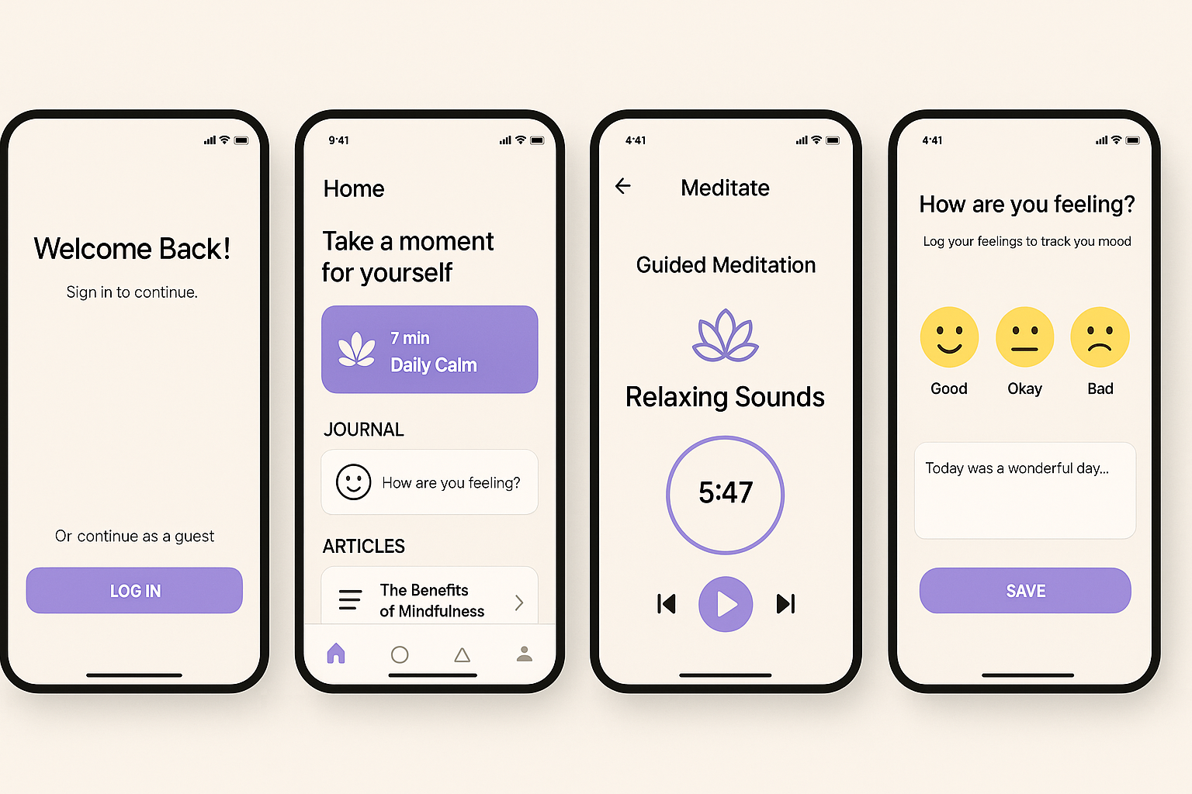

Key Features

* Guided Meditation
* Mood Tracker
* Daily Journal
* Notifications
* Articles Feed

ICOAN APP

