
MBARARA UNIVERSITY OF SCIENCE AND TECHNOLOGY
FACULTY OF COMPUTING & INFORMATICS
BACHELOR OF SCIENCE IN COMPUTER SCIENCE

CSC1204 - DATABASE SYSTEMS

LAND SALES ACCOUNTING SYSTEM REPORT
……………………………………………………...
Submitted by:
ALLAN AHABWE
2025/BCS/012/PSs
Lecturer:
Dr. Kenneth Baguma

EXECUTIVE SUMMARY
The Land Sales Accounting System is a database-driven information system developed to assist land-selling organizations in managing sales transactions, payments, commissions, salaries, and expenses efficiently. The system was designed and implemented using MySQL, PHP, HTML, and CSS.
The project was developed as part of the Database Systems course to demonstrate practical database design, implementation, and management concepts. The system supports important accounting activities such as recording land sales, tracking installment payments, calculating staff commissions automatically, managing salaries, and recording organizational expenses.
The system includes a user-friendly interface that allows users to interact with the database without requiring knowledge of SQL queries. Public users are limited to viewing records, while administrative users can securely access data entry and management features through an admin login system.
The project also involved the development of an Entity Relationship Diagram (ERD), logical and physical database designs, implementation of relational tables, data population, and execution of sample queries. The completed system improves accuracy, reduces redundancy, enhances record management, and supports better decision-making within land sales organizations.
BUSINESS CASE
- Application Domain
The Land Sales Accounting System was developed to support accounting and financial management activities within land-selling companies and real estate organizations. The system focuses on managing land sale transactions, recording customer payments, handling installment payment tracking, calculating sales commissions, managing staff salaries, and recording company expenses.
The system is intended to support accountants, sales agents, administrators, and management staff by providing organized and centralized storage of financial records. The system improves efficiency in handling daily accounting operations and reduces reliance on manual record-keeping methods.
- System Requirements
The system requires a computer with XAMPP installed to provide Apache and MySQL services. The system was developed using PHP, HTML, CSS, and MySQL. Users access the system through a web browser.
The system requires:
- A web browser
- XAMPP server environment
- MySQL database server
- PHP support
- Basic user authentication for administrative access
The system also requires users to enter accurate sales, payment, and accounting information for effective operation.
- Benefits of the System
- The system provides several benefits to land-selling organizations:
- Improved management of sales records and financial transactions
- Reduction of data redundancy through relational database design
- Automatic commission calculation for sales agents
- Improved accuracy in payment tracking and reporting
- Enhanced security through role-based access control
- Faster retrieval of records through search and view features
- Improved accountability and financial monitoring
- Better organization of company expenses and salary records

- Cost-Benefit Analysis
The development costs of the system mainly involved time spent on analysis, design, implementation, testing, and documentation. Open-source technologies such as XAMPP, PHP, and MySQL were used, reducing software acquisition costs.
The benefits of the system outweigh the costs because the system improves operational efficiency, reduces errors associated with manual record management, supports faster report generation, and improves financial accountability within the organization.
- User Issues
Some users may require basic training to understand how to use the system interface effectively. Users unfamiliar with computerized accounting systems may initially face challenges when entering or retrieving information.
To address this challenge, the system was designed with a simple and user-friendly interface that uses forms, buttons, and organized dashboards to simplify user interaction.
- Risk Assessment
The system may face risks such as unauthorized access, accidental data deletion, incorrect data entry, and hardware failure. To reduce these risks, the system implements an admin login mechanism to restrict sensitive operations such as adding records and managing commissions.
Regular database backups are also recommended to prevent data loss in case of system failure.
- System Limitations
The system currently operates on a local server environment and is not yet deployed online. The authentication system implemented is basic and may require stronger security measures for real-world deployment.
The system also depends on manual data entry and does not currently integrate directly with external payment gateways or third-party systems.
DESIGN
- Logical Design
The logical design of the Land Sales Accounting System was developed based on the financial and accounting requirements of land-selling organizations. The design focused on identifying the major entities involved in sales management, payment tracking, commission handling, salary management, and expense recording.
The system was designed using a relational database approach where related data is organized into multiple tables connected through primary keys and foreign keys. This design reduces data redundancy and improves consistency and integrity of data within the system.
The logical design mainly consists of binary relationships between entities. Some logical foreign key references such as Client_ID, Staff_ID, and Plot_ID refer to external subsystem entities and are therefore not physically represented in this subsystem ERD.
- Entities and Attributes
The following entities were identified during the design of the system:
ENTITY | MAIN ATTRIBUTES
Sales | Sale_ID, Plot_ID, Client_ID, Staff_ID, Sale_Date, Selling_Price, Payment_Status, Sale_Status
Payments | Payment_ID, Sale_ID, Payment_Date, Payment_Amount, Payment_Method, Receipt_Number, Transaction_ID, Payment_Type
Commissions | Commission_ID, Sale_ID, Staff_ID, Commission_Amount, Commission_Date, Commission_Status
Salaries | Salary_ID, Staff_ID, Salary_Amount_Paid, Payment_Date, Payment_Status
Expenses | Expense_ID, Expense_Type, Expense_Amount, Expense_Date, Description

- Entity Relationships and Multiplicities
The system mainly uses binary relationships between entities. The relationships were designed to support efficient data management and minimize redundancy.
The Sales entity has a one-to-many (1:M) relationship with the Payments entity because one sale transaction can have multiple installment payments.
The Sales entity has a one-to-one (1:1) relationship with the Commissions entity because each sale generates at most one commission record.
The system also includes logical references to external subsystems through the Client_ID, Staff_ID, and Plot_ID foreign keys.
- Entity Relationship Diagram (ERD)
The Entity Relationship Diagram (ERD) below illustrates the structure of the database system, including entities, attributes, primary keys, foreign keys, and relationships between tables.
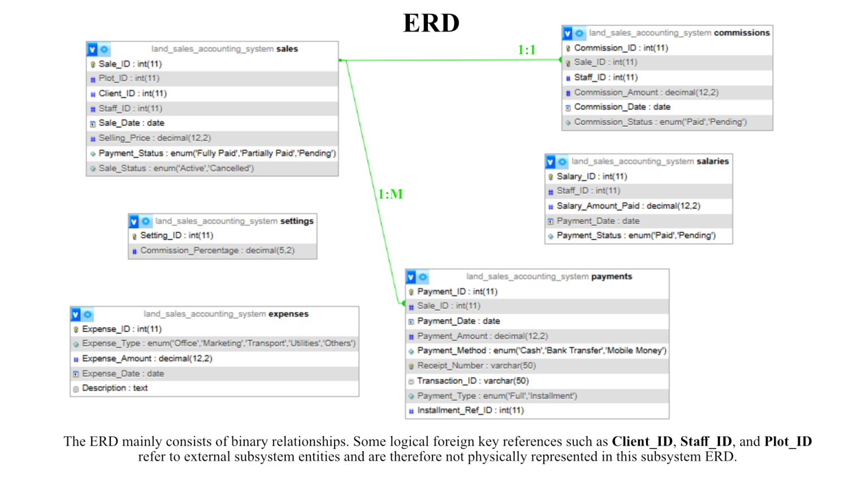
Figure: Entity Relationship Diagram (ERD) of the Land Sales Accounting System.
- User Interface Design
The system includes a web-based user interface developed using PHP, HTML, and CSS. The interface was designed to simplify user interaction with the database system by allowing users to perform operations using forms, buttons, and dashboards instead of SQL queries.
The homepage provides public users with access to view sales and payment records. Administrative operations such as adding sales, recording payments, managing commission settings, and updating commission status are restricted to authorized users through an admin login system.
The interface design focused on simplicity, usability, and ease of navigation. Features such as search functionality, color-coded status indicators, and navigation buttons were implemented to improve user experience.
- Physical Design
The physical design of the system was implemented using MySQL within the XAMPP environment. The database consists of relational tables connected through primary keys and foreign keys.
The Sales table serves as the central table of the system and is linked to the Payments and Commissions tables using the Sale_ID foreign key. The system also contains independent tables for Salaries and Expenses.
The database schema was implemented physically in MySQL and tested using sample data and SQL queries.
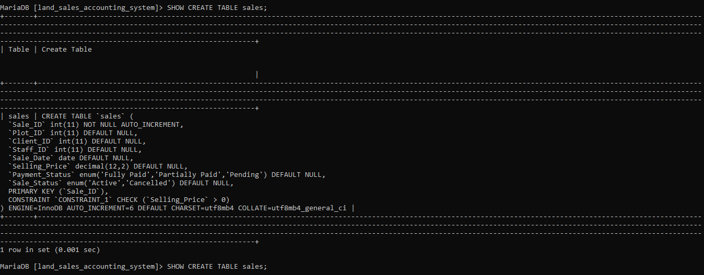
Figure: Physical implementation of the Sales table structure in MySQL.

IMPLEMENTATION
- Database Implementation
The database was implemented using MySQL within the XAMPP environment. The relational tables were created using SQL commands and connected using primary keys and foreign keys where applicable.
The implemented tables include:
- Sales
- Payments
- Commissions
- Salaries
- Expenses
- Settings
Sample data was inserted into the tables to support testing and demonstration of the system functionalities.
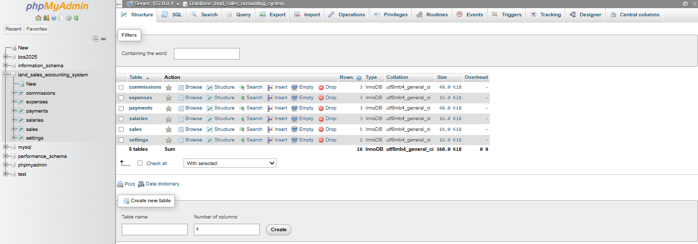
Figure: Implemented relational tables in MySQL.
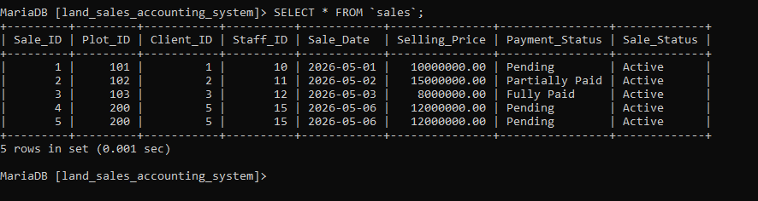
Figure: Sample records stored in the Sales table.
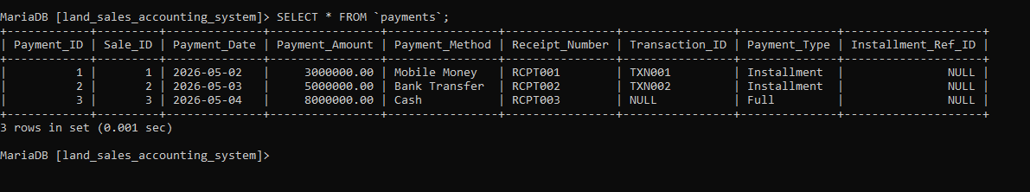
Figure: Sample records stored in the Payments table.
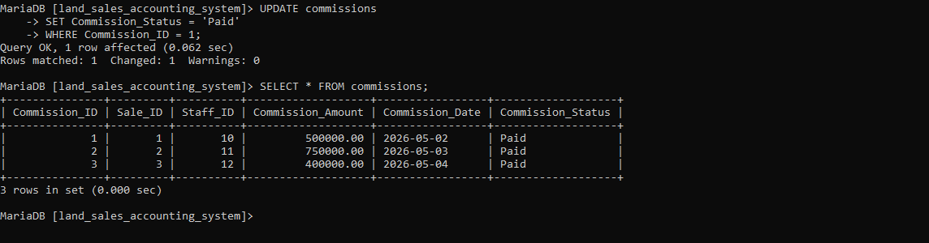
Figure: Sample records stored in the Commissions table.

- User Interface Implementation
The system interface was developed using PHP, HTML, and CSS. The interface allows users to interact with the database through forms and dashboards without directly writing SQL queries.
The system supports two levels of access:
- Public users who can view records
- Administrative users who can add and manage records after authentication
The interface includes features such as:
- Add Sale form
- Record Payment form
- View Sales page
- View Payments page
- View Commissions page
- Commission Settings page
- Admin login system
- Search functionality
- Color-coded status indicators
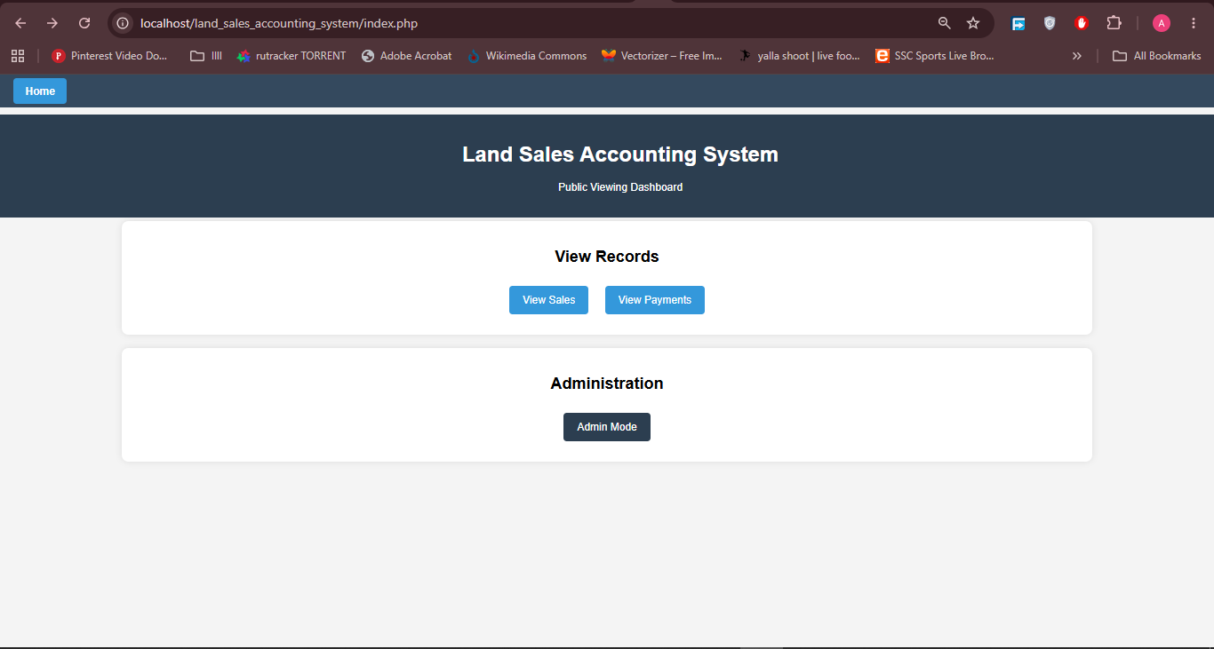
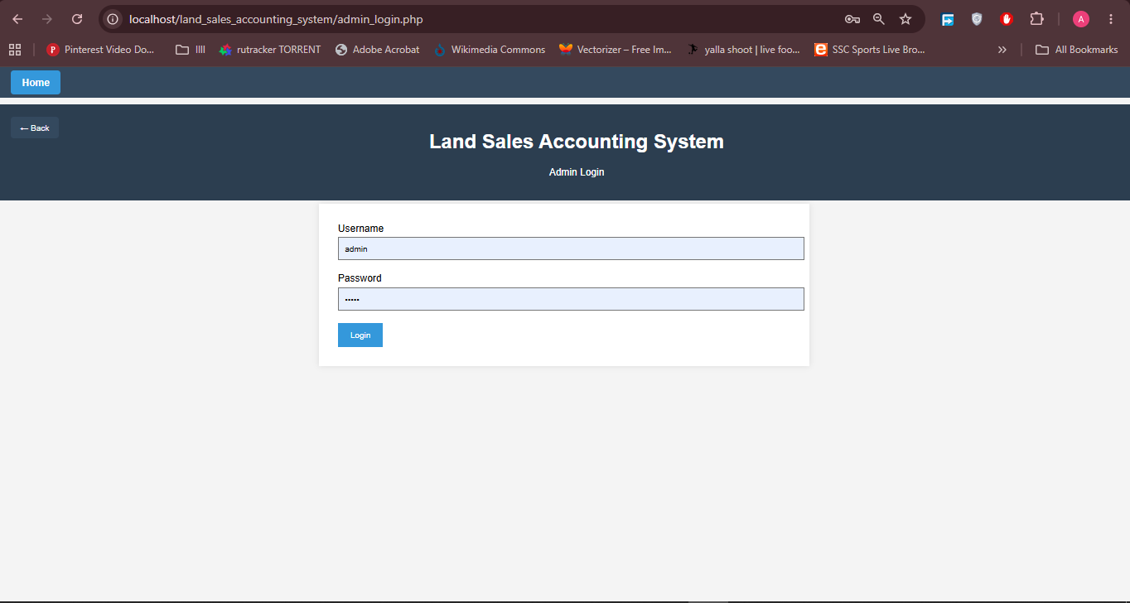
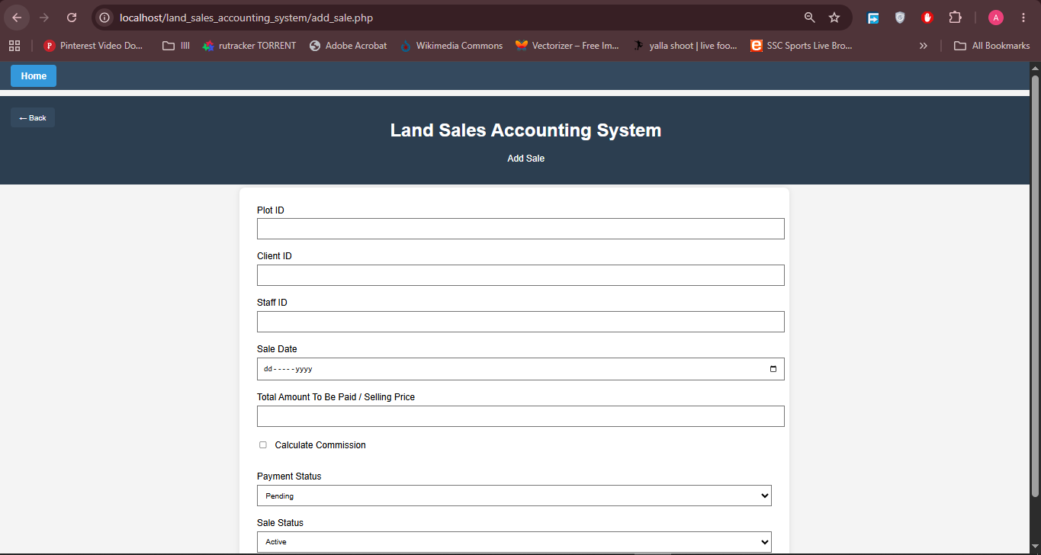
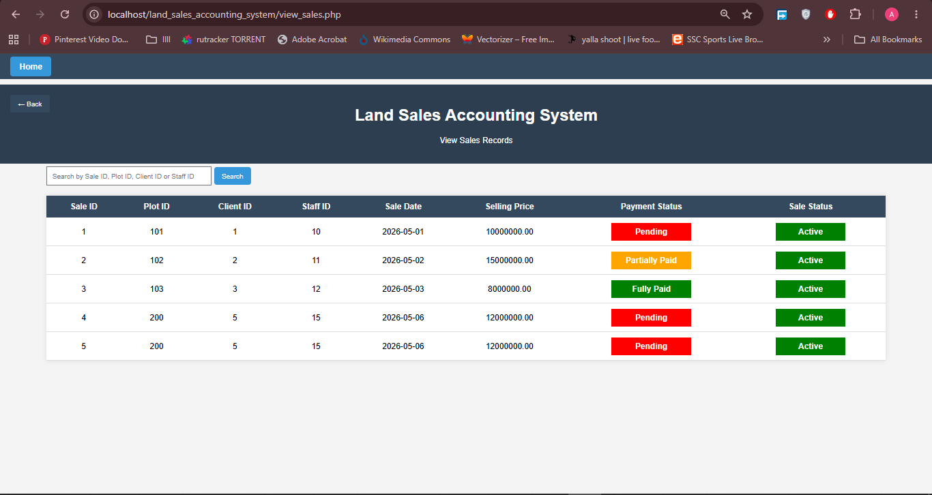
- Sample Queries and Outputs
Sample SQL queries were executed to test the functionality and correctness of the implemented database system.

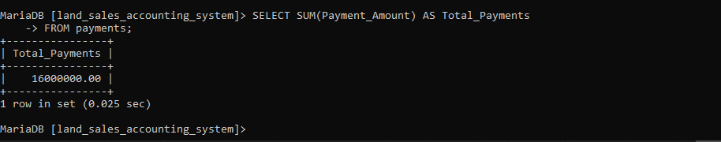
The query above retrieves Total Payments.
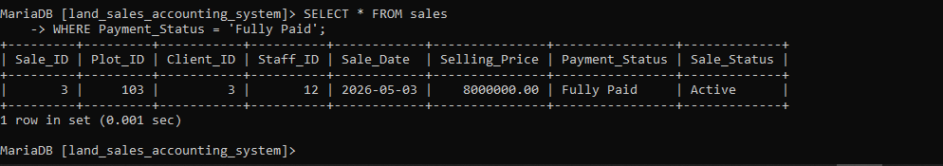
The query above retrieves all fully paid sales records stored in the system.
- Testing and Results
The implemented system was tested using sample sales, payments, commissions, salaries, and expense records. Testing confirmed that the system successfully stores, retrieves, updates, and displays information correctly.
The commission calculation functionality correctly computes commissions based on the configured commission percentage. The admin authentication mechanism also successfully restricts sensitive operations to authorized users only.
Search and viewing functionalities operated correctly, and status indicators were displayed appropriately throughout the system interface.
BIBLIOGRAPHY
- Database System - A Practical Approach to Design Implementation and Management by T Connoly C Begg.
- Lecture notes and class materials provided in the Database Systems course.
- W3Schools. PHP Tutorial.
- W3Schools. MySQL Tutorial.

