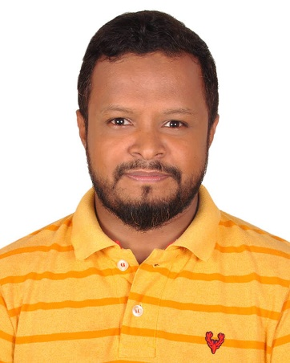

**Abdullah Al Ahad**

+880 1911160045

ahad2beside@gmail.com - LinkedIn://ahad2beside

Jigatola, Dhaka-1209, Bangladesh.

**Professional**

Software developer with 4+ years of experience in backend develop and as a computer engineer to enter in a well reputed organization in a suitable position having the intention to work with honesty, sincerity and to learn grow and eventually take greater responsibilities and to face the challenge of the time to gain experience and skill for a successful career.

**Specialties in:** PHP frameworks Laravel & RAW PHP into OOP, JavaScript, HTML5, CSS, Bootstrap, jQuery, MySQL

**Core Professional Competencies**

**-** Code reviews **-** Software documentation control **-** Programming languages

**-** Multitasking Expert **-** Web based software engineering **-** Team collaboration

**-** Excellent Communicator **-** Dealing with difficult Situation **-** Time management

**-** Program testing software **-** Attention to detail **-** Adaptability

**Skill Summery**

● Well-versed in software tools including HTML, JavaScript, CSS and jQuery, code editor, version control git

● Skilled at reading and writing code using viable inputs and outputs after an accurate assessment of pre- and post-conditions

● Experienced at designing unit tests to measure the effectiveness of software programs, backend services and user interfaces

● confident problem-solving abilities to overcome glitches with creative solutions that are strategically designed to last long-term

● Strong communication skills and the ability to listen carefully to user feedback to determine modifications for optimal user function

**Works Experience**

**Web Application Developer** JUL 2020 – OCT 2022

Employer name Advance Apps Bangladesh, Mirpur, Dhaka, BD.

Key Responsibilities:

● Implementing new features and enhancements to existing systems

● Develop websites and web applications using PHP (OOP), Laravel framework

● Writing clean, efficient, and well-documented code that meets project requirements and standards

**Assistant Web Developer** DEC 2018 – AUG 2019

Employer name Coder71 LTD, Mirpur, Dhaka, BD.

Key Responsibilities:

● Working with existing frameworks such as Laravel, CodeIgniter or Yii

● Web applications using PHP into OOP and related technologies such as HTML, CSS, JavaScript, and MySQL

**PHP Developer** MAR 2016 – ARP 2018

Employer name DUSRA Soft, Dhanmondi, Dhaka, BD.

Key Responsibilities:

● Working with version control systems such as Git to manage

● Writing clean, maintainable, and efficient PHP code based on requirements

**Education**

**B.Sc. in Computer Science & Engineering (CSE).** JAN 2009 – COT 2011

State University of Bangladesh, Bangladesh

**Professional Diploma in Info Technology.** SEP 2006 – AUG 2007

NIIT, Bangladesh

**Courses & Trainings**

Developing Dynamic Web Application Using PHP & MY SQL

IBCS-PRIMAX Software (Bangladesh) Ltd, Dhaka

Respectfully,

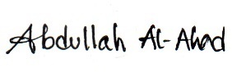

Abdullah Al Ahad