BHAO.PK PRICE COMPARISON ENGINE V1.1
MUHAMMAD AHAD ALI KHAN
SHERYAR KARIM
MUHAMMAD HARIS JAMALI



Fall-2025

Department of Computer Science
Capital University of Science & Technology, Islamabad
Submission Form for Final-Year
PROJECT REPORT

  Version | V 1.0
  NUMBER OF MEMBERS | 03

TITLE | Bhao.pk Price Comparison Engine

SUPERVISOR NAME | DR. Najam Aziz

MEMBER NAME | REG. NO. | EMAIL ADDRESS
Muhammad Ahad Ali Khan | BCS213129 | alik123kh@gmail.com
Sheryar Karim | BCS221074 | sheryarkarim65@gmailgmail.com
Muhammad Haris Jamali | BCS221027 | harisshaheen09@gmail.com

MEMBERS’ SIGNATURES

Supervisor’s Signature

APPROVAL CERTIFICATE

This project, titled as “Bhao.pk Price Comparison Engine” has been approved for the award of
Bachelors of Science in Computer Science

Committee Signatures:

Supervisor: __________________________

(Dr. Najam Aziz)

Project Coordinator: __________________________

(Mr. Ibtisam Zia)

Head of Department: __________________________

(Dr. Masroor Ahmed)

DECLARATION

I/We, hereby, declare that “No portion of the work referred to, in this project has been submitted in support of an application for another degree or qualification of this or any other university/institute or other institution of learning”. It is further declared that this undergraduate project, neither as a whole nor as a part thereof has been copied out from any sources, wherever references have been provided.

MEMBERS’ SIGNATURES

ACKNOWLEDGEMENTS

Executive Summary

Table of Contents
Declaration 4
Acknowledgements 5
Executive Summary 6
Chapter 1 10
Introduction 10
1.1. Project Introduction 10
1.2. Existing Examples / Solutions 11
1.3 Business Scope 13
1.3.1 The Intended Audience 13
1.3.2 Use in Commercial Settings 13
1.3.3 Models of Revenue 13
1.4. Useful Tools and Technologies 14
1.5. Project Work Break Down 15
1.6. Project Time Line 15
Chapter 2 17
2.1. Functional Requirements 17
2.2. Non-Functional Requirements 19
2.3. Selected Functional Requirements 20
2.4. System Use Case Modeling 22
2.6. Domain Model 42
Chapter 3 43
System Design 43
3.1. Layer Definition 43
3.1.1. Presentation Layer: 43
3.1.2. Business Logic Layer: 44
3.1.3. Database Layer: 44
3.2. Software Architecture 44
3.3. Class Diagram 45
3.4. Sequence Diagram 48
3.4.1. User 48

List of Tables
i: Table 1.1: Comparison with Existing Examples 12
ii: Table 2.1: Functional Requirements 17
iii: Table 2.2: Non-Functional Requirement 19
iv: Table 2.3: Selected Functional Requirement 20
iii: Figure 2.1: Use case Diagram v: Table 2.4: Search Product 22
vi: Table 2.5: Set Price Alert 23
vii: Table 2.5: Set Price Alert 24
viii: Table 2.7: View Product Details 25
ix: Table 2.8: Filter & Sort Results 27
x: Table 2.9: View Price History 28
xi: Table 2.10: Sign Up 29
xii: Table 2.11: Login 30
xiii: Table 2.12: View Recommendations 31
xiv: Table 2.13: Manage Wishlist 32
xv: Table 2.14: View Dashboard Stats 34

List of Figures
i: Figure 1.1: Project Work Break down 17
ii: Figure 1.2: Project Timeline 18
iii: Figure 2.1: Use case Diagram v: Table 2.4: Search Product 23
iv: Figure 2.2: SSD Search Products SSD 37
v: Figure 2.3: SSD Filter and Sort SSD 38
vi: Figure 2.4: View Details SSD 38
vii: Figure 2.5: SSD View Price History SSD 39
viii: Figure 2.6: Set Price Alert SSD 39
ix: Figure 2.7: Product Recommendation SSD 40
x: Figure2.8: Manage Wishlist SSD 40
xi: Figure 2.9: Sign Up SSD 41
xii: Figure 2.10: Login SSD 41
xiii: Figure 2.11: Admin Stats SSD 42
xiv: Figure 2.19: Domain Model 43
xv: Table 3.1: Layers Definition 44
xvi: Figure 3.1: Software Architecture Diagram 46
xvii: Figure 3.2: Class Diagram 47
xviii: Figure 3.2: Search Products Sequence Diagram 49
xix: Figure 3.3: Filter & Sort Sequence Diagram 50
xx: Figure 3.4: View Details Sequence Diagram 51
xxi: Figure 3.5: Price History Sequence Diagram 52
xxii: Figure 3.6: Set Price Alert Sequence Diagram 53
xxiii: Figure 3.7: Show Recommendations Sequence Diagram 54
xxiv: Figure 3.8: Manage Wishlist Sequence Diagram 55
xxv: Figure 3.9: Sign Up Sequence Diagram 56
xxvi: Figure 3.10: Login Sequence Diagram 56
xxvii: Figure 3.11: Sign Up Sequence Diagram 57
xxviii: Figure 3.12: Entity Relations Diagram 58
xxix: Figure 3.13: Entity Relations Diagram 59
xxx: Figure 3.13: Web Homepage UI 60
xxxi: Figure3.14: Mobile Homepage UI 60
xxxii: Figure 3.15: Mobile Search UI 61
xxxiii: Figure 3.16: Mobile Search UI 62
xxxiv: Figure 3.17: Web Product Page UII 63
xxxv: Figure 3.18: Mobile Product Page UI 63
xxxvi: Figure 3.19: Web Profile Page UI 64
xxxvii: Figure 3.20: Mobile Profile Page UI 65
xxxviii: Figure 3.21: Web Login Page UI 66
xxxix: Figure 3.22: Mobile Login Page UI 66
xl: Figure 3.23: Web Sign Up Page UI 67
xli: Figure 3.24: Mobile Sign Up Page UI 68
xlii: Figure 3.25: Web Admin Login Page UI 69
xliii: Figure 3.26: Mobile Admin Login Page UI 69
xliv: Figure 3.27: Web Admin Login Page UI 70
xlv: Figure 3.28: Mobile Admin Login Page UI 71

Chapter 1

Introduction
This chapter introduces the Bhao.pk project, describing its problem statement, objectives, and the technologies used to implement it. It also presents the scope, significance, and development plan of the proposed system. By the end of this chapter, the reader will understand how the project aims to simplify online shopping decisions in Pakistan through intelligent price comparison and alert mechanisms.

1.1. Project Introduction
Bhao.pk is an intelligent web and mobile platform that aggregates prices of products listed across multiple Pakistani e-commerce sites. It enables users to quickly identify the lowest price for a specific product and receive instant alerts when prices drop below a set threshold. The system collects product and pricing data through automated web scrapers, cleans and normalizes the data, and then displays results on an interactive dashboard.
The project’s core purpose is to give users transparent access to price information that is otherwise scattered across different retailers. A single search query such as “70W USB-C Charger” will return aggregated listings from major online stores like Daraz, Shophive, Mega.pk, PriceOye, and BTech. The backend clusters identical or similar products using fuzzy text matching to eliminate duplicates and inconsistencies.
The platform will also maintain a historical record of price changes, allowing users to visualize price trends over time and set up alerts when prices fall below their target value. The entire system is designed to be cross-platform: the same codebase will generate both a responsive web application and a mobile app.
.

1.2. Existing Examples / Solutions

Existing global price comparison systems show that price aggregation is highly valuable for consumers, but none are specialized for Pakistan’s fragmented e-commerce ecosystem.

Google Shopping aggregates product listings from thousands of retailers worldwide, offering side-by-side comparisons and filtering by category or brand. However, it depends on merchant data feeds and lacks real-time integration with local Pakistani stores. Its algorithms are optimized for structured APIs, which limits adaptability to dynamic regional websites.


Idealo, one of Germany’s leading price comparison engines, provides detailed price histories, vendor ratings, and automated alerts when prices change. It uses a mix of API and web-scraping methods but operates exclusively in European markets. While technically advanced, it cannot process PKR pricing or local vendor structures.


Local Attempts in Pakistan include smaller startups and online deal-sharing communities that post offers manually on social media platforms like Facebook or WhatsApp. These efforts lack automation, consistent data collection, and historical tracking. As a result, users must still visit multiple sites individually to verify prices and authenticity.

i: Table 1.1: Comparison with Existing Examples
System/ Platform | Core Functionality | Data Source | Limitations | Unique Value of Bhao.pk
Google Shopping | Aggregates global product listings, enabling real-time price and availability comparison across thousands of retailers. | Merchant-supplied APIs and global data feeds. | No integration with Pakistani vendors; does not support PKR-based pricing. | Serves as a global benchmark for automated product aggregation and intelligent ranking.
Idealo (Germany) | Provides price tracking, vendor ratings, and discount alerts across European retailers. | Retailer APIs and automated web crawlers across EU marketplaces. | Limited to European markets; cannot process PKR or local Pakistani vendors. | Demonstrates how historical price tracking builds trust and empowers consumers.
Local Attempts (Pakistan) | Manual deal sharing through Facebook, WhatsApp, and Telegram communities. | User-posted, unstructured community data. | No automation, centralized dashboard, or consistent price tracking. | Highlights the need for a unified, automated, Pakistan-specific price comparison ecosystem like Bhao.pk.

1.3 Business Scope
Bhao.pk has strong market potential in Pakistan, where online shopping continues to grow but lacks transparent price comparison tools:

1.3.1 The Intended Audience
- Everyday Online Shoppers: Looking for lowest prices without visiting multiple websites.
- Students and Budget Buyers: Seeking affordable tech, accessories, or daily items.
- E-commerce Analysts: Can study price trends and market volatility.
- Retailers: Can analyze competitor pricing dynamically.

1.3.2 Use in Commercial Settings
- Integration into affiliate marketing networks.
- Tools for businesses to track competitor prices and adjust strategies.
- Integration with fintech cashback or coupon systems.
- Academic use in data analytics and information retrieval projects.

1.3.3 Models of Revenue
- Affiliate Commissions: Redirect users to retailers through tracked links.
- Ad-Based Revenue: Sponsored listings or priority placement for vendors.
- Subscription Plans: Users pay for extended alerts and historical data exports.
- API Access: Businesses pay to access aggregated pricing data.

1.4. Useful Tools and Technologies

The development of Bhao.pk relies on a combination of web technologies and data-processing frameworks to ensure smooth cross-platform performance and efficient information retrieval.


The system is built using React with React Native (Expo), which allows both the web dashboard and the mobile application to share the same codebase. This framework ensures responsive interfaces, real-time updates, and reduced development effort compared to maintaining separate apps.

For backend services, Node.js with Express provides a lightweight, scalable environment capable of handling multiple concurrent API requests efficiently. It manages data flow between the scrapers, database, and user interface, forming the communication core of the system.

Automated data collection is powered by Scrapy and BeautifulSoup, which extract structured product and pricing data from e-commerce websites. These libraries handle HTML parsing, data cleaning, and link traversal, enabling continuous updates without manual input.


The project stores and manages information using PostgreSQL, an open-source relational database that supports large-scale data queries, indexing, and time-series analysis. It ensures reliability and fast retrieval for price tracking, user alerts, and historical analytics.

1.5. Project Work Break Down
The project breakdown structure is shown in Figure 4
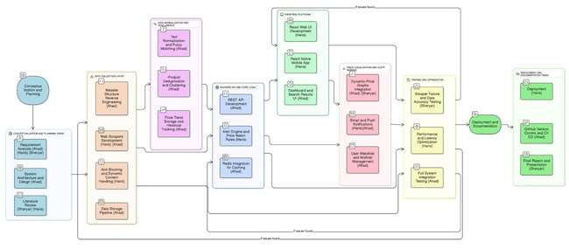
i: Figure 1.1: Project Work Break down

1.6. Project Time Line

The proposed project timeline is shown in the following the figure.
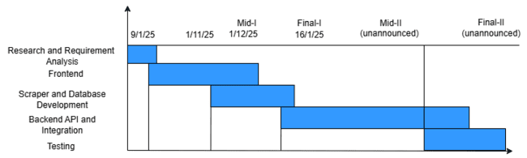
ii: Figure 1.2: Project Timeline

Chapter 2
Requirement Specification and Analysis
Requirements analysis is a process of determining user expectations for a new or modified product. These features, called requirements, must be quantifiable, relevant and detailed. In software engineering, such requirements are often called functional specifications. In Chapter 2 we will enlist the functional and non-functional requirements and model functional requirements in the form of use case model.

2.1. Functional Requirements

A functional requirement defines a function of a system or its component. Functional requirements may be calculations, technical details, data manipulation and processing and other specific functionality that define what a system is supposed to accomplish.

ii: Table 2.1: Functional Requirements
S. No. | Functional Requirement | Type | Status
1 | The user shall view product listings retrieved from multiple supported e-commerce platforms. | Core | Pending
2 | The user shall view a section of "Trending Products" highlighted on the homepage. | Core | Pending
3 | The user shall view real-time search suggestions while typing in the search bar. | Core | Pending
4 | The user shall view a list of their recently viewed products for quick access. | Core | Pending
5 | The user shall view a single unified product page containing prices from multiple vendors. | Intermediate | Pending
6 | The user shall search for a product using keywords in the search bar. | Core | pending
7 | The user shall view aggregated search results from multiple stores. | Core | Pending
8 | The user shall sort search results by Price (Low to High). | Core | Pending

9 | The user shall filter results by specific Store. | Core | Pending
10 | The user shall filter results by Price Range (Min/Max). | Core | Pending
11 | The user shall view detailed product information on a dedicated page. | Core | Pending
12 | The user shall click "Open in Vendor Site" to navigate to the original vendor's website. | Core | Pending
13 | The user shall create a new account (Sign up) using email and password. | Core | Pending
14 | The user shall log into the system using valid credentials. | Core | Pending
15 | The user shall log out of the system. | Core | Pending
16 | The user shall recover a forgotten password via email. | Core | Pending
17 | The user shall set a specific target price alert for a product. | Core | Pending
18 | The user shall receive an email notification when a price drops to or below the target. | Core | Pending
19 | The user shall receive a push notification on the mobile app for price drops. | Core | Pending
20 | The user shall view a graphical history of price changes over time. | Core | Pending
21 | The user shall add products to a personal "Wishlist". | Intermediate | Pending
22 | The user shall remove items from their "Wishlist". | Intermediate | Pending
23 | The user shall view updated prices refreshed at scheduled intervals. | Advanced | Pending
24 | Admin shall log into the backend dashboard. | Backend | Pending
25 | Admin shall view statistics on total products scraped and active users. | Intermediate | Pending
26 | The user shall identify the best deals via automatically assigned "Best Value" badges. | Intermediate | Pending
27 | The user shall view personalized product recommendations based on their browsing history. | Advanced | Pending

2.2. Non-Functional Requirements

A non-functional requirement is a requirement that specifies criteria that can be used to judge the operation of a system, rather than specific behaviors. They are contrasted with functional requirements that define specific behaviors or functions.

iii: Table 2.2: Non-Functional Requirement
S. No. | Non-Functional Requirements | Category
1 | The system interface shall be user-friendly and easy to navigate for new users. | Usability
2 | The system shall ensure that user passwords and personal data are stored securely. | Security
3 | The system shall provide helpful messages and feedback to user enters input. | Usability
4 | The mobile application shall run smoothly on standard mobile devices. | Performance
5 | The design shall use consistent fonts, colors, and icons throughout the application. | Usability
6 | The website shall be responsive. | Usability

2.3. Selected Functional Requirements

Following is the list of the requirements selected for the current iteration.
iv: Table 2.3: Selected Functional Requirement
S. No. | Functional Requirement | Type
1 | The user shall view product listings retrieved from multiple supported e-commerce platforms. | New
2 | The user shall view a section of "Trending Products" highlighted on the homepage. | New
3 | The user shall view real-time search suggestions while typing in the search bar. | New
4 | The user shall view a list of their recently viewed products for quick access. | New
5 | The user shall sort search results by Price (Low to High). | New
6 | The user shall filter the results by specific Store. | New
7 | The user shall filter the results by Price Range (Min/Max). | New
8 | The user shall create a new account (Sign up) using email and password. | New
9 | The user shall set a specific target price alert for a product. | New
10 | The user shall log into the system using valid credentials. | New
11 | The user shall log out of the system. | New
12 | The user shall recover a forgotten password via email. | New
13 | The user shall receive an email notification when a price drops to or below the target. | New
14 | The user shall receive a push notification on the mobile app for price drops. | New
15 | The user shall view a graphical history of price changes over time. | New
16 | The user shall add products to a personal "Wishlist". | New
17 | The user shall remove products from their "Wishlist".
18 | The user shall identify the best deals via automatically assigned "Best Value" badges. | New
19 | The user shall view personalized product recommendations based on their browsing history. | New
20 | Admin shall log into the backend dashboard. | New
21 | Admin shall view statistics on total products scraped and active users. | New

2.4. System Use Case Modeling

A use case is a list of actions or event steps, typically defining the interactions between a role (known in the Unified Modeling Language as an actor) and a system, to achieve a goal. The actor can be a human or other external system. Customer’s use cases are shown in the following the figure.
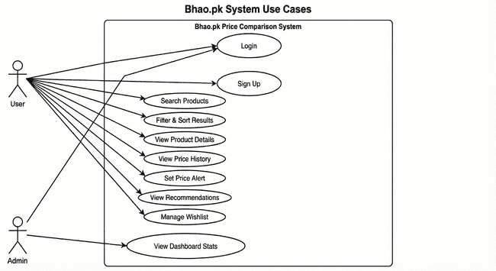
iii: Figure 2.1: Use case Diagram
v: Table 2.4: Search Product
Use Case ID: | Uc1
Use Case Name: | Search Product
Created By: | Muhammad Ahad Ali Khan | Last Updated By: |  | Muhammad Haris Jamali
Date Created: | 15/11/2025 | Last Revision Date: |  | 16/11/2025
Actors: | User (Guest or Registered)
Description: | The user searches for a specific item to compare prices across stores.
Trigger: | Search Button
Preconditions: | The scrapper must be functional or the system must have scraped data available in the database.
Postconditions: | A list of relevant products with prices is displayed.
Normal Flow: | Customer |  | System
Normal Flow: | 1: User enters keywords in search bar. |  | System queries the database using fuzzy matching.
 | 2: User clicks search. |  | System displays aggregated results.
Alternative Flows: | User applies filters (price/store) to the results.
Exceptions: | 1. No products found matching the query.  2. Database connection error.

vi: Table 2.5: Set Price Alert
Use Case ID: | Uc2
Use Case Name: | Set Price Alert
Created By: | Muhammad Ahad Ali Khan | Last Updated By: |  | Muhammad Haris Jamali
Date Created: | 15/11/2025 | Last Revision Date: |  | 16/11/2025
Actors: | Registered User
Description: | User sets a target price to receive notifications when the product becomes cheaper.
Trigger: | "Set Alert" Button
Preconditions: | User must be logged in.
Postconditions: | An alert record is created in the database.
Normal Flow: | Customer |  | System
Normal Flow: | 1: User views product details. |  | System verifies value is lower than current price.
 | 2: User clicks "Set Alert". |  | System saves the alert preference.
 | 3: User enters target price.
Alternative Flows: | User hits back or cancel.
Exceptions: | 1. Target price is higher than the current price (System displays warning).

vii: Table 2.5: Set Price Alert
Use Case ID: | Uc3
Use Case Name: | View Search Results
Created By: | Muhammad Ahad Ali Khan | Last Updated By: |  | Muhammad Haris Jamali
Date Created: | 15/11/2025 | Last Revision Date: |  | 16/11/2025
Actors: | User (Guest), Registered User
Description: | The system presents a list of products that match the user's search query, showing key details like title, image, and price range.
Trigger: | Successful completion of the "Search Products" use case.
Preconditions: | A search query has been executed.
Postconditions: | A curated list of product cards is presented to the user.
Normal Flow: | Customer |  | System
Normal Flow: | 1: User views search page. |  | System receives the list of matching products from the database.
 |  |  | System aggregates listings from different stores for the same product.
 |  |  | System displays products in a grid layout, showing image, title, and "Starts from Rs. X".
Alternative Flows: | 1. The number of results exceeds one page limit (e.g., >20 items).  2. System displays pagination controls (e.g., "Next", "Page 2").  3. User clicks "Next".  4. System fetches and displays the next set of results.
Exceptions: | 1. No results: System displays "No products found."

viii: Table 2.7: View Product Details
Use Case ID: | Uc4
Use Case Name: | View Product Details
Created By: | Muhammad Ahad Ali Khan | Last Updated By: |  | Sheryar Karim
Date Created: | 15/11/2025 | Last Revision Date: |  | 16/11/2025
Actors: | User (Guest), Registered User
Description: | The user views full details and a price comparison table for a product.
Trigger: | User clicks a product card.
Preconditions: | Product ID exists.
Postconditions: | Product Detail Page is displayed.
Normal Flow: | Customer |  | System
Normal Flow: | 1: User clicks a product. |  | System receives the list of matching products from the database.
 | 2: User sees product details, store listings, and history. |  | System aggregates listings from different stores for the same product.
 | 3: User can proceed to other actions. |  | System displays products in a grid layout, showing image, title, and "Starts from Rs. X".
Alternative Flows: | User decides to go to some other page from navigation.
Exceptions: | 1. Product not found: Redirect to 404 page.

ix: Table 2.8: Filter & Sort Results
Use Case ID: | Uc5
Use Case Name: | Filter & Sort Results
Created By: | Muhammad Ahad Ali Khan | Last Updated By: |  | Muhammad Haris Jamali
Date Created: | 15/11/2025 | Last Revision Date: |  | 16/11/2025
Actors: | User (Guest), Registered User
Description: | The user applies criteria (price range, store) or changes the order (low-to-high) to narrow down search results.
Trigger: | User interacts with filter sidebar or sort dropdown.
Preconditions: | Search results must be currently displayed.
Postconditions: | The product list is updated to reflect specific criteria.
Normal Flow: | Customer |  | System
Normal Flow: | 1. User selects a filter (e.g., Store: Daraz) or sort order. |  | System filters the current list.
 |  |  | System filters the current list.
 |  |  | System refreshes the grid with updated results.
 |  |  | System refreshes the grid with updated results.
Alternative Flows: | User clicks "Clear All" to revert to the original search results.
Exceptions: | System displays "No products match your filters."

x: Table 2.9: View Price History
Use Case ID: | Uc6
Use Case Name: | View Price History
Created By: | Muhammad Ahad Ali Khan | Last Updated By: |  | Muhammad Haris Jamali
Date Created: | 15/11/2025 | Last Revision Date: |  | 16/11/2025
Actors: | User (Guest), Registered User
Description: | User views a graph of price changes over time.
Trigger: | User views Product Detail Page.
Preconditions: | Historical price data exists.
Postconditions: | Price graph is displayed.
Normal Flow: | Customer |  | System
Normal Flow: | 1: User loads product page. |  | System fetches historical data.
 |  |  | System renders graph.
Alternative Flows: | 1. User changes graph view from default "30 Days" to "6 Months" via a control.  2. System fetches additional historical data from the database.  3. System re-renders the graph with the new time scale.
Exceptions: | Insufficient data: System doesn’t show the graph and instead says it doesn’t have enough historical data to construct a graph.

xi: Table 2.10: Sign Up
Use Case ID: | Uc7
Use Case Name: | Sign Up
Created By: | Muhammad Ahad Ali Khan | Last Updated By: |  | Muhammad Ahad Ali Khan
Date Created: | 15/11/2025 | Last Revision Date: |  | 21/11/2025
Actors: | User (Guest)
Description: | New user creates an account.
Trigger: | User clicks "Sign Up".
Preconditions: | User email is not already registered.
Postconditions: | New user account created and logged in.
Normal Flow: | Customer |  | System
Normal Flow: | 1: User provides email and password. |  | System validates and checks uniqueness.
 | 2:: User clicks create account. |  | System creates user record.
 |  |  | System logs user in.
Alternative Flows: | User clicks login link from the signup page.
Exceptions: | Email exists: Show error message.

xii: Table 2.11: Login
Use Case ID: | Uc8
Use Case Name: | Login
Created By: | Muhammad Haris Jamali | Last Updated By: |  | Sheryar Karim
Date Created: | 18/11/2025 | Last Revision Date: |  | 21/11/2025
Actors: | User (Guest), Admin
Description: | Existing user authenticates.
Trigger: | User clicks "Login".
Preconditions: | User/Admin has an account.
Postconditions: | User is authenticated as Registered User.  Admin is authenticated as Admin
Normal Flow: | Customer |  | System
Normal Flow: | 1: User/Admin enters email and password.  . |  | System verifies credentials.
 | 2: User/Admin clicks create account. |  | System creates session.
Alternative Flows: | User clicks "Forgot Password?" link on login form.
Exceptions: | Invalid credentials: Show error message.

xiii: Table 2.12: View Recommendations
Use Case ID: | Uc9
Use Case Name: | View Recommendations
Created By: | Muhammad Haris Jamali | Last Updated By: |  | Muhammad Ahad Ali Khan
Date Created: | 18/11/2025 | Last Revision Date: |  | 23/11/2025
Actors: | Registered User
Description: | User sees personalized product suggestions.
Trigger: | User visits homepage.
Preconditions: | User is logged in with some activity history.
Postconditions: | Recommended items are displayed.
Normal Flow: | Customer |  | System
Normal Flow: | . |  | System identifies user.
 |  |  | System retrieves user persona and finds matching products.
 |  |  | System displays recommendations.
Alternative Flows: | User clicks a "Show More" button in the recommendations section.
Exceptions: | No history: System shows popular items.

xiv: Table 2.13: Manage Wishlist
Use Case ID: | Uc10
Use Case Name: | Manage Wishlist
Created By: | Sheryar Karim | Last Updated By: |  | Muhammad Ahad Ali Khan
Date Created: | 20/11/2025 | Last Revision Date: |  | 24/11/2025
Actors: | Registered User
Description: | The user saves products to a personal list for future reference or removes them when no longer needed.
Trigger: | User clicks the "Heart" icon or "Add to Wishlist" button.
Preconditions: | User is logged in.
Postconditions: | Product is added to or removed from the user's saved list in the database
Normal Flow: | Customer |  | System
Normal Flow: | 1: User clicks the "Heart" icon on a product card. |  | System checks if the item is already in the wishlist.
 |  |  | System adds the item ID to the user's wishlist record.
 |  |  | System updates the icon to appear "filled".
Alternative Flows: | If the item is already in the wishlist, clicking the icon removes it.
Exceptions: | System fails to save the item and displays an error "Try again later".

xv: Table 2.14: View Dashboard Stats
Use Case ID: | Uc11
Use Case Name: | View Dashboard Stats
Created By: | Sheryar Karim | Last Updated By: |  | Muhammad Haris Jamali
Date Created: | 20/11/2025 | Last Revision Date: |  | 24/11/2025
Actors: | Admin
Description: | The admin views system health metrics, including total products scraped and active user counts.
Trigger: | Admin logs into the backend portal.
Preconditions: | Admin must be authenticated.
Postconditions: | Statistical graphs and counters are displayed.
Normal Flow: | Admin |  | System
Normal Flow: | 1: Admin navigates to the main Dashboard tab. |  | System queries the database for total product count and user logs.
 |  |  | System renders charts (e.g., Scraper Status, New Signups).
Alternative Flows: | None.
Exceptions: | System displays 0 values if the database is empty.
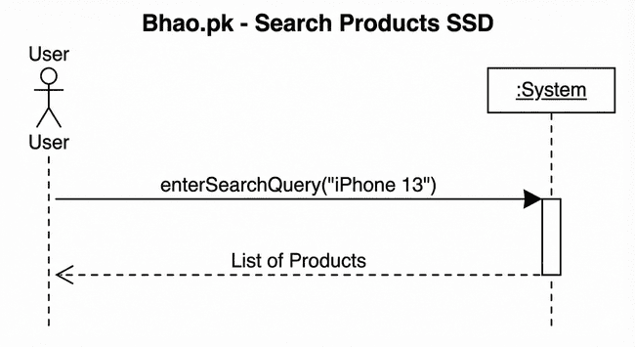
iv: Figure 2.2: SSD Search Products SSD
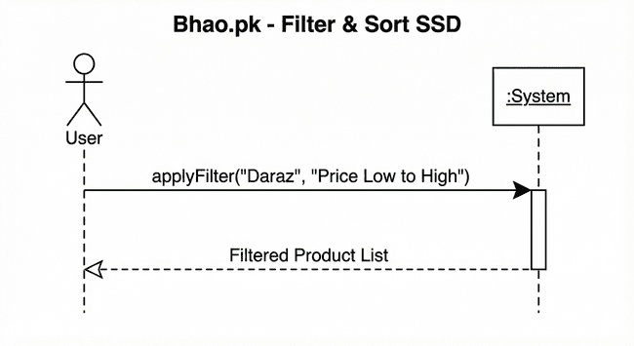
v: Figure 2.3: SSD Filter and Sort SSD
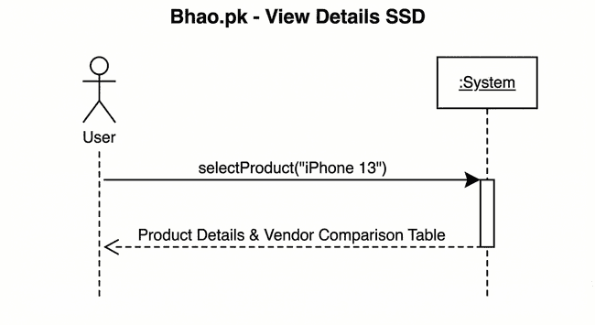
vi: Figure 2.4: View Details SSD
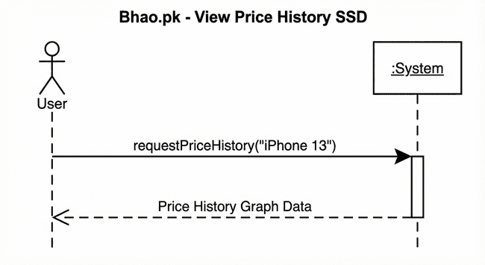
vii: Figure 2.5: SSD View Price History SSD
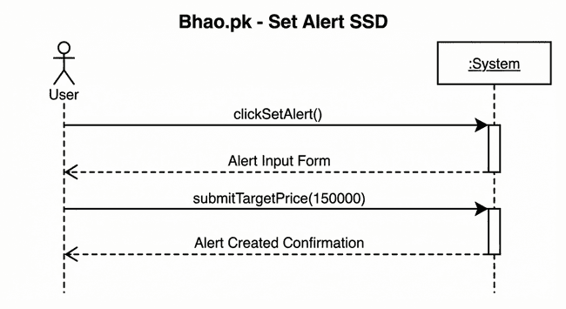
viii: Figure 2.6: Set Price Alert SSD
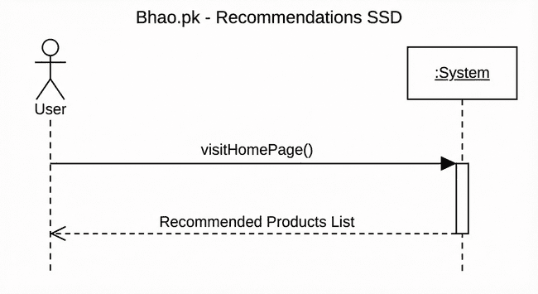
ix: Figure 2.7: Product Recommendation SSD
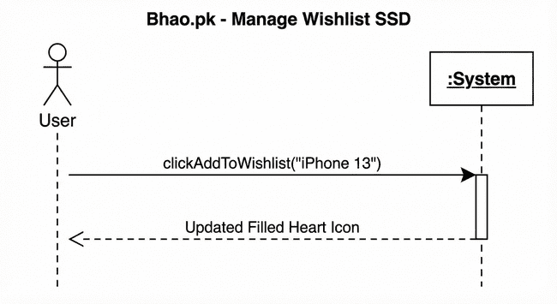
x: Figure2.8: Manage Wishlist SSD
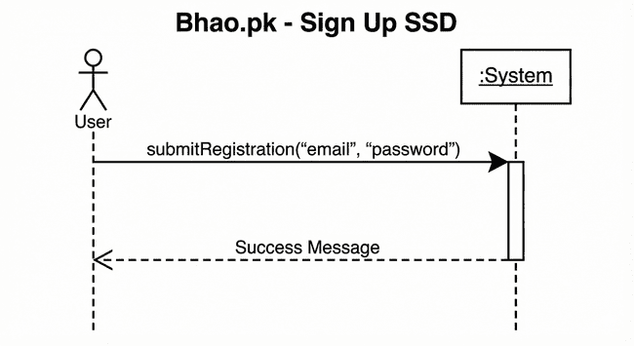
xi: Figure 2.9: Sign Up SSD
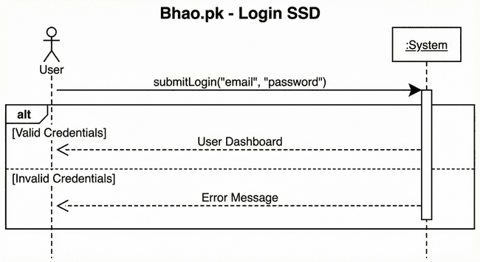
xii: Figure 2.10: Login SSD
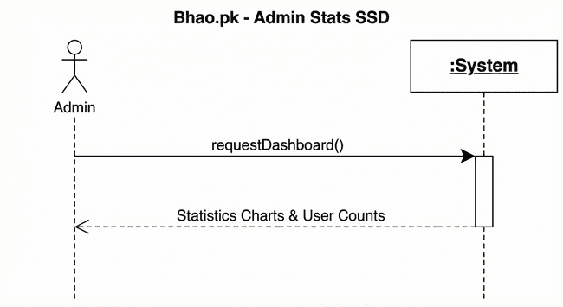
xiii: Figure 2.11: Admin Stats SSD

2.6. Domain Model
The Domain Model for Bhao.pk illustrates the conceptual structure of the price comparison ecosystem, centering on the Product entity as the core item being tracked. Each generic product is linked to multiple StoreListings, representing specific offers from external Stores like Daraz or Telemart. Users interact with the system by setting Alerts on these products to monitor price changes. To maintain up-to-date information, a backend ScraperBot creates and updates listings, while a PriceHistory entity logs every price fluctuation over time to support historical trend analysis.
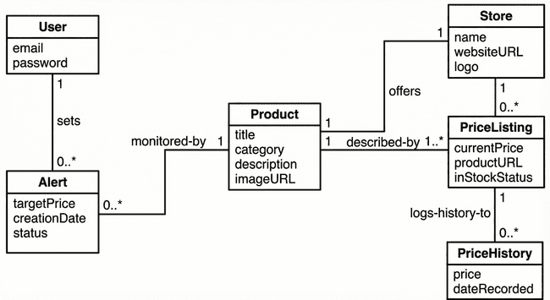
xiv: Figure 2.19: Domain Model

Chapter 3

System Design

The system design of Bhao.pk is built upon a robust, multi-tiered Software Architecture that ensures scalability and clear separation of concerns. It is organized into three primary layers: the Presentation Layer, which handles user interactions via a React-based frontend; the Business Logic Layer, which serves as the core engine managing APIs, the automated Scraping Manager, and the Alert System; and the Database Layer, which ensures persistent data storage using PostgreSQL

3.1. Layer Definition

xv: Table 3.1: Layers Definition
Layers | Description
Presentation Layer | This layer will be used for the interaction with the user through a graphical user interface.
Business Logic Layer | This layer contains the business logic. All the constraints and majority of the functions reside under this layer.
Database Layer | This layer contains the database of the application being developed.

3.1.1. Presentation Layer:
This layer is responsible for the user interface and user experience. It handles user inputs and displays data retrieved from the server. It includes the web frontend (React.js) and potential future mobile interfaces.

3.1.2. Business Logic Layer:
This layer contains the core functionality. It manages data processing, executes search algorithms, handles scraping scheduling, and processes alerts. It serves as the bridge between the UI and the database.

3.1.3. Database Layer:
Database layer includes database servers where information is stored and retrieved. Data in this tier is kept independent of application servers or business logic.

3.2. Software Architecture
This layer is responsible for persistent data storage. It manages the relational database (PostgreSQL) holding information on users, products, stores, and historical price records. Below is the architecture diagram of the system:
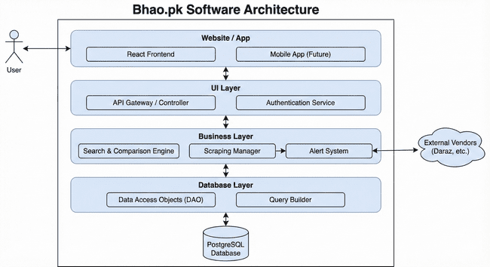
xvi: Figure 3.1: Software Architecture Diagram

3.3. Class Diagram
The Class Diagram for Bhao.pk defines the system's static structure, centering on the Product class which is composed of multiple specific StoreListings to represent offers from different vendors. Stores act as aggregators for these listings, while Users maintain a strict composition relationship with Alerts, allowing for personalized price monitoring that depends on the user account's existence. Additionally, the diagram illustrates backend automation through the ScraperBot class, which demonstrates a dependency on StoreListings to dynamically create and update price data from external sources.
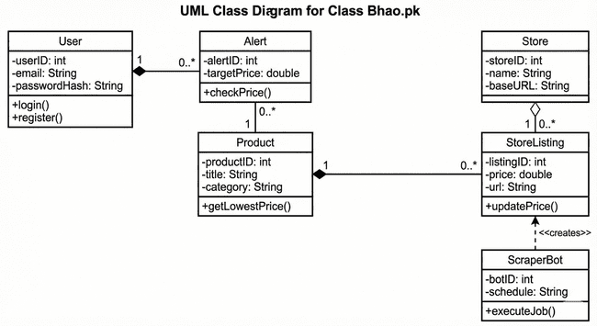
xvii: Figure 3.2: Class Diagram

User:
This class represents a user of the Bhao.pk system. It stores essential account information such as userId, email, passwordHash, and their role (e.g., guest or registered). The main responsibilities of this class include managing user authentication via login() and creating new accounts via register().
Alert:
This class represents a price notification set by a registered user. It holds data including its unique alertId, the user's desired targetPrice, the creationDate, and a boolean isActive status. Its primary operation, checkPrice(), compares a product's current price against the target price to determine if a notification should be triggered.
Product:
This is the central entity of the system, representing a generic item that can be sold by multiple vendors. It contains general attributes like productId, title, category, and a baseImage URL. Its key operations include getLowestPrice() to calculate the best available deal and getListings() to retrieve all associated vendor offers.
StoreListing:
This class represents a specific offer for a Product from a single Store. It links the general product to a concrete vendor and contains listing-specific details like listingId, current price, the direct vendorUrl to the purchase page, and a lastUpdated timestamp. It includes an updatePrice() operation to modify its price based on new data.
Store:
This class represents an external vendor or e-commerce website (e.g., Daraz, PriceOye). It stores identity information such as the storeId, the store's name, its baseUrl, and a logoUrl.
ScraperBot:
This class is part of the backend system responsible for automated data extraction. It includes attributes for its botId, the targetDomain it is assigned to crawl, and its execution schedule. Its operations include executeJob() to start the crawling process and extractData() to parse product information from raw HTML.

3.4. Sequence Diagram

The Sequence Diagrams for Bhao.pk model the dynamic behavior of the system, illustrating the precise step-by-step message flows between the User, Web Browser, Server, and Database. They provide a detailed blueprint of the logic required to execute core functionalities, such as Searching for Products, Viewing Price History, and Setting Alerts, by visualizing how frontend API requests are processed, validated, and responded to by the backend architecture.

3.4.1. User
This Sequence diagram shows the flow of User actions how he interacts with the system and how he performs general tasks like sign up and login.

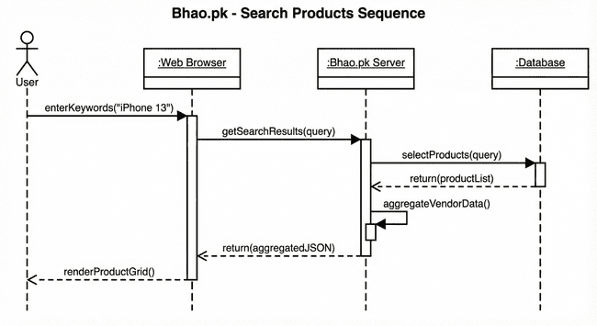
xviii: Figure 3.2: Search Products Sequence Diagram
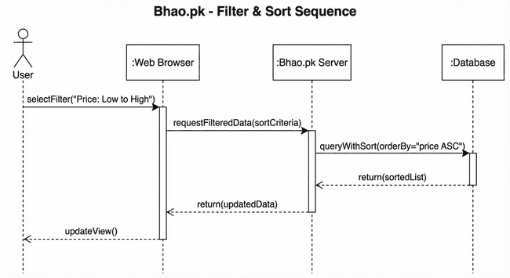
xix: Figure 3.3: Filter & Sort Sequence Diagram

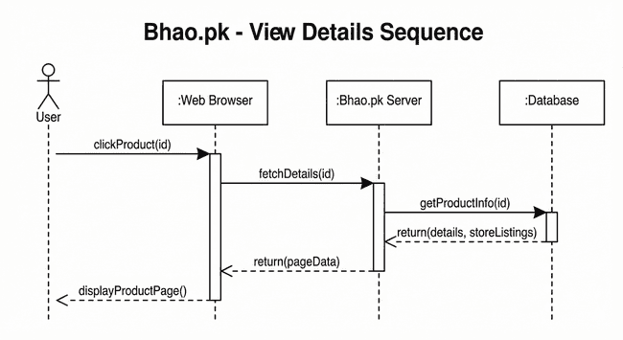
xx: Figure 3.4: View Details Sequence Diagram

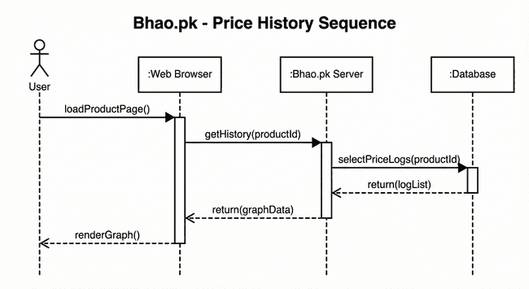
xxi: Figure 3.5: Price History Sequence Diagram

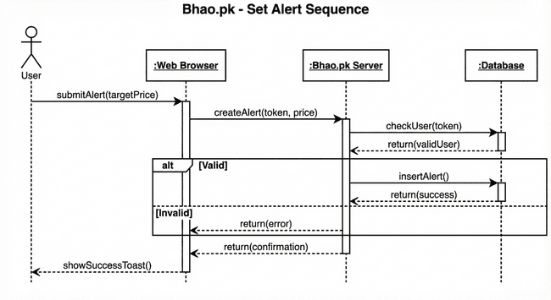
xxii: Figure 3.6: Set Price Alert Sequence Diagram

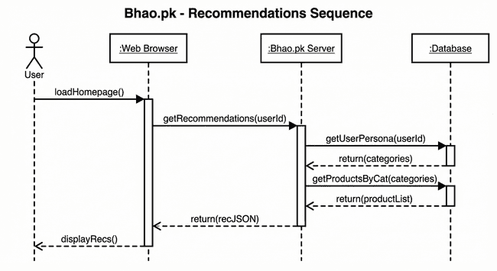
xxiii: Figure 3.7: Show Recommendations Sequence Diagram
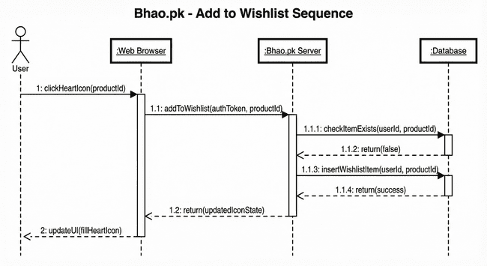
xxiv: Figure 3.8: Manage Wishlist Sequence Diagram

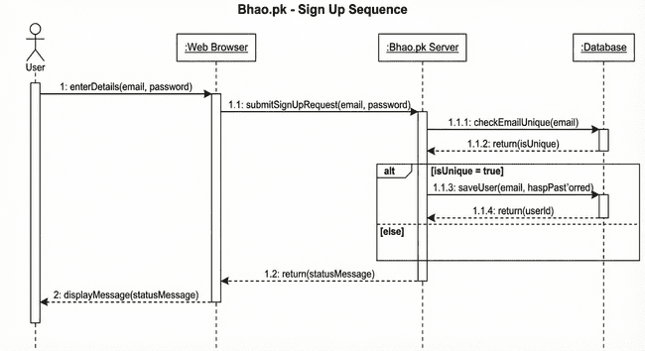
xxv: Figure 3.9: Sign Up Sequence Diagram

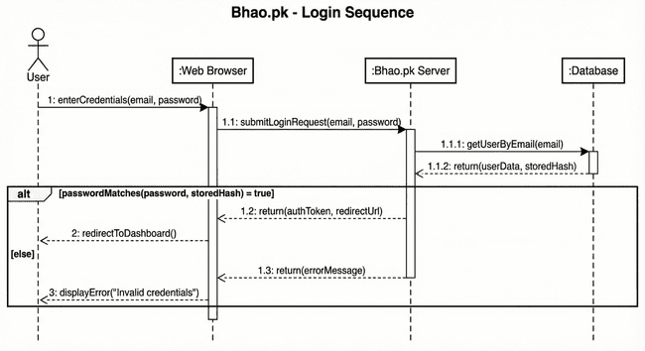
xxvi: Figure 3.10: Login Sequence Diagram
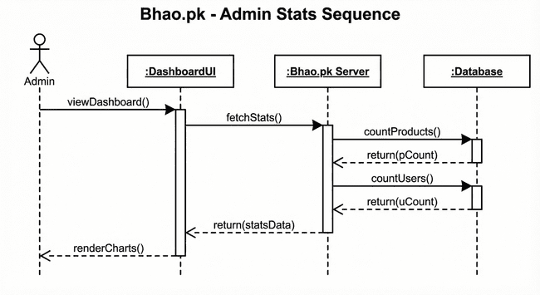
xxvii: Figure 3.11: Sign Up Sequence Diagram

3.5. Entity Relationship Diagram

The Entity Relationship Diagram (ERD) for Bhao.pk visualizes the system's logical data structure, anchored by the Product entity which connects to multiple StoreListings to represent unique offers from various Stores. Users interact with the system by establishing Alerts on these products, creating a direct link between user preferences and market data. Additionally, the model incorporates a PriceHistory entity related to each listing, ensuring that every price fluctuation is recorded to support historical trend analysis.
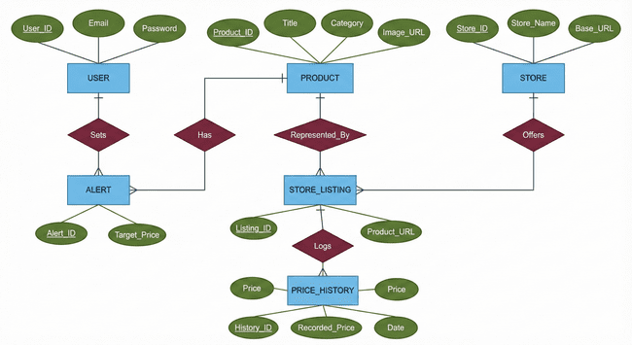
xxviii: Figure 3.12: Entity Relations Diagram

3.6. Database Schema
The Database Schema for Bhao.pk represents the logical configuration of the relational database, structured around the central Product table which maintains a universal catalog of items. It utilizes a Store_Listings table to bridge these generic products with specific external Stores, allowing the system to manage multiple vendors and prices for a single item. Users are connected to specific products through an Alerts table to manage notifications, while a dedicated Price_History table archives temporal data for every listing to support historical trend analysis

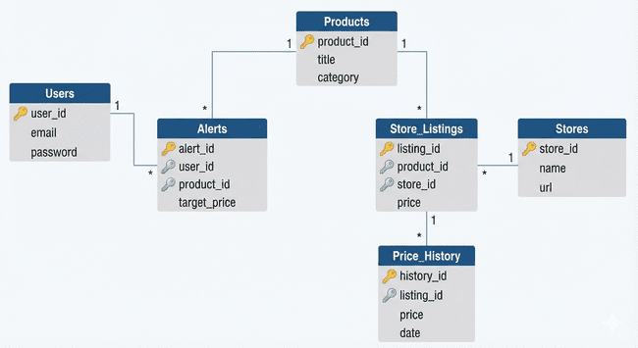
xxix: Figure 3.13: Entity Relations Diagram

3.7. User Interface Design

The Bhao.pk user interface employs a sleek, dark-mode aesthetic with high-contrast neon accents to ensure readability and reduce eye strain. Its minimalist design prioritizes the search function and aggregates complex price data into clean, intuitive dashboards and graphs, enabling users to compare vendors and set alerts effortlessly.

Homepage:

The Home Page serves as the primary entry point for Bhao.pk, featuring a minimalist, search-centric layout designed for immediate user engagement. Adopting a cohesive dark-mode aesthetic with neon accents, the web version centers around a prominent search bar and a "Trending Now" grid to encourage exploration. The mobile interface adapts this structure for smaller screens, placing the search bar at the top and utilizing a vertical scroll layout, accompanied by a fixed bottom navigation bar for seamless accessibility across devices.
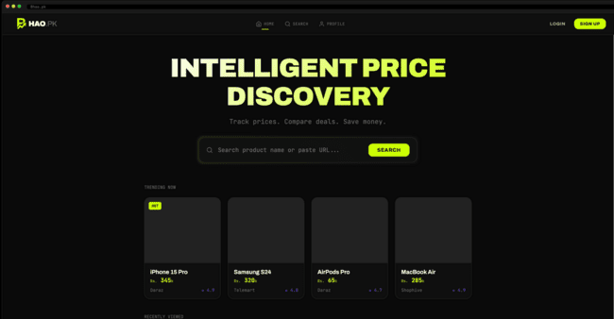
xxx: Figure 3.13: Web Homepage UI
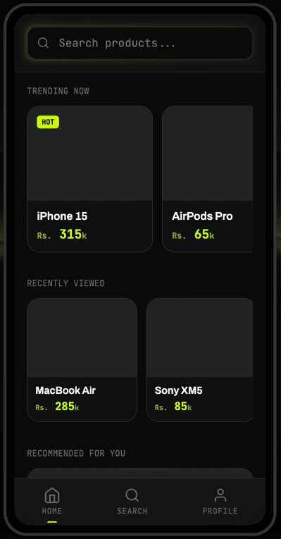
xxxi: Figure3.14: Mobile Homepage UI
Search:
The Search Page provides a unified product discovery experience, tailored for both web and mobile platforms. On the web interface, the page features a robust sidebar with filters for price, store, and category, alongside a sorting dropdown, allowing users to efficiently refine their search results within a spacious grid layout. The mobile version optimizes this experience for smaller screens by condensing filters into a collapsible menu or modal, stacking product cards vertically for easy scrolling, and ensuring key actions like "Sort" and "Filter" are accessible via touch-friendly buttons at the top of the viewport.
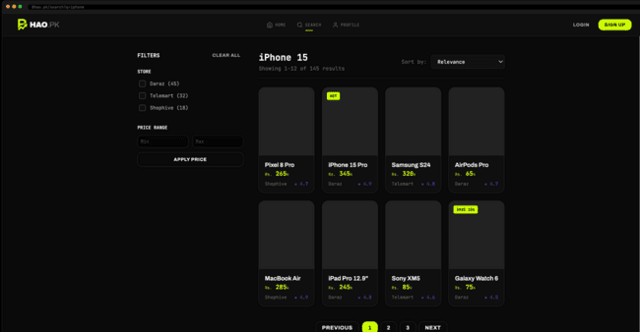
xxxii: Figure 3.15: Mobile Search UI
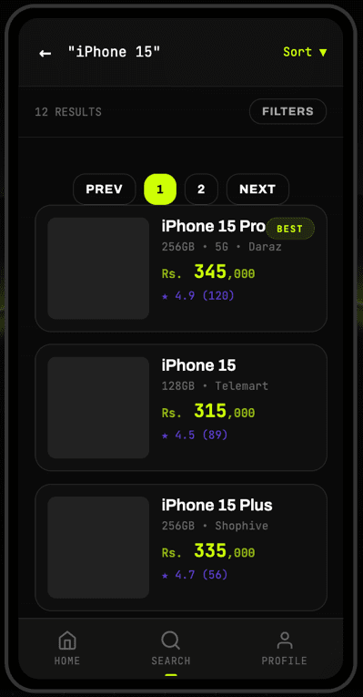
xxxiii: Figure 3.16: Mobile Search UI

Product:
The Product Detail Page serves as the primary decision-making hub, presenting comprehensive product specifications and historical price trends in a unified, dark-mode interface. The web layout utilizes a split-screen design to showcase high-resolution imagery alongside an interactive price history graph and vendor comparison links. On mobile, this content is optimized into a vertical scroll, prioritizing price visibility and anchoring key actions like "Open in Store" and "Set Alert" at the bottom for seamless one-handed interaction.

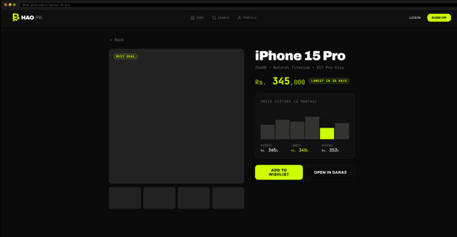
xxxiv: Figure 3.17: Web Product Page UII
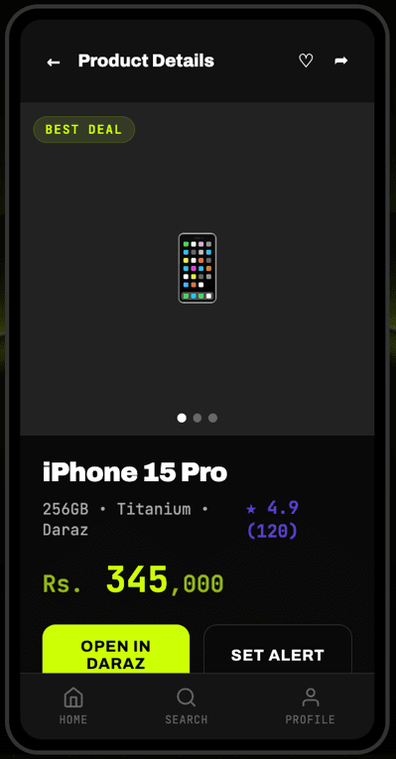
xxxv: Figure 3.18: Mobile Product Page UI

Profile:
The User Profile Page acts as a personalized command center, featuring a consistent dark-mode design across both platforms. On the web, it presents a dashboard-style layout with key metrics like "Active Alerts" and "Saved Items" displayed as prominent cards alongside a "Recent Activity" table. The mobile version streamlines this into a vertical menu with quick-access buttons for "Dashboard," "Wishlist," and "Price Alerts," ensuring users can manage their account settings and preferences efficiently on smaller screens.

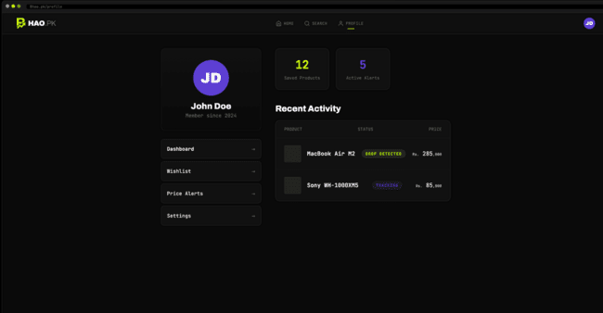
xxxvi: Figure 3.19: Web Profile Page UI
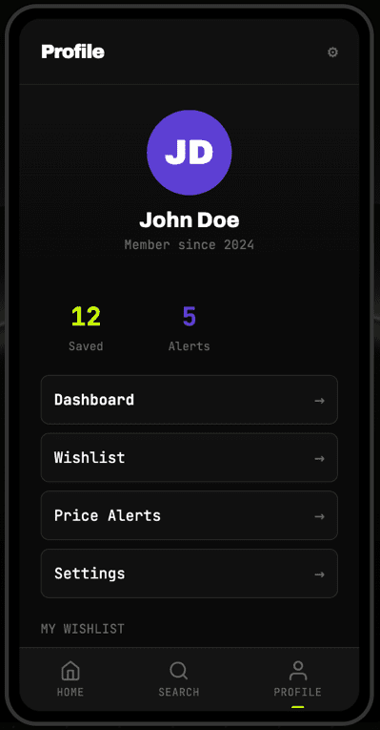
xxxvii: Figure 3.20: Mobile Profile Page UI

Login:
The Login Page provides a secure and intuitive entry point for registered users across both platforms. Adhering to the app's dark-mode aesthetic, it features a clean form for email and password input, prominent "Login" and "Forgot Password" actions, and clearly visible links for new user registration. On mobile, the layout is vertically centered with large, touch-friendly buttons, while the web version centers the form within a spacious, branded container to maintain focus.

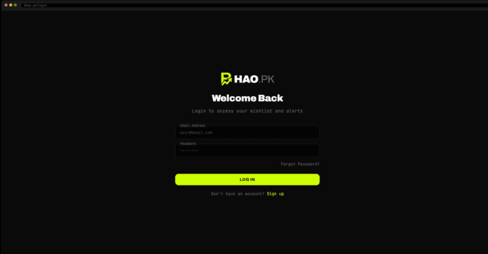
xxxviii: Figure 3.21: Web Login Page UI
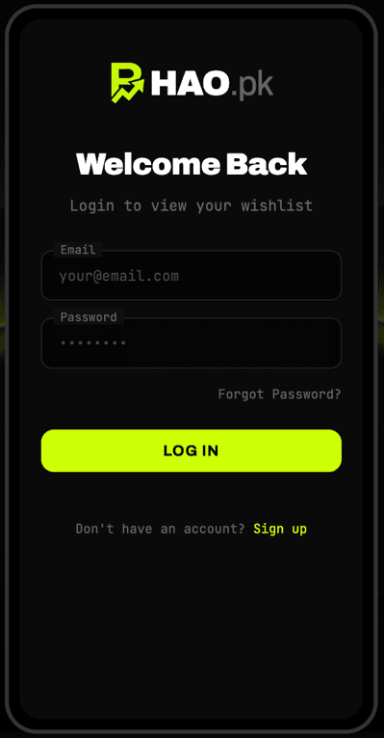
xxxix: Figure 3.22: Mobile Login Page UI

Sign Up:
The Signup Page offers a streamlined registration process for new users, maintaining a consistent dark-mode aesthetic across platforms. Both the web and mobile interfaces feature a simple form for "Full Name," "Email," and "Password" (with confirmation), clearly labeled input fields, and a prominent neon "Sign Up" button. The design minimizes friction by including clear error validation and a direct link to the "Login" page for existing users, ensuring a smooth onboarding experience.

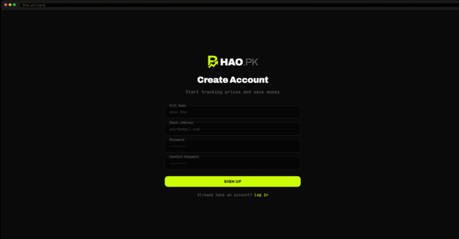
xl: Figure 3.23: Web Sign Up Page UI
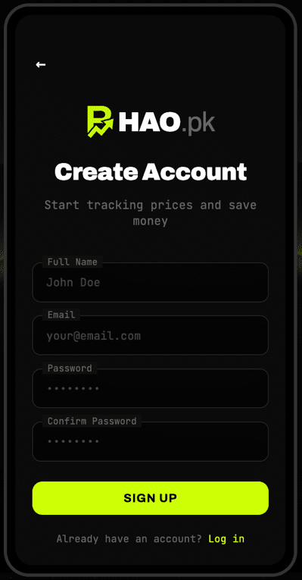
xli: Figure 3.24: Mobile Sign Up Page UI

Admin Login:
The Admin Login Page is a secure, restricted-access portal designed with the same cohesive dark-mode aesthetic as the user-facing application. It features a simplified login form requiring specific admin credentials, stripped of social login options or registration links to ensure security. The interface is optimized for both desktop and mobile, providing administrators with a direct gateway to the backend dashboard for monitoring system health and statistics.

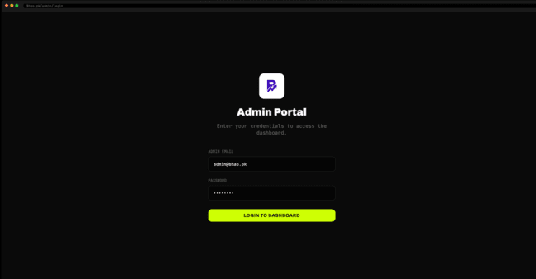
xlii: Figure 3.25: Web Admin Login Page UI
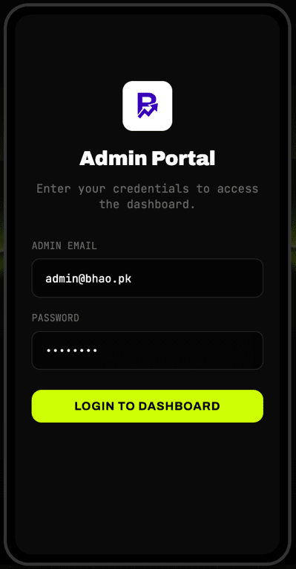
xliii: Figure 3.26: Mobile Admin Login Page UI
Admin Dashboard:
The Admin Dashboard Page acts as a centralized command center, accessible securely on both web and mobile platforms. The interface provides real-time oversight of system health, featuring prominent metrics for total active users, scraped products, and system uptime. The design is optimized for rapid assessment, with interactive charts visualizing user growth and scraper performance, alongside quick-action tools for managing user accounts and system configurations.

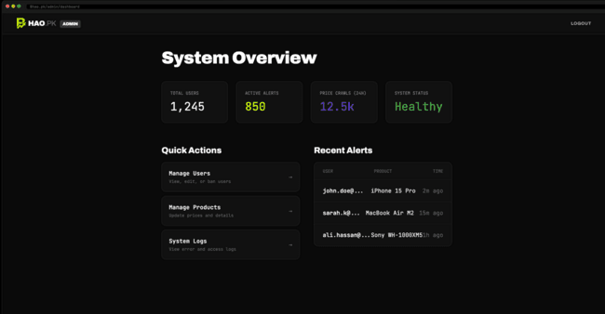
xliv: Figure 3.27: Web Admin Login Page UI
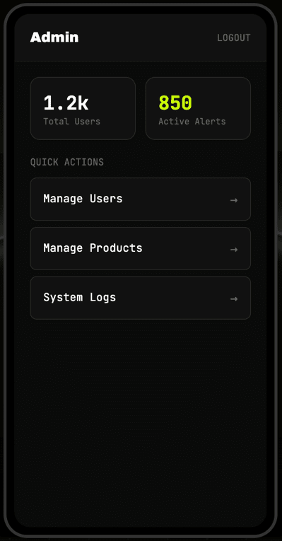
xlv: Figure 3.28: Mobile Admin Login Page UI

