Flapping Bird

|  | Alahad Ibrahim Patrawala  Student  Abbotsford, Canada  [alahadibrahim.patrawala@student.ufv.ca](mailto:alahadibrahim.patrawala@student.ufv.ca)  Student ID: 300154937 |  |
| --- | --- | --- |

# ABSTRACT

My project is about a bird flying through obstacles. The UI includes 2 custom buttons, slider, radio button and a color picker. Each UI component has its own feature which can be used either to control the bird or to make changes on the environment.

## Author Keywords

Bird, stickman, flapping, object, trees, sky, pipes, obstacles, cloud, game, buttons, slider, radio button, color picker.

# INTRODUCTION

This document gives an idea of what kinds of UI components are implemented in the game. Each component has its own function which can be used to provide certain functionality in the game.

# Start Button

The start button is custom UI component created using rectangle which is a primitive shape. It is on the first screen of the game and provide functionality of starting the game. The start button waits for mouseClick() event. If the mouse is clicked within the area of the button, then the game starts. The state of the game changes when as we proceed from start screen to the actual screen where the game is played. Finally, if the bird hits the pipe, the game reaches its final state. The code for the button is referred from (Processing.org)



Rectangle Button reference

# Movement buttons

The game also has buttons to control the movement of the bird. The bird needs to avoid the obstacles and move up and down to progress in the game. The arrowhead up and down buttons can be used to move the bird up and down respectively. Alternatively, a key can be pressed to move the bird up and down.



Arrow head reference image (main-qimg-5c3a698e59479ad93306dc5c68c5ae8a)

## Slider

The slider in the game can be used to change the color shade of the sky. The slider implemented in the game is from a UI library known as ControlP5 which has various UI Components that can be implemented in processing. The slider modifies the value of the blue shade specified within the given range. As the slider is used the shade changes and the effect can be seen. The code is referred from (wizord-gaming)

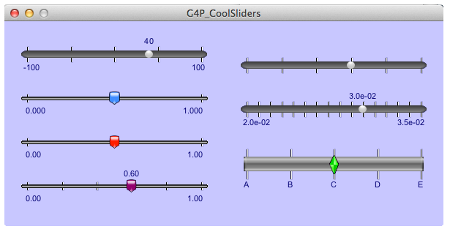

Slider reference (Peter Lager)

**Radio Button**

The radio button is a custom UI Component made using ellipse(). The radio button waits for the user to perform the mouseClick ( ) event within the designated area of the radio button. Once the user has clicked within the designated area, the environment is affected, and it starts snowing. The radio button looks sets the Boolean value true which controls whether there should be a snowfall or no snowfall.



Radio Button Reference Image (IconFinder)

## ColorPicker

The color picker is a ControlP5 UI component. It is used to change the color of the bird. The user can select the color of the bird using the color picker and the bird’s color will change accordingly. It is a UI component for those who like to customize the character they play with in games.

## UI Sketch

The UI components are placed in different screens according to the game. Each UI component is placed where most convenient and without being in the view of the actual game. The positions of UI components where decided accordingly so as that it has minimum effect on the gameplay and is convenient for the user as well.

**Success! Your submission appears on this page. The submission confirmation number is c6b25999-33c6-4cab-bab2-d82e0e3dc094. Copy and save this number as proof of your submission.**

# References

CodingTrain. (n.d.). *website/CodingChallenges at master · CodingTrain/website · GitHub*. Retrieved from GitHub: https://github.com/CodingTrain/website/tree/master/CodingChallenges/CC_31_FlappyBird

Heinrich. (n.d.). *Flappy Bird Clone Tutorial*. Retrieved from Open Processing: https://www.openprocessing.org/sketch/136753

IconFinder. (n.d.). *Checked, control, radio, radio button icon | Icon search engine*. Retrieved from IconFinder: https://www.iconfinder.com/icons/1637632/checked_control_radio_radio_button_icon#size=128

*main-qimg-5c3a698e59479ad93306dc5c68c5ae8a*. (n.d.). Retrieved from Main QIMG: https://qph.fs.quoracdn.net/main-qimg-5c3a698e59479ad93306dc5c68c5ae8a

Peter Lager. (n.d.). *Quarks Place*. Retrieved from Quarks Place: http://www.lagers.org.uk/g4p/guides/g06-customslider.html

wizord-gaming. (n.d.). *youtube/slider.pde at master · wizord-gaming/youtube · GitHub*. Retrieved from GitHub: https://github.com/wizord-gaming/youtube/blob/master/slider/slider.pde