User Manual for ermapp 2

1. Getting Started 3

2. Managing Risks and Mitigations and the rest of the entities 4

3. Approvals amd Risk Assesements 9

Create: 9

Approving/Rejecting: 11

Complete the Assesesment: 12

4. Change Password 13

# User Manual for ermapp

This user manual provides detailed instructions on how to manage various entities within the **ermapp** application.

The application provides a streamlined interface for organizing and operating the **E**nterprise **R**isk **M**anagement program of our company therefore its name **ermapp**.

# Getting Started

After logging in to the ermapp, you will be presented with the admin interface, which allows you to manage various entities such as Risks, Mitigations, Indicators, Actions, Events, Procedures, and Opportunities, as well as implementing risk approvals and risk assessments.

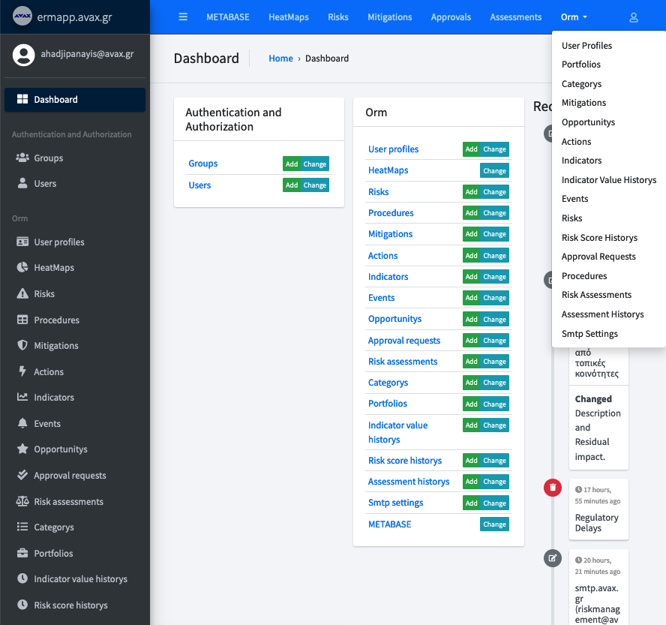

# 2. Managing Risks and Mitigations and the rest of the entities

Risks and mitigations are central to the risk management functionality. To manage risks, go to the Risk section in the admin panel. You can add new risks, define mitigations and other entities, and assign owners for each risk. The application also tracks risk history and allows you to view historical risk scores. In addition, the app allows you to interlink risks with the remaining entities through many-to-many relationships.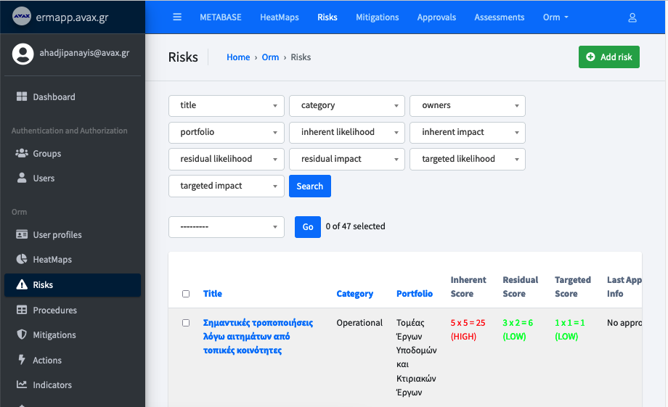

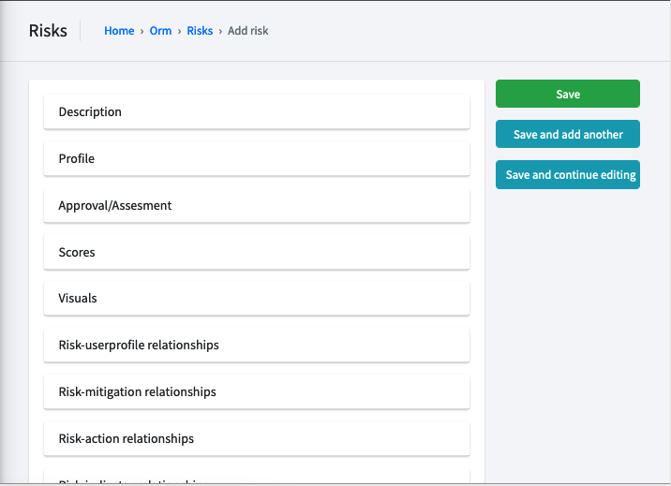

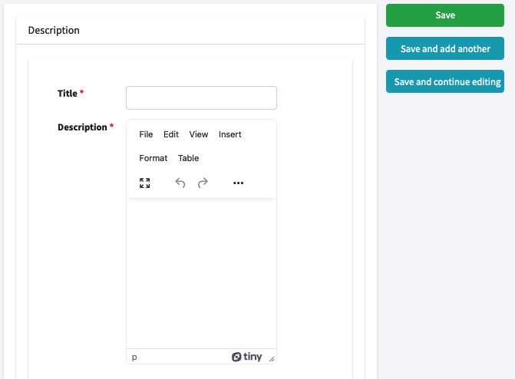

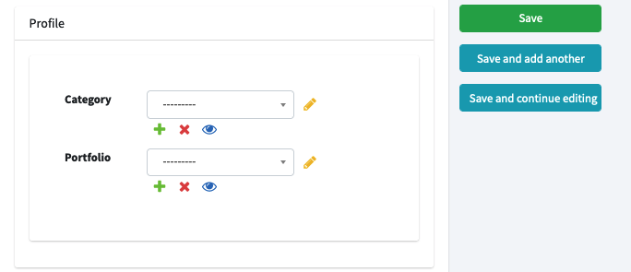

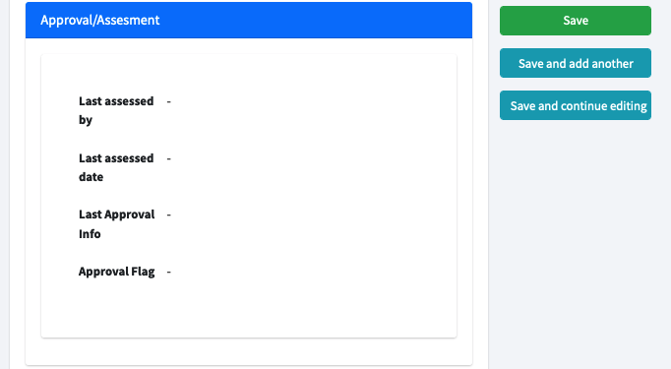

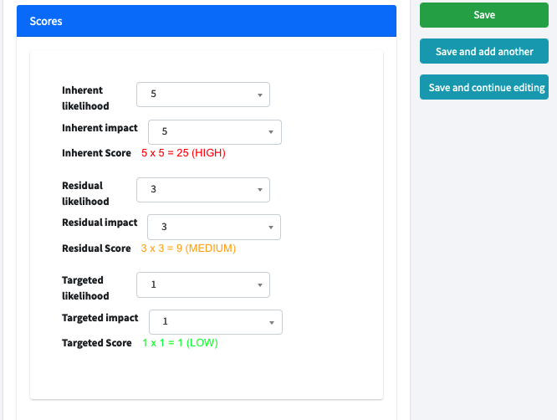

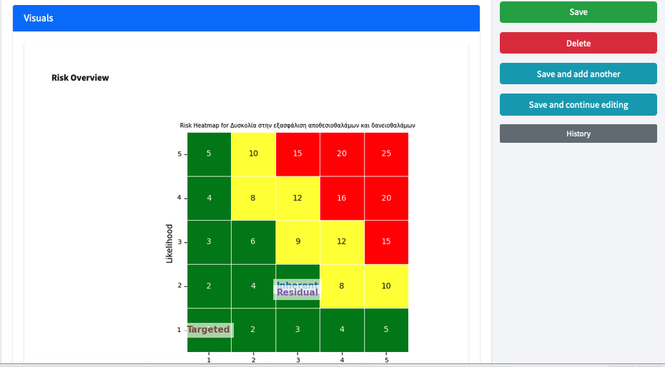

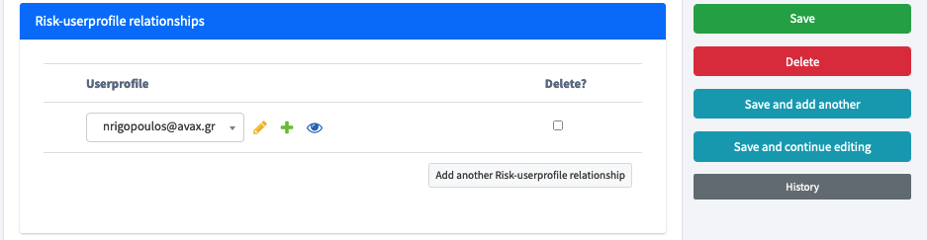

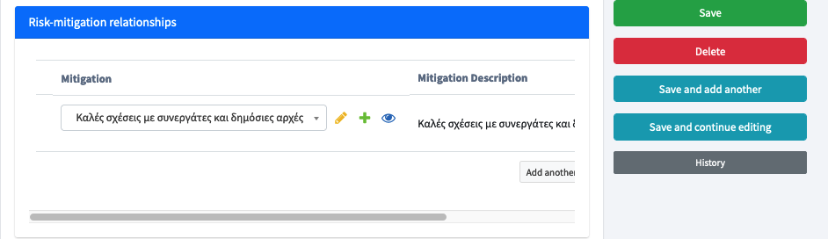

# Approvals amd Risk Assesements

## Create:

On the main Risk screen, select the risks for which you would like to request approval or add a new risk assessment. From the dropdown options, choose either "Approvals" or "Assessment."

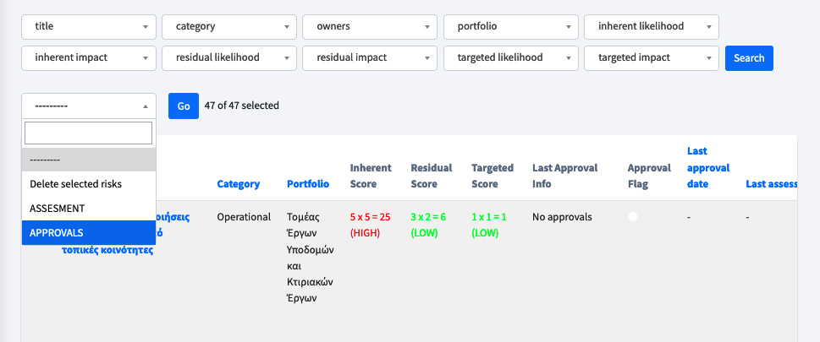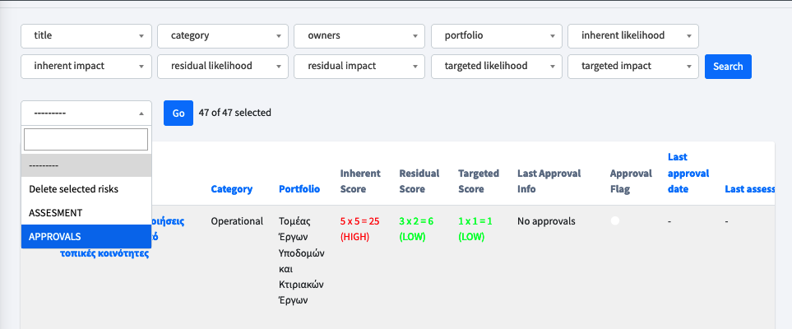

The app will then create an approval request and send it to the risk owner for approval. If "Assessment" is selected, the app will create a new assessment for the selected risks and assign the current user as assessor.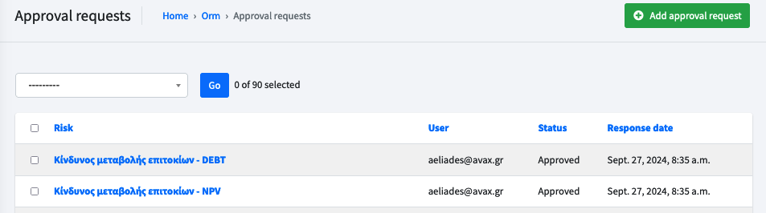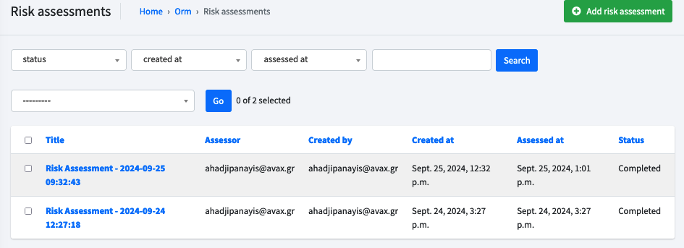

## Approving/Rejecting:

In Approvals screen select the approvals you want to approve or reject then select the relevant option from the drop down menu.

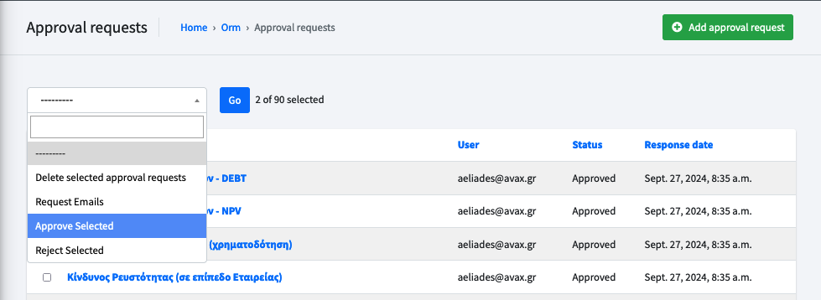

The app will then update the relevant records

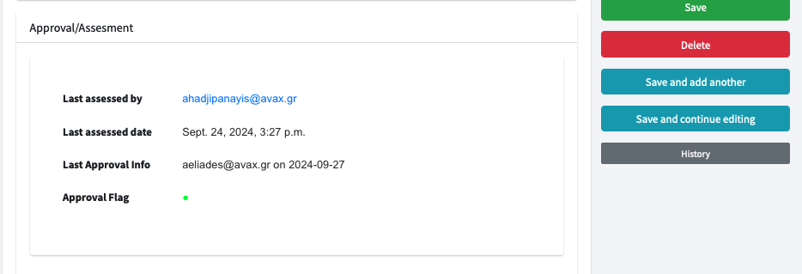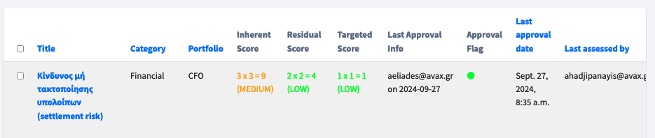

## Complete the Assesesment:

In the Assessment screen, select the assessment you want to complete, then choose the relevant option from the dropdown menu.

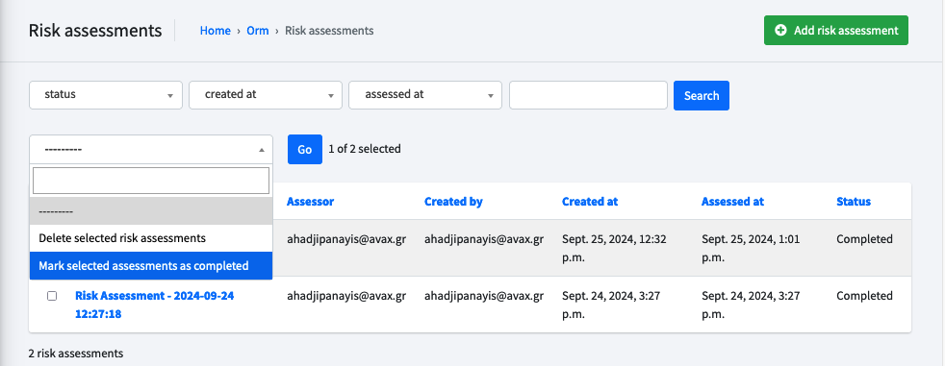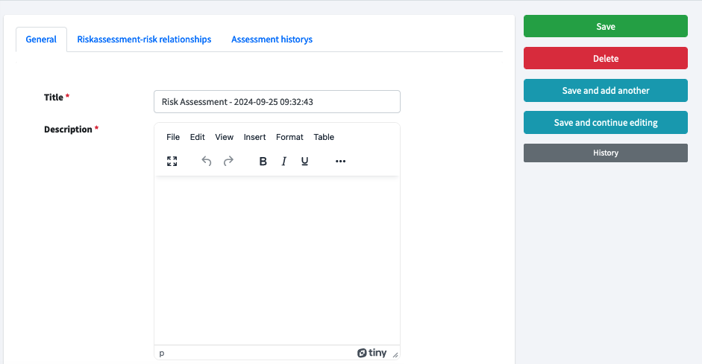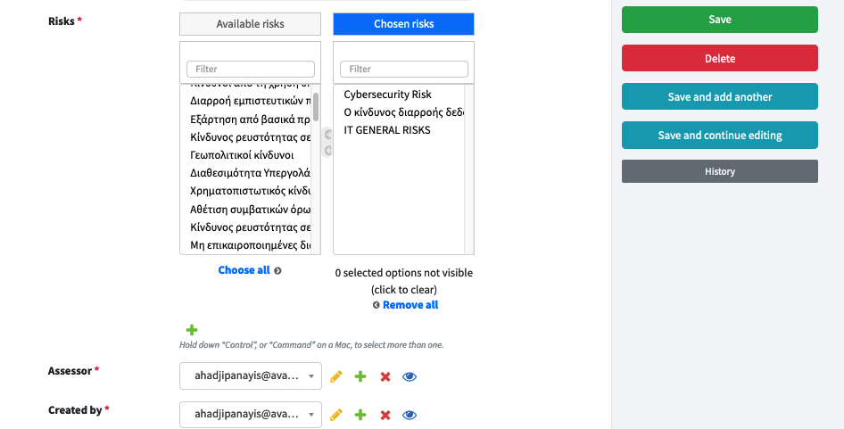

# Change Password

This section provides instructions on how users can change their password. This can be done by clicking on the user icon located on the top right side of the navigation bar.

