📖 Book Library — User Guide & Quick Start

Welcome to your personal and household Book Library! Whether you have 20 books or 2,000, this app helps you catalog your physical collection, track what you are reading, lend books to friends without losing them, and decide what to read next.
1. Viewing & Exploring Your Library

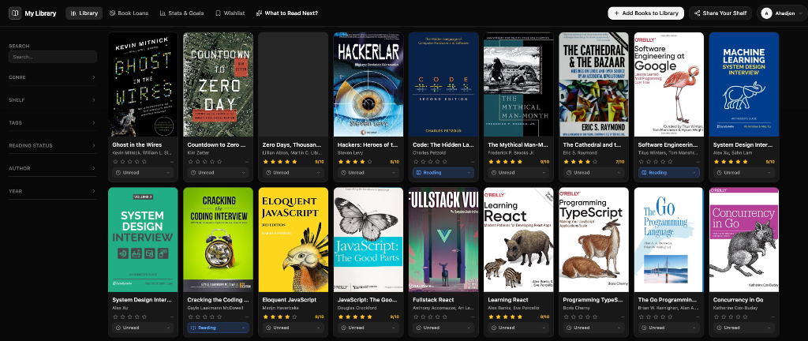

You can view and browse your collection in two ways:
🖼️ Gallery View (Visual Grid)
Displays your books as cards with high-resolution cover art. Directly on any book card:
- Click the Status Badge (e.g. ⏳ Unread ▾) to instantly mark it as 📖 Reading or ✅ Finished.
- Click the Stars (★) to rate the book from 1 to 10 without leaving the page.
📋 Table View (Spreadsheet Style)
Perfect for quickly sorting your library by Author, Publication Year, Page Count, or Shelf Location.
🏷️ Shelves & Tags (Finding Where Books Are)
- Shelves: Physical locations in your home (e.g., 'Living Room Shelf A', 'Bedside Table', 'Office Desk').
- Tags: Themes, topics, or genres (e.g., 'Favorites', 'Sci-Fi', 'Clean Code', 'Gift').
- Use the Filter Sidebar on the left to instantly filter books by genre, shelf, or author with one click.
2. Adding Books (4 Fast Ways)
Click the '+ Add Books to Library' button in the top navigation bar to open the add modal:
📸 Method A: Take a Photo of Your Bookshelf
Got a full shelf of books? You don't need to type them one by one.

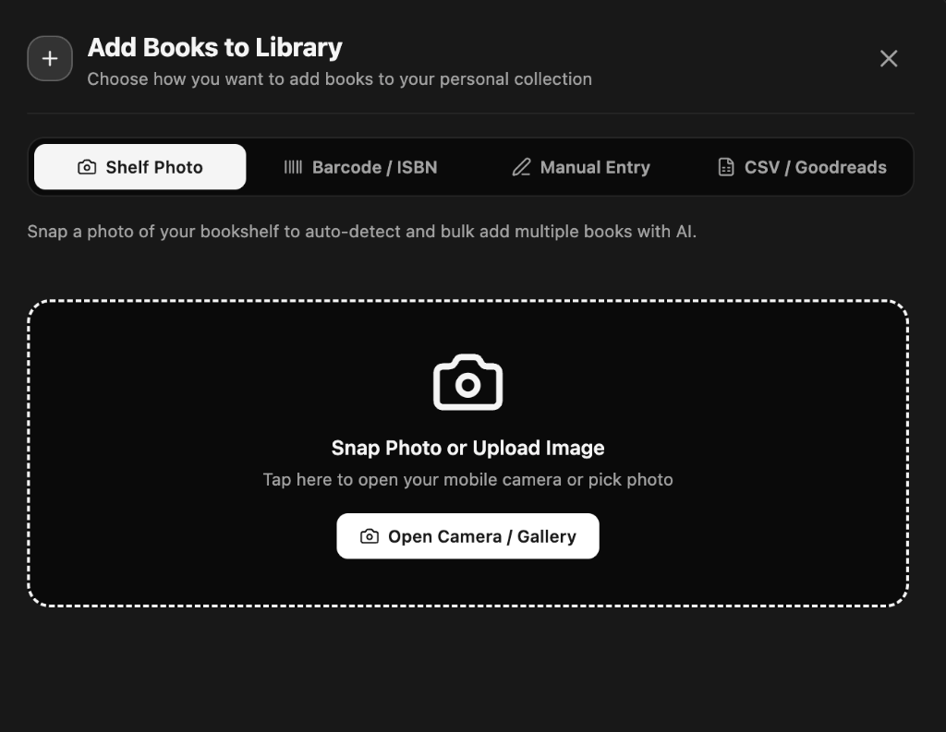

1. Select the Shelf Photo tab.
2. Snap or upload a photo of your physical bookshelf.
3. The AI reads the book spines, finds cover art, authors, and page counts automatically.
4. Review the detected list and click Add Selected Books.
📷 Method B: Scan Barcode or Look Up by ISBN
Have a book in your hand?

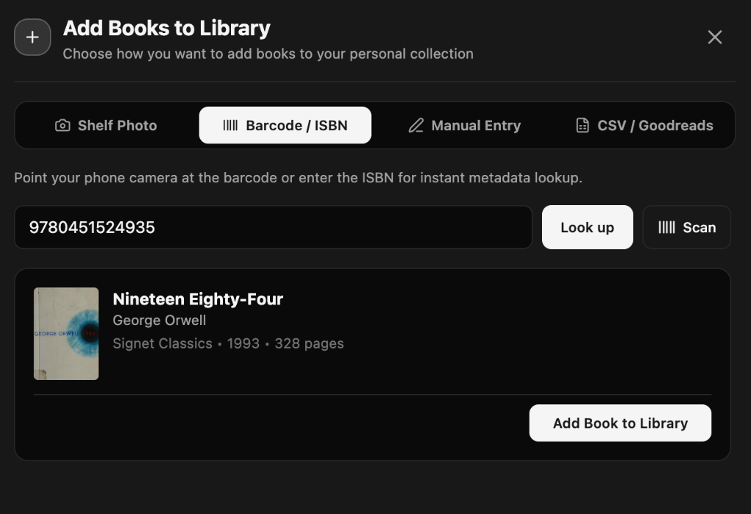

1. Select the Barcode / ISBN tab.
2. Click Scan to point your phone or webcam camera at the barcode on the back cover.
3. Or type the ISBN (the 10 or 13-digit number) and click Look up.
4. The title, author, publisher, cover image, and page count will auto-populate instantly. Click Add Book to Library.
✍️ Method C: Manual Entry
For rare, vintage, or custom books without barcodes.

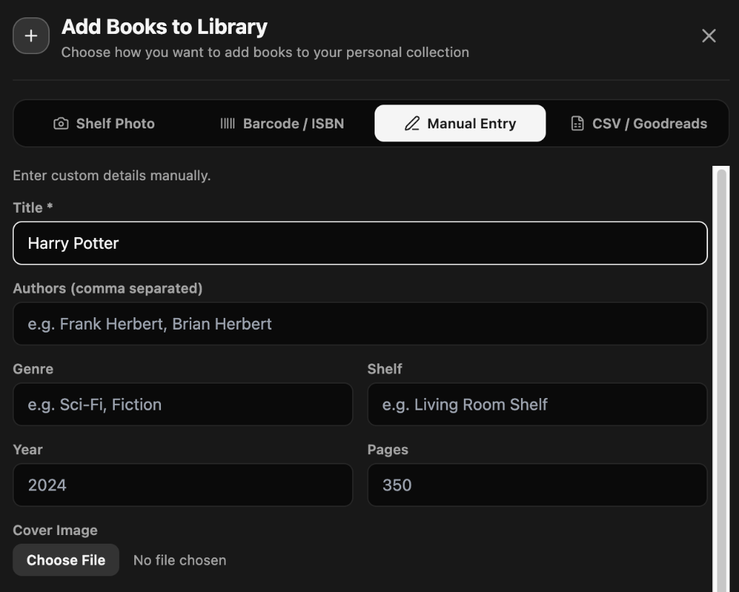

1. Select the Manual Entry tab.
2. Fill in the title, author(s), shelf, genre, and page count.
3. Optionally upload a custom cover photo and click Add Book to Library.
📁 Method D: CSV / Goodreads Import
Transfer your entire reading history from Goodreads or an Excel spreadsheet in one go.

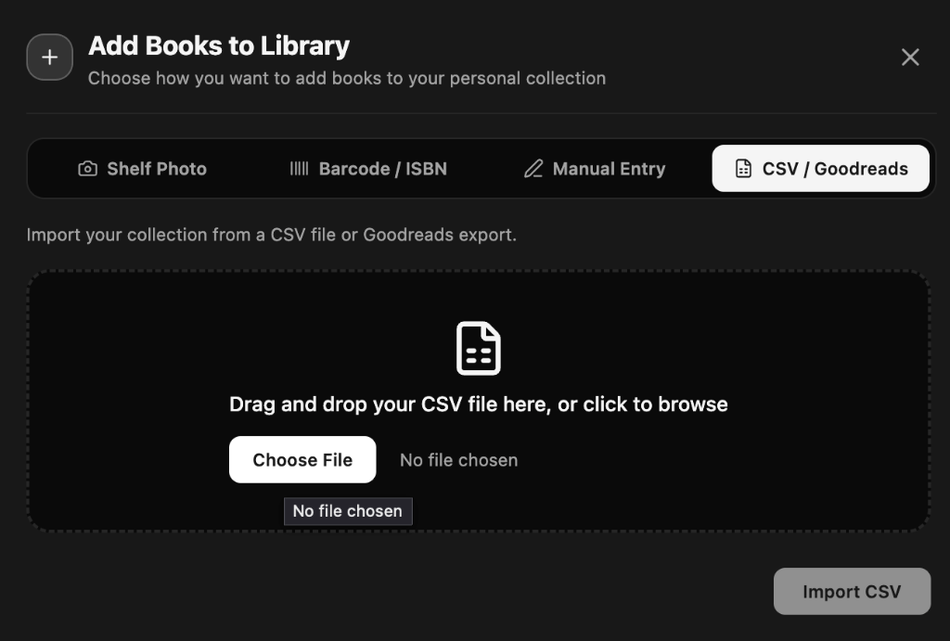

1. Select the CSV / Goodreads tab.
2. Drag and drop your .csv file.
3. Click Import CSV — your books, ratings, and read dates will import in seconds.
3. Tracking Your Reading Progress & Ratings
Every book has a reading status: ⏳ Unread, 📖 Reading, ✅ Finished, or 🛑 Abandoned.
⚡ 1-Tap Quick Actions: You don't have to open a book detail page to update your progress. Click the status badge or star rating directly on the card.
4. Sharing with Family & Roommates (Household Library)
Do you share your physical home library with your spouse, family, or roommate? With Household Libraries, everyone shares the catalog of physical books, but maintains independent reading progress and private ratings.
How to Invite a Member:
1. Click your profile menu in the top right -> Household Library.
2. Copy your 6-character Invite Code or invite link.
3. Your family member creates an account and enters the code to join your library.
5. Lending Tracker — Never Lose a Book
Keep track of books you lend to friends or colleagues:
1. Go to the Book Loans tab in the top navigation.
2. Click '+ Lend a Book'.
3. Choose the book, enter your friend's name, contact details, and a return due date.
4. The book will display an orange 'On Loan' badge across your library.
5. When returned, click 'Mark as Returned' with 1 tap.
6. Reading Goals & Personal Stats
Stay motivated with your yearly reading challenge. Go to the Stats & Goals tab and set your Yearly Reading Goal (e.g. 25 books in 2026). The app tracks your live pace: Ahead of schedule, On track, or Behind pace.
7. AI 'What to Read Next?' Assistant
Standing in front of your shelf wondering what to read? Click '✨ What to Read Next?' in the top navigation, select your mood ('Quick Weekend Read', 'Deep & Thoughtful', 'Fast-Paced'), and the assistant recommends top matches from your unread shelf.
8. Public Shareable Profile
Want to show friends what books you own? Click 'Share Your Shelf', toggle Public Shelf to ON, and share your custom link (e.g. /share/your-name). Anyone can browse your shelf without creating an account.
9. Exporting Your Data
Click the Export button on the Table View to download your entire collection as an Excel (.xlsx) or CSV file anytime. Your data is always 100% yours.
10. Changing Language
Click your user menu in the top right to switch between 🇬🇧 English and 🇺🇿 O'zbekcha.

