Hybrid Modeling of Microelectromechanical Systems

EE291e Hybrid Systems

J. Clark

Berkeley Sensor and Actuator Center
University of California at Berkeley, CA, USA,
jvclark@eecs.berkeley.edu

Abstract
A methodology to model and simulate a certain class of microelectromechanical systems which can be viewed as a hybrid system is proposed. The test case is based on a micro motor designed at UC Berkeley by Richard Yeh et. al. [1]. Currently, research and commercial software packages have been successful at modeling MEMS mainly to the extent of simple structural dynamics such as vibration analysis and nonlinear deflections. The system equation are usually based on finite element analysis, boundary element methods, and nodal analysis [2]. What makes the modeling and simulation of MEMS complex is coupling of multi-scales and multi-energy domains such as electromagnetic, mechanic, thermal, digital/analog electrical, etc.
- paper layout
Text should be produced within the dimensions shown on these pages; each column should be 85 mm wide. The two columns should be separated by 10 mm and should be right/left justified. Print your papers in single-sided format on standard size white paper (A4 or 8-1/2x11"). For either paper size, the print area should be no larger than 235 mm (length) x 180 mm (width). On each page of the manuscript, position the print area 20 mm from the top and 15 mm from the left edge of the paper, see Figure 1. Make use of the maximum stipulated length except for the following cases, (a) do not begin a new section at the bottom of a page, transfer the heading to the top of the next column, (b) you may exceed the text area by one line in order to complete a section of text or a paragraph.
- Text format
The title should be in boldface letters centered across the top of the first page using 14-point type. First letter capitals only for the title. Insert a blank line after the title, followed by Author Name(s) and Affiliation(s), centered and in 12 point non-bold type. The paper begins with the abstract and keywords as illustrated, followed by the Main Text.
  - Fonts and Spacing
Times or Times Roman is the recommended typeface for the main text using 10-point type. The smallest allowed type size for all text, figures, captions, references and within figures is 10-point. See Table 1 for a compete summary of Font formats. Single (1.0) line spacing is recommended for the main text, however, when typing complicated mathematical text it is important to increase the space between text lines in order to prevent sub- and super-script fonts overlapping.
  - Section and Sub-section Headings
Section headings should be 12 point boldface capital letters, centered in the column. Sub-section headings require initial capitals using boldface and left justification. All headings should appear on separate lines as demonstrated above. Follow the Arabic numbering scheme shown.
  - References
References should be collected at the end of your paper. They should be prepared according to a recognized style, e.g. the Harvard or sequential numeric system making sure that your accumulated list corresponds to the citations made in the main text and that all material mentioned is generally available to the readers. When referring to them in the text, type the corresponding reference number in square brackets as in this example [1].
  - Manuscript
The manuscript should be printed on 60# white, hard finish paper (European 89 gsm), preferably using a laser printer. Use black print and ink for all text and mathematical symbols. The printout must be an original copy. To achieve optimal reproduction quality, the contrast of text lettering must be uniform, sharp, and dark over the entire page and throughout the article. Be sure the final page is clean and can be easily handled without smearing.
  - Page Numbers
Each page should be marked on the back side, using a light pencil, with the last name of the first author and with a page number. Do not put page numbers on the front of any page.
- EQUATIONS
Equations must be placed flush-left with the text margin and should be preceded and followed by one line of white space.

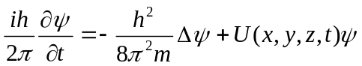 (1)

If they are numbered make sure that they are numbered consecutively. Place numbers in parentheses flush with the right-hand margin of the column and level with the last line of the equation.
- TABLES AND ILLUSTRATIONS
Tables and illustrations should be originals or sharp prints. They can appear within columns or span both columns as illustrated in Figure 1 and Table 1. If two column figures or tables are required, place them at the top or at the bottom a page. The figures must not extend into the margins. They should have a self-contained caption and be center justified.

 | Style | Size | Justified
Title | Bold | 14 | Center
Authors | Normal | 12 | Center
SECTION | BOLD, ALL CAPS | 12 | CENTER
Subsection | Bold | 12 | Left
Main Text | Normal | 10 | Left/Right
Captions | Normal | 10 | Center
Figure Text | Normal | 10 | N.A.
Table 1: Formatting summary for MSM manuscripts.

Using your word processing software, photographs and line drawings can be scanned, sized and integrated into the manuscript, however, the resolution needs to be 600 dpi or equivalent. If figures cannot be integrated electronically, they should be attached to your manuscript page, correctly aligned, with rubber cement or spray adhesive (do not use water-based glue or transparent tape). All lettering should be 10-point type or larger.
Figures and Tables should be sequentially numbered. Figure captions should centered below the figure and use the same type and size font as regular text. Table captions should be centered above the table and use the same type and size font as regular text. A single line should be skipped both before and after all captions.

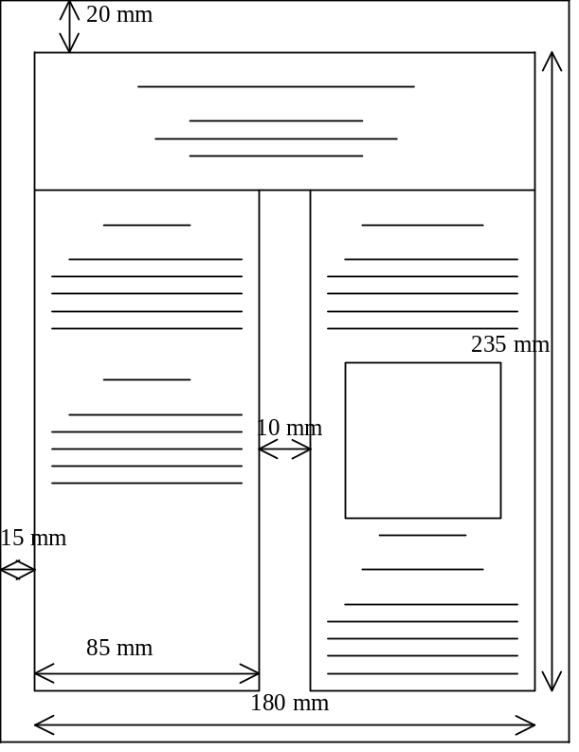
Figure 1: Formatting dimensions for manuscripts.
- DEADLINES AND AUTHOR KIT
Four camera ready originals of the manuscripts are due at the conference secretariat by January 1st, 2000, together with a signed copyright form, and a signed conference registration form with valid form of payment. Email an electronic copy of your paper for inclusion in CDROM and online proceedings. Additional information, templates, style files, and valid electronic document formats are available on the conference web page at URL http://www.cr.org/MSM2000. Manuscripts received after Janary 21st, 2000,, or without a signed copyright form will not be published.
references
[1] Timoshenko and Woinowski-Krieger, "Theory of Plates and Shells," McGraw-Hill, 415-428, 1959.
[2] D. Snow, M. Major and L. Green, Microelectronic Engr. 30, 969, 1996.
[3] Author, "Title (optional)," Journal, Volume, Pages, Year.

MSM 2000, 4847 Hopyard Road, Suite 3-381, Pleasanton, CA 94588, Ph(Fx): (925) 847-9152(3), wenning@dnai.com

