Mirpur Dhaka, Bangladesh



(+880)1737155233



 ahaduzzamanapon@gmail.com

MD Ahaduzzaman

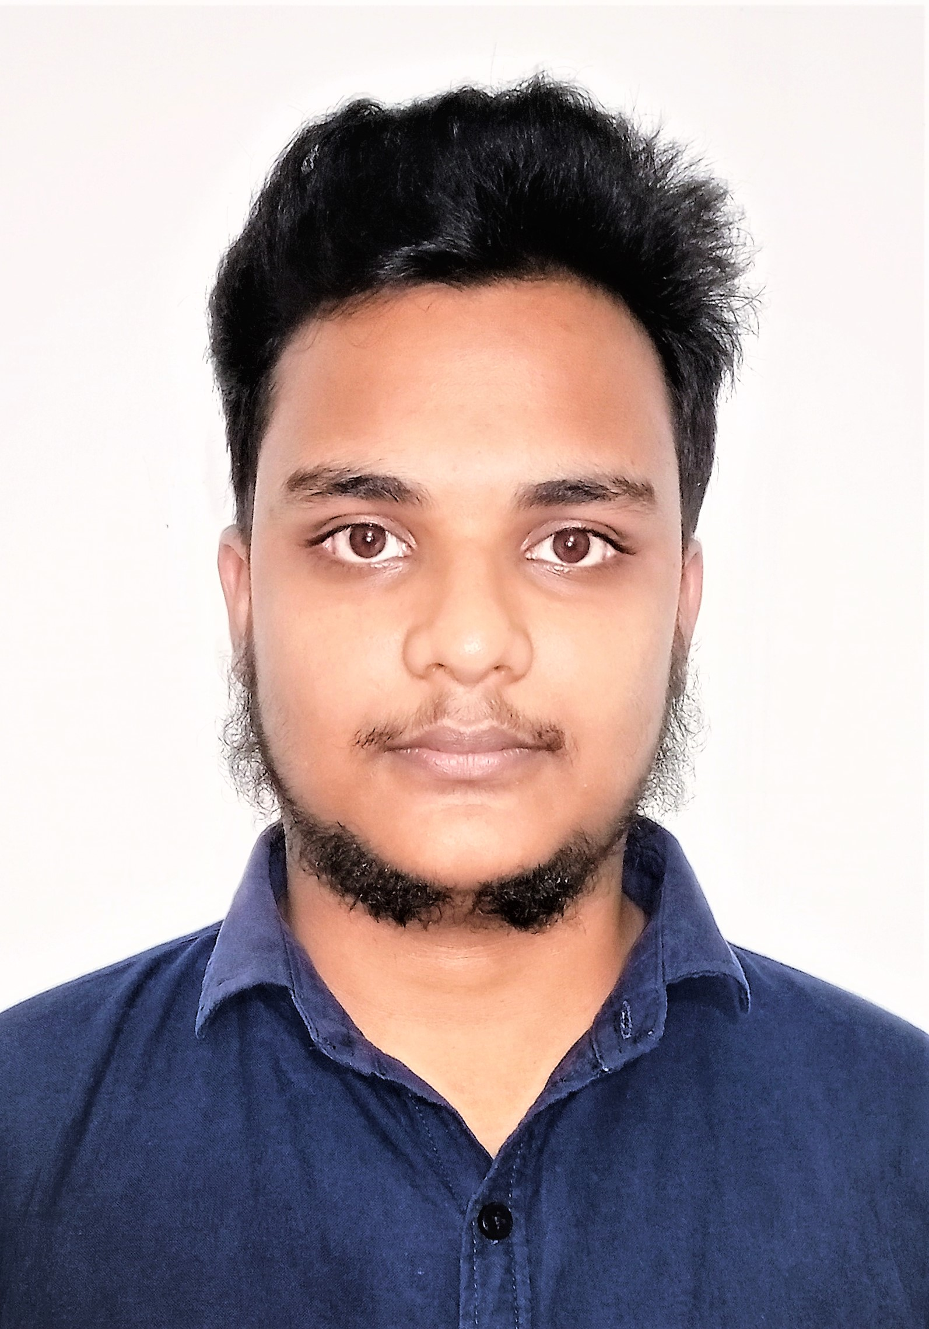

**EDUCATION:**

* SSC in Science at Sharifabad High School & College, Kishoreganj, Nilphamari.
* Diploma in Computer at Rangpur Ideal Institute Of Technology, Rangpur.

**Laravel Project:**

**Title: A online job portal for Industrial Attachment, Dhaka, Bangladesh** (**2022**).

**Summary:** There are 3 type user, in this project a candidate can search job and view job details. A employee can post a job and receive resume and admin can see candidate list, employee list ,job list [Technology –**HTML, CSS, BOOTSTRAP, PHP, MySQL**, **LARAVEL FRAMEWORK**]

**ADDITIONAL EXPERIENCE AND AWARDS:**

**(Programming Problem Solving)** Participated in **1 onsite** programming contest and solved more than **70 problems** in [www.beecrowd.com.br](http://www.beecrowd.com.br)

Profile link : [www.beecrowd.com.br/judge/en/profile/770297](http://www.beecrowd.com.br/judge/en/profile/770297)

**Languages and Technologies:**

* **Language:** PHP 8 (**Prior experience**)
* **Framework:** Laravel 9 (**Prior experience**)
* **Databases & Storage:** MySQL
* **Version Control:** Git

**Frontend Development:** Good Working knowledge HTML, CSS, BOOTSTRAP (**Basic**)