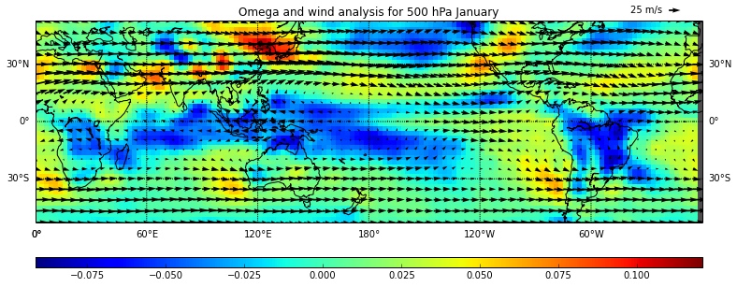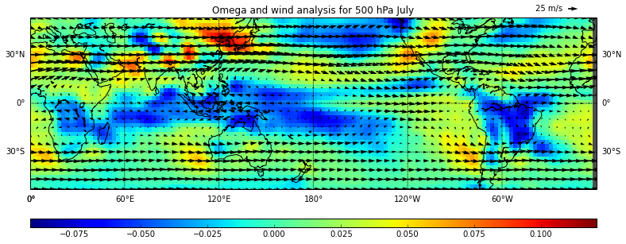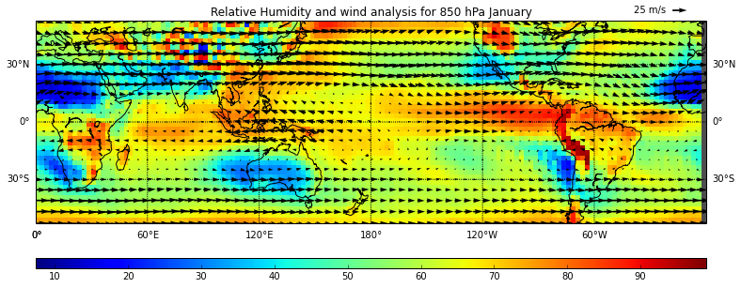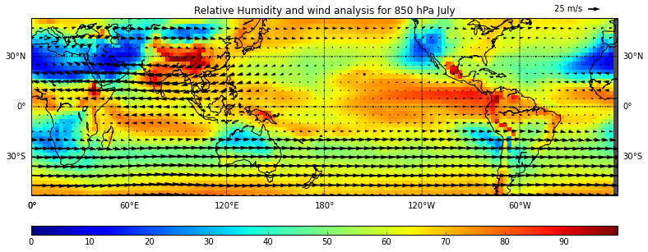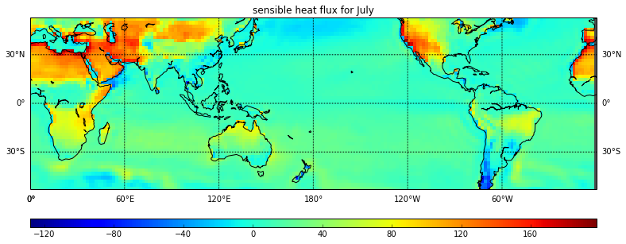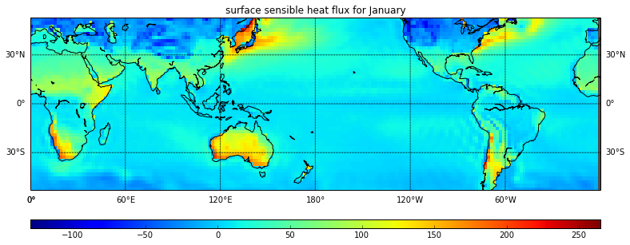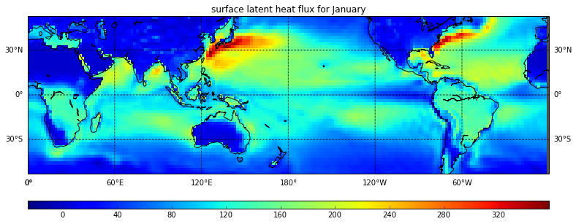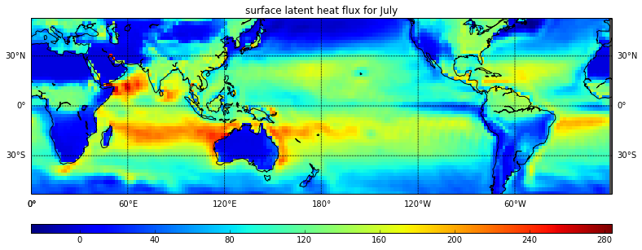

[5] no relationship between RH and wind, air becomes dryer as it sinks and air becomes more moist as it rises because RH decreases as air descends and RH increases as Air rises because of temperature.

{6} Higher Rh is a sign of rising air. Rising air cools and condenses releasing latent heat. Therefore higher RH leads to greater latent heat flux. Wind blows dryer air of over the ocean where I increases evaporation which drives latent heat increasing latent heat flux.