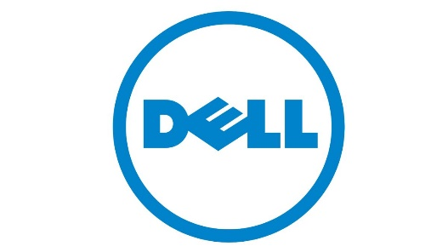

COMPANY ANALYSIS

DELL

**TECHNOLOGY ENTREPRENEURSHIP (ENT600): A1 CASE STUDY**

|  |  |
| --- | --- |
| **FACULTY & PROGRAMME** | **: CS264** |
| **SEMESTER** | **: 6** |
| **PROJECT TITLE** | **: INDIVIDUAL ASSIGNMENT** |
| **NAME** | **: MUHAMMAD ARIF HAIKAL BIN SAMED** |
| **LECTURER** | **:** **DR. NAJDAH ABD AZIZ** |

# **ACKNOWLEDGEMENT**

The success and final outcome of this assignment requires a lot of guidance and assistance from many people and I extremely fortunate to have got this all along the completion of this assignment work. First of all, I would like to thank Dr. Najdah Abd Aziz, ENT600 Lecturer, UiTM Kuala Terengganu for giving me an opportunity to do this assignment work and providing support and guidance throughout numerous consultations.

I would like to expand my deepest gratitude to those who have directly and indirectly guided me in writing this assignment. Many people, especially my friends, have provided helpful comments and suggestions on this assignment, which has motivated me to improve it. I thank and appreciate everyone's assistance in completing my assignment, both directly and indirectly.

# **TABLE OF CONTENT**

**ACKNOWLEDGEMENT** i

**TABLE OF CONTENT** ii

**LIST OF FIGURE** iii

**LIST OF TABLE** iv

**EXECUTIVE SUMMARY** 1

**1.** **INTRODUCTION** 2

1.1 BACKGROUND OF THE STUDY 2

1.2 PROBLEM STATEMENT 2

1.3 PURPOSE OF THE STUDY 2

**2.** **COMPANY INFORMATION** 3

2.1 BACKGROUND 3

2.2 ORGANIZATIONAL STRUCTURE 4

2.3 PRODUCTS/SERVICES 5

2.4 TECHNOLOGY 6

2.5 BUSINESS, MARKETING, OPERATIONAL STRATEGY 6

2.6 FINANCIAL ACHIEVEMENTS 7

**3.** **COMPANY ANALYSIS** 8

3.1 Strengths 8

3.2 Weaknesses 8

3.3 Opportunities 9

3.4 Threats 9

**4.** **FINDINGS AND DISCUSSION** 10

**5.** **CONCLUSION** 10

**6.** **RECOMMENDATION AND IMPROVEMENT** 11

**7.** **REFERENCES** 12

**8.** **APPENDICES** 13

# **LIST OF FIGURE**

|  |  |  |
| --- | --- | --- |
| **Figure** |  | **Page** |
| 2.1 | Dell Organization Chart | 4 |
| 2.2 | Dell Organization Structure | 5 |
| 8.1 | Dell Headquarters | 13 |
| 8.2 | Dell Factory | 13 |
| 8.3 | Dell Website | 13 |

# **LIST OF TABLE**

**EXECUTIVE SUMMARY**

This case study is a part of study, which student UiTM Kuala Terengganu is taking part in subject Technology Entrepreneur (ENT600). The main purpose of this case study is to expose the student with the real world of business and taught the student how to the analysis on the company. Others, the student will be exposed with the technology entrepreneur and can get know the obstacles and challenges of the real-world business.

This case study is about Dell Technologies Company, which is one of the world's largest technology firms, with approximately 165,000 people worldwide. Dell is an American technology company that designs, sells, repairs, and provides technical support for computers and related products and services. The information stated in this case study is obtained from articles, internet sources and their websites.

SWOT analysis used to help the company during the development of their company. The 4 factors help them in detecting the problems and solution for their company to be expanding. This case study also provided some solution to their problem in making sure their company can run effectively.

1. **INTRODUCTION**
2. **BACKGROUND OF INDUSTRY**

Dell Technologies is one of the world's largest technology firms, with approximately 165,000 people worldwide. Michael Dell founded the company in 1984 and now concentrates on selling personal computers, network servers, data storage solutions, and software. As of January 2021, Dell was the world's largest shipper of PC displays and the third-largest PC manufacturer in terms of unit sales. In April 2021, the business announced its intention to spin off its 81% investment in VMware, a cloud-computing and virtualization software company that joined Dell Technologies in 2015 as part of its $67 billion acquisition of software giant EMC.

1. **PROBLEM STATEMENT**

Dell transformed the buying experience for customers with its mass customization approach. Due to Dell's years-long use of the same approach, HP has a window of opportunity. Dell experienced several terrible incidents in 2006, including rechargeable battery packs that could self-ignite, extremely poor earnings reports, and experts' extremely pessimistic predictions for Dell's future. Dell has lost a significant market share to Hewlett-Packard (HP). Each year, HP, Sony, Lenexa, Apple, and other rivals advance and pose a greater danger to Dell. Over time, rivals may gain more market share. They could also attempt to undermine Dell's competitive advantages and eliminate it from the market.

Dell has issues on the inside as well. The turnover rate appears to be a rising issue, and the employees at Dell are not entirely content. Dell is hiring brilliant people for other organizations. Dell will need to find fresh talent if all of these people leave. Not only does hiring new personnel take a lot of time, but it also costs a lot of money. Other internal concerns, such as challenges with business culture, cause employees to be dissatisfied with the organization. There is no close relationship between Dell and its staff.

1. **PURPOSE OF THE STUDY**

The purpose of the study is to study the obstacles of the real-world entrepreneur. Others, this study will help the student to be exposed to the real business and the current industry. The purpose of this study also makes the student know how making an analysis on company by using SWOT analysis.

Besides, this study also assists the student in obtaining a better knowledge of sustainable technology, business and the student will gain knowledge in managing the business and always keep in track with the flow of entrepreneur.

# **COMPANY INFORMATION**

1. **BACKGROUND**

Dell is an American technology company that designs, sells, repairs, and provides technical support for computers and related products and services. Dell Technologies, the parent company, own it and Dell is headquartered in Round Rock, Texas. Michael Dell founded Dell in 1984 to provide customers with computers that fulfil their needs. At the University of Texas, he was a student at the time, and his company was called PC's Limited. Dell purchased components in bulk, assembled them into clones of IBM computers, and sold them to customers who did not want to pay the higher prices charged by computer stores via mail order.

The following year, Dell introduced the first computer with an eight-megahertz processor, the Turbo. The primary purpose was to build personal computer systems that were fully compatible with IBM and relied on stock components. In addition to the company's consumer-centric focus, customers were able to customize their computers during the ordering process. This was possible because each computer was built individually. In its first year of business, the company earned $73 million. When it went public in 1988, the company offered $8.50 per share. In 1995, these $8.50 shares were worth $100 each. Dell launched the first laptop in 1991, and by 1993, Dell had become one of the world's top five computer manufacturers.

Early in the 21st century, Dell expanded its product line to include televisions, digital cameras, and several computer-related products. The 2003 rebranding of Dell Inc. reflected the company's development into the consumer electronics market. As Dell's market dominance began to erode in 2013, Michael Dell and the private equity firm Silver Lake Partners repurchased the company for $25 billion. In 2016, the organization and an investment firm acquired EMC, an American data storage specialist. At the time, the merger, valued at around $60 billion, was the largest technology transaction ever.

1. **ORGANIZATIONAL STRUCTURE**

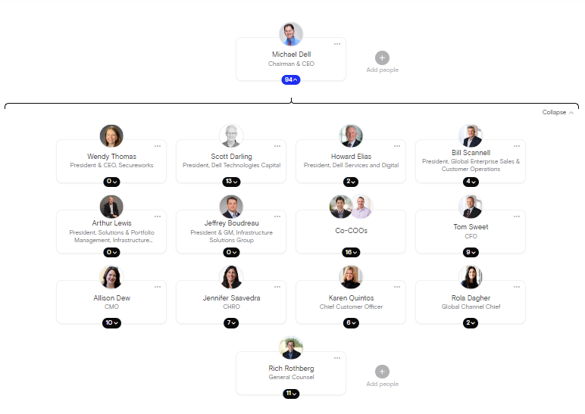

**Figure 2.1** *Dell Organization Chart*

Michael Dell is the founder, chairman, and chief executive of Dell. In 2016, dell altered the hierarchical leadership structure due to Dell's $67 billion acquisition of EMC. In the process, a new company known as Dell Technologies was formed. Some members of this executive group are responsible for independently operating Dell Technologies subsidiaries. Dell has two COOs beneath him besides Chief Officers for customers, marketing, services, human resources, global sales, operations, and finance.

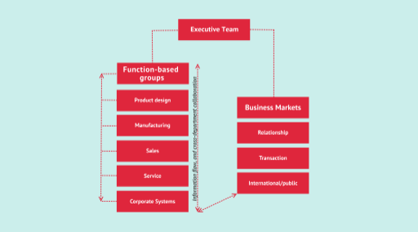

**Figure 2.2** *Dell Organization Structure*

Dell's organizational structure is functional and partially decentralized. This signifies that functional departments share information, offer ideas to the organization's development, and have some degree of decision-making authority. Consideration is given to function-based groups in three commercial marketplaces, each supported by functions from some or all categories. The organization is structured according to three large geographic areas and three within the Americas to boost sales effectiveness. After its 2016 acquisition of Dell Technologies, Dell's leadership structure was modified. Michael Dell returned to the job of CEO with a team of 14 executives directly report to him.

1. **PRODUCTS/SERVICES**

Dell Technologies, Inc. (Dell) provides desktop PCs, software, and peripherals. The company designs, develops, manufactures, markets, sells, and supports information technology infrastructure, such as laptops, desktops, mobiles, workstations, storage devices, software, cloud solutions, and notebooks. It sells products under the names of Dell, Pivotal, Dell EMC, SecureWorks, Alienware, and Virtustream. Dell also provides various financial services, including the origination, collection, and maintenance of customer receivables financing arrangements relating to the usage of its goods, software, and service solutions. Dell provides services to large businesses, the government, educational institutions, law enforcement agencies, healthcare organizations, and small and medium-sized companies. The company has a business presence throughout Europe, Africa, Asia-Pacific, and the Middle East.

1. **TECHNOLOGY**

Dell has the reputation of being one of the world's leading computer system businesses. Dell can earn industry-leading profits due to its adept utilization of information, communication, e-commerce, e-business, internet, and web technologies. Because of its incredibly efficient supply chain and distribution infrastructure, Dell can maintain its competitive advantage in the computer business.

Dell implements a Just-In-Time (JIT) inventory system, which operates on only six days of inventory. Dell is able to achieve greater profit margins and increased profits because of their inventory system. Operating only with six days of inventory allows Dell to reduce its expenses on hiring people to track and maintain inventory, warehousing, and holding on to obsolete technology. This allows Dell to free up cash flow to invest in other value-adding activities.

Customers are only allowed to order directly from Dell, hence the direct Model approach requires the firm to adopt a JIT inventory system. Dell's website, www.Dell.com, is used to accept customer orders. The organization focuses solely on direct sales, eliminating all other routes of distribution. This helps Dell to develop a closer relationship with its clients, enabling them to provide enhanced service, savings, convenience, and efficiency.

1. **BUSINESS, MARKETING, OPERATIONAL STRATEGY**

Today, the computer sector is undoubtedly the most crucial industry in the world. It is the foundation of all information technology and accounts for around 5% of the world's gross domestic product. As a tool, the computer is indispensable to numerous industries, ranging from telecommunications and consumer electronics to medical research and vehicles. IDC's Worldwide Quarterly PC Tracker stated that first-quarter 2008 PC shipments increased by 14.6% to 69.5 million units. However, the current state of the computer business differs significantly from that of twenty years ago. Every highly technological and innovative industry has trends and structures that change frequently, and the computer industry is one of them that requires businesses to stay abreast of the most recent technological developments.

Dell Inc. is one of the few companies that has been able to remain at the top of the market while having a difficult time due to the discrepancy between its strategy and the environment's rapid evolution. Build-to-order manufacturing, mass customization, supplier partnerships, just-in-time component inventories, direct sales, market segmentation, customer service, and extensive data and information sharing with supply partners and customers have been cornerstones of Dell's strategy since the company's inception. Today, however, Dell and other U.S. personal computer (PC) manufacturers are struggling to profit in a climate of lowering prices and intense global competition.

From an unorthodox PC startup to a worldwide technology giant, Dell's history is unified by an uncompromising dedication to the consumer. As a market-leading technology firm, Dell has an excellent long-term growth plan and a singular emphasis on customers. It was among the first laptop manufacturers to provide mass customization. DELL classifies its products and services according to psychographic and demographic criteria. It is intended for tech-savvy professionals and executives. In addition, it strengthens client engagement channels so businesses can get a competitive advantage. Dell is focusing on a solid connection with consumers and serviceability in the hardware and software business, which are the criteria that determine success. The strategy of Dell is worldwide. It understands that being geographically closer to the customer is crucial for executing its marketing strategy and expanding its customer base.

1. **FINANCIAL ACHIEVEMENTS**

Over the years, Dell Technologies has become a household name when it comes to dependable computers, laptops, processors, and more. As of August 2019, Dell Technologies had a net value of $23.4 billion. In its 36-year history, it's has had some Dell achievements. By this time, the company has already produced the fastest performing PC on the market and unveiled it at the Spring Comdex trade show. They follow that up by opening their first international subsidiary in the United Kingdom.

In 1988 Growing at 80% year-over-year, the company goes public. The company is named Dell Computer Corporation. With its newfound capital, it expands its global presence. It opens a manufacturing center in Ireland to meet demands in Europe, the Middle East, and Africa. In 2016 Dell merges with EMC to form Dell Technologies. It is the biggest tech deal in history, making Dell a global enterprise solutions powerhouse. Today, Dell Technologies is worth roughly $70 billion. They are a global leader in technology and synonymous with quality and excellent customer service.

1. **COMPANY ANALYSIS**

## **Strengths**

According to Dell.com, Dell Inc. claims to be the world's leading computer manufacturer. Dell is the world's leading PC manufacturer. In 2009, the company, which began with a $1000 investment, generated a net income of $2.47 billion. Dell has been the market leader for the past number of years. Dell's brands are among the most well-known and prestigious in the world. Dell circumvents intermediaries and sells straight to end users. It collects data on its loyal consumers through Customer Relationship Management strategies and information and communication technologies.

So, when a customer selects a specific PC model, it then adds things and upgrades based on the client's preferences until the PC meets the customer's exact requirements. The components used to assemble a computer are never manufactured by Dell, but rather by suppliers. Installing computers requires relatively inexpensive labor. Contacting customer service allows you to even track your delivery. When the goods are ready, a courier will deliver them to the customer.

## **Weaknesses**

Dell has a huge variety of devices and components manufactured by many suppliers and countries. Consequently, it is occasionally confronted with unanticipated challenges resulting from the many components employed in its products. It is a minor incident that occurred in 2004. Due to concerns that they could overheat and cause electric shocks or fires, Dell had to recall 4.4 million laptop adaptors. Dell's primary weakness is that it does not produce the product.

It depends on another manufacturer, purchases the goods from the supplier, and assembles the product according to the customer's preferences. In a case study of Dell, we find that the company's dependability is its primary flaw. Dell purchases its components from the selected manufacturer of high-tech components. Therefore, when a manufacturer or supplier who supplies Dell ceases production, Dell must absorb a substantial decrease in overall sales.

## **Opportunities**

In 2004, when Kevin Rollins replaced Michael Dell as chief executive officer, the corporation received new blood, management, vision, and strategy. Dell is pursuing its diversification strategy by developing many new goods. This could usher the firm into an era of even greater profitability.

In addition, it offers different services to its customers, such as three-in-one and two-in-one packages, such as computer peripherals when purchasing a Dell PC. It also manufactures non-computer products, including the iPod and other electronic brands. Therefore, Dell's non-computing products compete with those of others.

Through diversification, Dell can discover new markets and customers to sell its mass-market products. Dell cultivates low-cost price clients to sell its products to merchants worldwide. The manufactured PCs are unbranded and should not be identified as Dell when the buyer makes a purchase. Although a departure for Dell, rebranding and rebadging for retailers enables the corporation to target new market segments with the related marketing costs.

## **Threats**

The biggest threat for Dell incorporation is the competition in the existing global PC market. Well-respected firms such as IBM and COMPAQ are also employing the same marketing methods; therefore, Dell's ability to compete with identical products in the present global PC market is a growing problem.

Threats posed by competitors' retaliation and new market entrants exist for all lucrative brands. Dell obtains its raw materials from countries in the Far East with low labor prices. However, nothing prevents competitors from doing the same, including procuring identical or comparable components from identical or similar sources. Remember that Dell is a PC builder, not a PC producer.

Dell's dedication to client value, our team, being direct, operating responsibly, and ultimately winning continues to set us apart from other businesses. The Background section gives essential facts and an overview of Dell's company history. Economic aspects; The recession lowers consumer spending and diminishes disposable income. In a variety of methods, Dell Inc. handles these concerns. It manages vulnerabilities and threats to achieve a successful conclusion.

1. **FINDINGS AND DISCUSSION**

To execute the solution, Dell must clearly understand the fundamental issue and begin by developing a programme with its employees. Dell must know its obstacles and why it must enhance its competencies and innovations. The greatest starting point is a programme that explains the company's culture, aims, and threats to employees. In addition, Dell will provide employees with a more dynamic and open work atmosphere to encourage creativity and development. Once the company has begun working to improve its services/products, it may begin advertising to the public and showcasing its progress. Using its core skill (custom-built computer services) will aid in customer acquisition, as many of the company's customers have been loyal for years. Additionally, Dell is a seasoned company with a substantial market share among its competitors.

Now is the time to implement the employee training and in-house education portion of the plan. It may take employees some time to integrate the changes and work towards the new goals. In contrast, innovation and custom computer development might be more time-consuming. The optimum outcome is for Dell to regain its lost market share and continue to expand. The employee turnover rate should decrease, and employee motivation should be boosted. Dell will then be more lucrative and able to maintain the satisfaction of its stakeholders.

1. **CONCLUSION**

Overall, we can see a lot of improvement that dell can make in dealing with the problems they face. Through swot analysis, we can also identify strengths, weaknesses, opportunities and threats, which Dell can use to deal with all the problems. Through this case study, we can find out that the incident that occurred in 2004 has become a weakness for dell where there are problems with their products. From the event, dell has focused on producing products so that such events do not repeat.

This case study indirectly shows us how to conduct a company analysis. SWOT analysis has helped me comprehend a business company's analysis, which is a critical component of a business company for achieving the most significant progress for that business. In addition, this case study taught me to consider the current technology that can be used by a firm based on their difficulty so that their organization may operate efficiently.

1. **RECOMMENDATION AND IMPROVEMENT**

Dell must include more of its partners in the system, from raw material to supply chain partners, to use a powerful JIT method. Since numerous partners are involved in creating Dell products, JIT shouldn't be restricted to only the manufacturing and assembly facilities. If these things are done, there will be more income and more value added to the products and everyone involved. An excellent example is Dell allowing its suppliers to store raw materials directly at the manufacturing facilities. This will lower the cost of transporting expensive commodities from supply hubs to production locations. This is crucial in ensuring that the business doesn't lose time processing customer orders.

Another recommendation is for Dell to improve the effectiveness of its lean management; Dell must integrate JIT Scheduling into its JIT procedures. JIT mechanisms operate rapidly for orders and production schedules that can only be controlled by minor adjustments to orders and production plans. As it helps to change order and delivery schedules, JIT scheduling will assist the business in lowering inventory to the lowest working levels. Initiating frequent orders for supplies and short production runs can help increase communication throughout the supply chain.

1. **REFERENCES**

Gennaro-Cuofano. (2022, August 21). *Dell organizational structure*. FourWeekMBA. Retrieved November 11, 2022, from https://fourweekmba.com/dell-organizational-structure/

Anderson, M. C., Ellingsen, T., Saldanha, T. J. V., Xue, L., Dewan, S., Mithas, S., Dutta, S., Levina, N., Banker, R. D., & Ang, S. (2000, April 1). *Executive compensation in the Information Technology Industry*. Management Science. Retrieved November 10, 2022, from https://pubsonline.informs.org/doi/10.1287/mnsc.46.4.530.12055

*Dell Case Study*. Studymode. (n.d.). Retrieved November 10, 2022, from https://www.studymode.com/essays/Dell-Case-Study-1927445.html

*A history of achievements: A timeline of Dell Technologies*. Recompute. (n.d.). Retrieved November 10, 2022, from https://www.recompute.com.au/blog/a-history-of-achievements-a-timeline-of-dell-technologies/

Jurevicius, O. (2022, July 11). *Dell Company SWOT analysis 2022 - SM insight*. Strategic Management Insight. Retrieved November 11, 2022, from https://strategicmanagementinsight.com/swot-analyses/dell-swot-analysis/

*Problem analysis to manage and enhance customer-supplier relationships*. Problem analysis to manage and enhance customer-supplier relationships - Dell Community. (2010, December 1). Retrieved November 10, 2022, from https://www.dell.com/community/New-to-Dell-Community/Problem-analysis-to-manage-and-enhance-customer-supplier/td-p/3552659

Razo. (2020, February 9). *Dell case study - analysis - internal challenges*. Slick College Tips. Retrieved November 10, 2022, from https://slickcollegetips.com/index.php/2020/02/17/dell-case-study-analysis-internal-challenges/

1. **APPENDICES**

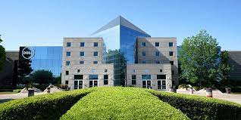

**Figure 8.1** *Dell headquarters*

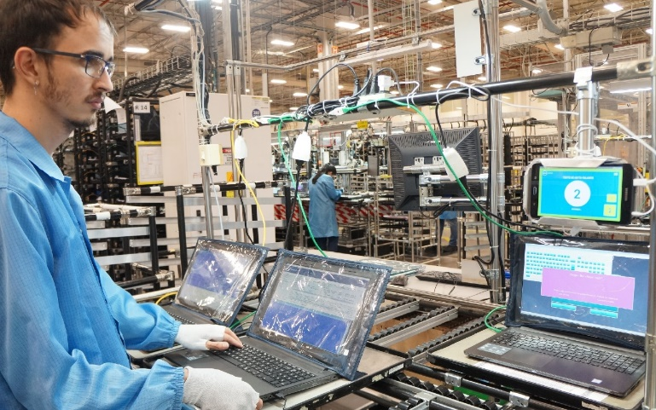

**Figure 8.2** *Dell Factory*

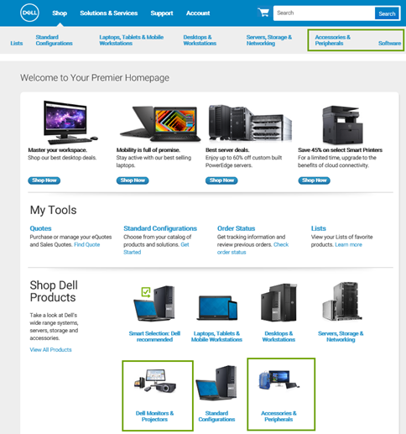

**Figure 8.3** *Dell Website*