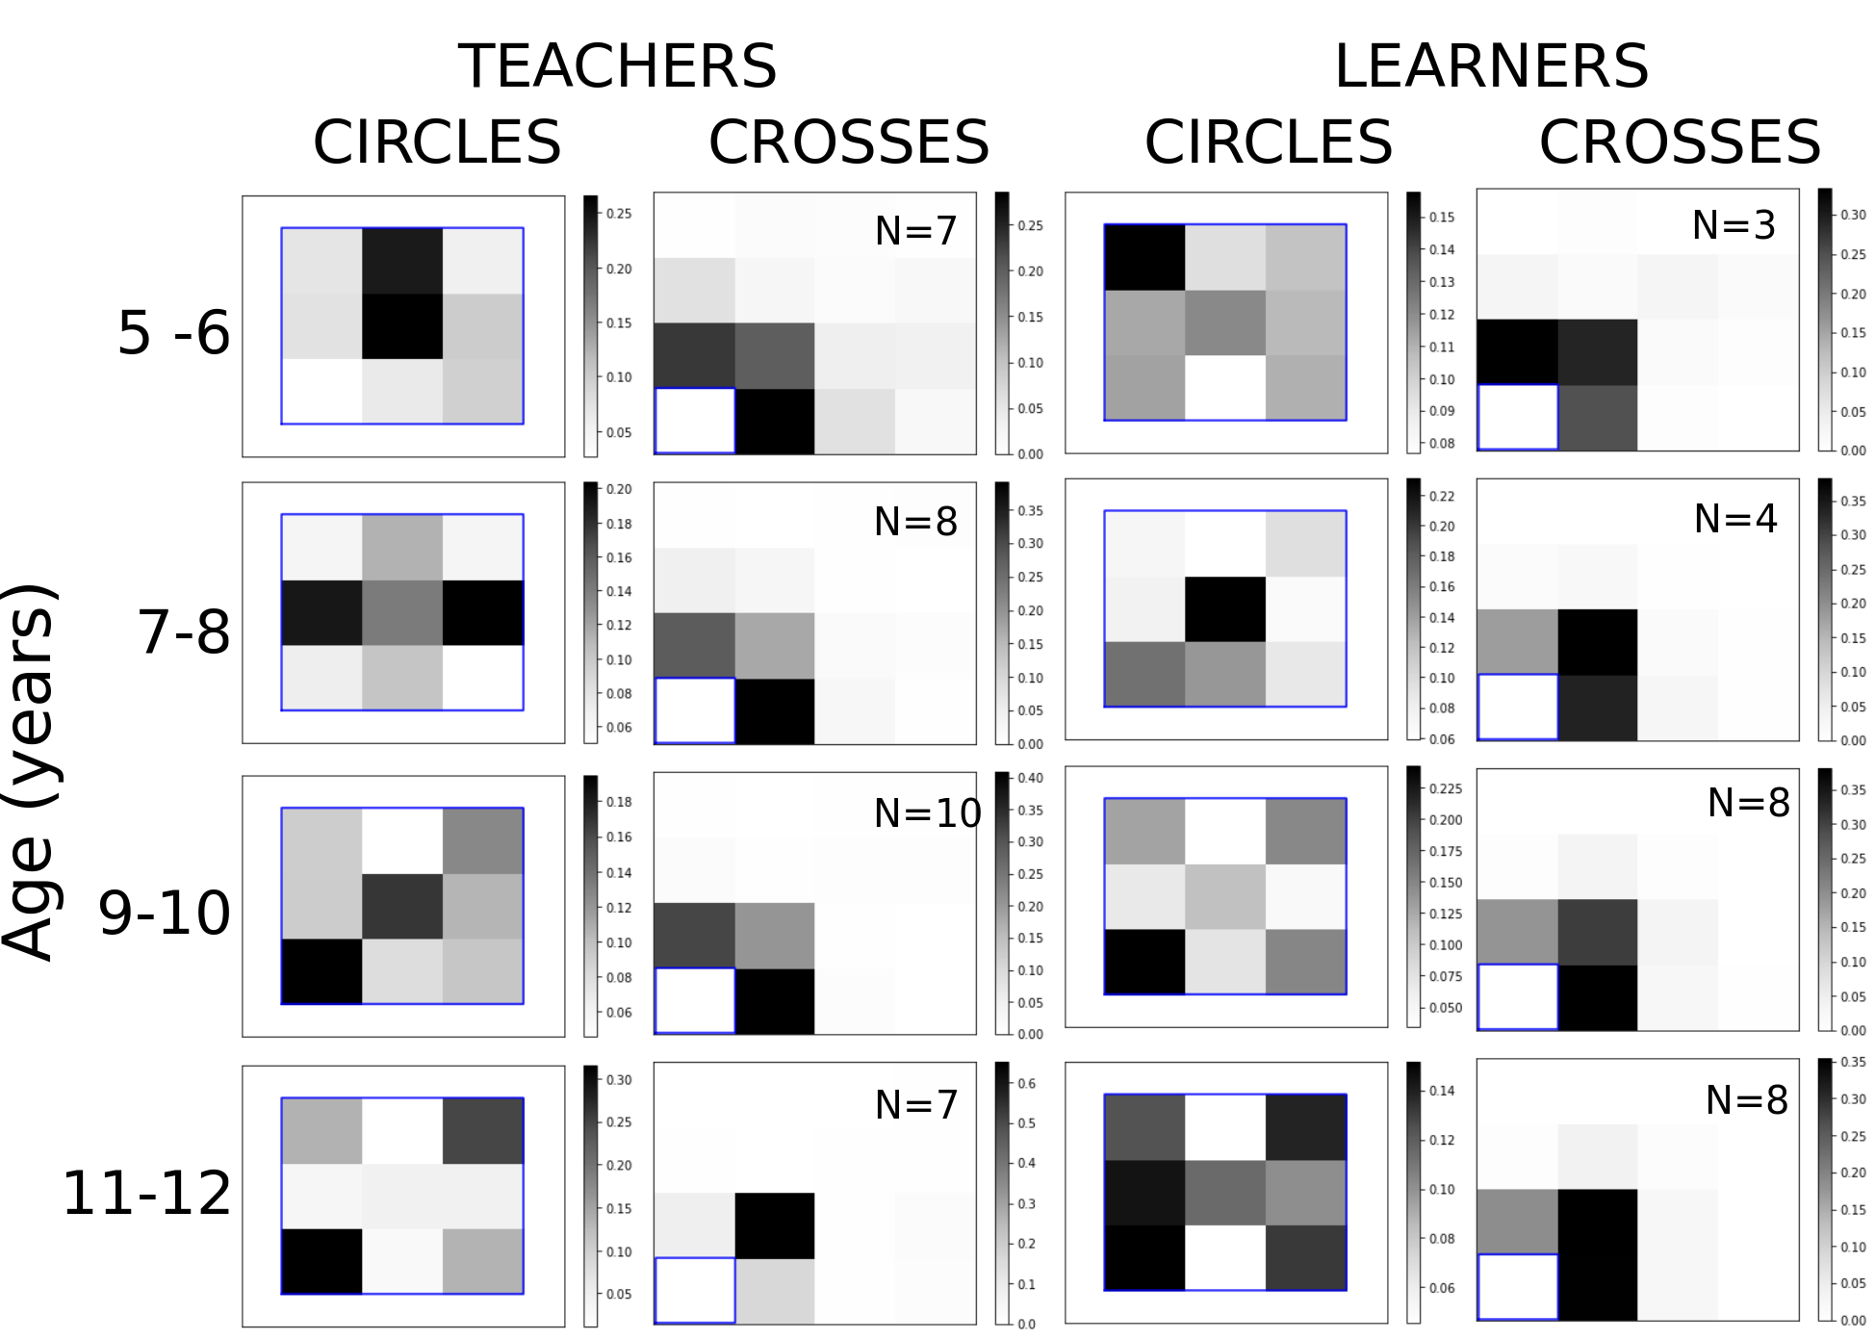
Figure 1: Histograms showing the position of samples relative to the blue rectangle. The circles were samples inside and crosses were samples outside the rectangle. The rectangle size and position varied from trial to trial. To compare trials we build the histograms for circles by dividing each rectangle into a 3x3 grid. The total number of samples tallied for all trials in each cell of the grid were averaged across players. The histograms for crosses were build by dividing the space outside the rectangle as follows: for each of the four sides we divided the area between the edge of the rectangle and the nearest border of the canvas in three bins. For one quadrant, this results in 15 bins, 3 to each side of the rectangle, and 9 for the intersection of these bins extending diagonally from the rectangle. The four cuadrants were summed for statistical purposes. Most of the children completed 50 trials. In each histogram N is the number of children. 32 children played the teacher rol and 23 the learner rol, but some of them played both roles. 6 out of 32 had played learner before teacher and 7 out of 23 had played teacher before learner.

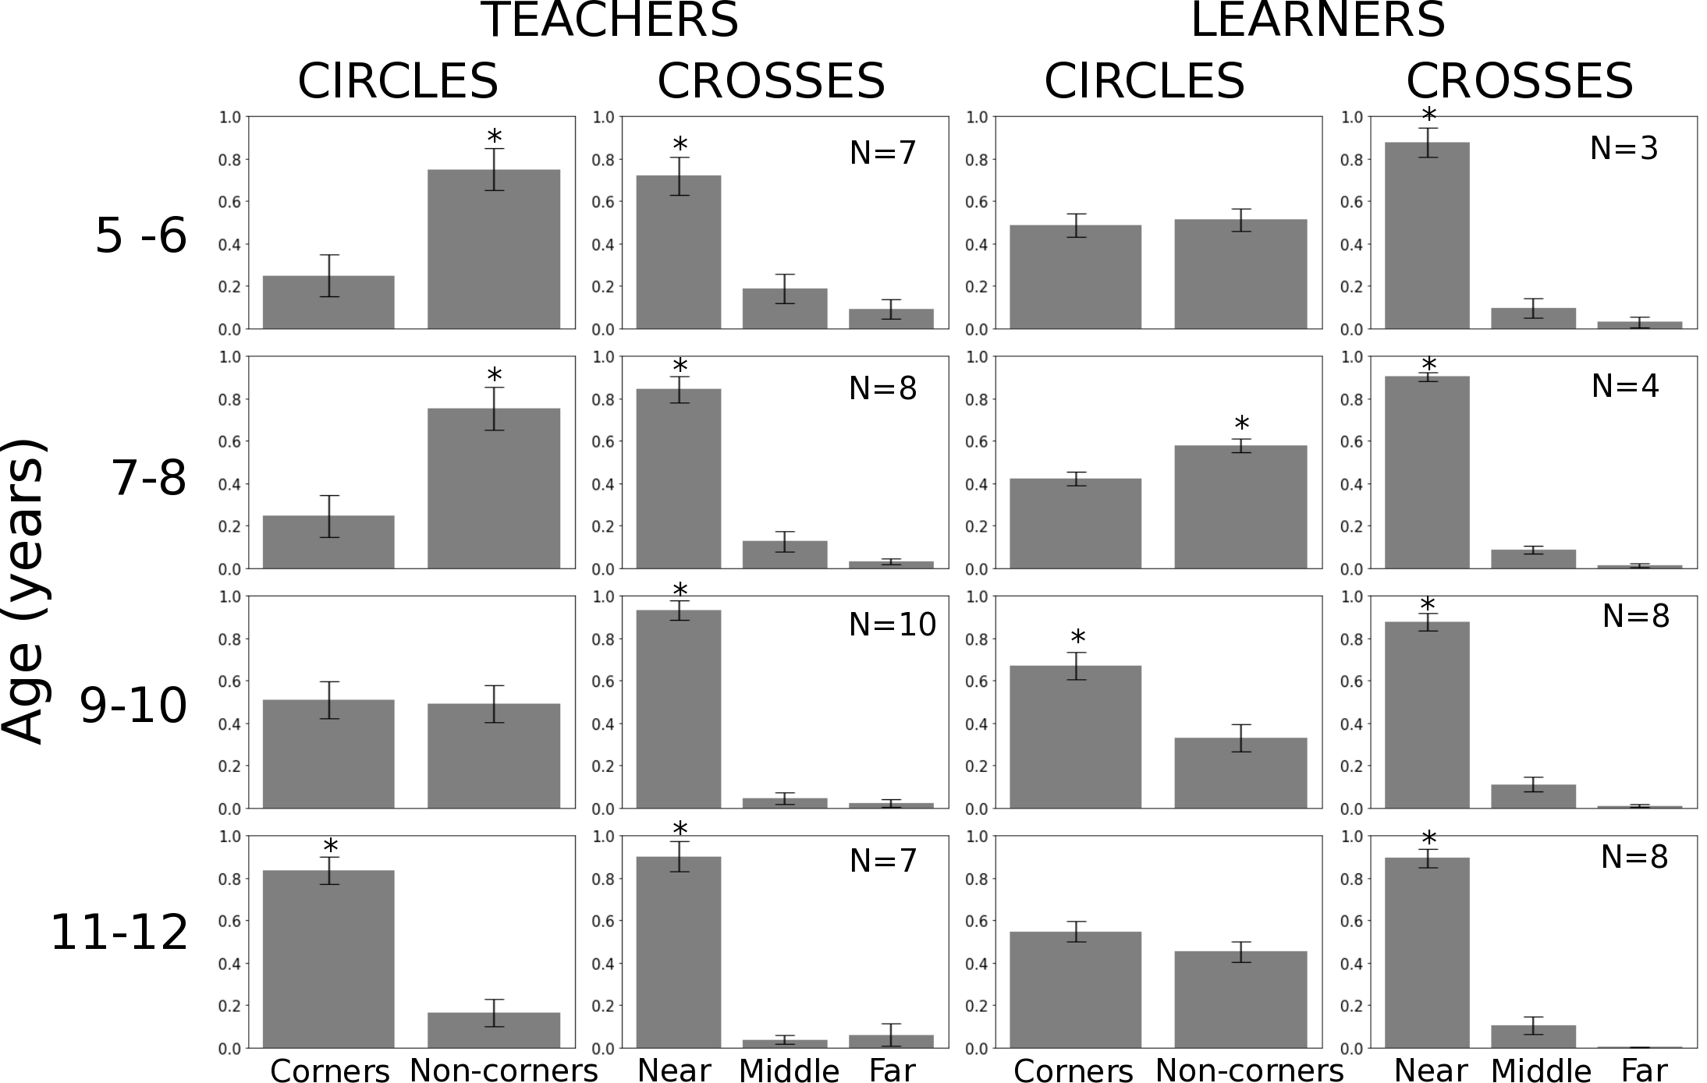
Figure 2: Mean proportion of circles lying in the corners vs non corners of the rectangle; and mean proportion crosses at a distance near, middle and far from the edges of the rectangle. Statistical differences were assessed by a ttest for Corners vs non corners (p<0.05) and one way anova followed by post-hoc tukey’s test for near vs middle vs far (p<0.05).

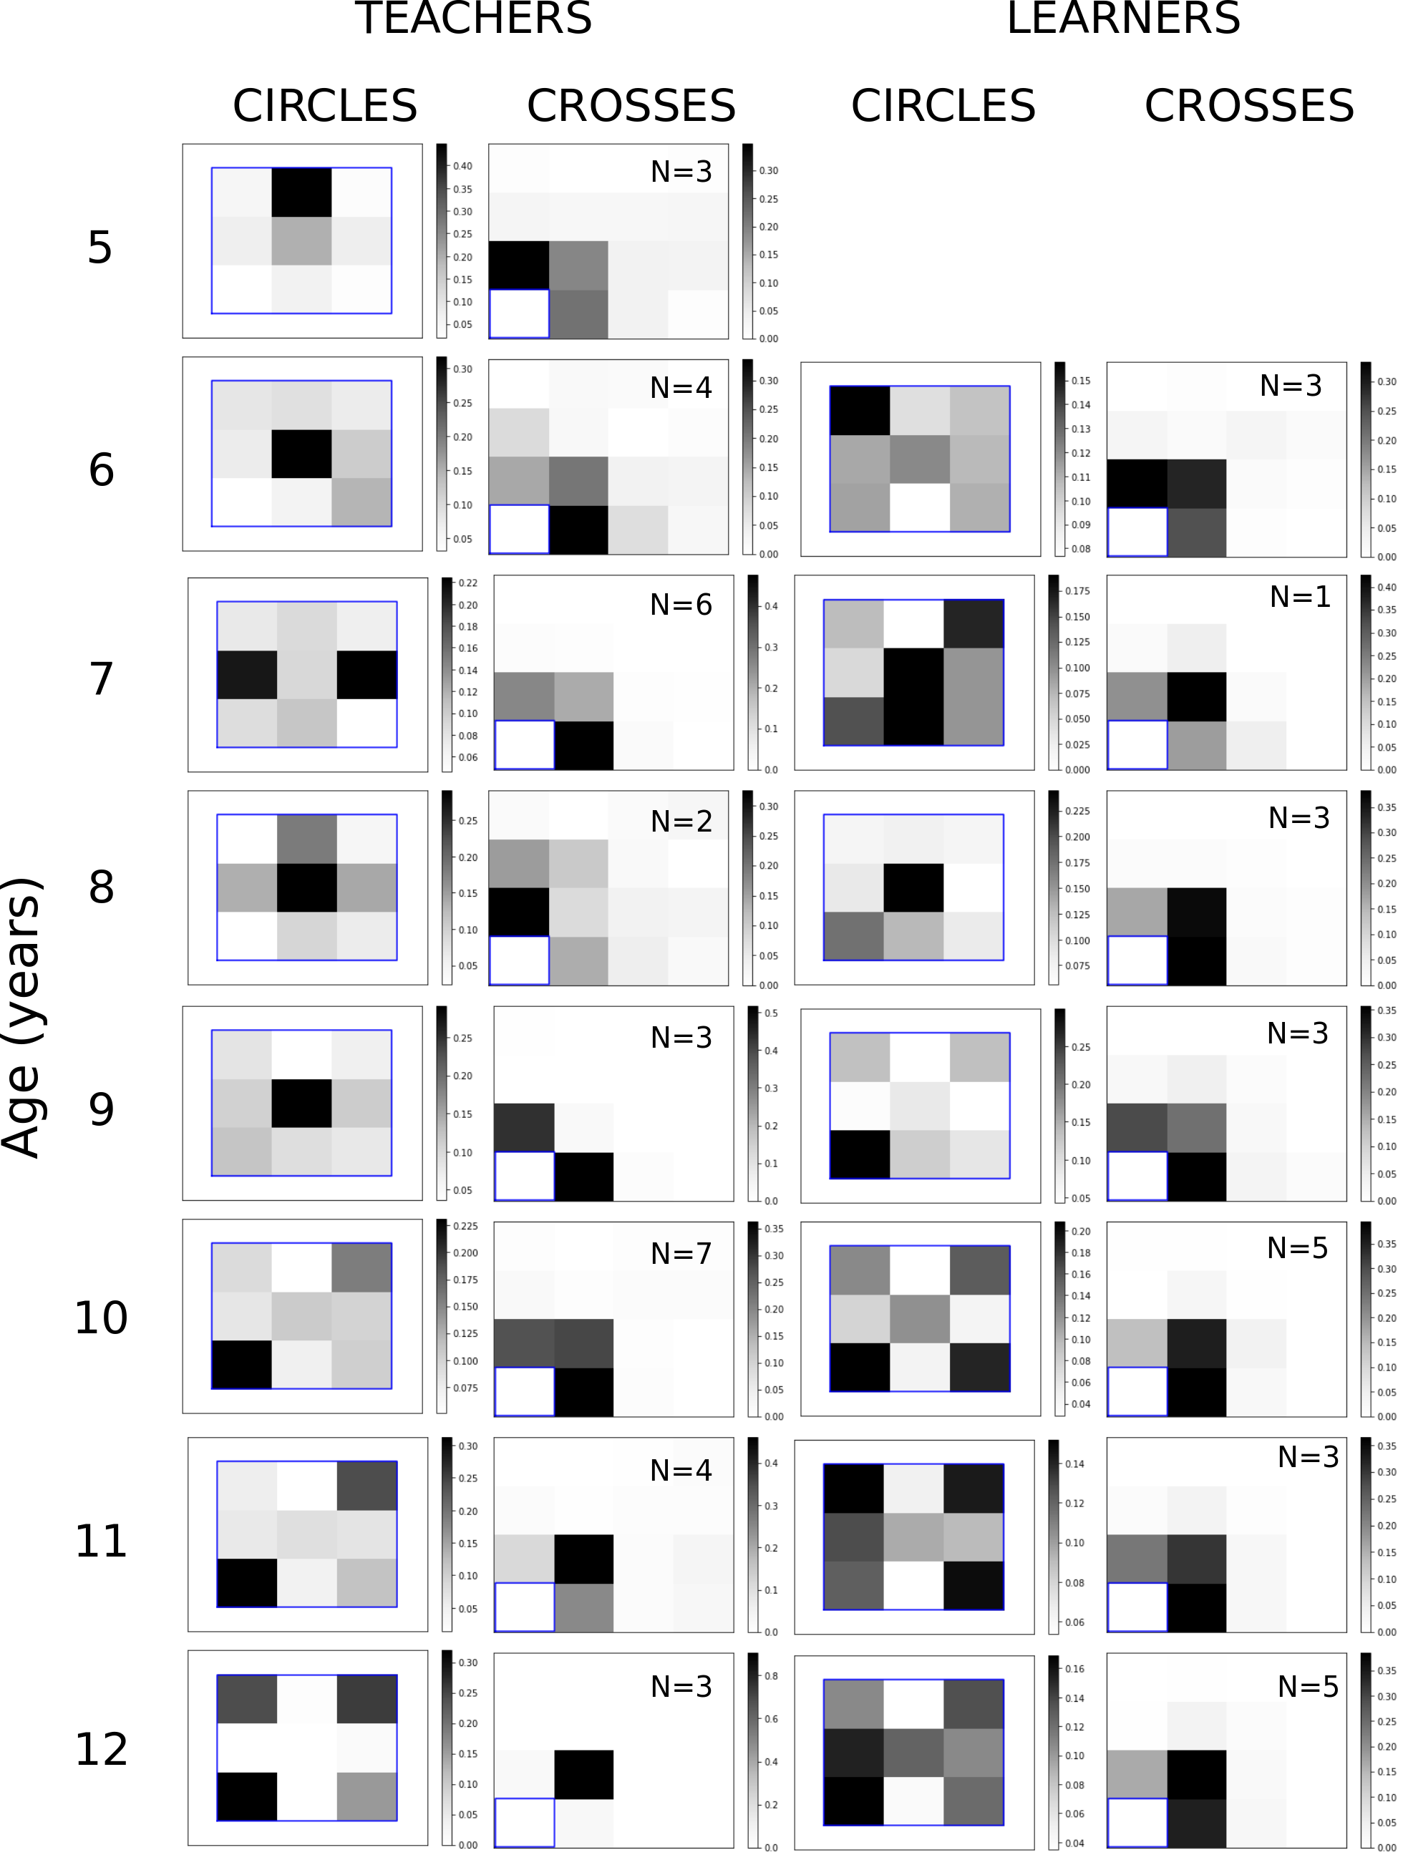
Figure 3: Same as figure 1 grouping ages at a finer scale.
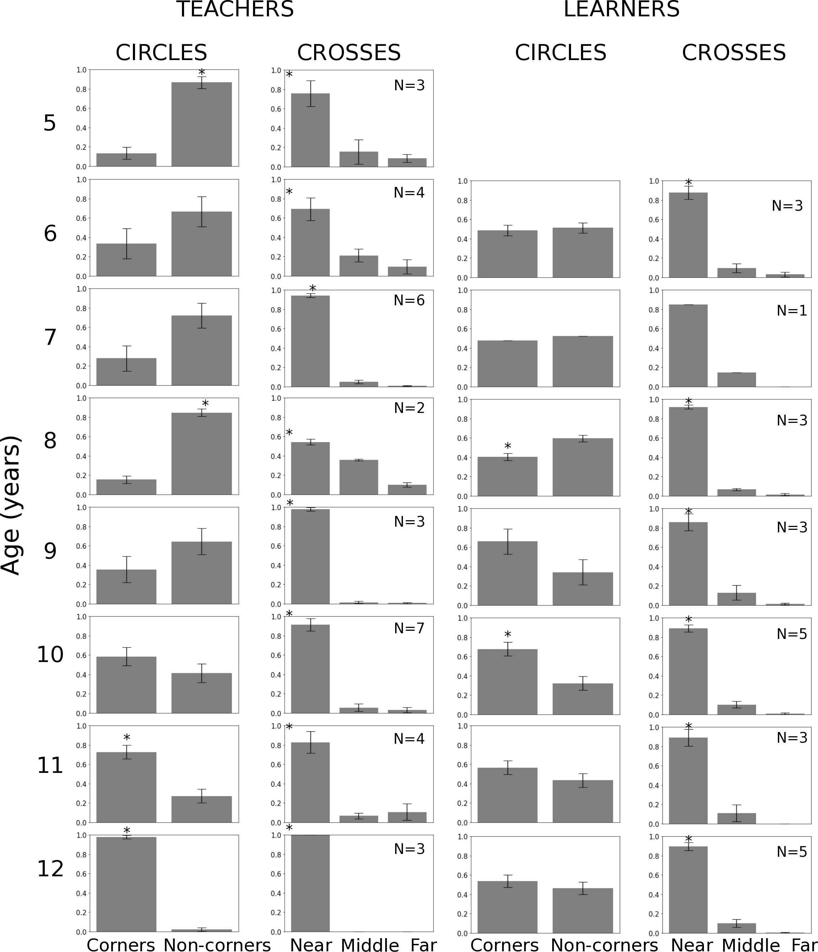
Figure 4: Same as figure 2 grouping ages at a finer scale.

