ClubUML
Test Plan Document

Version 1.3

Table of Contents

1. Introduction 4
2. Reference Material 6
3. Test Items 6
3.1 Unit Test 7
3.2 Integration Test 8
3.3 User Acceptance Test 9
3.4 Operational Readiness Test 9
4. Test Execution Procedures 10
4.1 Unit Test 10
4.1.1 Unit Test Entry Criteria 10
4.1.2 Unit Test Plan Exit Criteria 10
4.1.3 Suspension and Resumption Criteria 10
4.2 Integration Test 10
4.2.1 Integration Test Entry Criteria 10
4.2.2 Integration Test Plan Exit Criteria 11
4.2.3 Suspension and Resumption Criteria 11
4.3 User Acceptance Test 11
4.3.1 User Acceptance Test Entry Criteria 11
4.3.2 User Acceptance Test Plan Exit Criteria 11
4.3.3 Suspension and Resumption Criteria 12
4.4 Operational Readiness Test 12
4.4.1 Operational Readiness Test Entry Criteria 12
4.4.2 Operational Readiness Test Plan Exit Criteria 12
4.4.3 Suspension and Resumption Criteria 12
5. Bug Tracking/Bug Process 13
6. Test Deliverables 13
7. Roles and Responsibilities 14
Development Team 14
Testing Team 14
8. Test Schedule 15
9. Test Environment 16
7.1 Unit Test 16
7.2 Integration Test 16
7.3 User Acceptance Test 16
7.4 Operational Readiness Test 17
10. Plan Approvals 17

Revision History

Version | Date | Description | Author
1.0 | 12/01/2012 | Initial Draft – Test plan template | Soumya Tripathy
1.1 | 12/01/2012 | Final Test plan | Soumya Tripathy
1.2 | 12/07/2012 | Implemented the steps for Unit and Integration Testing | Prathamesh Bhagat
1.3 | 12/07/2012 | Formated the final draft of the Test Plan with necessary changes | Soumya Tripathy

1. Introduction

This document is a high-level overview defining our testing strategy for the ClubUML application. Its objective is to communicate project-wide quality standards and procedures. It portrays a snapshot of the project as of the end of the planning phase. This document will address the different standards that will apply to the unit, integration and system testing of the specified application. We will utilize testing criteria under the black box, and system-testing paradigm. This paradigm will include, but is not limited to, the testing criteria, methods, and test cases of the overall design.

1.1 Objectives
The objective of our test plan is to find and report as many bugs as possible to improve the integrity of our program. Although exhaustive testing is not possible, we will exercise a broad range of tests to achieve our goal. We will be testing ClubUML application, a web-based tool to upload and compare different versions of a UML diagram. User uploads a diagram and the tool compares the diagram with another already uploaded diagram and report the similarities and differences to the user, thereafter user will make decisions on how to modify their diagram based on the report provided by the tool.
The ClubUML Test Plan also supports the following specific objectives:
- Identifies items that should be targeted by the tests.
- Identifies the motivation for and ideas behind the test areas to be covered.
- Outlines the testing approach that will be used.
- Identifies the required resources and provides an estimate of the test efforts.
- Lists the deliverable elements of the test project.

1.2 Testing Strategy
The purpose of the Test plan for the ClubUML application is to provide a central artifact to govern the strategic approach of the test effort; it defines the general approach to be employed when testing the application and when evaluating the result of that testing.

Testing will consist of several phase, each phase may or may not include testing of more of the following aspects of the ClubUML application:
- Accessibility
- Availability
- Coding standards
- Compatibility
- Content
- Functional
- Navigation
- Performance
- Reliability
- Scalability
- Security
- Usability
The testing will use a combination of manual and automated testing, due to the limited duration of the testing; only automated tools that are already familiar to the testing resources will be used.
Due to the lack of available tools and time, no attempt will be made to collect more sophisticated test metrics.

1.3 Scope
ClubUML Test Plan will cover the following testing activities as identified in the testing strategy:
- Unit Test
- Integration Test
- User Acceptance Test
- Operational Readiness Test

2. Reference Material

Applicable references are:
- ClubUML Architecture Document
  - Architectural Framework
- ClubUML Design Document
  - Upload Sequence Diagram
  - Compare Sequence Diagram
- ClubUML Use case documents
  - Login use case
  - Upload diagram use case
  - Download diagram use case
  - Display diagram use case
  - Compare Diagram use case
  - Promote Diagram use case

3. Test Items

The items below identify the test items ⎯ software, hardware, and supporting product elements ⎯ that have been identified and excluded as targets for testing. This represents what items will and will not be tested.
The purpose of the test for the ClubUML application is to eliminate any problem before the application change goes to production. The scope of the test will be limited to the web application software and related database component.

3.1 Unit Test

3.1.1 Overview
The unit test is performed during construction phase by application developers. The unit testing is the initial testing of new and/or changed code in the system. In this case, it will be all the code done for the first release of the ClubUML.
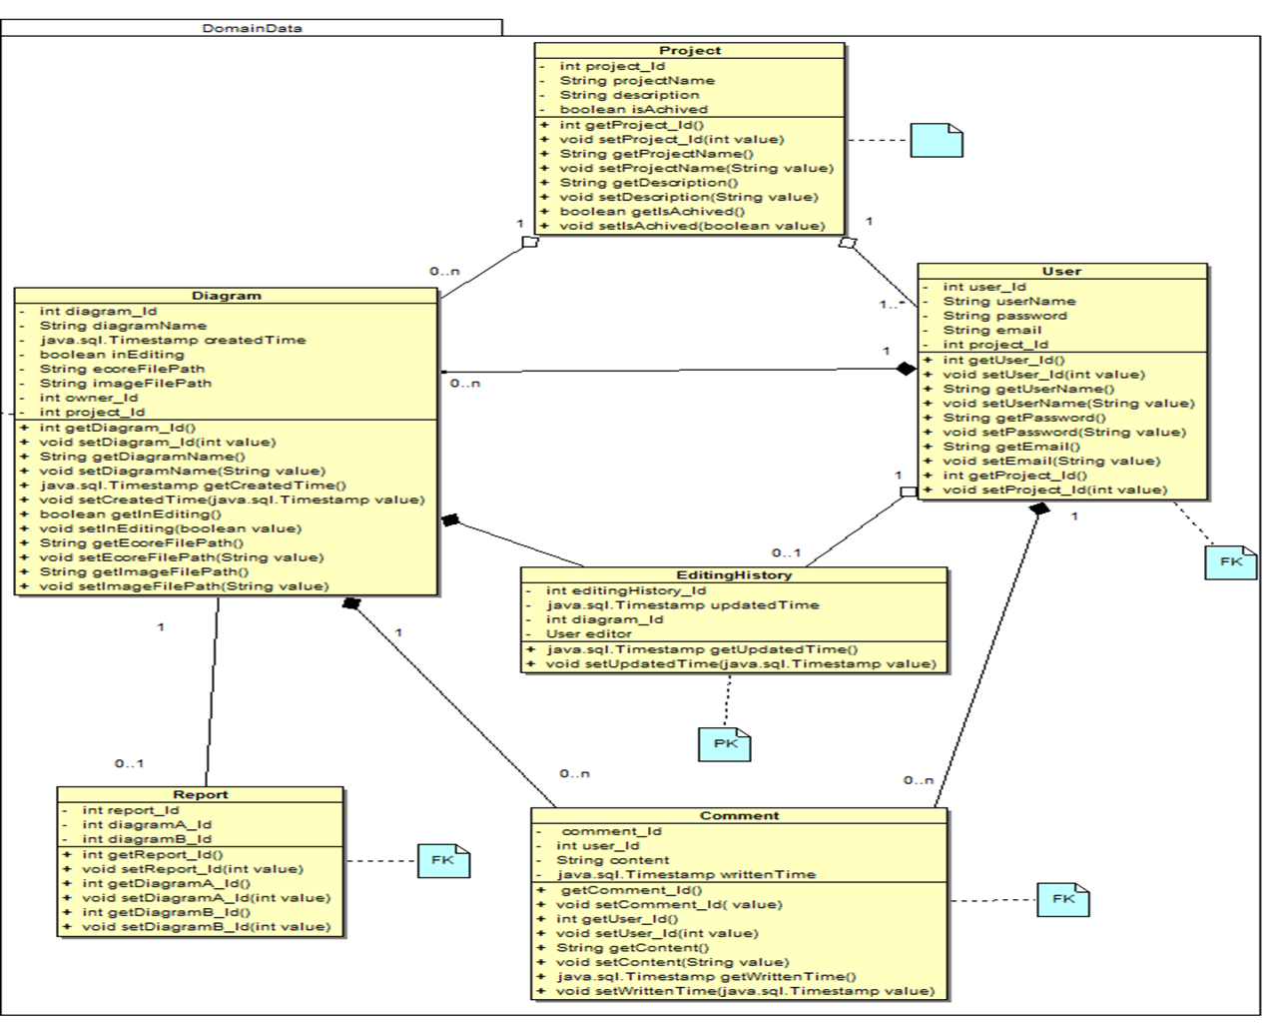

3.1.2 Items Tested
- Verify each JSP page displays correctly according to the design document.
- Verify each action form bean supports all the values in JSP pages and comply with design model.
- Verify all the action classes correctly implement the design model.
- Verify that the path of the Report generated after comparison of the diagram is valid or not.
- Verify whether the png files are created for every ecore files.
- Verify if the session variables are set after each successful login to the system.

3.1.3 Items Not Tested
All items will be tested. To ensure previously existing functionality was not adversely impacted, regression testing will be performed to all previous releases.

3.2 Integration Test

3.2.1 Overview
Integration testing confirms that each piece of the application interacts as designed and that all functionality is working. Integration testing includes interactions between all layers of the application, including interfaces to other applications, as a complete end-to-end test of the functionality.
The development team will be responsible for the creation of the integration test scripts in accordance to the integration test plan.
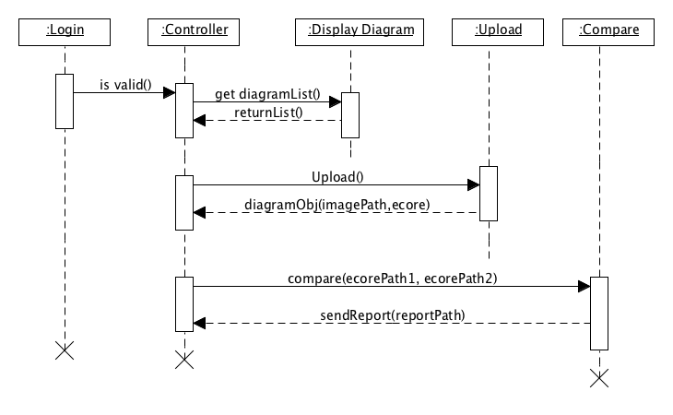

3.2.2 Items Tested
- Verify Login Use Case
- Verify Upload diagram Use Case
- Verify Download diagram Use Case
- Verify Display diagram Use Case
- Verify Compare diagram Use Case
- Verify Promote diagram Use Case

3.2.3 Items Not Tested
- Load testing will not be performed due to the low volume of concurrent users.

3.3 User Acceptance Test
3.3.1 Overview
The purpose of user acceptance testing (UAT) is to simulate the business environment and emphasize security, documentation, and regression tests.
UAT shall be conducted to gain acceptance of all functionality from the user community. UAT shall verify that the system meets user requirements as specified.

3.3.2 Items Tested
The same items as listed under Integration Test.

3.3.3 Items Not Tested
The same items as listed under Integration Test.

3.4 Operational Readiness Test

3.4.1 Overview
The purpose of operational readiness testing is to identify any potential issues with the production environment setup before users access the system.
Operational readiness testing shall verify that the application move from the acceptance environment to the production environment was successful. The ClubUML development team will be responsible for creating the operational readiness test script and performing operational readiness testing.

3.4.2 Items Tested
Testing following item will be enough to know if there is any environment problem.
- Verify the Database connectivity
- Verify whether the Server is up and in running.
- Verify if all the files have been deployed on the Server.

3.4.3 Items Not Tested
Because the purpose of this test is just to verify the connectivity and configuration of the application server and database server, there is no need to test all use cases.

4. Test Execution Procedures

4.1 Unit Test

4.1.1 Unit Test Entry Criteria
The criteria that determine when unit testing can begin include the following:
- Completed Code Units
- Completed Unit Test Scripts
- Database modifications are complete and tables are populated with initial data

4.1.2 Unit Test Plan Exit Criteria
The criteria that determine when the unit testing is complete, or that continued execution provides no further benefit, include the following:
- Completed Peer Code Review
- Successful execution of the Unit Test Script
- No issues of any severity remaining from unit testing unless the issue is determined to be low impact, low risk.

4.1.3 Suspension and Resumption Criteria
No special criteria for suspension and resumption of unit testing are required. The unit tester will use their best judgments to determine if coding changes are needed before testing can be completed. The tester should keep in mind that the entire unit test script must be completed with one version of the code.

4.2 Integration Test

4.2.1 Integration Test Entry Criteria
The criteria that determine when integration testing can begin include the following:
- No critical or major severity issues remaining from unit testing
- Completed Integration Test Scripts
- Correct version of the application is moved into the integration testing environment
- Database modifications are complete and tables are populated with initial data
- Test user ids have been established

4.2.2 Integration Test Plan Exit Criteria
The criteria that determine when the integration testing is complete, or that continued execution provides no further benefit, include the following:
- Successful execution of Integration Test Scripts
- No open critical, major or average severity issues unless the issue is determined to be low impact, low risk.

4.2.3 Suspension and Resumption Criteria
When a defect is detected during Integration Testing, testing should halt and the tester should log the defect. The tester should then review with the development team for determination of error and severity. If the defect is not critical or major severity then testing may continue.
To resume a suspended test, the defects must be corrected and the application promoted to the testing environment. Initialization steps may be required to resume the test script depending on where the defect occurred.

4.3 User Acceptance Test

4.3.1 User Acceptance Test Entry Criteria
The criteria that determine when user acceptance testing can begin include the following:
- No critical or major severity issues remaining from unit testing
- Completed User Acceptance Test Scripts
- Correct version of the application is moved into the user acceptance testing environment
- Database modifications are complete and tables are populated with initial data
- Test user ids have been established

4.3.2 User Acceptance Test Plan Exit Criteria
The criteria that determine when the user acceptance testing is complete, or that continued execution provides no further benefit, include the following:
- Successful execution of User Acceptance Test Scripts
- No open critical, major or average severity issues unless the issue is determined to be low impact, low risk.

4.3.3 Suspension and Resumption Criteria
When a defect is detected during User Acceptance Testing, testing should halt and the tester should log the defect in a defect report. If the defect is not critical or major severity then testing may continue.
To resume a suspended test, the defects must be corrected and the application is promoted to the testing environment. Initialization steps may be required to resume the test script depending on where the defect occurred.

4.4 Operational Readiness Test

4.4.1 Operational Readiness Test Entry Criteria
The criteria that determine when operational readiness testing can begin include the following:
- No critical or major severity issues remaining from any testing
- Completed Operational Readiness Test Scripts
- Correct version of the application is moved into the production environment
- Database modifications are complete and the county category table is populated with initial data

4.4.2 Operational Readiness Test Plan Exit Criteria
The criteria that determine when the operational readiness testing is complete, or that continued execution provides no further benefit, include the following:
- Successful execution of Operational Readiness Test Scripts
- No open critical, major or average severity issues unless the issue is determined to be low impact, low risk.

4.4.3 Suspension and Resumption Criteria
When a defect is detected during Operational Readiness Testing, testing should halt and the tester should log the defect. If the defect is not critical or major severity then testing may continue.
To resume a suspended test, the defects must be corrected and the application is promoted to the testing environment. Initialization steps may be required to resume the test script depending on where the defect occurred.

5. Bug Tracking/Bug Process

During testing, the testing team members normally encounter behavior that goes against a specified or implied design requirement in the product. When this happens, we will document and reproduce the bugs for the developers.

Expectation of a bug:

- Keep track of what version of the application the bug is found
- Determine if bug has already been written up
- Indicate the steps to reproduce the bug – write enough details for others looking at the bug to be able to duplicate it; exclude unnecessary steps
- Actual results – be specific on your findings.
- Expected results – how the application should behave based on the specified or implied requirements.
- Implications – How does the defect affect the quality of the application?

The following chart defines the impact levels to be used when entering bugs.

Impact | Definitions
1 – Fatal | Test Stopper: If you can’t access a function and need the bug to be fixed immediately. The defect prevents QA from testing the feature area, sub-area or functionality of the feature.
2 – Serious | Beta Stopper: This is a bug that users would experience such as: data corruption, calculation errors, incorrect data and system crash on common user scenarios, significant QA risk, and major UI defects.
3 – Minor | Live Release: A bug that must be fixed before the product is officially completed or crashes, content, and UI and graphic changes required for release.

6. Test Deliverables
The deliverables for all testing phases are the completed test cases, test scripts and test logs along with the bug report or the defect log. Any additional information validating the results of test scripts should be attached to the testing documentation, such as table printouts for data or screenshots of web pages. Once all testing documents have been completed, the application can be deemed ready for production use.
- The unit test will not produce any deliverable. But the developer may raise a problem as an issue in the risk and issue log if the problem cannot be fixed with the coding.
- The integration test will have test results logged in the test script document.
- The acceptance test team will produce the test report document.

7. Roles and Responsibilities

Development Team
Code Development Project Leader
- Ensure Phase 1 is delivered to schedule and quality
- Ensure exit criteria are achieved prior to system test signoff
- Regularly review testing progress with test planner.
- Raise and manage issues/risks relating to project or outside test teams control.
- Review and sign off test approach, plans and schedule.

Testing Team

Test Planner
- Ensure Phase 1 is delivered to schedule and quality
- Produce high level and detailed test conditions
- Produce expected results
- Report progress at regular status reporting meetings
- Co-ordinate review and signoff of test conditions
- Manage individual test cycles and resolve tester queries/problems.

Lead Tester
- Identify test data
- Execute test conditions and mark-off results
- Prepare software error reports
- Administrate error measurement system
- Ensure test systems outages/problems are reported immediately and followed up.
- Ensure entrance criteria are achieved prior to system test start.
- Ensure exit criteria are achieved prior to system test signoff.

8. Test Schedule

The key dates for overall ClubUML development and Testing are outlined below.

ClubUML Milestones | End Date | Notes | QA Deliverables/Roles
Planning Phase |  | High level planning should be completed. | High-level test planning activities, which include preliminary development of Test Plan.
Design Phase |  | The requirements and initiatives are further defined and solutions are finalized. | Inspection and reviewing the requirements and design documents.
Code Complete  -Infrastructure |  | Infrastructure development and functions should be complete. | Final Stage of Test Plan and test cases
Code Complete  -Function |  | Unit testing and code review of each function component prior to checking the code into the test phase. | Final Stage of Test Plan, test cases and other QA documents related to test execution for each feature or component such as test scenarios, expected results, data sets, test procedures, scripts and applicable testing tools.
Feature Complete |  | Feature clean up to verify remaining bug fixes and regression testing around the bug fixes. | All bugs verified and QA documentation is finalized.
Regression Test |  | All code and GUI interface to the ClubUML is ready for Regression Testing. | Complete regression test execution of the application and update Test Summary Reports for regression.
Go Live |  | Application is out. | Any unfinished Testing documents should be complete.

9. Test Environment

7.1 Unit Test
 | Workstations | Application Server | Database Server
Name |  | Local host | MySQL
Software | Apache Tomcat | Apache Tomcat | MySQL
Physical Location | Individual Laptops | Individual Laptops | Individual Laptops
URL/Database | Local host | Local host | Local host

7.2 Integration Test
 | Workstations | Application Server | Database Server
Name |  | RHO | MySQL
Software | Apache Tomcat | Apache Tomcat | MySQL
Physical Location | Individual Laptops | NEU campus | NEU campus
URL/Database | Local host | Rho.coe.neu.edu | Local host

7.3 User Acceptance Test
 | Workstations | Application Server | Database Server
Name |  | RHO | MySQL
Software | Apache Tomcat | Apache Tomcat | MySQL
Physical Location | Individual Laptops | NEU campus | NEU campus
URL/Database | Rho.coe.neu.edu | Rho.coe.neu.edu | Rho.coe.neu.edu

7.4 Operational Readiness Test
 | Workstations | Application Server | Database Server
Name |  | RHO | MySQL
Software |  | Apache Tomcat | MySQL
Physical Location |  | NEU campus | NEU campus
URL/Database | Rho.coe.neu.edu | Rho.coe.neu.edu | Rho.coe.neu.edu

.

10. Plan Approvals

Project Coordinator | Mitch Kokar
Project Manager | Tony
Development Manager
Team/Group Lead
Test Manager
Test Lead

