Author: Richard Do
Date: 1/20/2013
Version 0.1 (First draft)

This document is for setting up ClubUML on a local Windows machine. Please send any questions, comments, suggestions and errors to rdo524@gmail.com.

Prerequisite software:
GraphicViz (http://www.graphviz.org/Download..php)
MySQL Community Server (http://dev.mysql.com/downloads/mysql/)
MySQL Workbench (http://dev.mysql.com/downloads/workbench/)
TomCat 7 (http://tomcat.apache.org/download-70.cgi)
Tortoise SVN (http://tortoisesvn.net/downloads.html)
Eclipse IDE for Java EE Developers (http://www.eclipse.org/downloads/)

GraphicViz:
- Install GraphicViz to 'C:\Graphviz'. (The code will reference this directory when it attempts to generate UML class diagram images.)

Installing MySQL Community Server:
Once you install the Community Server, it'll take you through a MySQL Server Instance Configuration Wizard to setup a MySQL server. If this is the first time installing MySql Server then:
- Use Standard Configuration.
- Install As Windows Service
- Set root password: 1234
(Note: ClubUML source code for these instructions uses ‘1234’ as the password as of 1/20/13. This can be updated later for better security.)

Setup MySQL Workbench:
- Install MySQL Workbench. (Should be straight forward)
- Launch MySQL workbench.
- Under the “Open Connection to Start Querying” section, select 'New Connection' at the bottom.
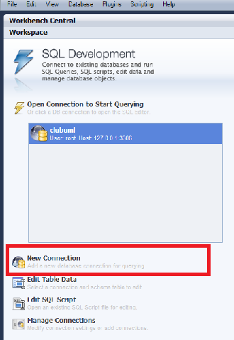

- Give the new connection a name (ex: clubuml) and press OK. Enter ‘1234’ when the password prompt appears. (This password was set in Installing MySQL Community Server)
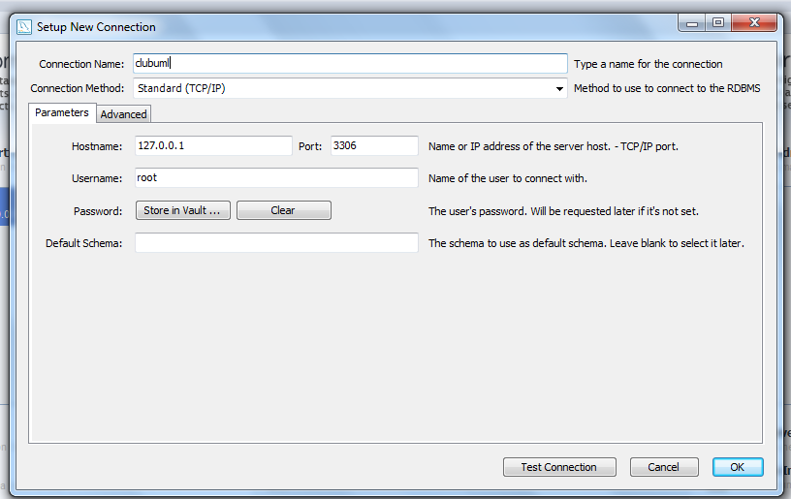

- Open the new connection you just made. In the left pane (Object Browser), right-click any schema object and choose Create Schema.
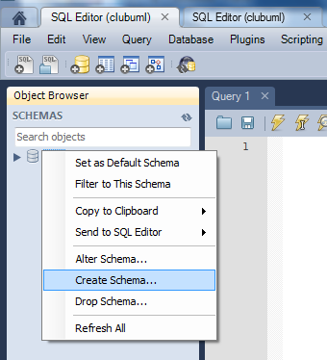

- Enter “ClubUML” as the Schema name and hit OK.
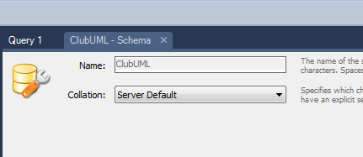

- Go to File->Open SQL Script and open “CreateClubUMLTables.sql”. This .sql file will accompany this document. Hit the execution button on the menu bar. (The lightning icon)
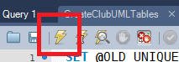

- Right-click on ClubUML in the Object Browser and Refresh All. Tables should be available under ClubUML.

Troubleshooting MySQL Workbench:
When installing MySQL Workbench, if “MSVCR100.dll is missing” error appears when installing MySQL Workbench, you will need to install Microsoft Visual C++ 1020 Redistributable Package (x86/x64) (http://www.microsoft.com/en-us/download/details.aspx?id=5555)
Tortoise SVN:
  - Install Tortoise SVN. (Straight forward)
  - Open Windows Explorer and create a folder to store ClubUML repository.
  - Right-Click on the folder to store the repository->SVN Checkout…
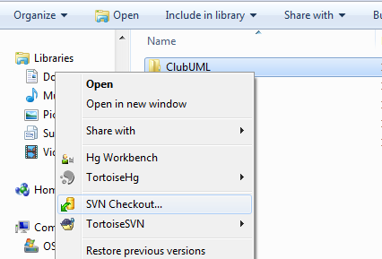

  - Enter repository url https://nuforge.coe.neu.edu/svn/clubuml2012 and hit OK. Files will be imported.

TomCat 7.0:
    - Installing TomCat 7.0 is straight forward. Use default settings and enter the optional Administer user name and password to avoid editing the user access XML file later.
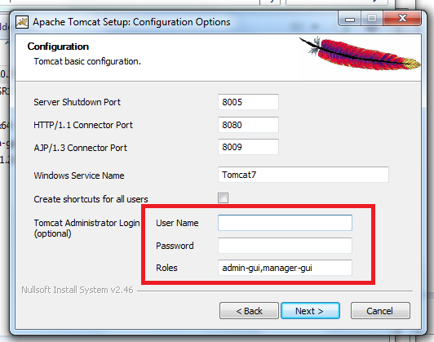
Eclipse EE:
      - Open Eclipse EE and in the menu bar: File->Import…
      - Select General->Existing Projects into Workspace…
      - Navigate to your ClubUml trunk folder imported from SVN and hit OK
      - A list of projects will be displayed. Only select the ClubUMLJan2013Test project and hit OK.
(Note: There is also an SVN tool that can be downloaded in Eclipse’s Market that can perform this task of importing from the respository.)

Troubleshooting Eclipse EE:
If there are any issues, it is usually a library path problem. Right-click on ClubUMLJan2013Test and go to properties. Go to Java Build Paths->Library and check if there are any issues. If there are issues, remap the libraries. Libraries can be found in ClubUMLJan2013Test/WebContent/lib.
Create WAR file and launch web app:
        - The project will appear in Eclipse’s Project Explorer,
        - Right-click ClubUMLJan2013 folder->Export->WAR file
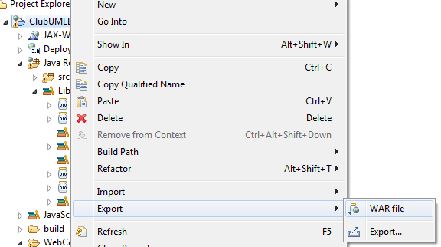

        - Set the destination of the WAR file to your TomCat7/webapp folder. (If TomCat is running, this WAR file will automatically deploy.)
        - Open a browser with URL: http://localhost:8080/manager/html
        - You should see a row for /ClubUMLJan2013Test with running = true.
        - Click on /ClubUMLJan2013Test and it’ll launch you into the web program.
        - Explore!
(Note: The project can also run in Eclipse using the “Run on Server” option, but I had an issue with file paths writing and reading in different directories.)

