## 通信协议 I2C UART SPI MIPI 比较

|  |  |  |  |
| --- | --- | --- | --- |
|  | I2C/双线 | UART/2或4线 | SPI/4线 |
| 同步异步 | 同步 | 异步/(同步需4线) | 同步 |
| 速度 | 100k-5m bps | 慢 | 高速 |
| 串行 | 串行 | 串行 | 串行 |
| 工作模式 | 半双工 | 全双工 | 全双工 |
| 可靠性 | 应答机制 | 奇偶校验 | 无,传输完要再读取 |
| 控制方式 | 主从模式 | 软:代码判断/  硬:RTS/CTS置高有效 | 主从模式(cs片选从设备) |
| 开始 | SCLK=1,SDA↓ | 以0开始 | 由CPHA和CPOL决定 |
| 关闭 | 主设备在ACK时间发送STOP (SDA=1) | 停止位高电平 | CPOL=1,高电平,反之低电平 |
| 空闲或挂起 | 从设备在ACK期间保持SCL低电平 | 空闲位高电平 | CPOL=1,空闲高电平,反之低电平 |
| 传输方向 | MSB在前 | 视情况而定 | MSB在前 |
| 数据位读取 | SCL=1 | CLK↑读取 | CPHA=1,下降沿读取  CPHA=0,上升沿读取 |

## UART

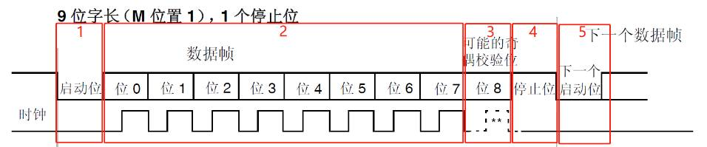

一次UART传输10bit:第一位启动位为0,表示传输开始,之后8位为数据位,第10位停止位置1,表示传输完成.其中数据位之后可以加上奇偶校验位. 奇校验 校验位为数据位异或值取反.偶校验为数据位异或值.停止位可以是1位,1.5位,2位的高电平.中止位可以方便通讯双方的时钟校准.

UART总线有至少有RX/TX线(收/发),因此可以进行全双工通信.

如果使用4线(RX/TX/CTS/RTS),可以进行流控,此时RTS请求发送数据,CTS暂停发送病清除发送数据.

## SPI

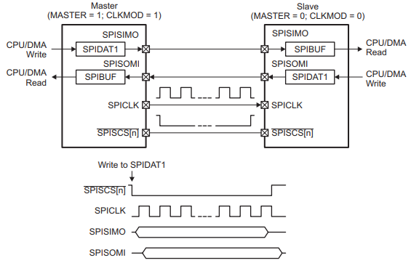

SPI从设备必须有来自主设备的时钟才能正常工作.SPI总线的同步方式有CPOL和CPHA控制.主设备通过CS选择从设备.由于没有控制位和校验位,所有的控制都要根据时钟和CPOL和CPHA来实现.

SPI总线不区分读写.主设备发送数据之后要读出数据,读数据之前也要先发送数据.即使数据无用.主要作用是保持队列干净,避免传送时污染数据.

SPI总线两端连接两个移位寄存器,每个寄存器指向一个内部缓冲区.每次数据传输时,移位寄存器读出缓冲区的数据传到对端的移位寄存器并保存在缓冲区. 缓冲区内部通过FIFO保持数据.缓冲区寄存器大多是16位,因此每次传输最多可以传16位,之后移位寄存器需要移位读取16次并传给对端.

SPI共有四根线:

MISO：主机输入,从机输出.

MOSI：主机输出,从机输入.

SCLK -时钟信号.

SS-片选信号.

/4 DQPSK /4 rotated differential quadrature phase shift keying

8DPSK 8-state differential phase shift keying

16 QAM 16-state quadrature amplitude modulation

64 QAM 64-state quadrature amplitude modulation

ACL Asynchronous connection-oriented link

ADC Analog-to-digital converter

AGC Automatic gain control

AP Access point

BB Baseband

BER Bit error rate

BLE Bluetooth low energy

BMPS Beacon-mode power save

BOM Bill of materials

BPF Bandpass filter

bps Bits per second

BPSK Binary phase shift keying

BR Basic rate

CCK Complimentary code keying

CDM Charged device model

CDMA Code Division Multiple Access

CLPC Closed loop power control

DAC Digital-to-analog converter

DBPSK Differential binary phase shift keying

DEVM Differential error vector magnitude

DNC Do not connect

DQPSK Differential quadrature phase shift keying

DTIM Delivery traffic indication message

EDR Enhanced data rate

EIRP Effective isotropic radiated power

eSCO Extended synchronous connection-oriented

ESD Electrostatic discharge

ESR Effective series resistance

ETSI European Telecommunications Standards Institute

EVM Error vector magnitude

FBPR Forbidden band power ratio

FCC Federal Communication Commission

FDD Frequency division duplexing

FEM Front-end module

FM Frequency modulation

GFSK Gaussian frequency shift keying

HBM Human body model

HCI Host controller interface

Hi-Z High impedance

I/O Input/output

kbps Kilobits per second

LSBit or LSByte Defines whether the LSB is the least significant bit or least significant byte. All

instances of LSB used in this manual are assumed to be LSByte, unless otherwise

specified.

MSBit or MSByte Defines whether the MSB is the most significant bit or most significant byte. All

instances of MSB used in this manual are assumed to be MSByte, unless otherwise

specified.

LNA Low-noise amplifier

LO Local oscillator

LPF Low-pass filter

LPO Low-power oscillator

LPPS Low-power page scan

MAC Medium access controller

MCS Modulation coding scheme

MPX Multiplex

MRC Master reference clock

NVM Nonvolatile memory

PA Power amplifier

PCB Printed circuit board

PCM Pulse-coded modulation

PDET Power detector

PER Packet error rate

PHY Physical layer

PLL Phase-locked loop

PM Power management

PMIC Power management integrated circuit

PTA Packet traffic arbitration

QAM Quadrature amplitude modulation

QoS Quality of service

QPSK Quadrature phase shift keying

QTI Qualcomm Technologies, Inc.

RBDS Radio broadcast data system for U.S.A.

RDS Radio data system for Europe

RF Radio frequency

RH Relative humidity

RoHS Restriction of hazardous substances

Rx Receive, receiver

SBI Serial bus interface

SCO Synchronous connection-oriented

SCPC Self-calibrated power control

SMT Surface-mount technology

SoC System-on-Chip

Sps Symbols per second (or samples per second)

SSBI Single-wire SBI

STBC Space-time block coding

TCXO Temperature-compensated crystal oscillator

TDD Time-division duplexing

TIM Traffic indication map

TKIP Temporal key integrity protocol

T/R Transmit/receive

Tx Transmit, transmitter

uAPSD Unscheduled automatic power-save delivery

VoIP Voice-over-internet protocol

WAN Wide area network

WEP Wired-equivalent privacy

WLAN Wireless local area network

WLNSP Wafer-level nanoscale package

WMM Wi-Fi multimedia

WMM-AC Wi-Fi multimedia access categories

WoWLAN Wake-on-WLAN

WPA Wi-Fi protected access

XO Crystal oscillator

ZIF Zero intermediate frequency