**Assignment5**

**(Full marks = 100)**

**(Sample answer)**

**Part I:  Microarray Analysis**: Using NCBI GEO, search *Gene Profiles* for our gene **RB1 (NP_00312)**, and pick *three* profiles in which our gene appears differentially regulated. The genes that are differentially regulated are the ones that change expression levels between conditions, phenotypes, and/or mutations.

In general, you are looking for bigger differences in the relative expression of our RB1 gene relative to all other genes in each sample (red bars). You want to see significant differences in the expression of our gene (or a homolog) between the two phenotypes.

In general, you will see a smaller difference in the relative rank of the expression of our gene relative to all other genes in each sample (blue squares). This is because of the rendered scales for the red bars and blue squares.

* For each of the 3 profiles, click the profile.  **Save these profile figures and place them in your document.**  What were the experimental conditions?  (For example, control versus treated, normal versus cancerous, stem cell versus differentiated cell, etc.)? [each profile and graph caption carries 15 points ]

Profile-1:

|  |  |
| --- | --- |
| **Profile** | GDS2115 / 7939 / Rb1 |
| **Title** | Developing mammary gland: terminal end buds and ducts |
| **Organism** | Homo sapiens |

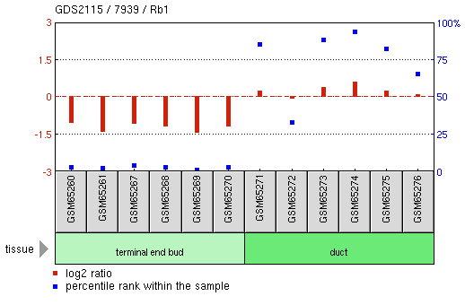

Graph caption help

|  |  |  |  |
| --- | --- | --- | --- |
| **Sample** | **Title** | **Value** | **Rank** |
| GSM65260 | 12Mm.190 | -1.066 | 3 |
| GSM65261 | 12Mm.192 | -1.427 | 2 |
| GSM65267 | 12Mm.197 | -1.101 | 4 |
| GSM65268 | 12Mm.198 | -1.207 | 3 |
| GSM65269 | 12Mm.200 | -1.481 | 1 |
| GSM65270 | 12Mm.203 | -1.217 | 3 |
| GSM65271 | 12Mm.191 | 0.262 | 86 |
| GSM65272 | 12Mm.193 | -0.088 | 33 |
| GSM65273 | 12Mm.196 | 0.402 | 89 |
| GSM65274 | 12Mm.199 | 0.632 | 94 |
| GSM65275 | 12Mm.201 | 0.286 | 83 |
| GSM65276 | 12Mm.202 | 0.113 | 66 |

- Experimental conditions: **terminal end bud tissue** versus. **Duct tissue**

Profile-2:

|  |  |
| --- | --- |
| **Profile** | GDS2530 / 201620_at / MBTPS1 |
| **Title** | Retinoblastomas with loss of heterozygosity at chromosome 16q |
| **Organism** | Homo sapiens |

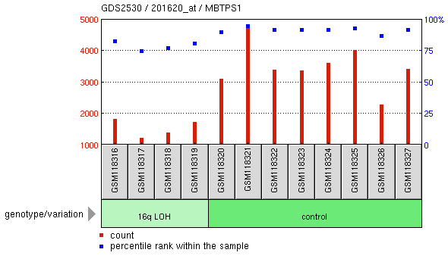

Graph caption help

|  |  |  |  |
| --- | --- | --- | --- |
| **Sample** | **Title** | **Value** | **Rank** |
| GSM118316 | Retinoblatoma M19484 | 1838.9 | 83 |
| GSM118317 | Retinoblatoma M22590 | 1240 | 75 |
| GSM118318 | Retinoblatoma M22641 | 1389.9 | 77 |
| GSM118319 | Retinoblatoma M22860 | 1727.3 | 81 |
| GSM118320 | Retinoblatoma M20517 | 3099.4 | 90 |
| GSM118321 | Retinoblatoma M22067 | 4751.2 | 95 |
| GSM118322 | Retinoblatoma M22233 | 3404.1 | 92 |
| GSM118323 | Retinoblatoma M23209 | 3362.7 | 92 |
| GSM118324 | Retinoblatoma M23449 | 3606.9 | 92 |
| GSM118325 | Retinoblatoma M23818 | 4035 | 93 |
| GSM118326 | Retinoblatoma M23869 | 2286.9 | 87 |
| GSM118327 | Retinoblatoma M23978 | 3427 | 92 |

- Experimental conditions: **16q LOH genotype** versus. **Control genotype**

Profile-3:

|  |  |
| --- | --- |
| **Profile** | GDS4960 / 203132_at / RB1 |
| **Title** | ISCU myopathy |
| **Organism** | Homo sapiens |

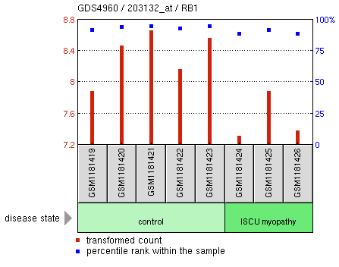

Graph caption help

|  |  |  |  |
| --- | --- | --- | --- |
| **Sample** | **Title** | **Value** | **Rank** |
| GSM1181419 | control, 1 | 7.89144 | 92 |
| GSM1181420 | control, 2 | 8.47174 | 94 |
| GSM1181421 | control, 3 | 8.66056 | 95 |
| GSM1181422 | control, 4 | 8.17 | 93 |
| GSM1181423 | control, 5 | 8.56229 | 95 |
| GSM1181424 | swedish subject, 1 | 7.3252 | 89 |
| GSM1181425 | swedish subject, 2 | 7.89144 | 92 |
| GSM1181426 | swedish subject, 3 | 7.39217 | 89 |

Experimental conditions: **control** versus. **ISCU myopathy**

* Go back to the GEO Profiles page (the result of your original search), and for each of your 3 profiles, **click the corresponding GDS____ link**.  This link will bring you to a description of the experimental conditions and usually have a PubMed reference (PMID).  Read the PubMed Abstract. **Do a brief write-up of these three experiments, and try to relate them to what we know about our RB1 gene**. [explanation of each profile carries 10 points]

1. Profile 1: GDS2115 / 7939 / Rb1 (Developing mammary gland: terminal end buds and ducts)
   1. The title of the PubMed reference was “Mammary ductal morphogenesis requires paracrine activation of stromal EGFR via ADAM17-dependent shedding of epithelial amphiregulin”. In the experiment, authors tried to examine the roll of epidermal growth factor receptor (EGFR) and its ligand amphiregulin (AREG) in mammary epithelial cells. In a culture setting, the transmembrane metalloproteinase (ADAM17) on mice can process AREG, while ADAM17 deficient mice tent to phenocopy EGFR deficient mice. Authors also tried to discover that ADAM17 release AREG from mammary epithelial cells and induce stromal EGFR activation. These two responses reciprocate off each other and help regulate the mammary epithelial development.
   2. RB1 is a tumor suppressor protein, when it becomes inhibited, rampant cell growth can occur. In the context of mammary epithelial cell development, RB1 may play a roll in addition to AREG and EGFR. Such a proposal would have to be explored through scientific means.
2. Profile 2: GDS2530 / 201620_at / MBTPS1 (Retinoblastomas with loss of heterozygosity at chromosome 16q)
   1. The title of the PubMed reference was: “Allelic loss in a minimal region on chromosome 16q24 is associated with vitreous seeding of retinoblastoma”. In the experiment authors tried to analyze gene expression by microarray hybridization and quantitative RT real-time PCR to see suppressor genes on 16q. Results ranged greatly as clinical presentations of tumors with or without 16 changes had very different results. Some results indicate that alterations of 16 could have an effect on cell-to-cell adhesions. There was no loss of heterozygosity at any 16q marker.
   2. This research is relative to RB1 because in addition to RB1 gene mutations, gains of 1q and 6p and losses of 16q have been known to contribute to retinoblastomas.
3. Profile 3: GDS4960 / 203132_at / RB1 (RB1 - ISCU myopathy)
   1. The title of the PubMed reference was: “Elevated FGF21 secretion, PGC-1α and ketogenic enzyme expression are hallmarks of iron-sulfur cluster depletion in human skeletal muscle”. Iron-sulfur clusters are enzyme cofactors that plays a large role in aerobic energy metabolism. When human skeletal muscle demonstrates decreased oxidative capacity, Fe-s deficient muscles up-regulate secreted protein FGF21 (fibroblast growth factor 21). Results demonstrate the Fe-S deficient skeletal muscle enhances HMCS2 ketogenic enzyme expression and increases FGF21.
   2. Increasing skeletal muscle could possibly enhance via deactivation of RB1. Deficiency of the tumor suppressor protein can induce rampant cell growth (including skeletal muscle).

**Part II:  Network Analysis**: To perform a network analysis on our gene NP_000312, use the String server at http://string-db.org/.  Open the HELP and read "**Getting Started**".  
  
Perform a network analysis of our human RB1 gene, and save images of the Evidence, Actions, and Confidence views. For each of these views: [5×3 = 15 points]

1. select the “advanced” option
2. pull down on the lower right corner to expand the network canvas
3. include at least 10 genes
4. Drag the nodes out into a circle that surrounds our RB1 gene placed in the center of the circle.
5. Medium resolution PNG images are fine here.

Describe several interactions, and be sure to interpret the interaction type found in the "Predicted Functional Partners" section of the Legend (e.g., co-expression, protein-protein interaction, textmining, etc). [It carries 5 points each]

Interpret this network from a biological perspective, and from what we know about the RB1 gene. [It carries 5 points]

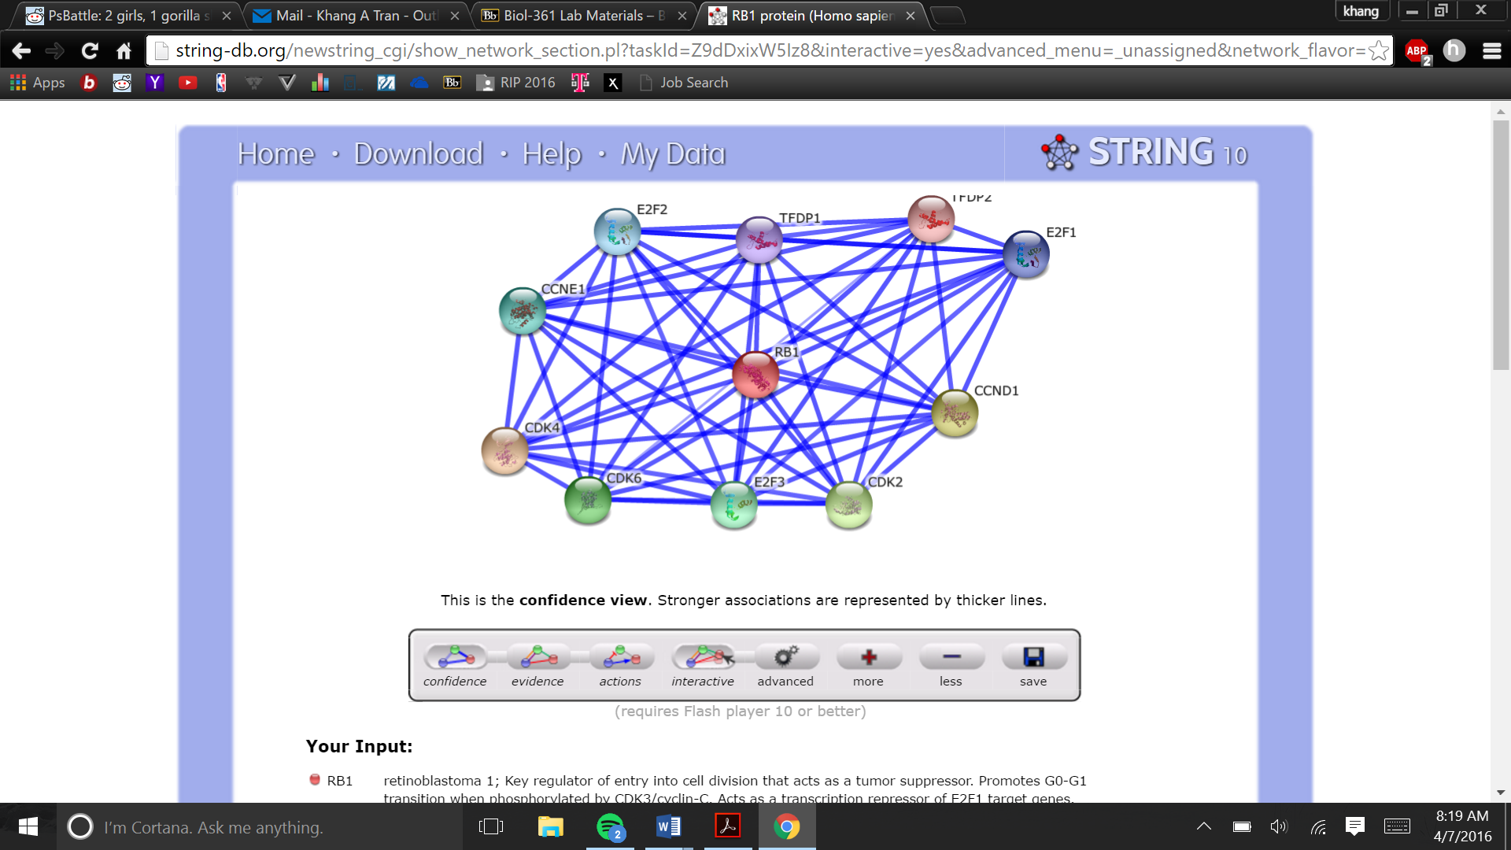

Confidence view

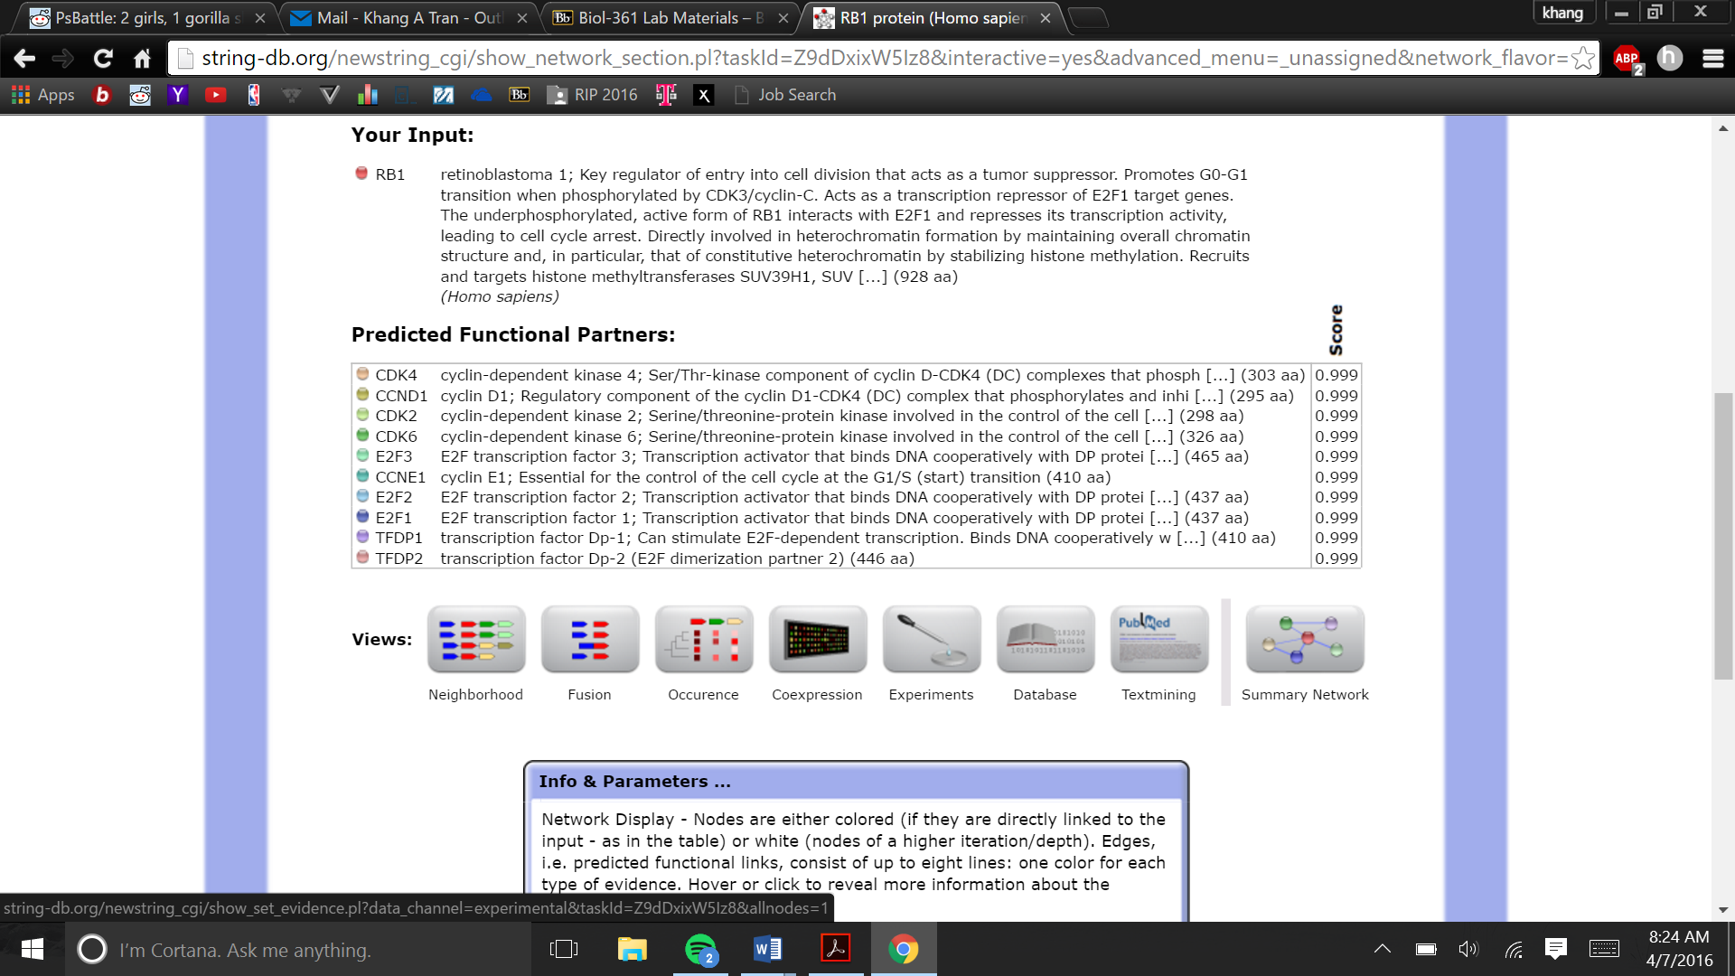

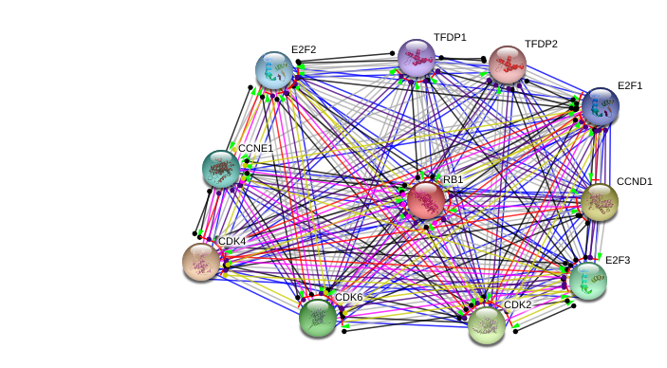

Evidence View

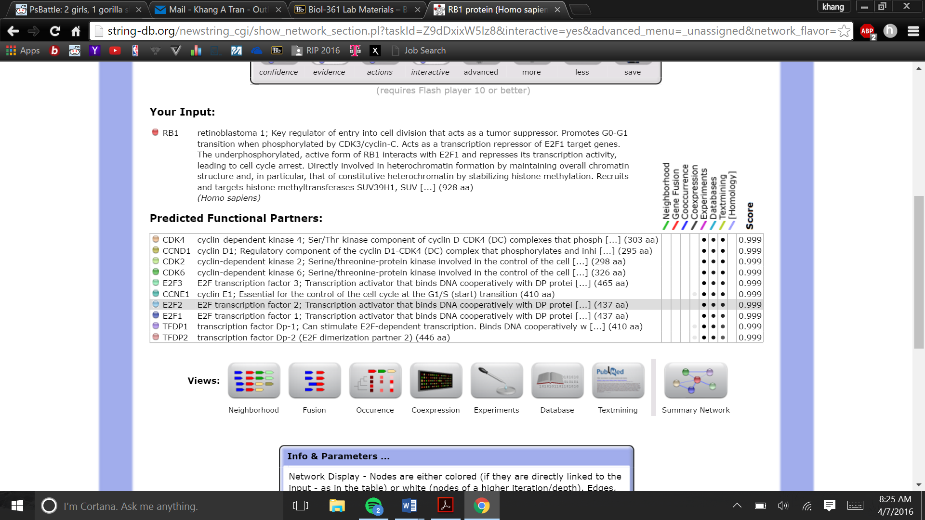

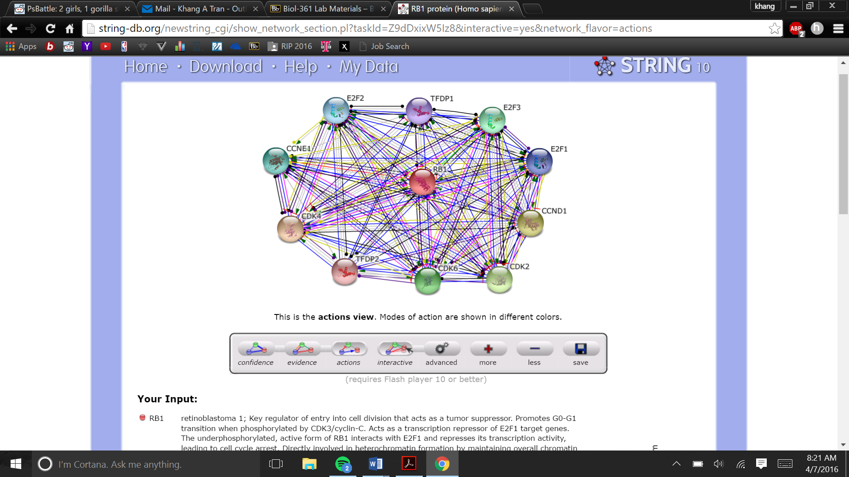

Action view

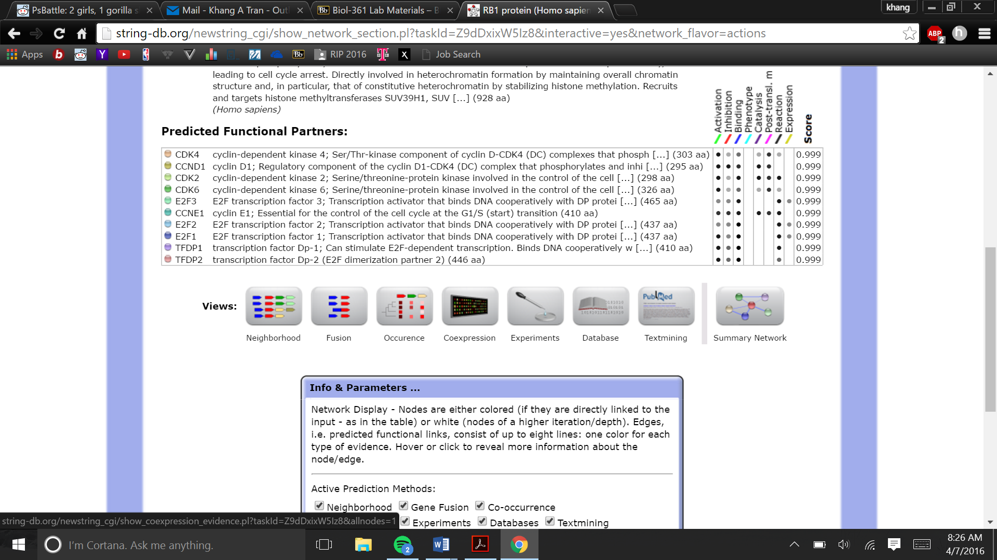

Dragging the nodes out into a circle that surrounds the RB1 gene placed in the center of the circle the 10 predicted functional partners all had a confidences score of 0.999. The stronger the association between each line, corresponds to thicker lines. Repetition of the same procedure and used the predicted functional patterns under the “evidence view,” revealed the relation between predicted functional partners and noticed that different line colors represented the types of evidence for the association. For the evidence view, the type of evidence that support this relation was experiments, databases, text mining, and homology (each had a score of 0.999).

Again, analyzing genes under the actions view, suggested that the modes of action were shown in different colors as represented in the diagram below. The relations in the “actions view” were based on different modes of actions as represented in the diagram. CDKA has a maximum interactions with RB1 in terms of activation, inhibition, binding, catalysis, post transl., and reaction. The relation is particularly strong in activation and post-translational modifications. These relations were determined with a score of 0.999. Another strong predicted functional partner of RB1was the CCNE1 gene. This gene has relations in activation, inhibition, binding, catalysis, post-translational modifications, and reaction at seemingly a stronger confidence than CDK4. These relations were determined (between CCNE1 and RB1 with a score of 0.999). Few genes seem to share relation with RB1 in terms of expression (only E2F3, E2F2, and E2F1). And even then, the relation seems to be weaker.

Explanation:

It is important to mention that RB1 and CDK4 is protein-protein interaction. CCND1 is the component of D-CDK4 is able to phosphorylate and inhibit RB1 which regulate cell cycle during G(1)/S transition. Cyclin D-CDK4 complexes are important combination of many mitogenenic and antimitogenic signals. For the Evidence part, there is no Co-expression for any genes. All three CDK2 or cyclin-dependent kinase 2 and CDK64 and CDK6 involved in the control of cell cycle with serine and threonine protein kinase. CDK2 determine when mitosis or meiosis is starting by phosphorylating cyclin B/CDK1. CDK6 also involved in differentiation of the cell. It initiates G1/S transition and it also can stop cell proliferation.

E2F1, E2F2 and E2F3 activator bind to DNA collectively along with DP protein to the E2 recognition site. E2F1, E2F2 and E2F3 bind to RB1 in the cell-cycle. E2F1 can mediate the proliferation of cell and also act as a tumor suppressor with dependent TP53/p53. E2F2 participates in the cell cycle regulation and DNA replication. Cyclin E1 or CCNE1 is important because it influences the cell cycle at G1/S transition as well. TDFP1 and TDFP2 are also involved in the cell cycle and DNA replication. TDFP1 tend to influence E2F-dependent transcription as well which tend to bind to DNA and also mediate cell proliferation and apoptosis of the cell.