Computer lab 1
Introduction to Genomics

Genomics
260.605.01
Wednesday, November 3, 2010

Goals of today’s lab (three parts, about 20-25 minutes each)
[1] Viruses
(1) Identify the proteins of Ebola (or any other virus) at Entrez Genome
(2) Use the tools at the LANL HIV site including SNAP
[2] Bacteria
(1) Use the Comprehensive Microbial Resource (CMR) including MUMmer
(2) Use Entrez Genome at NCBI including TaxPlot
[3] Preview of the eukaryotes: the UCSC Genome Browser
(1) View the human genome including the beta globin region on chromosome 11

[1] Viruses

[1] Ebola virus
a] What is ebola virus? Hint: while there are many approaches, go to NCBI and try MeSH; then PubMed Clinical Queries.

b] What is the accession number of the Zaire ebola virus? _________

c] How many genes are encoded by the Zaire ebola virus genome? __________

d] Do any of the Zaire ebola virus DNA sequences match eukaryotic proteins? Which of the matches are statistically significant? What is the biological significance of an ebola protein having homology to a eukaryotic protein, from the point of view of either the virus or the eukaryote?
Hint: Use the DNA accession number of the virus as a query in a blastx query of human RefSeq proteins.

[2] Using the LANL HIV site.
a] Go to the LANL HIV site (http://www.hiv.lanl.gov/), and visit the HIV sequence database. Explore its tools. (For example, under Search try the geography tool.)
b] Use the SNAP tool for synonymous/nonsynonymous substitution analysis.
--Define the difference between synonymous and nonsynonymous substitutions (see genetic code, page 2).
--Define positive selection and negative selection.
--For what sorts of research questions could the SNAP tool be useful?
Note 1: you may find the ReadMe file on the SNAP site helpful.
Note 2: optionally, see Web document 7.3 at www.bioinfbook.org for a set of globin sequences. You can copy and paste these into the SNAP tool.
c] Use TreeMaker to make a tree. The Tree Tutorial is excellent. You can used globin DNA sequences.
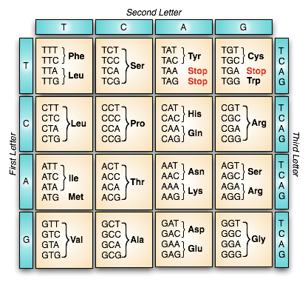

[2] Bacteria

[1] The COGs database (http://www.ncbi.nlm.nih.gov/COG/).

a] What is a COG?

b] Here is a screen capture of the front page of the COGs database. Find Escherichia coli and click on it.
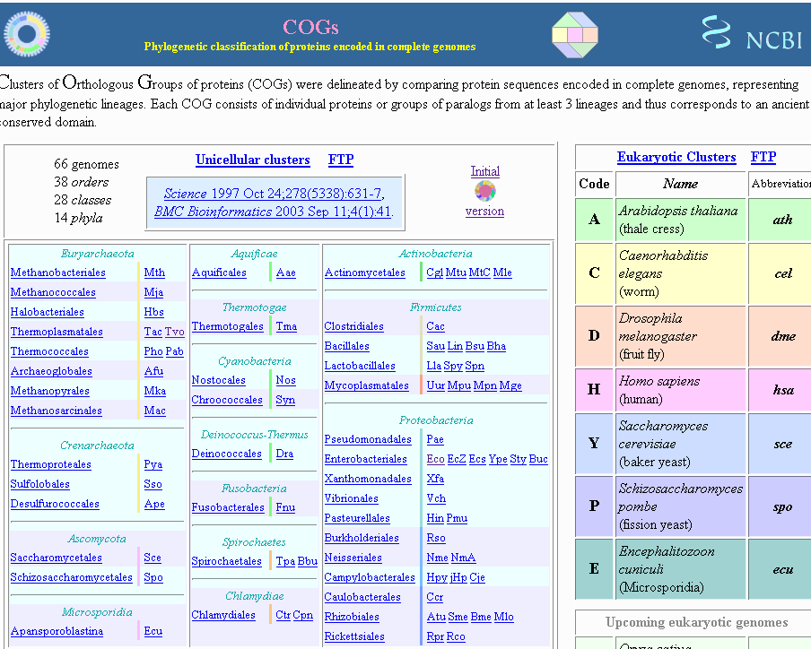

c] Here is the resulting page. What do the | and – symbols represent? Where is E. coli represented amongst those symbols? (Hint: look for the red.)
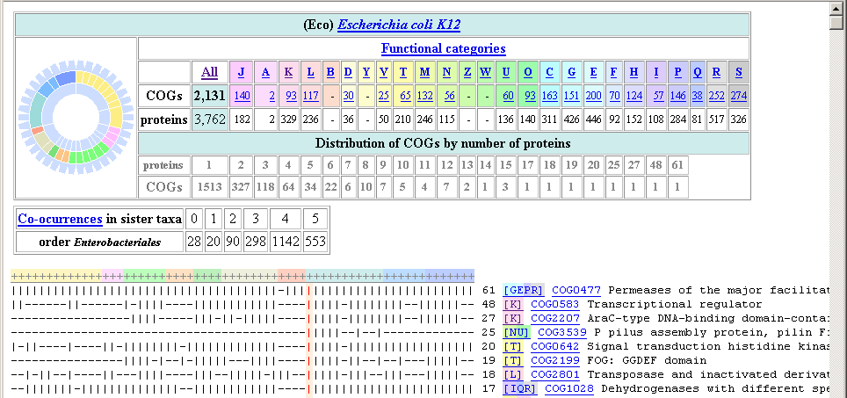

d] Note a column with the numbers 61, 48, 27,…0. What do those numbers represent? Suggestion: to answer this question, try scrolling down the page to click on COGs (e.g. COG0477) for which the number is 0, 1, or 2.

e] Identify a few COGs (~three) that are present in Escherichia coli and are also present in all other prokaryotes.

f] Return to the main page of COGs, and click the circle-shaped icon at top left.
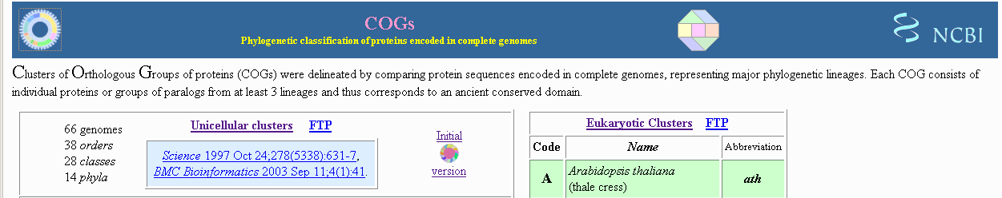

Next, click functional categories (at top right):
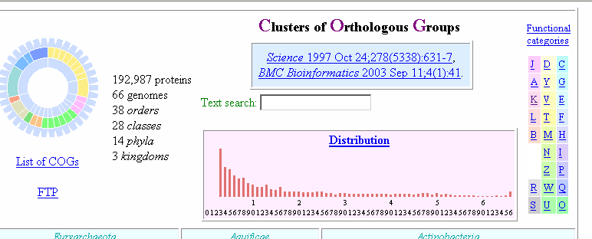

Compare code J (Translation, ribosomal structure and biogenesis) to code A (RNA processing and modification): which has more highly conserved proteins? Click on the portion of the distribution diagram (in the pink box above, right side) corresponding to the most conserved proteins; which functional category is most highly conserved?

[2] TaxPlot.
[a] Go to NCBI → Entrez Genomes → TaxPlot → Microbial. Alternatively,
go to NCBI → Homology (on left sidebar) → TaxPlot → Microbial.

[b] Enter a comparison using Yersinia pestis CO92 as a query, and for comparison choose Y. pestis CO92 and Y. pseudotuberculosis IP 31758. A screen capture is shown below.

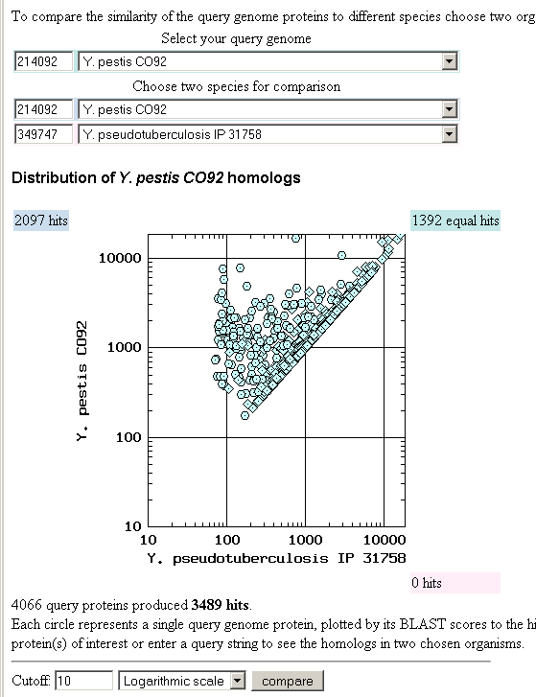
Try setting the scale to logarithmic, and click compare. What does each point on the graph represent? Why are there no points to the right of the main diagonal?

[c] Repeat this search with the same query but using two Y. pseudotuberculosis strains. Identify a differential hit that is involved in secretion.

[d] Explain the difference(s) between the two strains of Y. pseudotuberculosis. (Begin with TaxPlot and go to other NCBI sites as needed.)
Are they from the same species? ______
Do their genome sizes differ? _______
Do their GC contents differ? _______
What is a pathogenicity island? Do they each have one? (Hint: Try pCD1/pYv)

[e] Compare Shigella flexnei as a query to compare E. coli strains K12 (benign) and O157:H7 (virulent).

[f] Next change the query to a different subtype of O157:H7; what can you learn from the output?

[3] JCVI CMR.
[a] Visit JCVI (www.jcvi.org) → databases → Comprehensive Microbial Resource (http://cmr.jcvi.org). Explore the site.

[b] Type Yersinia in the text box at left; the output is shown here.
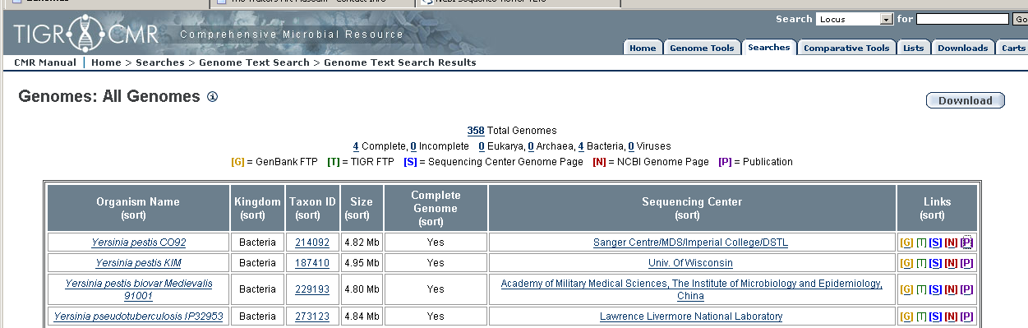
Familiarize yourself with the links G,T,S,N,P. We will pursue the first genome.

[c] Click Yersinia pestis CO92, and explore the page. How many genes are there according to primary annotation? _______ How many according to TIGR? _______
Why is there a discrepancy?

[d] Along the top bar, choose Genome Tools → Analysis Tools. Use these tools.
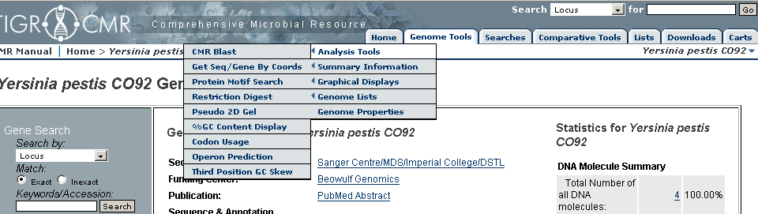

[4] Comparative tools including MUMmer for genome alignment.

[a] Go from CMR → Comparative tools → Genome Homology Graph to compare Y. pestis to Y. pseudotuberculosis. How does this tool compare to TaxPlot?
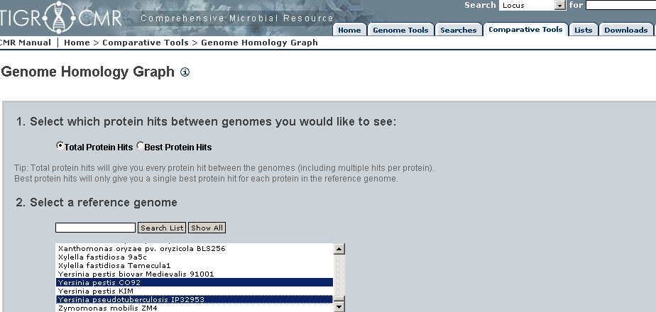

[b] Choose CMR → Comparative tools → alignment tools → MUMmer.
Align Y. pestis CO92 to Y. pseudotuberculosis.

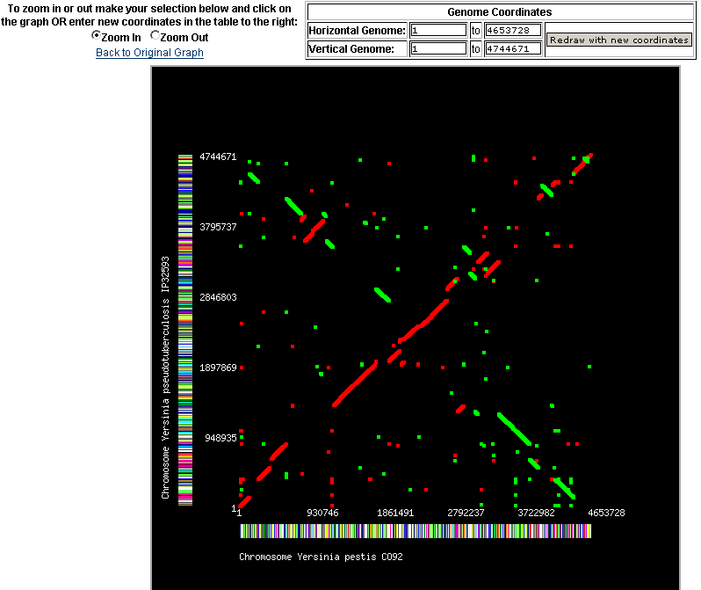
Explain the output, including the X shape. Zoom in to view inverted segments.
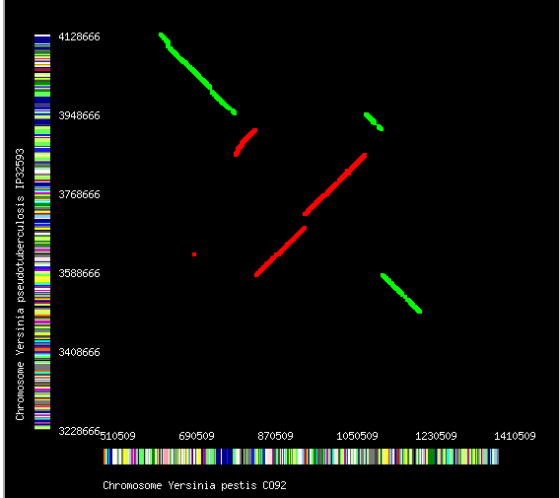
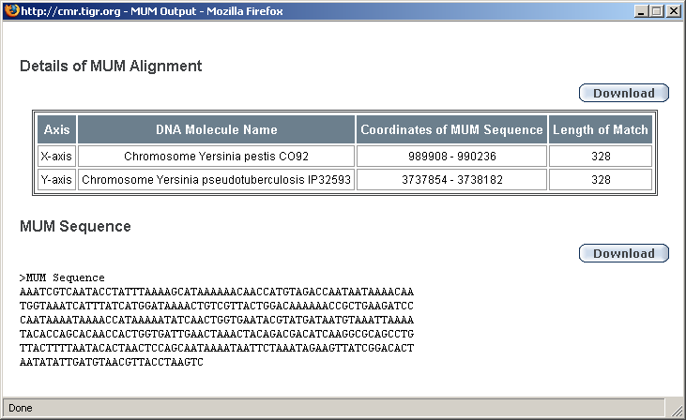
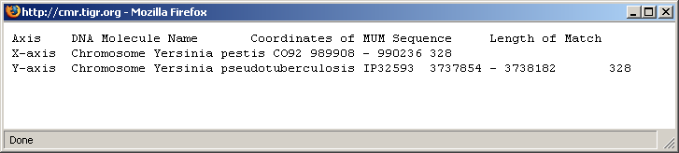

[3] Preview of the eukaryotes: the UCSC Genome Browser

[1] Visit http://genome.ucsc.edu. Find the human beta globin gene. How well conserved is it among other species?

[2] Are there variants in this gene in completely sequenced human genomes?

[3] Are there paralogs of this gene, that is, homologous genes present within the human genome? (Homology refers to relatedness due to shared ancestry.)

