Evolvability for 6 gates and 4 levelsback.
Draft of Jan. 7, 2024.

If you recall, I sent you the following image (from data/10_8_22/lgredund_vs_evolQ_and_samplingD_evolvability_exact3x1_8gts4lb4funcs.png):
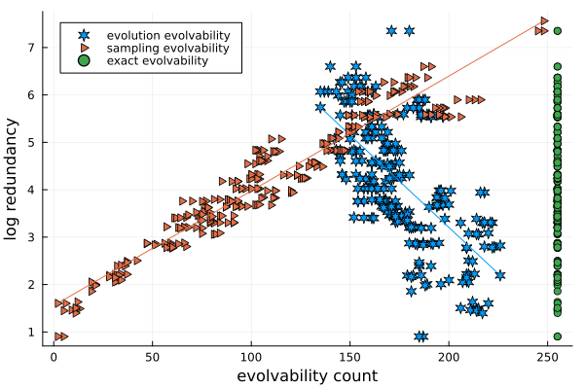

As you can see from the filename, this image was created from 3 inputs, 8 gates, 4 levelsback, and without the XOR gate. The “exact” results imply that every phenotype is reachable from every other phenotype. In other words, the phenotype adjacency matrix has no zero entries, and the phenotype adjacency graph is complete. The exact results are based on random-walk sampling with 2,000,000 walks of 10,000 steps each.

I have comparable results for 6 gates, 4 levelsback that almost show that every phenotype is reachable from every other phenotype. This is close to our previous exact results which were for 5 gates 3 levelsback. I have not yet carefully compared my 6 gate 4 lb results to the exact results, but I intend to do so.

Exact results: notes/11_8_22/ and plots data/9_24_22/log_freq_vs_evolvability_exact_5gts

As I write this up, I realize that these results are complicated by neutral components. When I say that every phenotype is reachable from every other phenotype, this does not mean that I can start with any genotype of a phenotype, and get to any phenotype of some other phenotype. So I need to revisit neutral components.

