ASG AIRLINES — DATA ENGINEERING & POWER BI DASHBOARD

End-to-End Data Pipeline, Data Quality and Business Intelligence Analysis

1. Project Overview
The project involves the creation of an end-to-end data engineering pipeline for airline operational data; it takes the flight, booking, payment and passenger datasets from an Excel source, carries out a data quality assessment and cleaning process, applies the necessary transformations and protects personal identifiable information, verifies the processed data, and then prepares the data for use in Power BI reporting. The last Power BI dashboard gives insights concerning flight duration, traffic organised by route, the distribution of airlines and the data anomalies that have been detected.

2. Dataset Structure
The source Excel workbook consists of the following tables.

Flights: This table includes flight details like flight ID, airline, source, destination, departure time, arrival time, and duration.

Bookings: This table consists of booking details like booking ID, passenger ID, flight ID, booking date, booking status, and passport details.

Payments: This table contains the payment details like payment ID, booking ID, amount paid, and mode of payment.

Passengers: This table consists of passenger details like passenger ID, name, email, and phone details.

3. Data Quality Issues Identified
The initial quality check of the data revealed that there were missing values and duplicates in the datasets. In the flight dataset, the number of records was 1020, with 41 missing values and 15 duplicates. The payments, bookings, and passengers’ datasets also had missing values.

Moreover, there were problems specific to the flight dataset, which included missing or UNKNOWN airline, a different number of flight occurrences for the same flight id, different departure and arrival dates for overnight flights, and invalid arrival timestamp order identified during the validation process.

4. Data Cleaning Strategy
The flight data was cleaned through a series of validation and transformation steps. Exact duplicates of the flight records were removed. A flight record that had a duplicated flight ID yet conflicting route information was marked for data-quality review instead of being arbitrarily corrected.

Missing or UNKNOWN values for the airline were recovered through the consistent relationships between the flight ID prefix and the name of the airline. The timestamps for the departure and arrival of the flights were validated, and overnight flights were handled using the date part of the timestamp. The cleaned flight data was used to calculate and validate the flight duration.

5. Data Transformation
I have calculated the flight duration based on the provided timestamps. The time difference between the “arrival” and “departure” fields was converted into a comparable time-delta value.
Furthermore, I have filtered out overnight flights, which implies that the day of the arrival should be later than the day of the departure. The traffic for routes was binned by source-destination pairs and summarized by the type of anomaly. This data structure was suitable for the next step of analytical reporting in Power BI.

6. PII Protection
Passenger-related personal information was identified during the data profiling stage. Sensitive passenger identifiers were protected by utilizing SHA-256 hashing prior to the protected passenger dataset’s export.
The protected passenger dataset is intended for controlled analytical purposes, but raw sensitive passenger information is not intended to be exposed within the analytical reporting layer or public repository.

7. Data Validation
Validation checks were done after data cleaning and transformation. This involved checking for duplicates, airline completeness, flight timing, as well as overnight flight identification and duration compared.
The final number of clean data in the flight dataset was 1005 records. The data pipeline identified 122 overnight flights and 2 flight ID conflicts for human verification.

8. KPI Definitions
The following KPIs and analytical measures were developed for the Power BI dashboard:
Average Flight Duration: Average duration of flights in minutes, calculated using the cleaned flight duration data.
Route-wise Traffic: Number of flights grouped by source and destination to identify flight traffic across routes.
Flight Anomalies: Summary of detected data-quality anomalies, including overnight flights and flight ID conflicts.
Distribution of Flights by Airline: Number of flights operated by each airline.
Overnight Flights: Flights where the arrival date is later than the departure date.
Flight ID Conflicts: Flight identifiers associated with conflicting records that require data-quality review.

9. Power BI Dashboard
The cleaned and aggregated datasets were used to develop an interactive Power BI dashboard. The dashboard is organized into five pages:
Overview: Provides overall flight volume, average flight duration, overnight flights, flight anomalies, source traffic and airline distribution.
Duration Analysis: Presents average flight duration by airline and source, flight duration distribution and overnight-flight information.
Route Performance: Provides route-wise flight traffic using source and destination information, along with interactive source and destination filters.
Airline Trends: Compares flight volume and average flight duration across airlines.
Delay & Anomaly Insights: Summarizes detected anomalies, including overnight flights and flight ID conflicts, along with key data-quality insights.
Interactive slicers were included where appropriate to allow users to filter and explore the data.

10. Data Architecture
The solution follows an end-to-end data processing architecture. Source Excel data is ingested into the Python environment, followed by data profiling and quality assessment. Cleaning and transformation rules are then applied, including duplicate handling, airline standardization, timestamp validation, duration calculation and overnight-flight identification. Passenger information is protected before analytical data is exported. The validated datasets are aggregated and used as the reporting layer for Power BI.
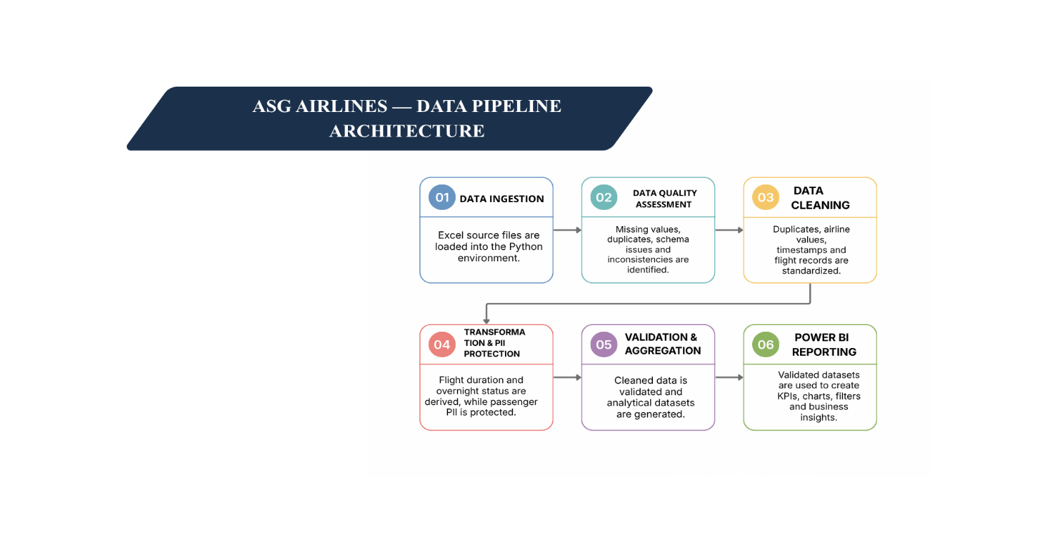

11. Data Flow Diagram
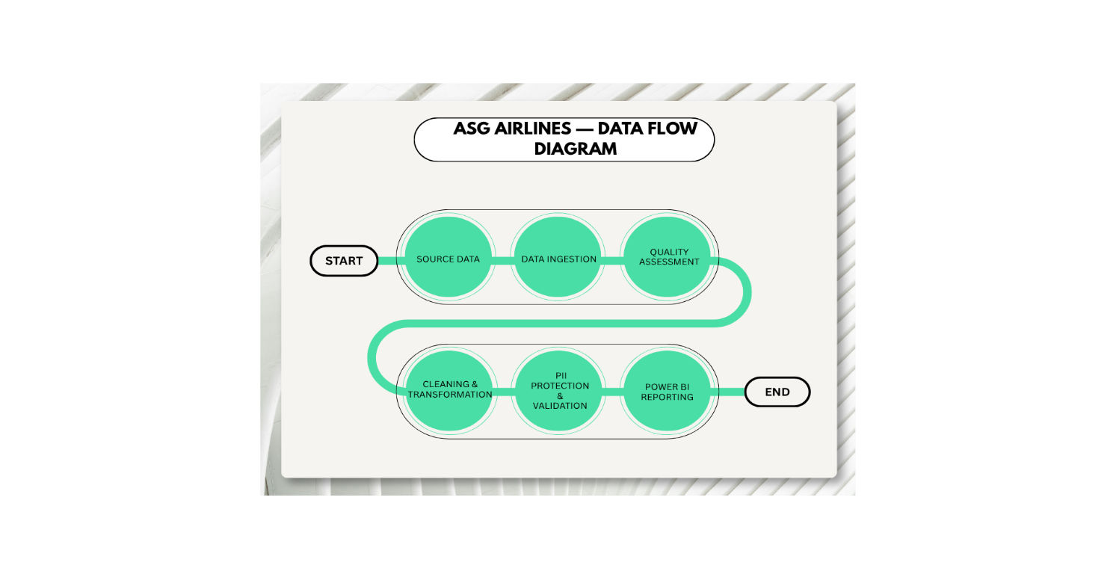12. Data Model
The data model consists of four main datasets: Flights, Bookings, Payments and Passengers. The datasets are connected using common identifiers. flight_id connects bookings with flight information, passenger_id connects bookings with passenger information, and booking_id connects bookings with payment information. The Flights dataset provides the main operational information used for flight analysis, while the other datasets provide related booking, payment and passenger information.

PASSENGERS
│
│ passenger_id
↓
BOOKINGS ── booking_id ──→ PAYMENTS
│
│ flight_id
↓
FLIGHTS

13. Assumptions:
- Missing or UNKNOWN airline values were recovered using the consistent flight ID prefix-to-airline relationship.
- Exact duplicate flight records were removed during cleaning.
- Conflicting flight ID records were flagged for data-quality review rather than arbitrarily changing the route information.
- Flights with an arrival date later than the departure date were treated as overnight flights.
- Flight duration was calculated using the cleaned departure and arrival timestamps and validated against the supplied duration.
- Passenger-sensitive information was protected before exporting the analytical passenger dataset.

14. Repository Structure
ASG_Airlines_Project/
│
├── ASG_airlines_pipeline.ipynb
├── cleaned_flights.csv
├── protected_passengers.csv
├── route_traffic.csv
├── anomaly_summary.csv
├── airline_distribution.csv
│
├── PowerBI/
│ └── ASG_Airlines_Dashboard.pbix
│
├── Screenshots/
│ ├── overview.png
│ ├── duration_analysis.png
│ ├── route_performance.png
│ ├── airline_trends.png
│ └── delay_anomaly.png
│
└── Documentation/
└── Project_Documentation.docx

