Collaboration Diagram - Study Assistant
This diagram illustrates the structural relationships and message exchanges between the core components of the Study Assistant.

Collaboration / Communication Model
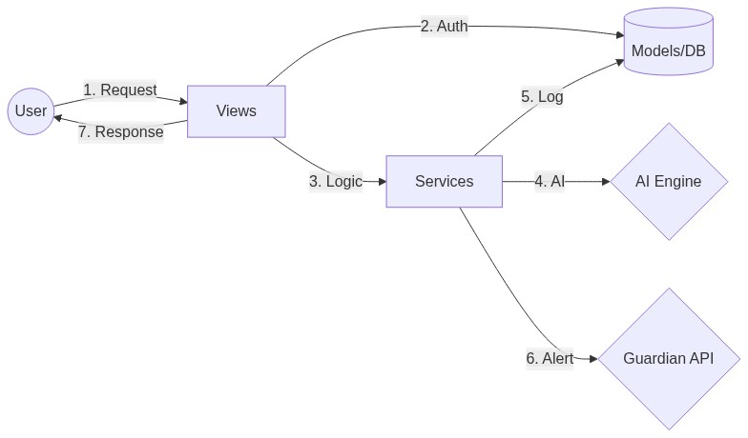

Key Collaborations
- Views & Services: Views delegate complex logic, such as AI analysis and messaging, to the Services layer to ensure clean separation of concerns.
- Services & Models: Services collaborate with Models to persist interaction logs, outbound message statuses, and performance data.
- Internal & External Engines: The system collaborates with AI (Gemini/Groq) for content generation and Twilio for real-time guardian notifications.

