System Development Life Cycle - Study Assistant

SDLC Phase Model
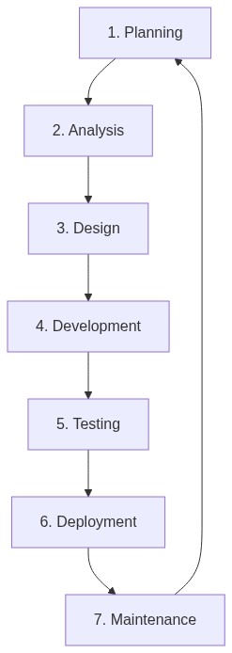

Phase Overviews
- Planning: Defining the vision of an emotion-aware tutor that prevents burnout.
- Analysis: Selecting Django, Gemini, and Groq for core backend and AI features.
- Architectural Design: Designing the MVT structure and glassmorphism UI system.
- Implementation: Developing features like active-recall MCQ generation and Twilio alerts.
- Testing: Verifying AI response stability and manual UI testing for browser webcam integration.
- Deployment: Database migrations and environment configuration for system startup.
- Maintenance: Iterative logging of WhatsApp statuses and handling AI API rate limits.

