Test Environment :

Vivo 1915

Android version 12

Processor 2.0 GHz Octa-core

RAM 4GB

Phone Storage 128GB.

Network : 4G Mobile Data – Hutch ISP

Bug Report

1. Bug_003
   1. Description :

“*” this symbol should have been indicated Infront of “I agree” check box to denote that it is required one.

* 1. Test – reproduce :
     1. Go to sign up page.
     2. A screenshot of a login form

        Description automatically generatedCheck the “*” symbol in front of “ï agree.” Check box

1. Bug_004
   1. Description :

Localization error, first name field did not accept first name with other languages(Tamil, Arabic and Sinhala) except English

* 1. Test – reproduce :
     1. Go to sign up
     2. Change the language.
     3. 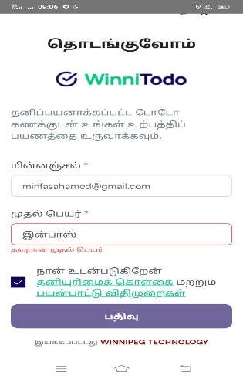Enter the first name in different language (Tamil )

1. Bug_005
   1. Description :

No confirmation Email or pop-up successfully sign-up message once click sign up

* 1. Test-reproduce :
     1. Go to sign up page.
     2. Enter email, first name and check agree check box
     3. Click sign up
     4. Check email for confirmation message

1. Bug_006
   1. Description :

No email verification link to verify email with real users.

* 1. Test-reproduce :
     1. Got to sign up page
     2. Enter the sign up details
     3. Click sign up
     4. Check email for verify link of the email

1. Bug_007
   1. Description :

“restore” do not give any functionality which should select the default payment option when we click but it does not do so.

* 1. Test-reproduce :
     1. go to package option page.
     2. see the default selected payment.
     3. select different payment.
     4. click restore button.
     5. 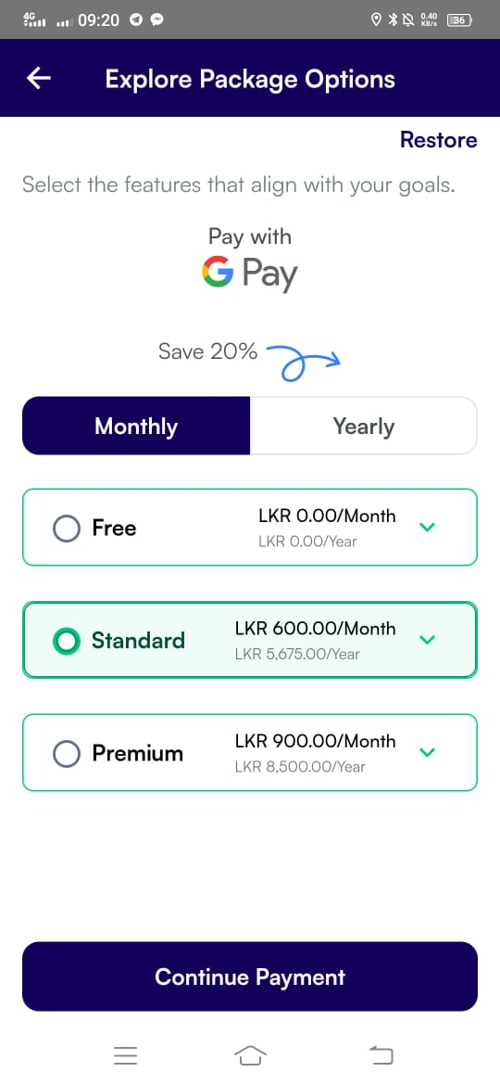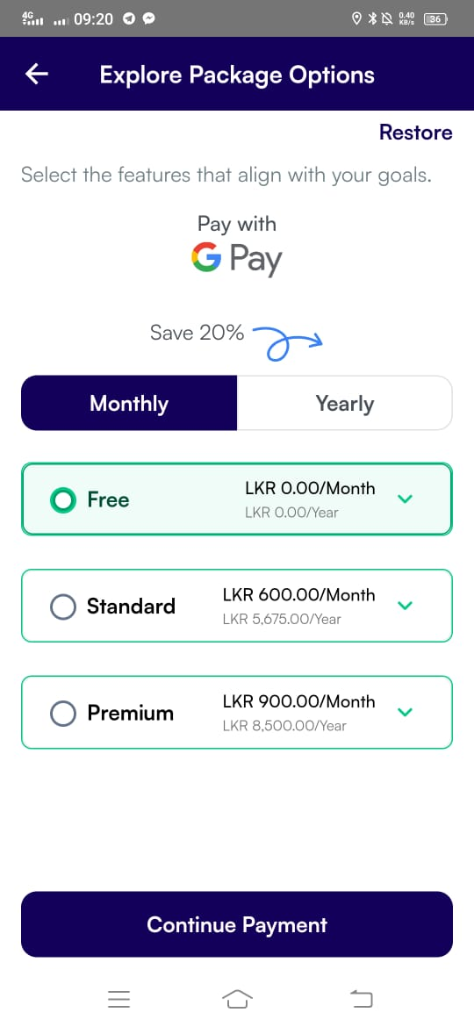check the restoring select default payment option.

1. Bug_008
   1. Description :

No confirmation pop up message when save the change of “Date/Time config.”

* 1. Test-reproduce :
     1. Go to date/time config page.
     2. Change the date and time format.
     3. Save the changes.
     4. Check if confirmation pop up message is shown.

1. Bug_009
   1. Description :

In the promotion field, when I select the different country and entered the wrong information of city, state and zip code. It accepts rather than showing “not matched city with your country”. Better to give drop down list for state, city and zip code corresponding with selected country.

* 1. Test-reproduce :
     1. Click promotion.
     2. View location info
     3. Select country as India
     4. enter region as western province.
     5. enter city as Nugegoda.
     6. enter zip code 32200.
     7. 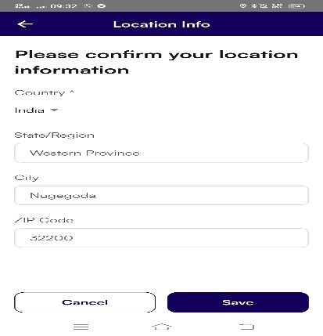check whether there is any warning message for entering the not matched details for selected country.

1. Bug_010
   1. Description :

The same wrong information of location getting updated inside the user profile’s location details.

* 1. Test-reproduce :
     1. Go to profile details page.
     2. A screenshot of a phone

        Description automatically generatedCheck whether other details align with selected country details.

1. Bug_011
   1. Description :

When editing the user profiles location field it accepts wrong data that is not related to each other Ex test data : country🡪 india, state🡪colombo/western province, zipcode : 32200

* 1. Test-reproduce.
     1. Go to profile
     2. Click edit
     3. select country as india
     4. enter region as western province
     5. enter city Nugegoda
     6. enter zip code 32200
     7. click save
     8. A screenshot of a phone

        Description automatically generatedcheck if any warning for entering not matched details with selected country

1. Bug_012
   1. Description :

camera is accessed without asking any permission from users when updating profile photos.

* 1. Test – reproduce :
     1. Go to profile page
     2. Click edit
     3. Click profile camera icon
     4. Click take picture option
     5. A screenshot of a computer

        Description automatically generatedCheck if there any permission dialog box asking for permission to access camera

1. Bug_013
   1. Description :

when uploading profile photo through photo gallery, it is not allowed to upload pic without editing.

* 1. Test – reproduce.
     1. Go to profile page
     2. Click edit
     3. Click camera icon
     4. Select from photo option
     5. Give permission to access photo gallery
     6. Select photo
     7. Check whether it directly upload or go to photo editing option of gallery
     8. A screenshot of a computer

        Description automatically generatedCheck whether it can be uploaded without any editing on picture.

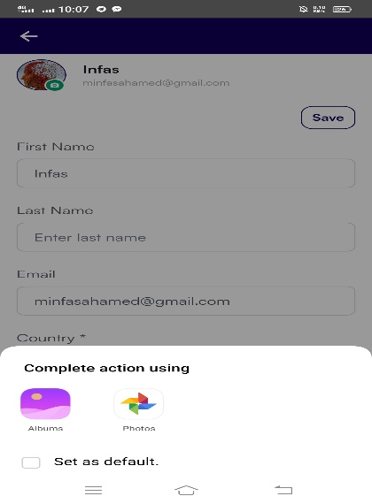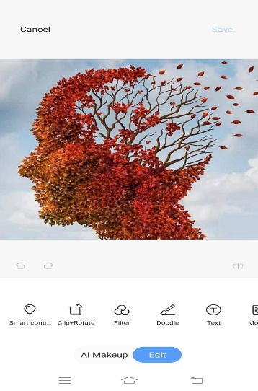

1. Bug_014
   1. Description

No permission asked to access photo gallery to insert attachments in todo sublists / todo list

* 1. Test – reproduce.
     1. Go to my ToDo
     2. Create a ToDo
     3. Go to edit ToDo
     4. Click the three (…) dots in the created toDo
     5. Click add files
     6. Click photo
     7. Check whether it asks permission to access device photo gallery
     8. A screenshot of a computer

        Description automatically generatedA screenshot of a phone

        Description automatically generatedA screenshot of a phone

        Description automatically generatedFollow the same test for the sublist created under a parent todo

1. Bug_015
   1. Description

No permission asked to access camera to take picture to insert attachment in todo sublist / todo list

* 1. Test – reproduce
     1. Go to my ToDo
     2. Create a ToDo
     3. Go to edit ToDo
     4. Click the three (…) dots in the created toDo
     5. Click add files.
     6. Click camera.
     7. Check whether any pop-up window asking to access the camera of device
     8. A screenshot of a computer

        Description automatically generatedA screenshot of a phone

        Description automatically generatedA screenshot of a phone

        Description automatically generatedFollow the same test for the sub list created under a parent Todo.

1. Bug_016
   1. Description :

ToDo list created inside the “today” automatically being sent to tomorrow or other category when selecting future dates as remiders. Here the future dates should not be selected, but a warning message should appear to prevent selecting future dates because the task to be done today should not have future reminder date also it should not be moved to tomorrow or other category as future task. [a task that is set to be done today should not have future dates as its reminder]

* 1. Test-reproduce :
     1. Go to myToDo
     2. Create a ToDo in todays category
     3. Go to edit ToDo
     4. Click … button in the created ToDo
     5. click remind me
     6. select a future date like tomorrow or day after tomorrow
     7. check if there is warning message that no future dates to be set as reminder
     8. go to my ToDo
     9. A screenshot of a computer

        Description automatically generatedA screenshot of a phone

        Description automatically generatedA screenshot of a chat

        Description automatically generatedA screenshot of a calendar

        Description automatically generatedcheck the created ToDo is in the todays category or it is automatically moved to tomorrow or other category

1. Bug_017
   1. Description :

No cropping features and view features for profile photo

* 1. Test-reproduce
     1. Go to profile page
     2. Tap the profile
     3. Check if there is any option to view the uploaded photo
     4. Check if there is any option to crop the picture in the applications itself

1. Bug_018
   1. Description :

No verification email is sent to old email address when changing the email address in the profile.

* 1. Test-reproduce :
     1. Go to profile
     2. Change the email address
     3. Check your old email
     4. A screenshot of a computer

        Description automatically generatedCheck if there is any warning or verification ling being send to your old email address

1. Bug_019
   1. Description :

once permission for photo gallery is denied and again when selecting the ‘’from photo’’ option to upload pictures, the photo gallery permission pop-up window is not shown and need to manually go to app permission and have to select for permission of photo gallery for app to access the photo gallery .

* 1. Test-reproduce :
     1. Got to profile
     2. Click camera icon
     3. Click from photo option
     4. Click deny option for the gallery permission window
     5. Then again do the steps 1,2,3
     6. Check if gallery permission window is again asking the permission to access photo gallery or not
     7. Then go to app permission on phone setting
     8. Give permission for photo
     9. Then again do the steps 1,2,3
     10. A screenshot of a computer

         Description automatically generatedCheck now whether app is accessing photo gallery or not

1. Bug_020
   1. Description :

old profile photo is disappeared while editing and saving the profile photo without selecting any new photo during the time that photo gallery permission is being on “not allowed” option

* 1. Test-reproduce.
     1. Set a profile photo
     2. Go to app permission of device and give deny option for gallery
     3. Then go to application profile
     4. Then click edit
     5. Then click save
     6. A screenshot of a computer

        Description automatically generatedCheck if old photo is exist in the profile or disappeared

1. Bug_21
   1. Description :

Attachment did not show which sub-todo list it is inserted in

* 1. Test – reproduce :
     1. Add the attachment to sub todo list
     2. Click attachment drop down.
     3. Check whether the attachment drop down box indicate the sub-todo list name in which the particular attachment was inserted .

1. Bug_22
   1. Description :

Reminder date is not shown in parent ToDo list but it is shown in sub-todo list

* 1. Test-reproduce :
     1. Go to my ToDo
     2. Check there is reminder date showing in created todo
     3. Go to edit todo
     4. 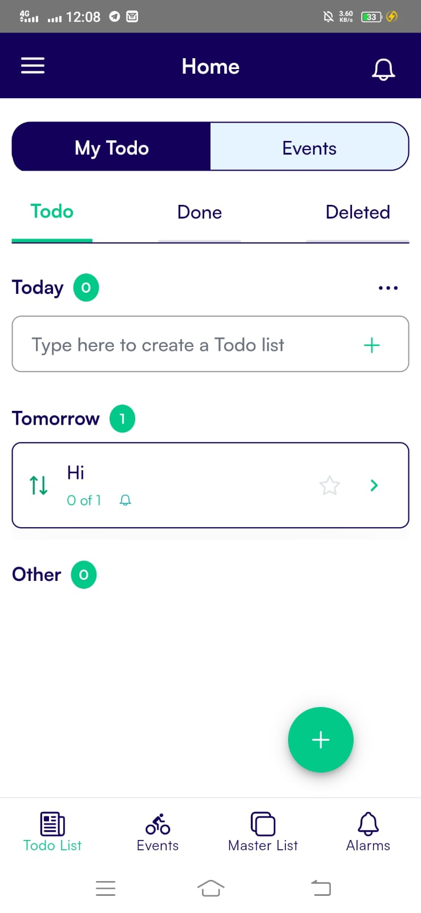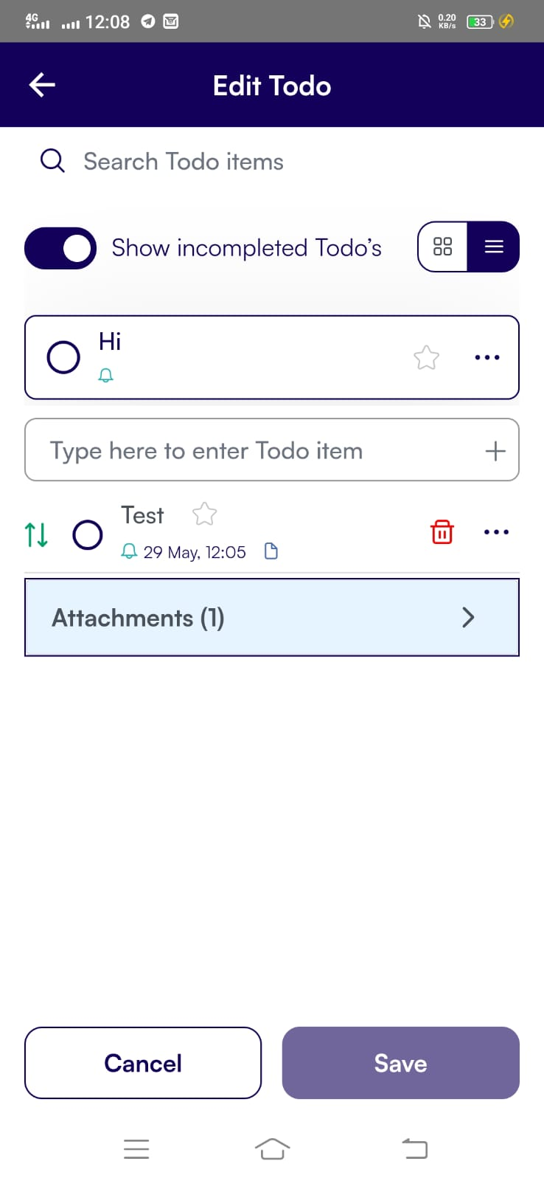Check there is reminder on parent todo and sub-todo

1. Bug_23
   1. Description :

Sub toDo list accept future dates as reminders while the parent ToDo list is having current date as reminders. It contradicts whether the sub-task should be done along with the parent-task or not [sub task should not accept the future date as its reminders since it is categorized under parent task which have current reminder date , so sub task that is to be done with parent task also have reminders within current date and time, it should not go beyond current date and time]

* 1. Test-reproduce :
     1. Set parent todo with current date and time as reminder
     2. Set sub todo with future date and time
     3. A screenshot of a phone

        Description automatically generatedA screenshot of a phone

        Description automatically generatedCheck if there is any warning message that sub todo should have reminder date and time that should not exceeds the reminder date and time of the parent todo

1. Bug_24
   1. Description :

Tomorrow’s Todo with today’s reminder date and time is able to be dragged and dropped into today’s Todo but the reminder of those Todo was already expired. for example : reminder of todo is today (27th) 12.45 clock but when we drag that Todo into today’s Todo category it should not be allowed because the reminder time 12.45 clock is passed when we drag and drop it at 12.47 into the todays Todo category [the reminder of the todays task cannot be passed time but it should be a upcoming time], so here pop-up window box should be appeared to change the reminder time with upcoming time

* 1. Tests reproduce :
     1. Set a tomorrow’s Todo with reminder of todays date and time
     2. Drag that tomorrow’s ToDo into today’s todo category after it is current reminder time is passed
     3. 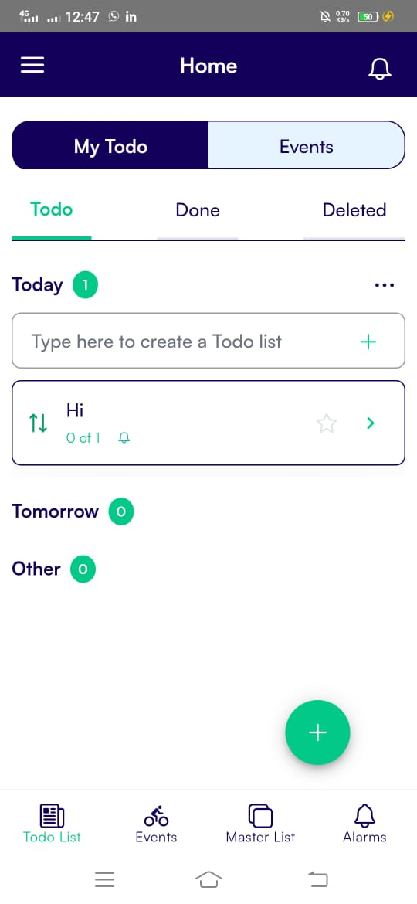A screenshot of a phone

        Description automatically generatedA screenshot of a computer

        Description automatically generatedA screenshot of a computer

        Description automatically generatedCheck if there is any warning message saying reminder of todays todo should be upcoming time.

1. Bug_25
   1. Description :

Even after delete some alarms of particular tasks, it again appears in the alarm section.

* 1. Test – reproduce :
     1. Delete the alarms of future tasks in the alarm section
     2. Close alarm section
     3. A screenshot of a phone

        Description automatically generatedA screenshot of a phone

        Description automatically generatedA screenshot of a phone

        Description automatically generatedAgain, open alarm section to check whether the future alarms of deleted tasks are still existing.

1. Bug_26
   1. Description :

Even after the to-do task is deleted, the corresponding alarm that was set for that task is not automatically deleted.

* 1. Test – reproduce :
     1. Delete the todo task permanently.
     2. A screenshot of a phone

        Description automatically generatedA screenshot of a phone

        Description automatically generatedCheck the alarm section whether corresponding alarm that was set for the deleted todo task is still appearing .

1. Bug_27
   1. Description :

Even after deleting the task, it appear on ToDo section but it is only removed from ToDo after clearing RAM space from phone

* 1. Test reproduce :
     1. Delete a ToDo task in the ToDo section (not permanent delete)
     2. Check the ToDo section if the task exist.
     3. Then again, remove the RAM space of phone.
     4. A screenshot of a phone

        Description automatically generatedA screenshot of a phone

        Description automatically generatedA screenshot of a phone

        Description automatically generatedAnd check again the deleted ToDo task exists in ToDo section.

Strength

1. Notifications does not disappear, soon after we click notification bell icon and view it, but it keeps showing, until we tap the particular notification and view it, so that we can track the task without forgetting notified tasks.
2. Master List : we can add our repetitive tasks and we can reuse it whenever we need.
3. Alarm option : it gives beep sound once the reminder time is reached, so that we can easily remember the tasks to be done.
4. There is option for import To-Do lists from CSV files as well as export it to csv/excel file.
5. There is option for merge two or more To-Do list as one.