American International University-Bangladesh (AIUB)
Introduction to Database
Midterm Lab Tasks-03
- Find average, maximum, minimum salary of the employees.
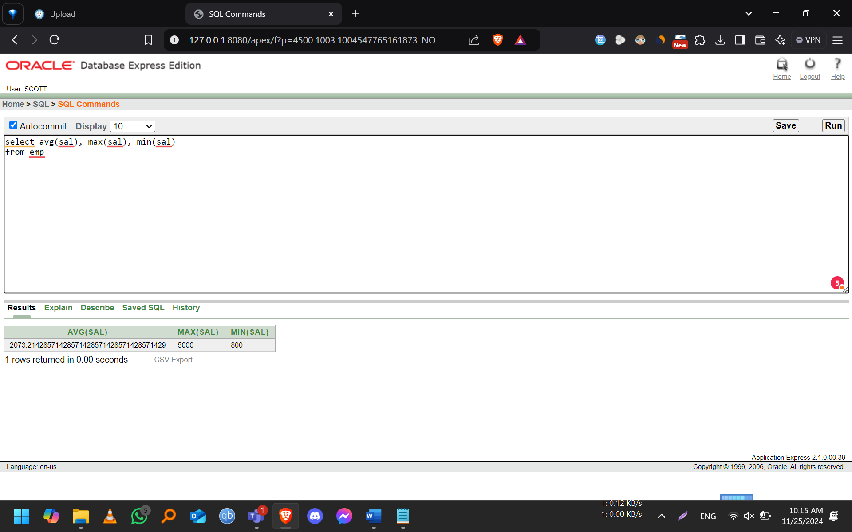
- Find average, maximum, minimum salary of the employees according to department number.
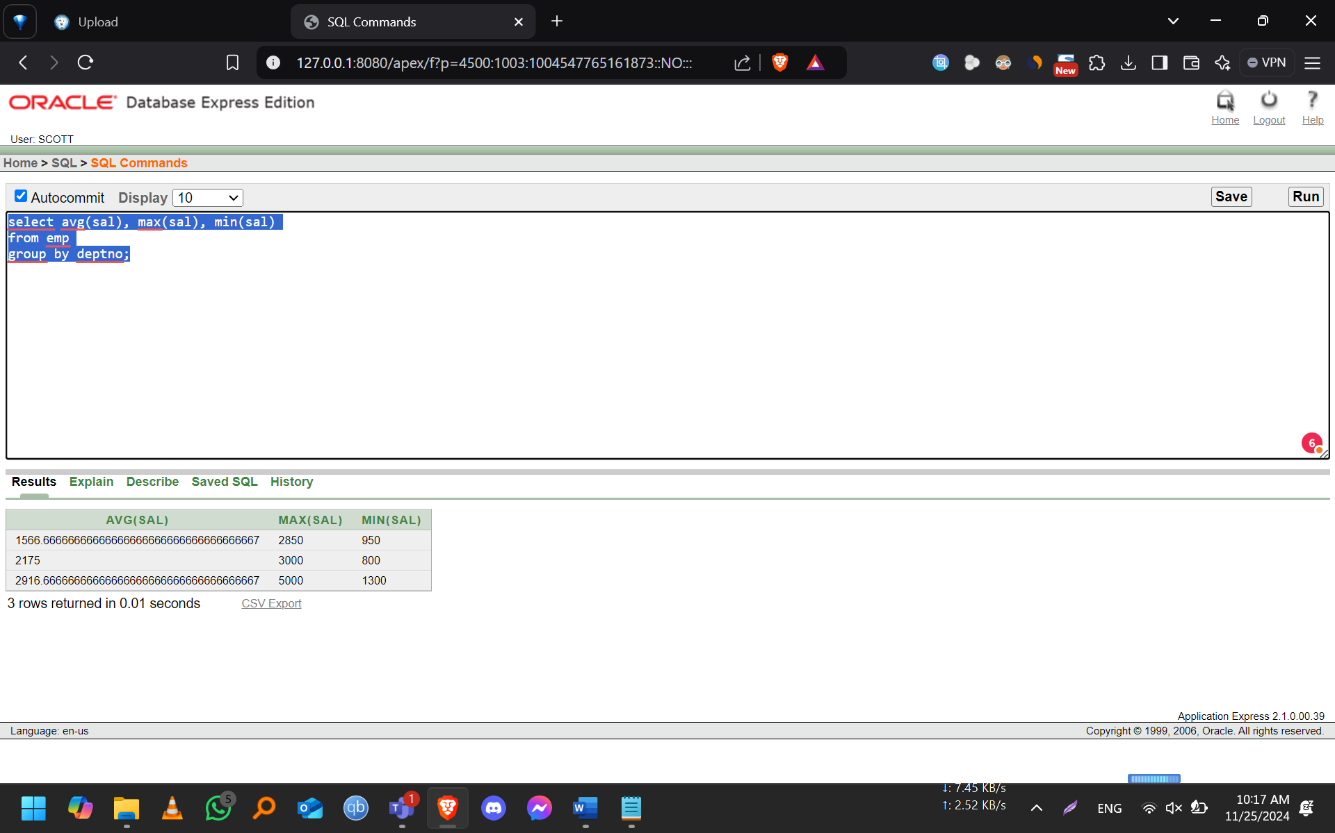
- Find average, maximum, minimum salary of the employees according to job category.
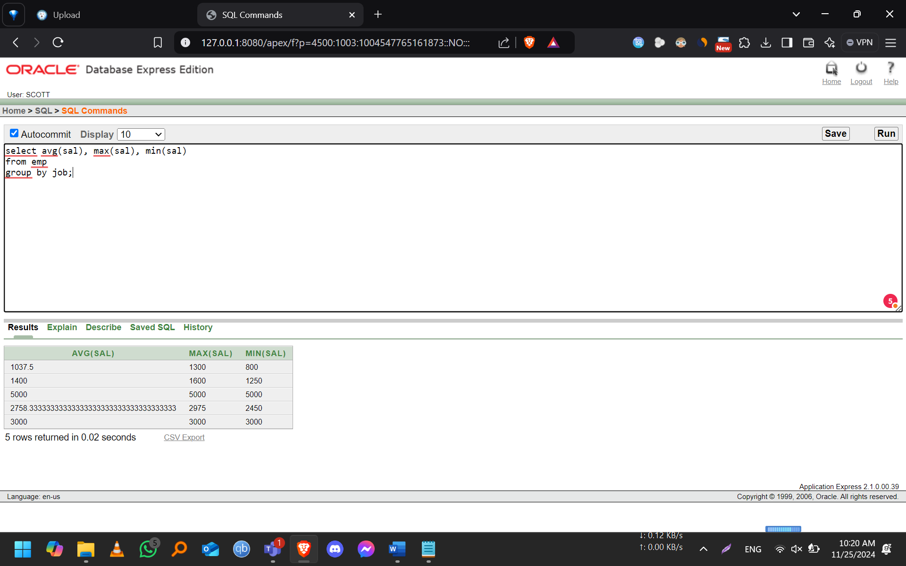
- Find the name of lowest paid manager. (Manager is not Job).
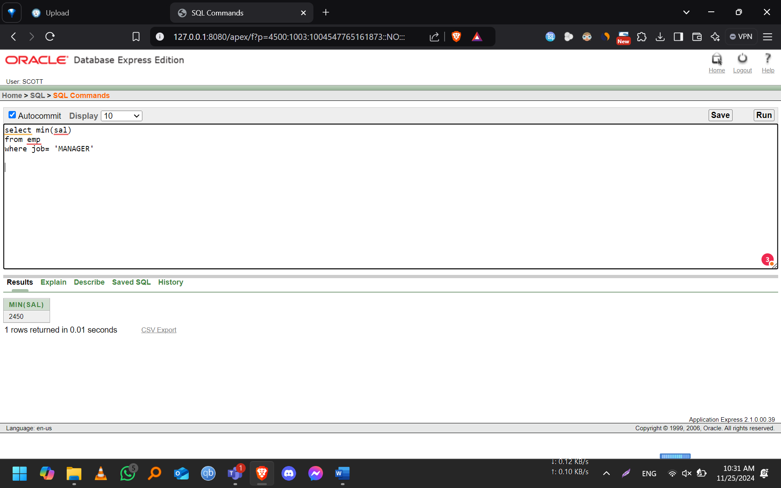
- Find out job group having highest amount of total salary. (Sal + comm)
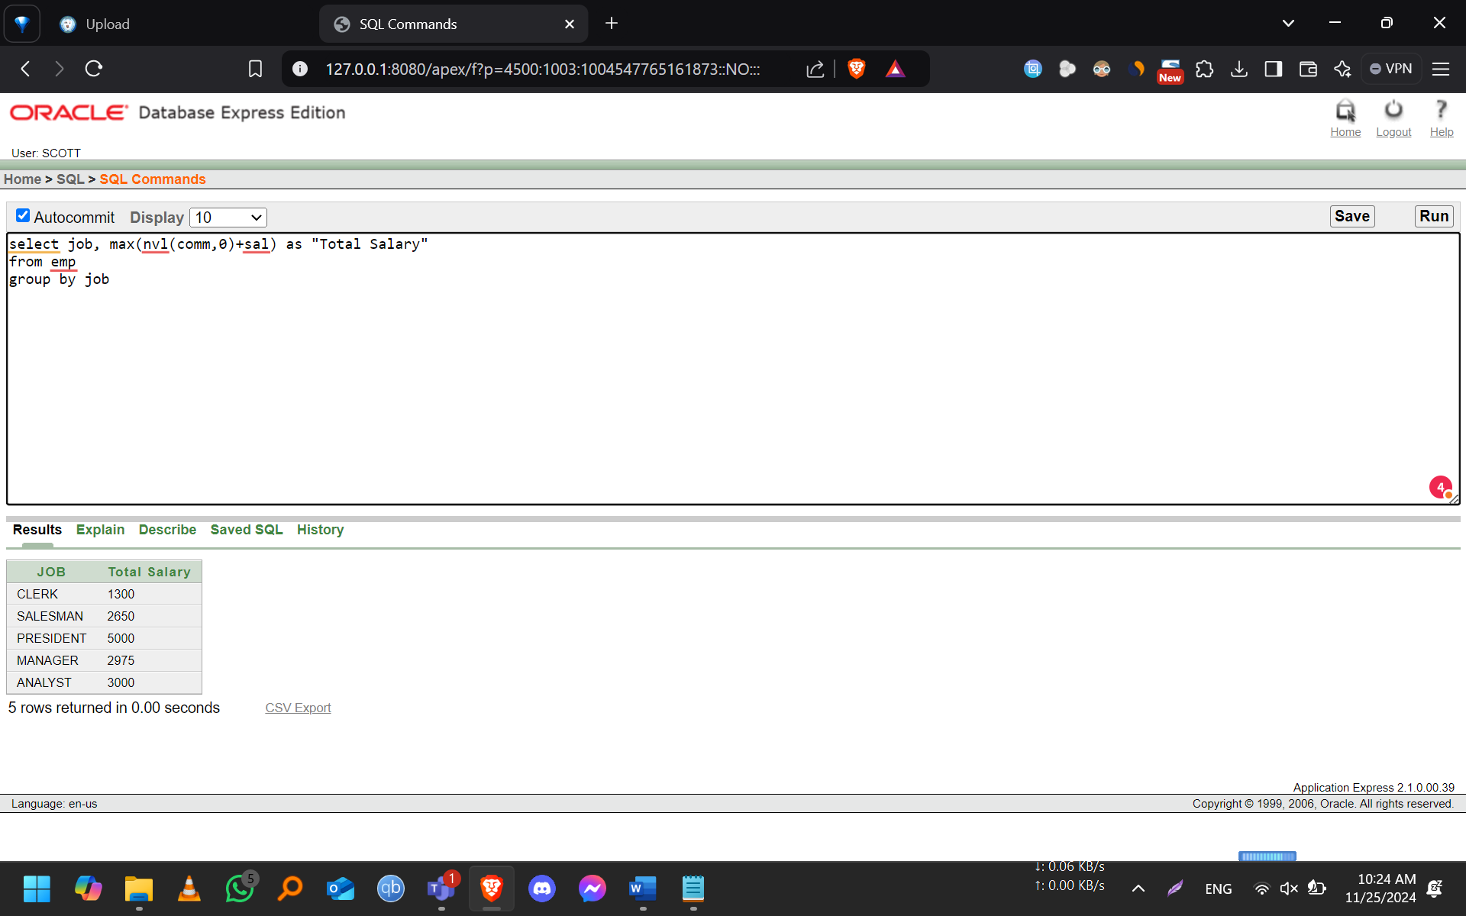
- Suppose you need to know the name and department no. of the employee who earns the highest salary. Write a SQL query to return this information.
