American International University-Bangladesh (AIUB)
Introduction to Database
Final term Lab Tasks-02
Subqueries
A subquery is a SELECT statement that is embedded in a clause of another SELECT statement. You can build powerful statements out of simple ones by using subqueries. They can be very useful when you need to select rows from a table with a condition that depends on the data in the table itself.
You can place the subquery in a number of SQL clauses:
- WHERE clause
- HAVING clause
- FROM clause
Guidelines for Using Subqueries
- A subquery must be enclosed in parentheses.
- A subquery must appear on the right side of the comparison operator.
- Subqueries cannot contain an ORDER BY clause. You can have only one ORDER BY clause for a SELECT statement, and if specified it must be the last clause in the main SELECT statement.
- Two classes of comparison operators are used in subqueries: single-row operators and multiple-row operators.
Errors with Subqueries
One common error with subqueries is more than one row returned for a single-row subquery. To correct this error, change the = operator to IN.
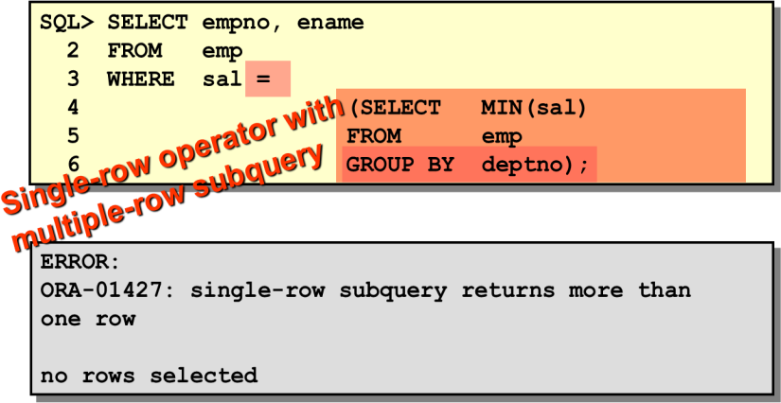

Exercise
- Display all the employees who are earning more than all the managers.
- Display all the employees who are earning more than any of the managers.
- Select employee number, job & salaries of all the Analysts who are earning more than any of the managers.
- Select all the employees who work in DALLAS.
- Select department name & location of all the employees working for CLARK.
- Select all the departmental information for all the managers
- Display the first maximum salary.
- Display the second maximum salary.
- Display the third maximum salary.
- Display all the managers & clerks who work in Accounts and Marketing departments.
- Display all the salesmen who are not located at DALLAS.
- Get all the employees who work in the same departments as of SCOTT.
- Select all the employees who are earning same as SMITH.
- Display all the employees who are getting some commission in marketing department where the employees have joined only on weekdays.
- Display all the employees who are getting more than the average salaries of all the employees.

