How to make your site beautiful with the knowledge of Web design principles?

"Have no fear of perfection -- you’ll never reach it."

Salvador Dali, artist

[Wikipedia]( https://en.wikipedia.org/wiki/Web_design) says that web design encompasses many different skills and disciplines in the production and maintenance of websites. The different areas of web design include web graphic design; user interface design (UI design); authoring, including standardized code and proprietary software; user experience design (UX design); and search engine optimization (SEO). Often many individuals will work in teams covering different aspects of the design process, although some designers will cover them all. The term "web design" is normally used to describe the design process relating to the front-end (client-side) design of a website including writing markup. However, in this article, we will discuss broadly some UI/UX design principles, how to be good at those, and make our websites beautiful. In short, if you want to master design skills, this article is for you. So, without wasting time, let’s get started.

For non-designers, it's a bit scary to start with designing a product. This product can be anything, for example, a logo, website, app or, anything that comes with a design. Web designing is a promising but incredibly challenging field. You need to have the technical knowledge and creative skills to be a successful web designer. If you are a website designer, then it might be quite common for you to be concerned about learning new skills and mastering the old ones. As a designer myself, I would love to share the things that I've learned so far.

Color

Though we should not judge anything by their looks, it is true that first impression always counts. This is especially true for a brand since in this busy world what most of your customers will see is your brand color. Colors evoke emotions, feelings, and convey certain information. This enables customers to form a first impression without even knowing what your product is about. Whether you’ve decided to branch out from a company and start your own business/startup, understanding the impact of color on consumer behavior will help your brand become a success. [[Research](https://www.colorcom.com/research/why-color-matters) shows](Research%5d(https://www.colorcom.com/research/why-color-matters)%20shows) that up to 85% of consumers believe color is the biggest motivator when choosing a particular product, while 92% acknowledge visual appearance as the most persuasive marketing factor overall.

We all know red is associated with danger and green is associated with nature, but both have additional meanings and associations. [Color psychology](https://en.wikipedia.org/wiki/Color_psychology) is the study of how colors affect perceptions and behaviors. It allows us to understand color and use it to our advantage, especially when it comes to marketing and branding. A lot of research has gone into color theory. You can definitely get lost down the rabbit hole finding the story behind each color, however, here’s a quick summary to give you an idea:

Red: danger, excitement, strength, love, energy

Orange: confidence, success, sociability, vitality

Yellow: creativity, happiness, warmth, cheer, optimistic

Green: nature, healing, freshness, quality, sustainability

Blue: trust, peace, loyalty, competence, depression

Pink: compassion, sophistication, sweet, feminine

Purple: royalty, luxury, spirituality, ambition

Brown: dependable, rugged, trustworthy, simple, earthly

Black: formality, dramatic, sophistication, security, luxurious

White: clean, simplicity, innocence, honest, minimal

Multicolor: united, open-for-all, diversity, fun

Of course, within this spectrum, there is a raft of additional colors. Different hues, such as baby blue, hot pink, or navy, also contribute to the color story.

Before using any of this color, you need to first identify your brand’s essence, it goals, services and how you want your targeted customers to feel about it. The way you can help further narrow down your color scheme. Most of the time, we can tell which color is not professional only by seeing at the website, but we failed to apply suitable colors professionally.

Tell me which website uses colors more professionally?

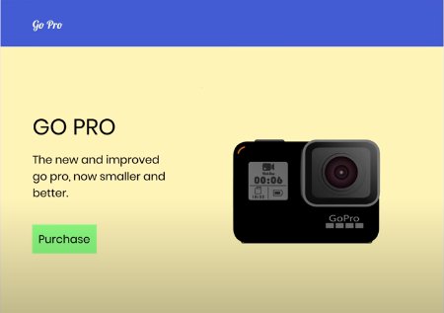 

Contrast

Web design consists of different elements, including typography, colors, shapes, whitespaces, etc. When it comes to synchronizing these elements, the most basic stuff is perhaps the contrast.

Now, when we say contrast, the first thing that comes to our mind is colors. Choosing the right color contrast is something that is part of our daily lives, for example when it comes to buying clothes, accessories, and wearables. But when it comes to web design, the [principles of contrast]( https://en.wikipedia.org/wiki/Contrast_(vision)) go beyond just colors.

Every beginner designer knows that using contrasting colors is important. It’s basic that using black foreground text on a navy background would make it difficult to read the text. Color contrast also means how one element on a web page contrast with the color of other elements on the same page.

Who would have thought that the size contrast also matters in web design? Well…it’s no surprise. Size contrast might be the most basic one here. Take an example of the size of a heading and a paragraph. The heading has a bigger font size than the paragraph so that it stands out from the rest of the text.

When I talk about contrast, I always show this picture.

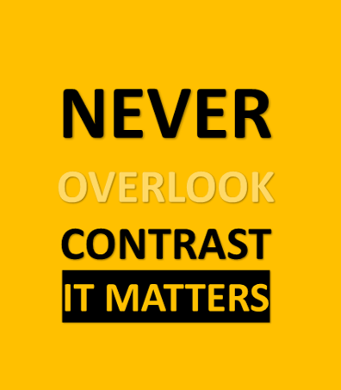

I think this tells a lot about contrast.

Whitespace

In general, most non-designers and beginning designers are afraid of whitespace. Thinking everything needs to contain something. However, this often comes across as clumsy and too busy. Remember one thing very clearly, the more your website is readable, the better experience your customers will get by visiting the website. Using whitespaces enables us to make our design already looks a lot better with just a very little amount of effort. In fact, Whitespace in design composition is the same as the use of silence in a musical composition. Without proportionate use of silence, music is unstructured; some may call it noise. Similarly, without whitespace, the design is unstructured and difficult to consume.

Designers use whitespace as an integral part of their design for good reasons. When used well it can transform not only the design but also the business for which the design is made. Whitespace significantly boosts not only the UI (User Interface) but also the UX (User Experience) of the page.

Using whitespace evenly makes the content in the design easily scannable and significantly improves legibility. A study conducted indicates that proper use of whitespace between lines of paragraphs and its left and right margins can increase comprehension up to 20%. Whitespaces help greatly in guiding the users through the page and prioritizing the focus area for the user.

Whitespaces help us by increasing interaction rate, guiding the users through logical grouping, establishing a branding and design tone, creating a breathing space for users.

Tell me which article is more readable?

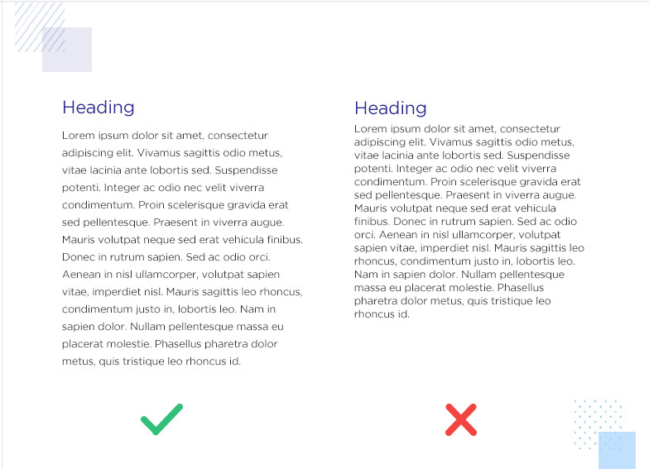

Typography

There are [thousands of different typefaces and fonts]( https://www.dafont.com/) available to designers today. Most are available in a digital format and can easily be used with modern computer technology. The vast amount of type available makes the specific classification of everyone nearly impossible and somewhat frivolous. However, it is important to have an understanding of the basic styles of typefaces to help narrow down the research and selection of the correct typeface.

**Calligraphic**

Letters associated with the art of [[calligraphy](http://en.wikipedia.org/wiki/Calligraphy)]( https://en.wikipedia.org/wiki/Calligraphy) and the fonts developed from their production can be classified as calligraphic. Calligraphic letters can be, although do not have to be, classified as Chancery, Etruscan or Uncial.

**Blackletter**

Blackletter typefaces are a script style of calligraphy that was popularized in German. A highly ornamental style of typography, different styles are often associated with the different regions in which they were developed and used. The main classifications include Textura, Schwabacher, Cursiva and Fraktur.

**Serif**

Serifed typefaces were popular much earlier than sans-serif typefaces and include semi-structural details on many of the letters. People often refer to them as feet, although that is in no way a [[proper anatomical](http://typedia.com/learn/only/anatomy-of-a-typeface/) term](http://typedia.com/learn/only/anatomy-of-a-typeface/) when referring to typography. There are many different classifications for serifed typefaces, often named for their origins, including Grecian, Latin, Scotch, Scotch Modern, French Old Style, Spanish Old Style, Clarendon, and Tuscan.

**Sans-Serif**

Just exactly like what it sounds, “sans” means without, so sans-serif is a typeface without serifs. Much like serifed typefaces, there are many different classifications for sans-serif typefaces, including Gothic, Grotesque, Doric, Linear, Swiss, and Geometric. Sans-Serif typefaces are very popular among web designers nowadays.

**Script**

Script typefaces are based on the forms made with a flexible brush or pen and often have varied strokes reminiscent of handwriting. There are many different classifications including Brush Script, English Roundhand, and Rationalized Script.

**Pixel**

Pixel fonts developed from the invention of the computer and were based on the on-screen display format of [pixels](http://en.wikipedia.org/wiki/Pixel). They are based on an array of pixels, are often called Bitmap fonts, and are often designed only for a specific point size. Many type foundries offer a selection of bitmap fonts and some, like “[Fonts for Flash](http://www.fontsforflash.com/)” create only bitmap fonts.

**Decorative**

While serifed and sans-serif typefaces can often be used for text typesetting, there are a vast majority of fonts and typefaces whose legibility wanes when used in smaller point sizes. These typefaces are often developed with a specific use in mind and are designed for larger point size use in headlines, posters, and billboards. Decorative is less of classification and can include a wide variety of typefaces underneath the umbrella of the term.

Well, I agree with you the typography part is the most boring part of this article. However, it’s important to know what each typeface offers us. There are so many typefaces and fonts overused, so designers nowadays never use them. When you select a font-stack for your websites, you need to be very careful about what’s that website’s contents are about, if they are education, you can go with serif. If they are fashion-related, go with decorative or calligraphic. If they are for fun, you can use san-serif or pixel. For general purposes, I recommend using san-serif and formal typefaces because they can create an impact on the users/customer’s mind.

Visual Hierarchy

After combining all these principles like color, contrast, whitespace, typography web designers try to create a visual hierarchy. Proper visual hierarchy ensures better user experience and improves website readability. It is often said that users often leave a website in just 10 seconds if they don’t like its visual hierarchy. Let’s look at a website and discuss how the designer has implemented a proper visual hierarchy.

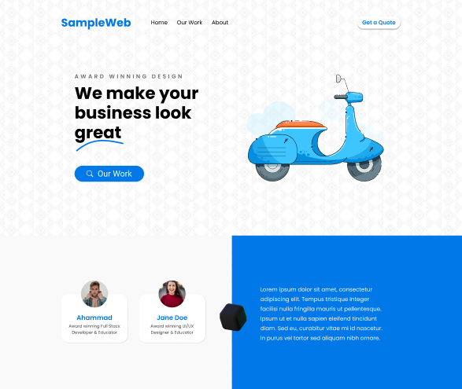

As you can see, on this website the very first thing you will notice is the big title “We make your business look great”. This attracts us most because of the usage of size contrast. Then, you will notice the “Our work” button, an example of color contrast. The subtitle “Award-winning design” is less noticeable because of using color and size contrast. The illustration used beside the title, although it doesn’t make sense with this website, makes the website nothing but beautiful.

You will also notice that colors have been used professionally. The primary color is a blueish color, secondary is white, black/off-white/grey are also used throughout the website. Proper spacing is used everywhere on the website and the background makes the website uncommon.

In the navbar, the first thing you will notice is the brand name, then the “Get a Quote” button, and finally the hyperlinks to different pages.

Overall, if you tell me to mark this design, I will give it a solid 8 out of 10. This web design is pretty much clean and professional, tells the users where to focus more, and thus creates an impact. By the way, have you noticed that similar margins are used on both sides of this webpage?

In this article, I tried to describe my knowledge about Web Design principles. This information is not unique at all because you can find the same sets of advice everywhere on the net. And it is a common scenario that after applying all these principles, web designers can’t make their websites what they actually want, though the website is beautiful enough. So, my last piece of advice will be “Don’t be frustrated if you can’t make your website super cool, always learn from your mistakes and cultivate a habit of visiting different types of websites daily so that you can know more about recent design trends.” Design is a part of the culture and the cultural trend changes a lot. You know that, right?

# Sources

* [Wikipedia](<https://www.wikipedia.org/>)
* [12 tips for becoming a successful web designer](<https://www.designhill.com/design-blog/tips-for-becoming-a-successful-web-designer/>) Anne Cartoon
* [Design Tips and Tricks]( <https://github.com/EddieHubCommunity/support/discussions/874>) DevCassie
* [How to choose right color for your brand](<https://www.canva.com/learn/choose-right-colors-brand/>)
* [Importance of contrast in web design](<https://www.fuelmybrand.com/blog/importance-of-contrast-in-web-design/#:~:text=Ensuring%20the%20contrast%20between%20different,and%20navigation%20on%20the%20website>.)
* [Importance of whitespaces in your design](<https://blog.prototypr.io/importance-of-white-space-in-design-5a40c0e65bfd>)
* [Type Classification](<http://www.designishistory.com/1450/type-classification/>)
* [Web Design Tutorials- 5 important tips](<https://www.youtube.com/watch?v=z-xkbNLIB5w>)