# VIZIYON BILISIM DATABASE PROJECT

Members:

**Ibrahim Kashbor 150119856**

**Ahmet Hamza Demir 150116025**

**Arda Tortumluğlu 150116003**

## Description:

Our project is about implementing and designing a database for an electronic and PC accessories shop named “Vizyon Bilisim”. The CEO asked us to design a database for the shop to make data more readable, fast access, easy to read, insert, delete, and update any record from the data.

## Scope:

The scope of the project is to create a database which hold the recorders of the shop such as all information about the customers, products, and wholesalers who are suppling the shop with PCs and its accessories.

## Tables:

1. Staff: this table holds information about the people who are working there.

Its columns are the following:

* StaffID: its type is “int” and it is a primary key, and an identity which starts from “1001”.
* FirstName: its type is “varchar(30)” which holds the first name of each staff in the shop.
* LastName: its type is “varchar(30)” which holds the last name of each staff in the shop.
* Birthdate: its type is “date” which holds the birthdate of each member in the staff.
* Gender: its type is “char(1)” which hold M if the person is male, and F if the person is female.
* PhoneNumber: its type is “int” which hold the record of phone number of the staff.

1. Manager: this table holds information about who is the manager from the staff and it has just one column which is:

* StaffID: its type is “int” and it is a primary key of the table.

1. Product: this table holds entropy about the products which are already in the store and has the following columns:
   * ProductID: its type is “int” and it both a primary key and an identity which auto incrementing starting from 1.
   * WhoalesalerID: its type is int which is both a foreign key and an identity which incrementing by 1 starting form 101 belongs to the WHOLESALER table.
   * ProductName: its type is “nchar(30)” which holds the names of each product in the store.
   * PurchaseDate: its type is “date” and it is holding the date which the store bought from the wholesaler.
   * ProductType: its type is “nchar(30)” and it is holding the type of each product such as pc, headphone, or keyboard etc.
   * Price: its type is “decimal(18,0)” which holds the price of each product.
   * Piece: its type is “int” which holds how many each product is in the store.

* This table has a Trigger which is “purchase_date” which get automatically the date of the product after whenever the store insert a new record in the table using “GETDATE()” function.

1. Services: the services table holds information about the services that the store did for each customer and has the following columns:
   * CustomerID: which is the primary and the foreign key in this table and its type is “int”.
   * CargoID: which is the foreign key to the Cargo table and its type is “int”.
   * DeliveryDate: its type is “date” and it holds the information about the date which was delivered to the customer.
   * Price: its type “decimal(18,0) which has the information about the price of the service done by the store.
   * DeliveryCheck: its type is “char(1)” and it holds T as true which indicate it is delivered and F as false which indicate it is not delivered yet.
   * DelivetAdress: its type is “nchar(50)” which holds the delivery address of each product/service done by the store.
2. Payment: this table has the information about each payment done by each customer to the store and the has the following columns:
   * PaymentID: its type is “int” and it is both a primary key and an identity which increment by 1 starting from 1.
   * ProductID: its type is “int” and it a foreign key to the product table and it specify which product the payment done for.
   * CustomerID: its type is “int” and it is a foreign key to the table customer to be able to specify which customer done the payment.
   * PaymentType: which tells how the payment was made by Cash or Credit Card and its type is “nchar(15)”.
   * PaymentCheck: its type is “char(1)” and it holds true as T which means that the payment was done, and false as F which means that the payment was not done.
   * Adress: its type is “nchar(50)” and it hold the address of the customer.
   * Piece: its type is “int” and which hold the number of pieces for each payment.

* This table has a Trigger which is “control_piece” which will fire after inserting a payment and it will subtract the number of the pieces in the table product after a customer bought that specific product.

1. Customer: This table holds all the record for each customer the store has and its columns as the following:
   * CustomerID: its type is “int” and it is a primary key, foreign key to the Payment and the Services tables, and it is an identity which increamting by 1 starting from 1.
   * FirstName: its type is “varchar(30)” and it has the first name of each customer.
   * LastName: its type is “varchar(30)” and it has the last name of each customer.
   * Age: it is the age of each customer, and its type is “int”.
   * PhoneNumber: its type is “char(13)” and it holds the phone number of each customer.
   * Gender: its type is “char(1)” which holds M as male and F female based on the customer gender.

* This table has a Constraint named as “Customer Age” which check if the customer is greater than 18 years old.

1. Wholesaler: this table hold the information of the suppliers of Viziyon Bilism and it has the following information as columns:
   * WholesalerID: its type is “int” and it is a primary key the table and a identity starting from 101.Moreover, it is a foreign key for the Product to be able to tell which product belongs to which supplier.
   * FirstName: its type is “varchar(30)” and it holds the first name of the supplier.
   * LastName: its type is “varchar(30)” and it holds the last name of the supplier.
   * Birthdate: it holds the birthdate of each supplier, and its type is “date”.
   * PhoneNumber: it holds the phone number of each supplier, and its type is “nchar(13)”.
   * Adress: it holds the address of each supplier, and its type is “nchar(50)”.
2. Cargo: The table Cargo has the data about the cargo of each product was sent to the customer, and it has the following columns:
   * CargoID: its type is “int”, and it is a primary key to the its table, a foreign key to the Services table, and it is an identity which starts from 101.
   * DeliverCheck: its type is “char(1)” and its true as T, and false as F which indicate the cargo has been delivered or not respectively.
   * CargoPrice: its type is “decimal(18,0)” and it holds information about the price of each cargo.
   * ProductPrice: its type is “decimal(18,0)” and it holds information about the price of each product.
   * TotalPrice: which is computed by adding CargoPrice and ProductPrice, its type is “decimal(19,0)”.

## Triggers:

1. control_piece: This Trigger is on Payment table and it will fire after inserting a payment which will subtract the number of the pieces in the table product after a customer bought that specific product.

Figure1 Payment Trigger Query.

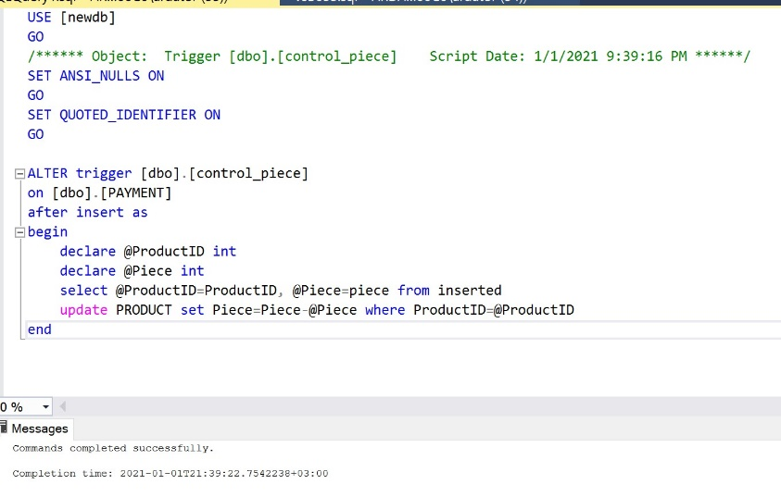

Figure2 Product Table Before.

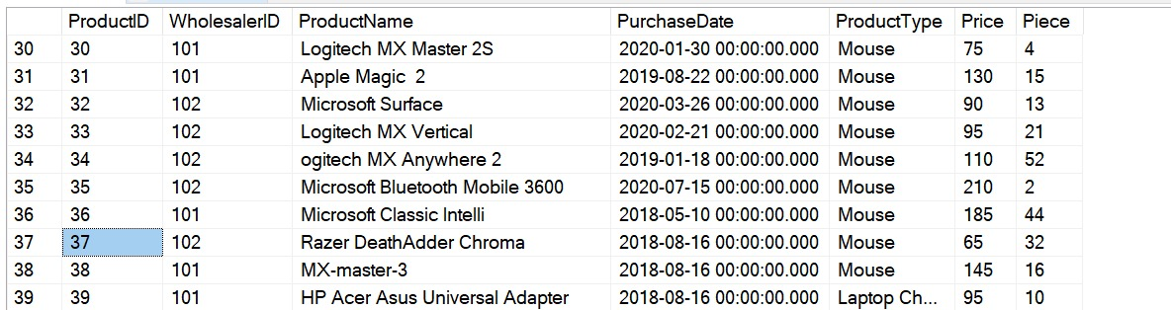

Figure3 Product Table After.

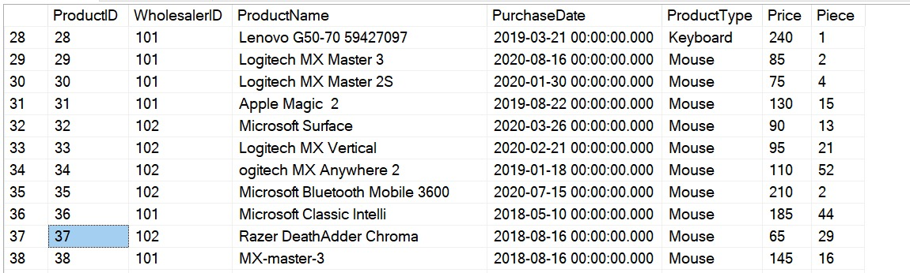

1. purchase_date: This Trigger is on the Product table which will get automatically the date of the product after whenever the store insert a new record in the table using “GETDATE()” function.

In this Trigger the date will automatically fulfill at the exact same time when inserted a new product to the table.

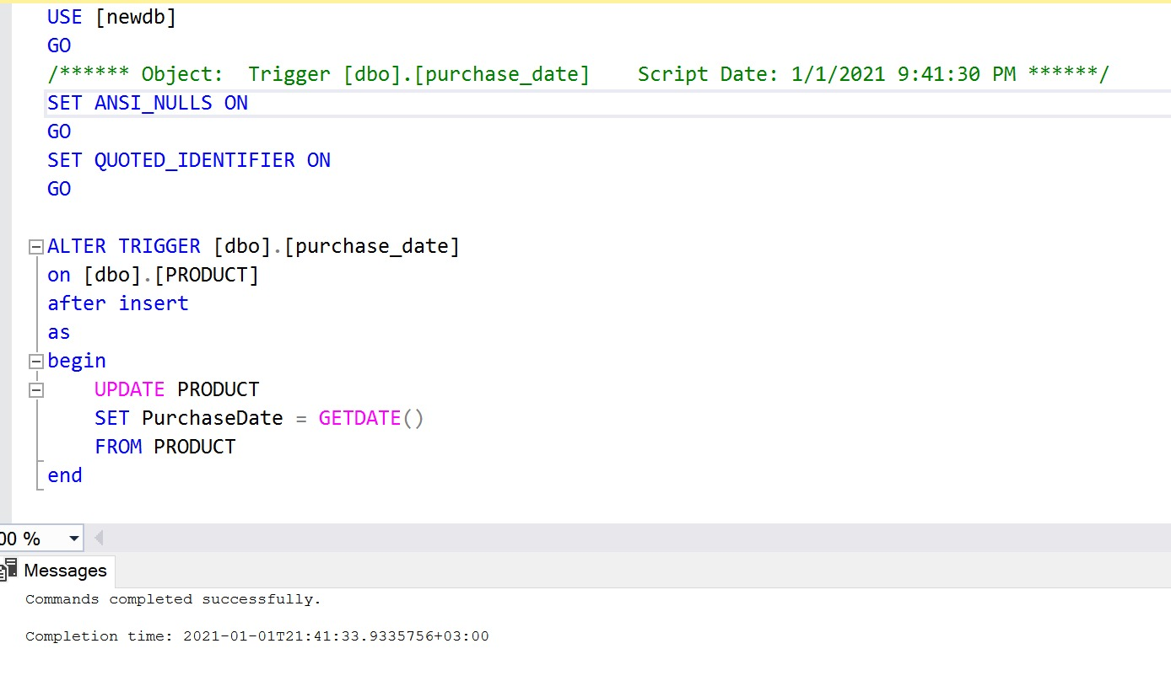

Procedures:

Figure 1

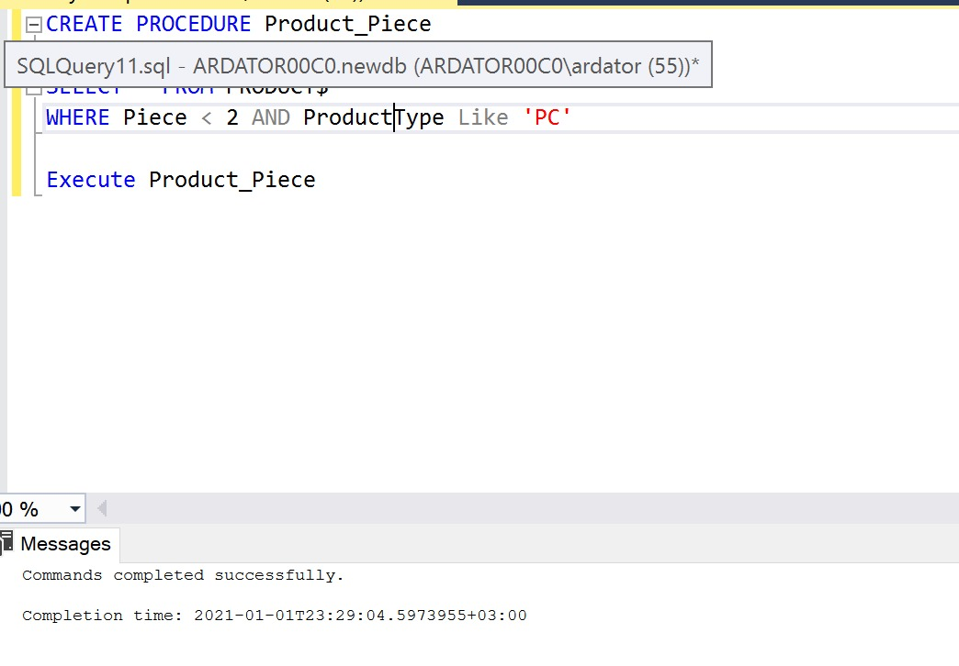

Figure 2

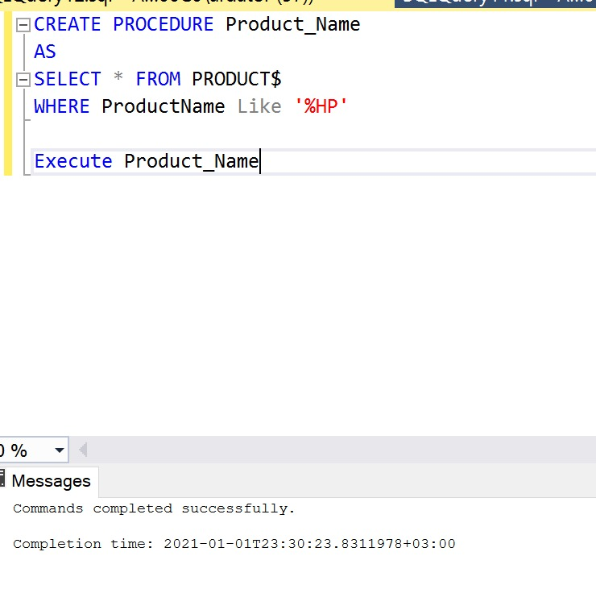

Figure 3

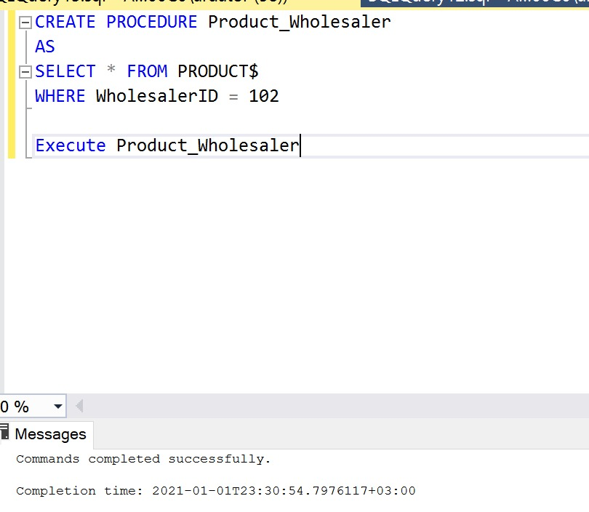

Figure 4

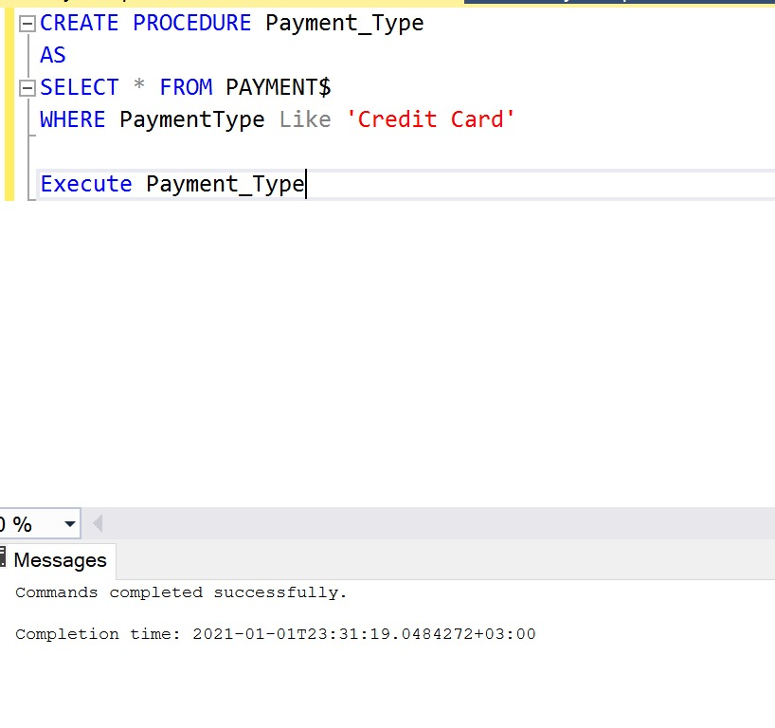

Figure 5

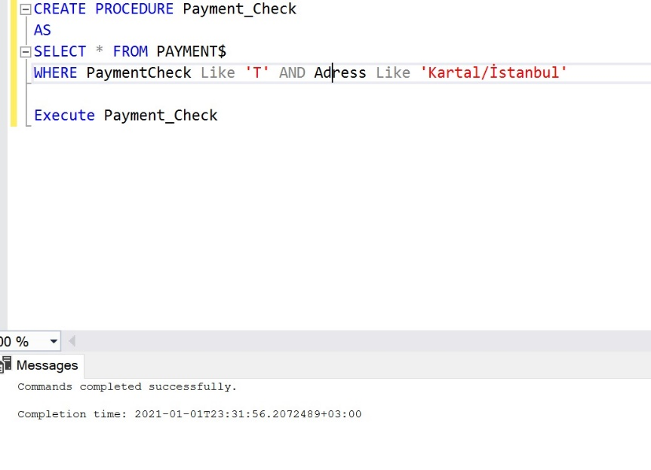

Figure 6

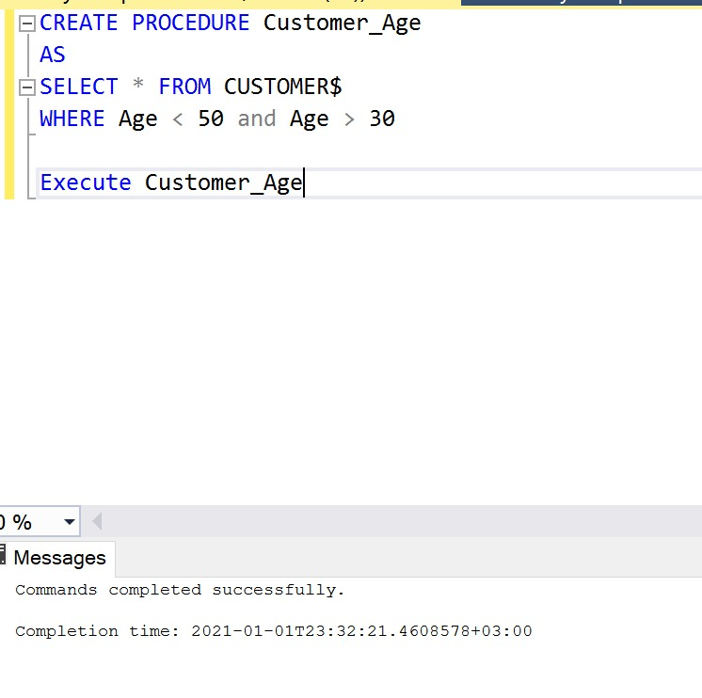

Figure 7

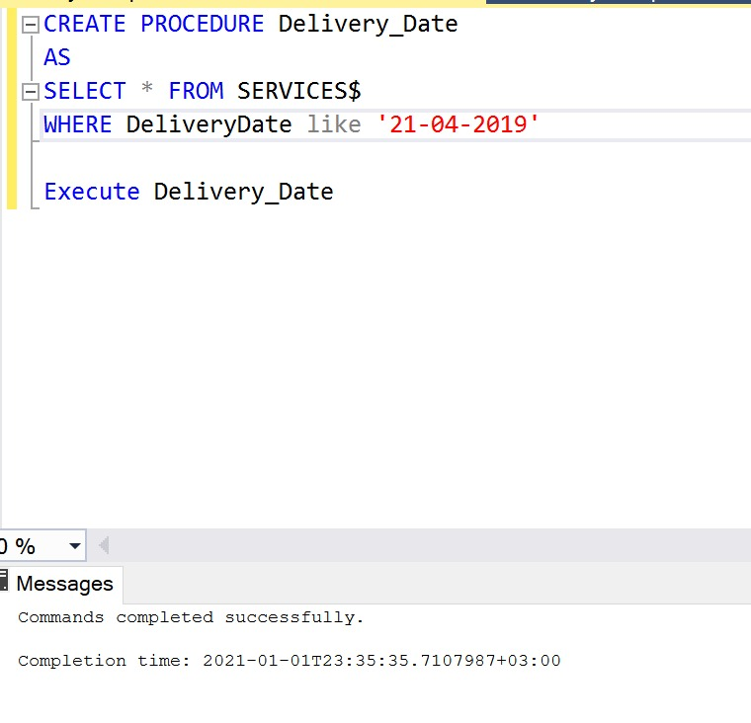

Figure 8

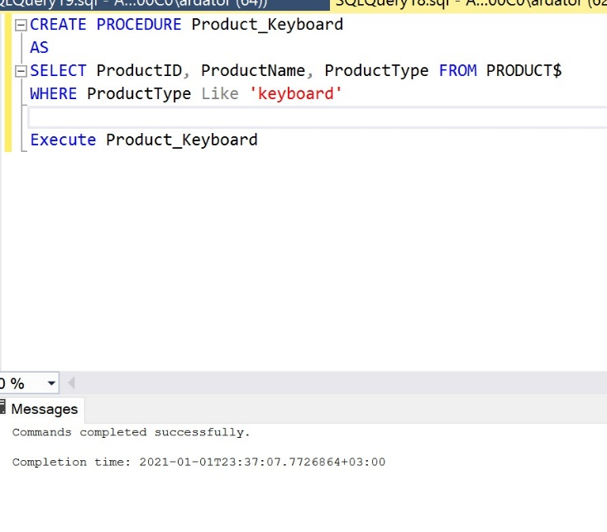

Figure 9

