LAB 6

Code and Branch
Coverage Analysis
Tennis Scoring System
Name | Ahan Charan
SRN | PES2UG24CS037
Section | A
Objective
Measure the execution of the Tennis Scoring System using pytest and coverage.py, then extend the tests to improve code coverage and branch coverage.
Environment
WSL (Ubuntu) | Python 3.14.4 | pytest 9.2.0 | coverage.py

Progress summary
Measure | Initial baseline | Current result
Tests executed | 2 starter tests | 20 expanded tests
Line coverage | 37% | 100%
Branch coverage | 32% | Not yet measured after expansion
Status note: The code coverage stage has reached 100% line coverage. The branch coverage stage and its final evidence are still pending; this report records progress to date and is not yet the complete Lab 6 submission.

Evidence 1 - Original baseline
The starter test file executed 2 tests. The initial report showed 37% line coverage and 32% branch coverage, identifying the need for additional tests.
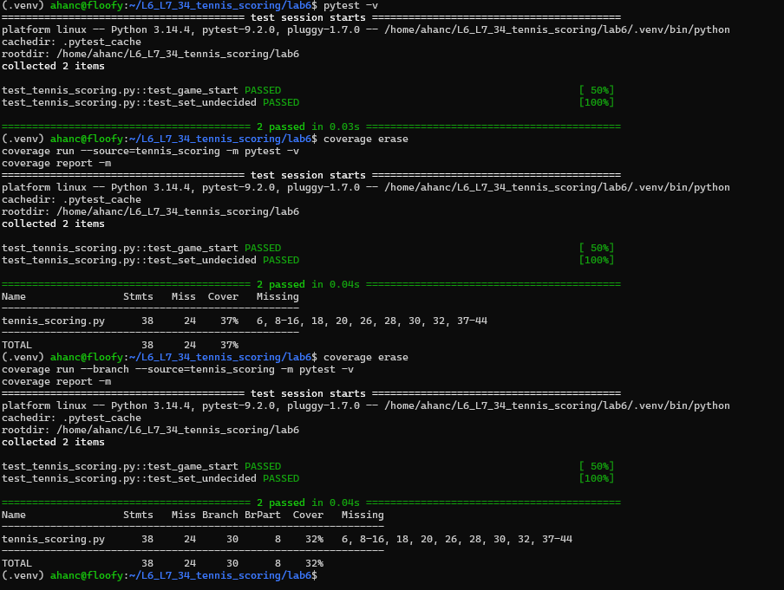
Figure 1. Initial pytest run and baseline line/branch coverage reports.

Evidence 2 - Expanded code coverage tests
The new test file, CodeCoverageTest_037_application.py, executed 20 test cases. All 20 tests passed.
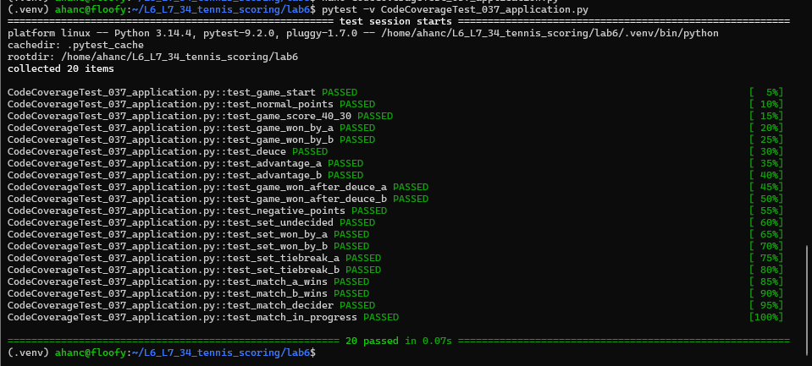
Figure 2. Successful execution of all 20 expanded code coverage tests.

Evidence 3 - Final line coverage result
The expanded tests were run with coverage.py using the tennis_scoring module as the coverage source. The report showed 38 statements, 0 missing statements and 100% line coverage.
RESULT: 100% LINE COVERAGE | 20 TESTS PASSED | 0 MISSING STATEMENTS

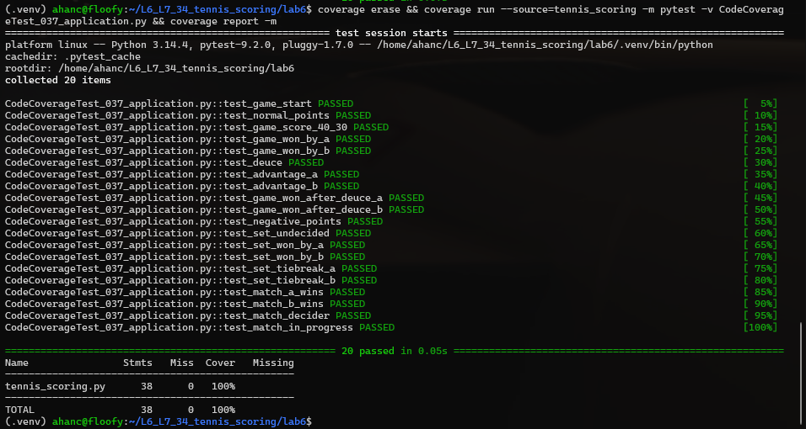
Figure 3. Terminal output showing 100% line coverage for tennis_scoring.py.

Remaining work
- Create and run BranchCoverageTest_037_application.py.
- Achieve at least 90% branch coverage and capture the final branch coverage terminal screenshot.
- Complete the two separate Git commits and push the deliverables to the assigned repository.

