LAB 6: COVERAGE SCREENSHOTS
Code Coverage and Branch Coverage Analysis
Name: Ahan Charan | SRN: PES2UG24CS037
Section: A | Application: Tennis Scoring System
Only the final coverage results meeting the lab target are included. Earlier baseline and intermediate test-run screenshots have been omitted.

1. Code (Line) Coverage
Result: 20 tests passed | 38 statements | 0 missing | 100% line coverage
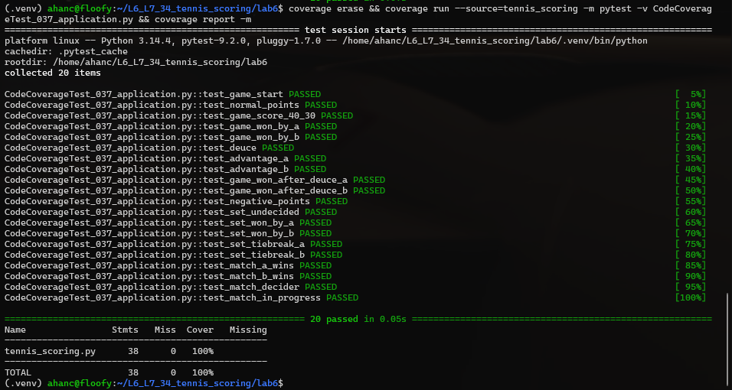

2. Branch Coverage
Result: 26 tests passed | 38 statements | 30 branches | 0 partial branches | 100% coverage


