User Manual:

When a user started using this spreadsheet app, all the cells are zero in value and all the formulas are null initially.

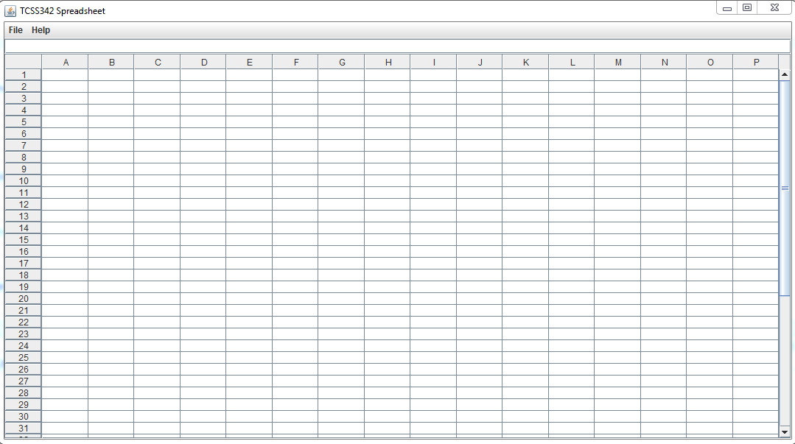

* User can enter the formula directly in the cell or can enter the formula in the formula bar.
  + The formula will go into the most recently selected cell
* When a new formula is entered, its evaluated value will be shown in the cell while the actual formula will be shown in the formula bar.

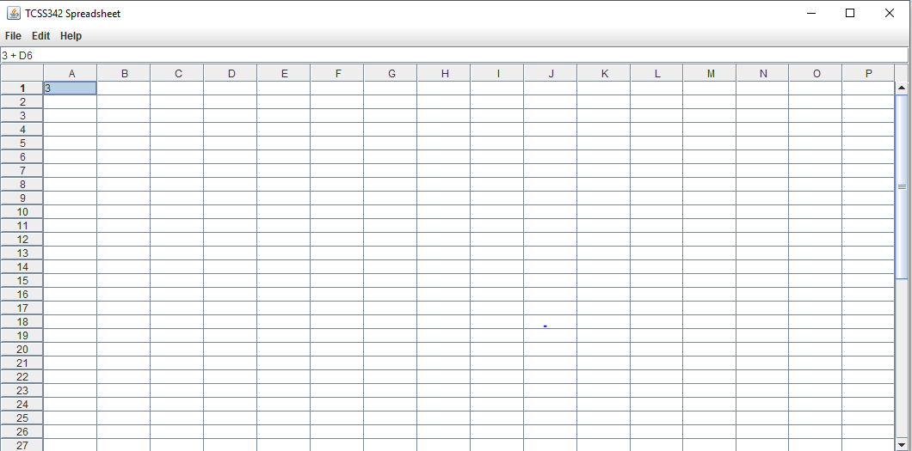

* If formula is invalid, that would not change the old formula.
* If formula shows circular dependency, a pop up window will appear on the screen with an error message.
* If a cell formula is changed, that will also change the formula of all those cells dependent on that particular cell.

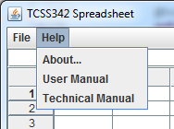

* We have help menu in the menu bar which has a menu item named ‘user manual’ item that helps a user to operate the app properly.

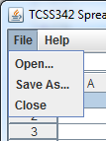

* File menu has a menu item named ‘save as’ which saves the spreadsheet into a file.

**Special Cases:**

Negative Numbers:

* When using negative numbers, there can be no space between the number and the minus sign

Good: -5

Bad: - 5

* If you want to use negative numbers in a formula, put parenthesis around it

Good: (-5) + 12

Bad: -5 + 12

Though this particular formula produces the same outcome, if parenthesis aren’t used, it gets out of wack with bigger formulas.

Order of Operations:

* The only operators that can be used in this program are + , - , * , /
  + Parenthesis are mainly used for negative numbers
  + * and / have a higher precedence than + and – so the formula will be rearranged so that they will be evaluated first going left to right.