CI/CD Pipeline using Drone CI and Gitea

Project Overview
This project demonstrates the setup of a self-hosted CI/CD pipeline using Drone CI integrated with Gitea in a Dockerized environment. The pipeline automates the process of code integration, build execution, and validation for a Python application.

Architecture
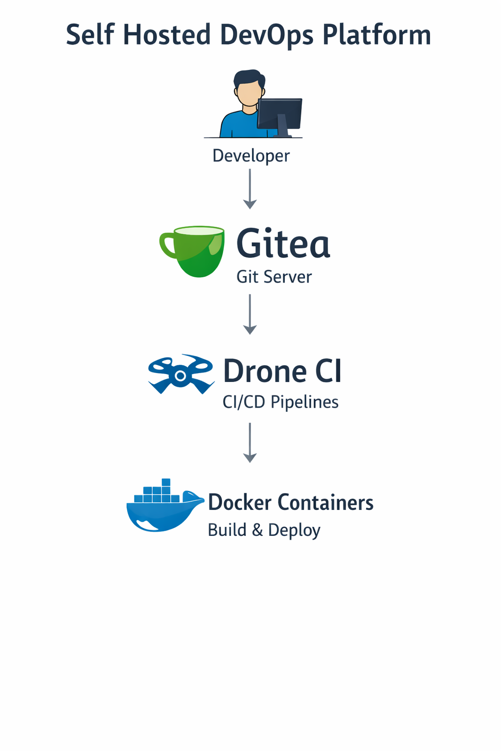

Technologies Used
Drone CI
Gitea
Docker & Docker Compose
Git
Python
Linux

System Setup
Gitea is used as the Git repository hosting service, while Drone CI is used for pipeline automation. Both services are deployed as Docker containers and communicate over a shared Docker network.

Pipeline Workflow
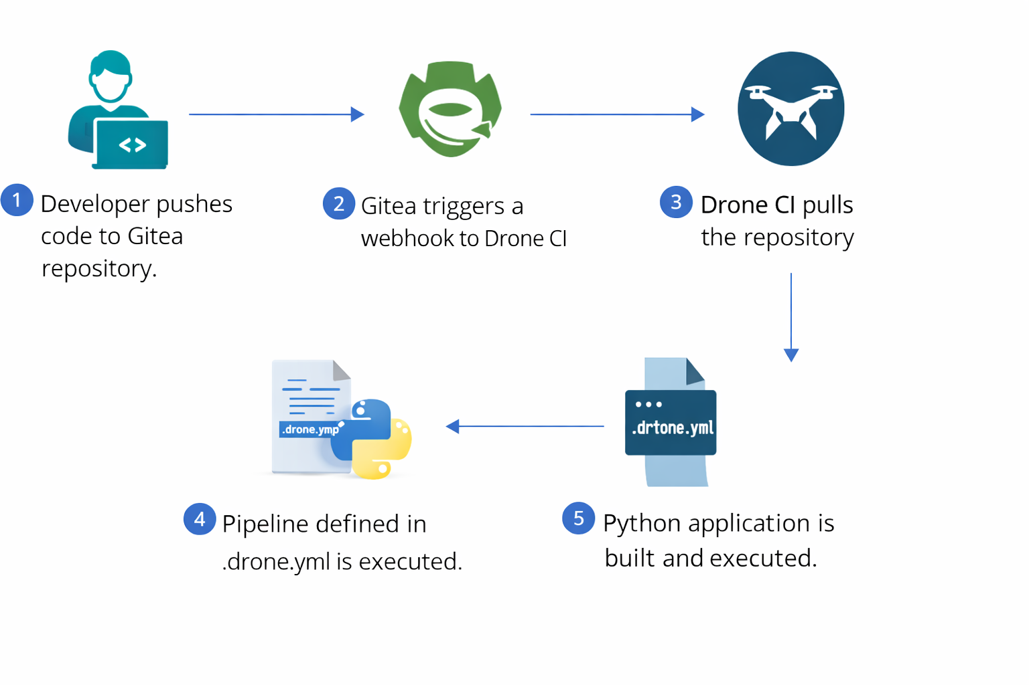

Screenshots
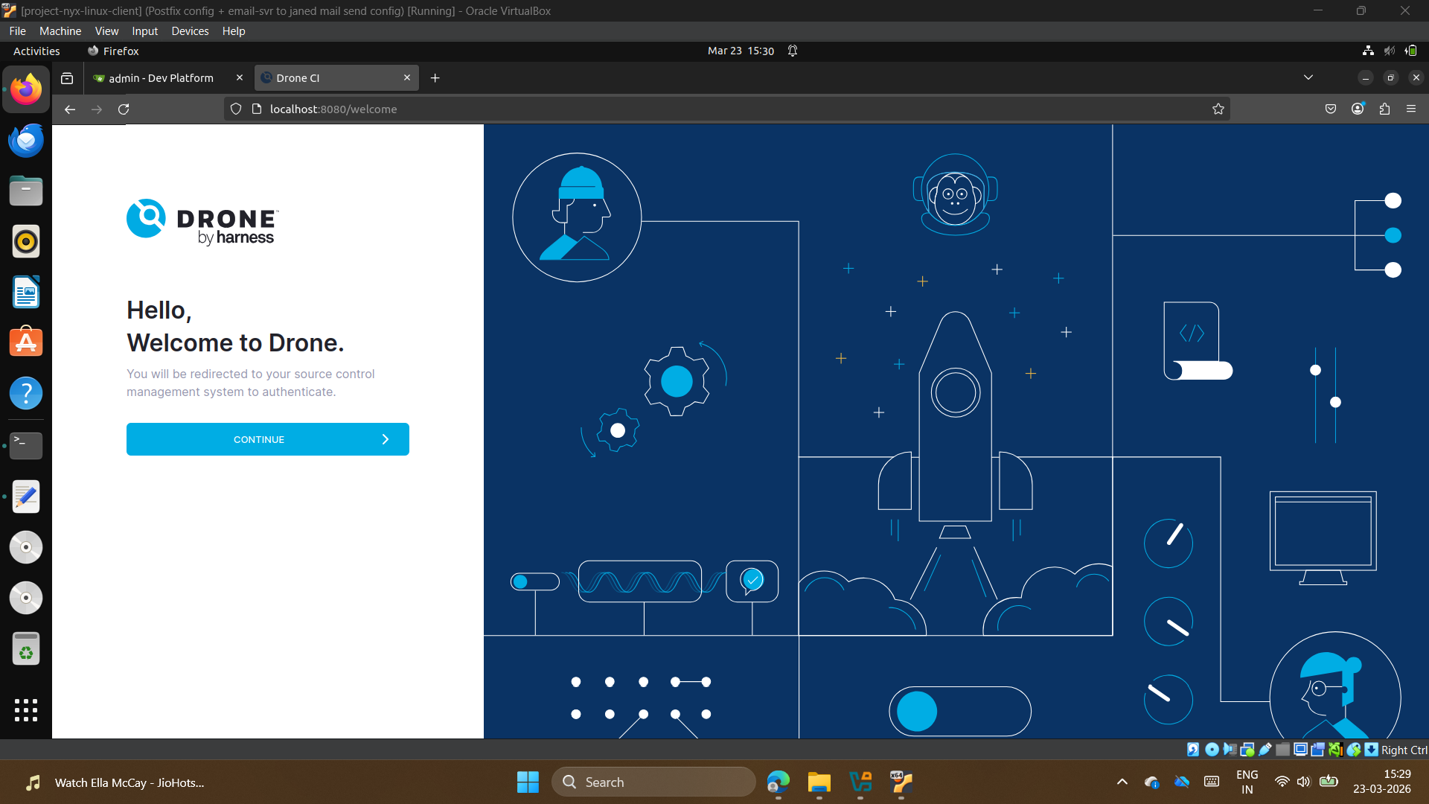
- Drone CI Homepage

- Drone CI Build in Progress
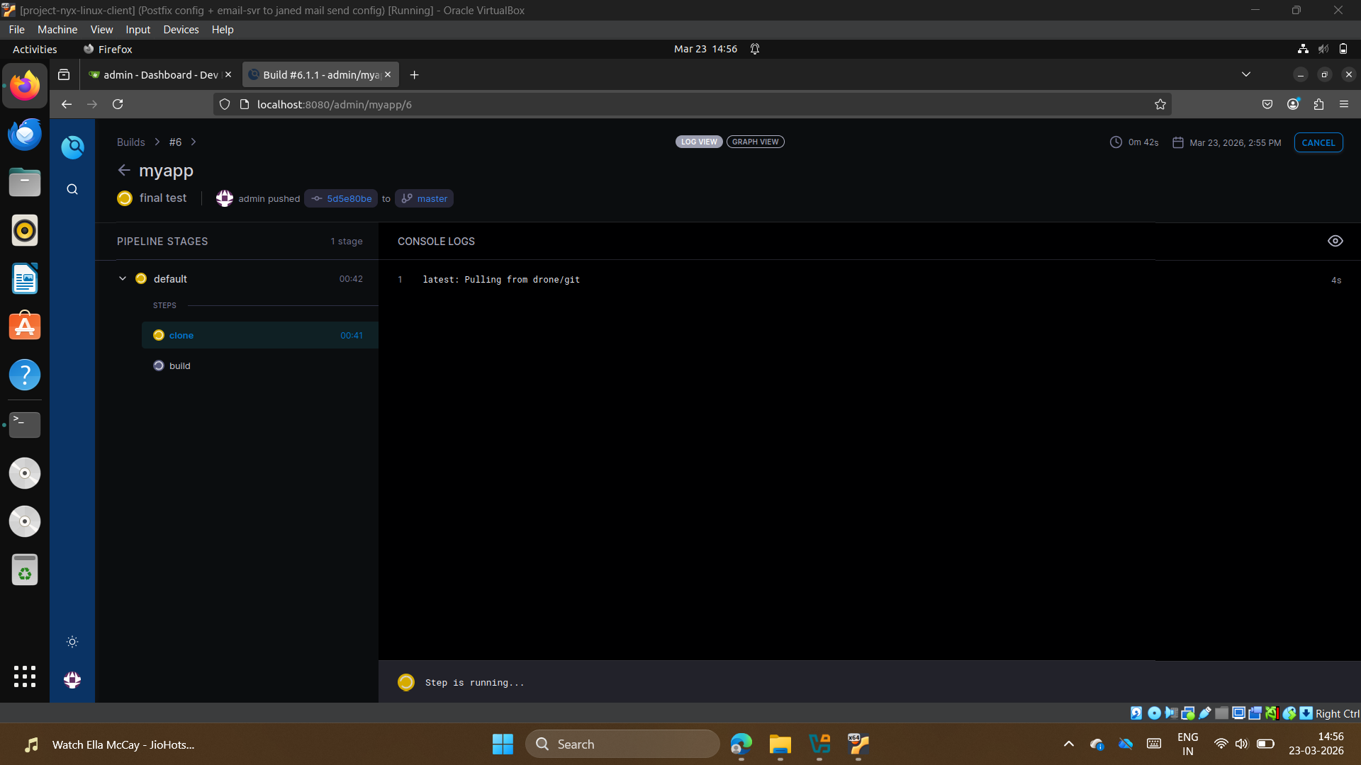

- Gitea Homepage
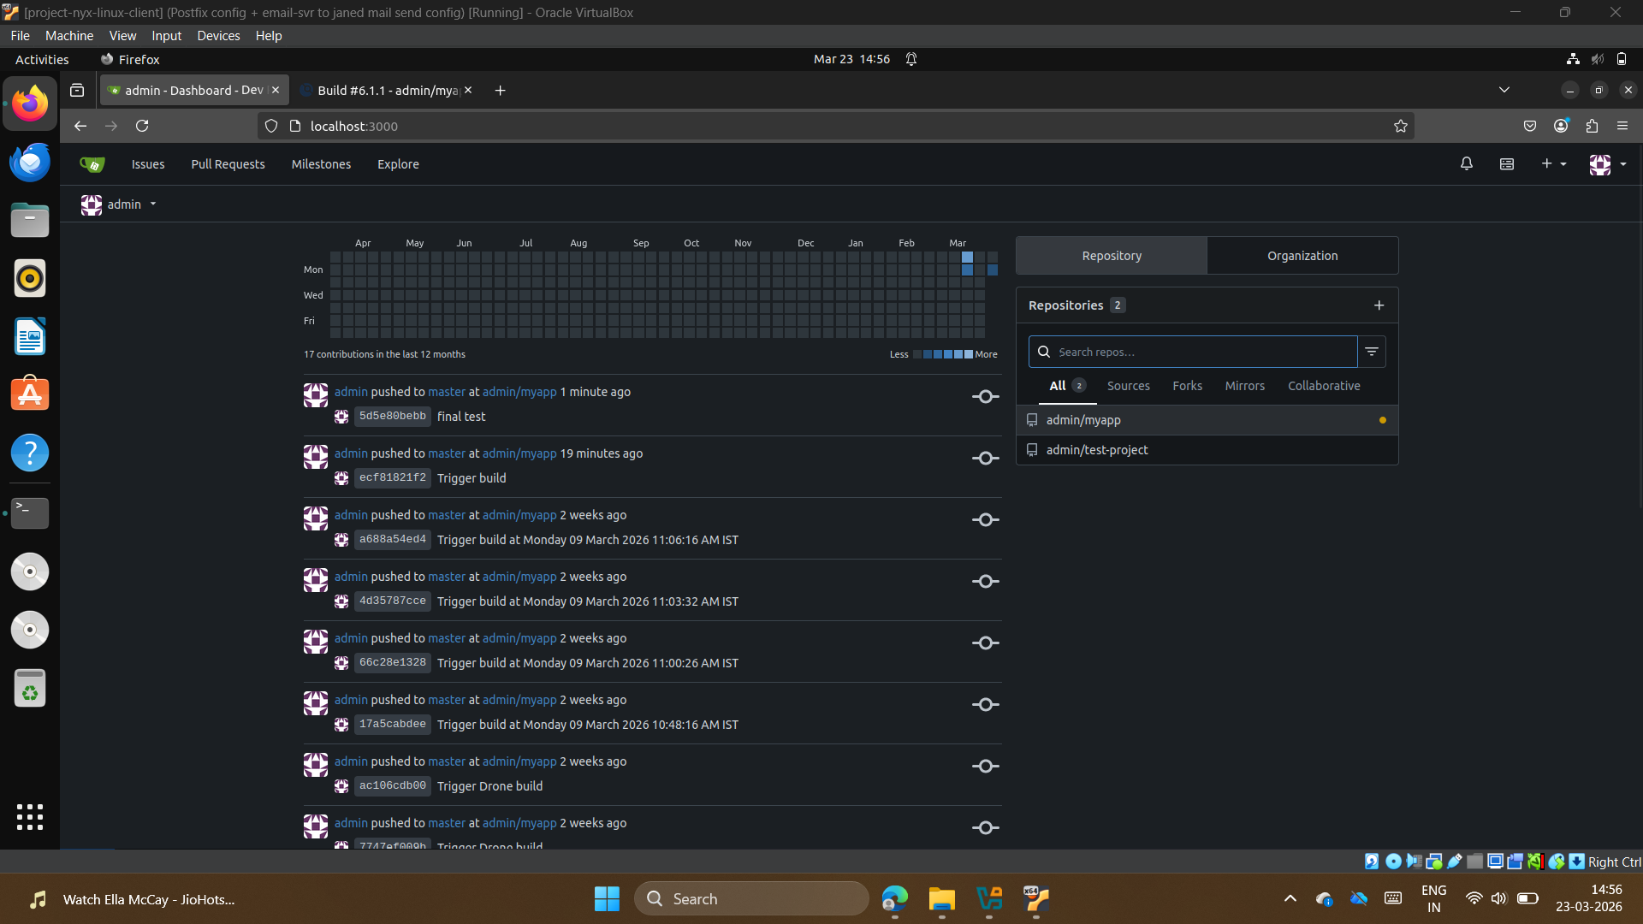

- Gitea Admin Page (Repositories)
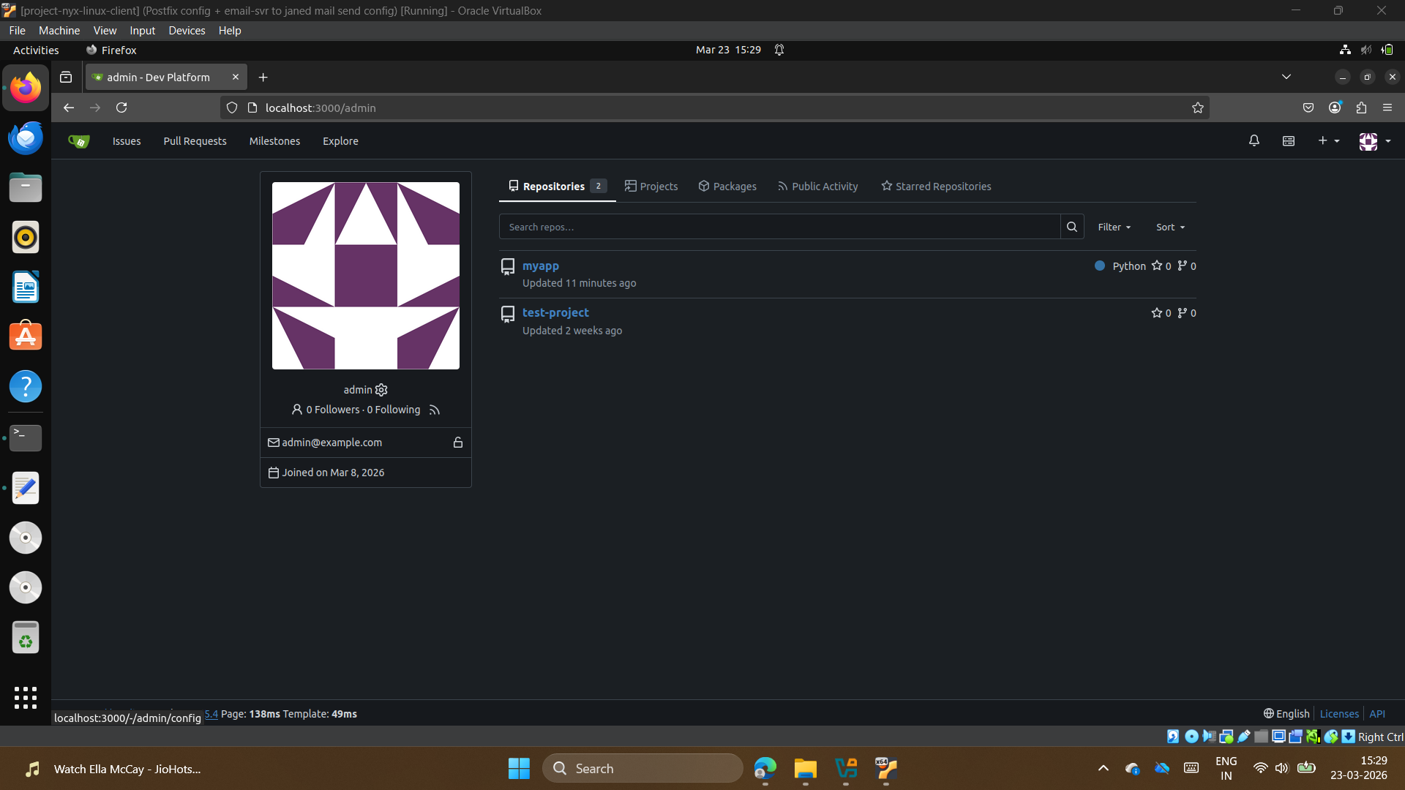

Key Challenges & Solutions
• Resolved Docker networking issues by using service names instead of localhost.
• Fixed OAuth redirection errors by configuring correct ROOT_URL.
• Solved DNS issues affecting Docker image pulls.
• Ensured secure communication using matching RPC secrets.

Conclusion
This project demonstrates practical implementation of CI/CD concepts, container networking, and troubleshooting in a real-world DevOps environment.

