Initial database with modified Element 6:
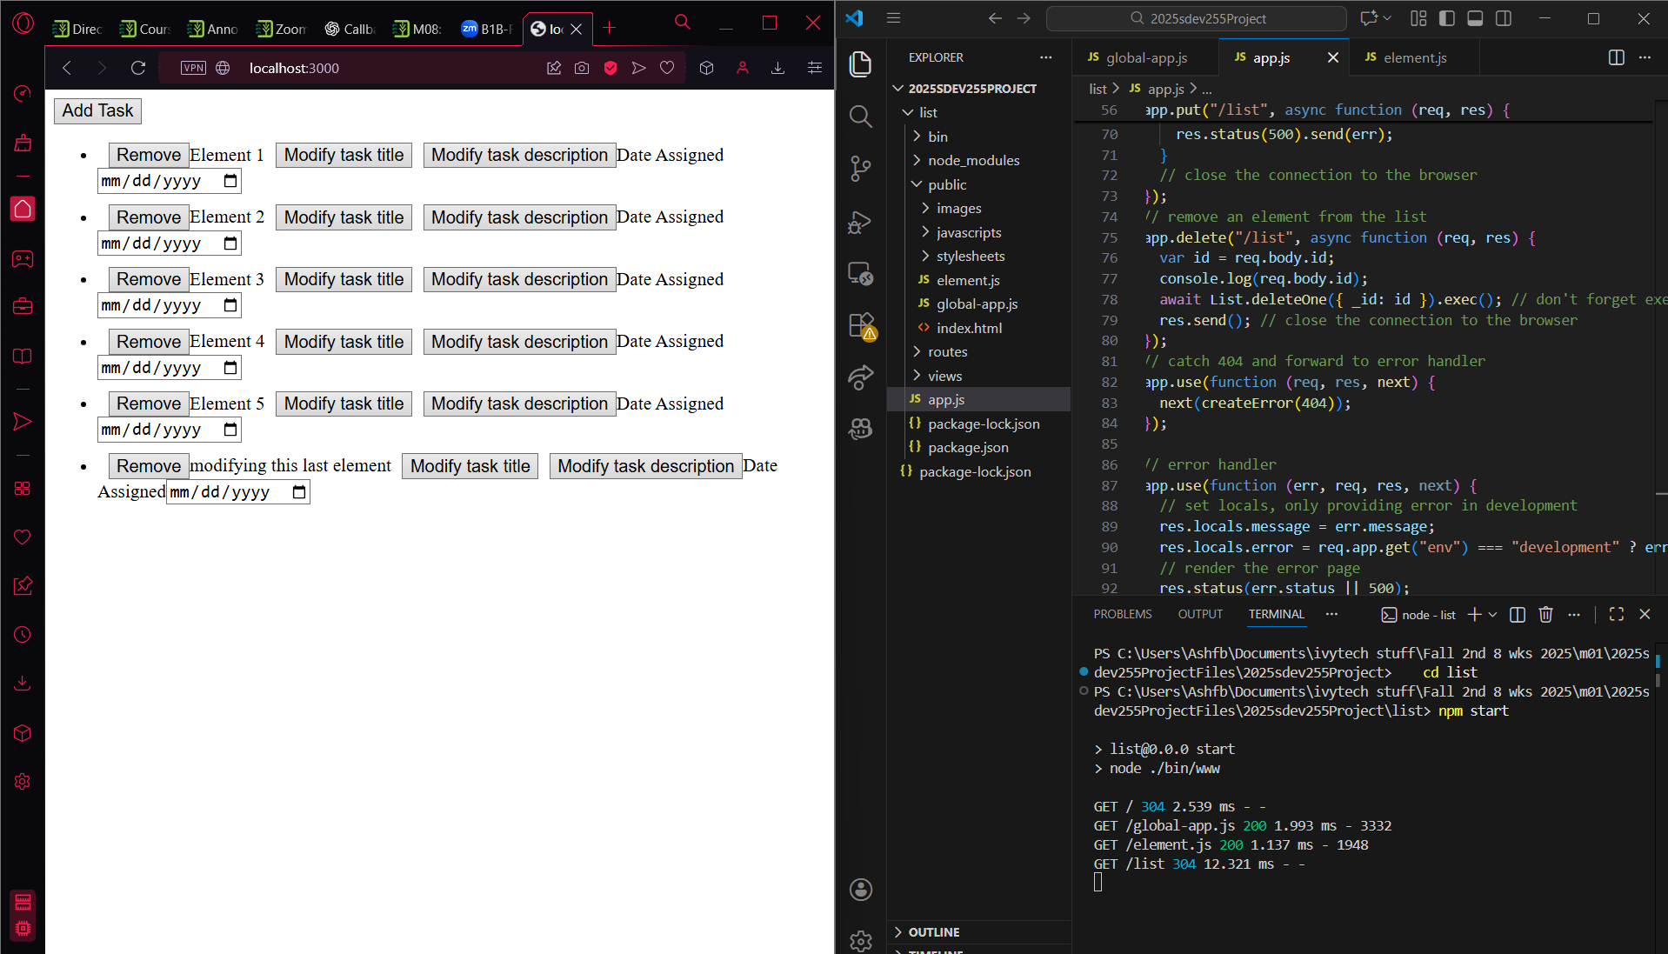

Modified Element 1’s task title, description, date, and removed last 3 entries:
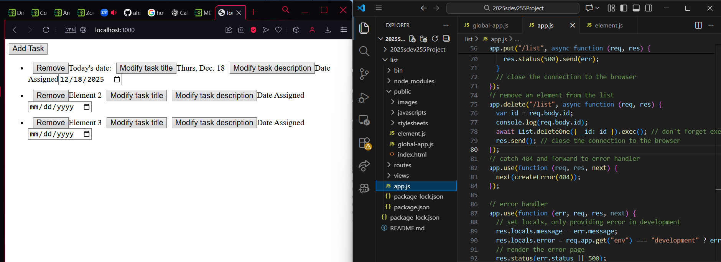

Added new Task 4 with new date:
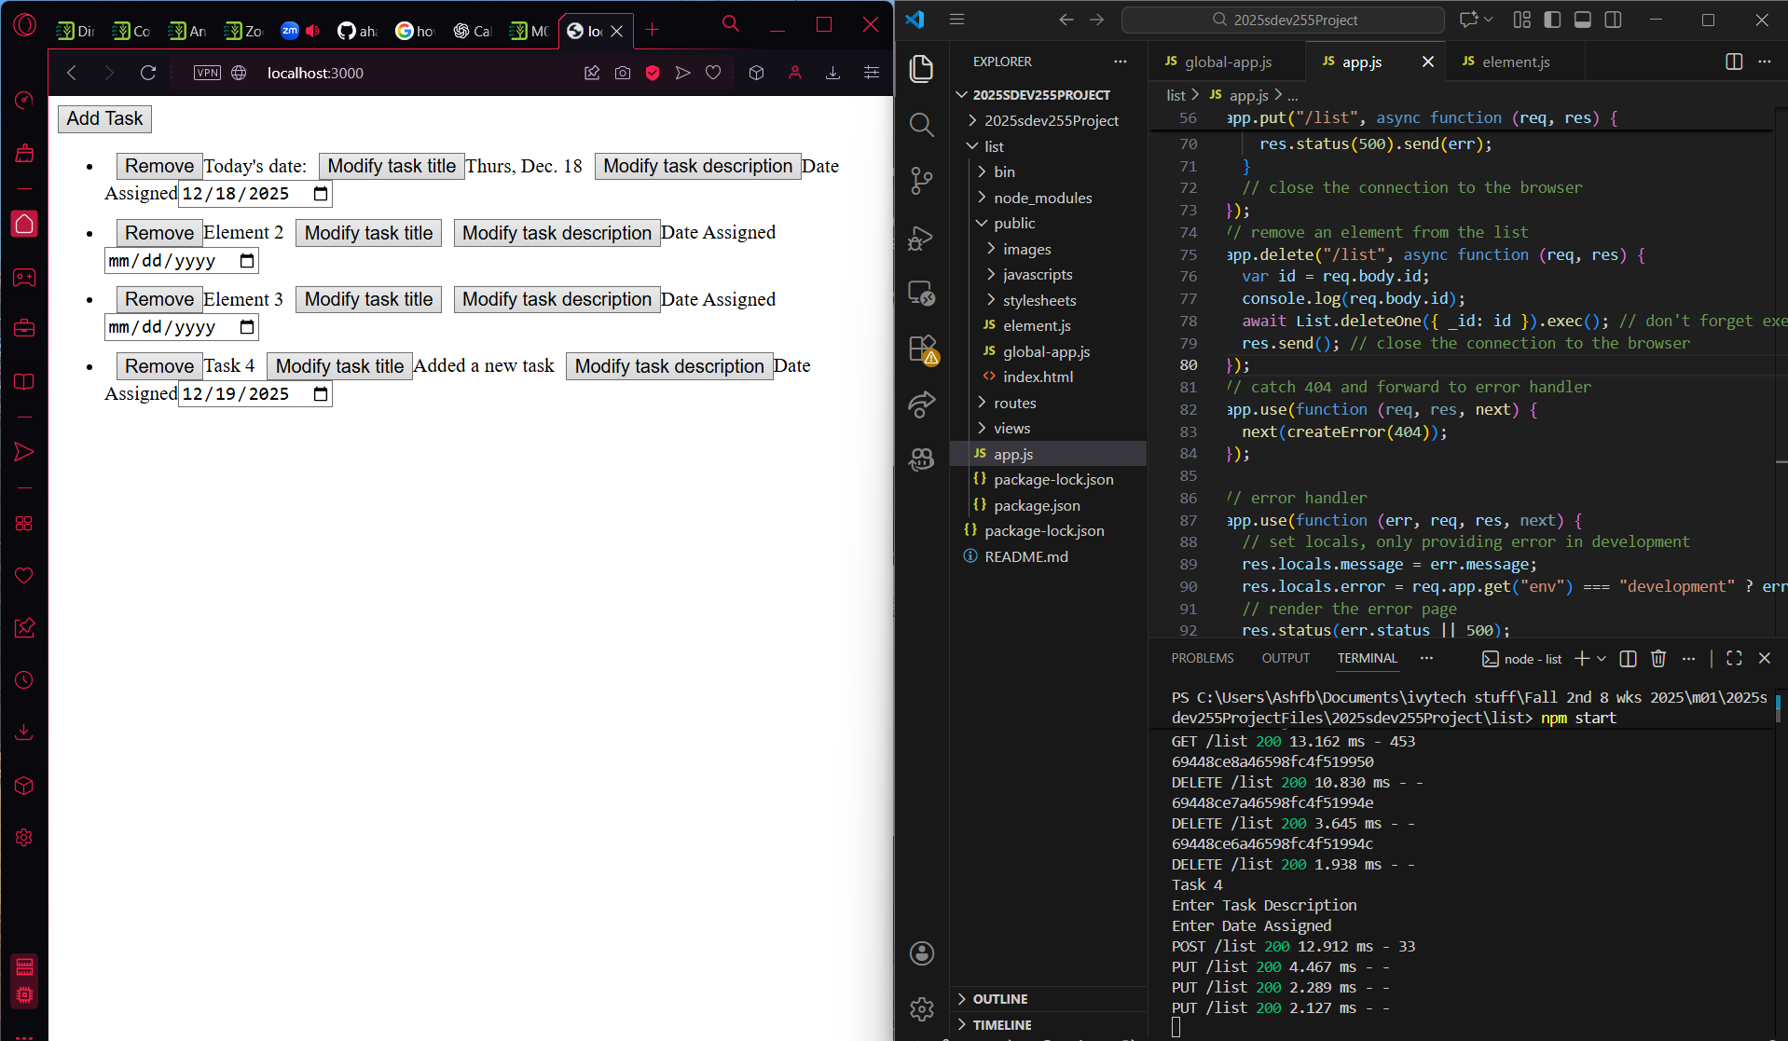

Database info on VSCode terminal:
