**个人工作报告**

**一、多智能体系统** (Multi-agent System, MAS or self-organized system)

1. 定义：多智能体系统是由多个相互作用的智能体 (intelligent agents) 构成的计算机化系统。多智能系统能解决一些个体或单个庞大的系统 (monolithic system) 很难或不可能解决的问题。智能体的“智能”包括组织化 (methodic)、子进程 (subrotine)、算法搜索 (algorithm search) 和强化学习 (reinforcement learning) 等。[1]

2. 现有的一些应用：在线交易，灾害响应，社会结构建模

3. 组成：多智能体系统主要由智能体 (agent) 和环境 (environment) 组成。

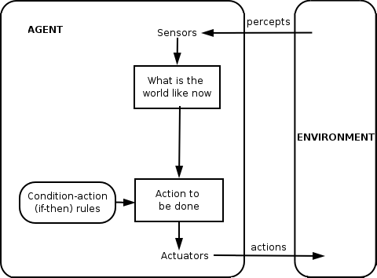

图一 带有简单反射 (simple reflex) 的智能体 [2]

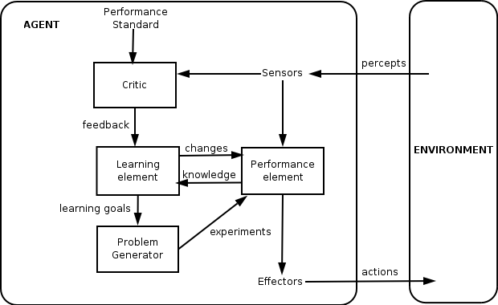

图二 学习型智能体 [2]

4. 特性：多智能体主要有以下三个特性

**·** 自主性 (Autonomy)：智能体至少是部分独立，有自我意识的，自动化的

**·** 局部视角 (Local views)：没有智能体拥有全局视角，或是系统过于复杂使单个智能体无法开发这样的知识。

**·** 去中心化 (Decentralisation)：no agent is designated as controlling (or the system is effectively reduced to a monolithic system) [3]

**二、联合学习** (Federated Learning)

(基于论文：Communication-Efficient Learning of Deep Networks

from Decentralized Data）

1. 定义：*FederatedAveraging* algorithm, which combines **local stochastic gradient descent (SGD)** on each client witha server that performs model averaging.
2. 特点：
3. **Massively distributed:** We expect the number of clients participating in an optimization to be much larger than the average number of examples per client.
4. **Limited communication**: Mobile devices are frequently offline or on slow or expensive connections.
5. **算法**

The amount of computation is controlled by three key parameters: **C**, the **fraction** of clients that perform computation on each round; **E**, the number of training passes each client makes over its local dataset on each round; and **B**, **the local minibatch size** used for the client updates.

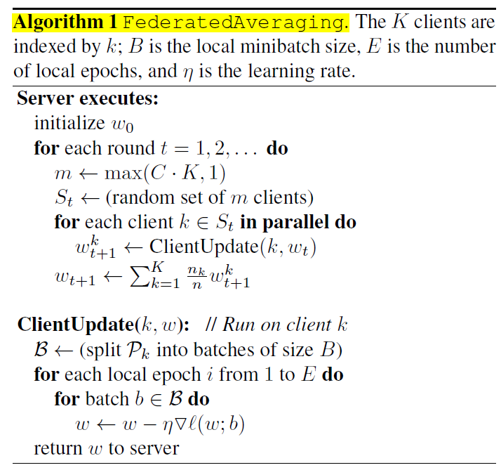

**参考文献**

[1] 维基百科，Multi-agent system，en.wikipedia.org/wiki/Multi-agent_system

[2] Utkarshraj Atmaram, “Artificial Intelligence: A Modern Approach”. 20 January 2006

[3] Panait, Liviu; Luke, Sean (2005). "Cooperative Multi-Agent Learning: The State of the Art" (PDF). Autonomous Agents and Multi-Agent Systems. 11 (3): 387–434. doi:10.1007/s10458-005-2631-2.