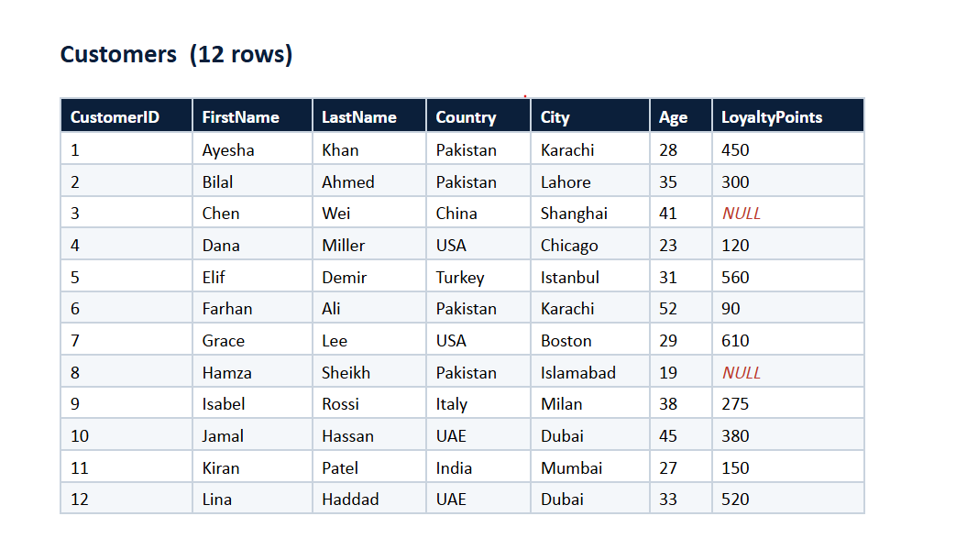
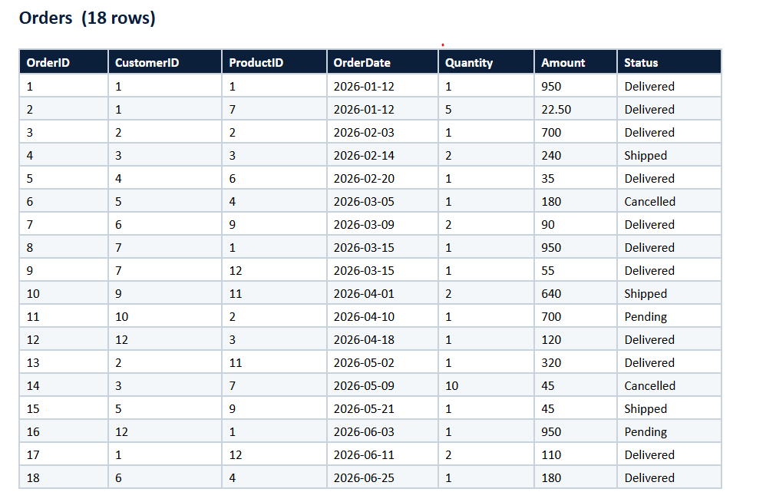
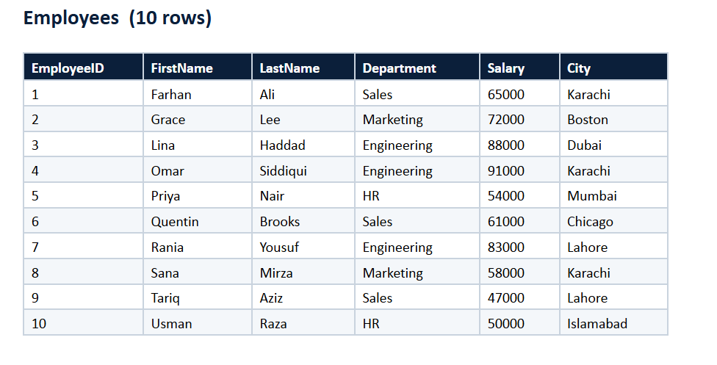

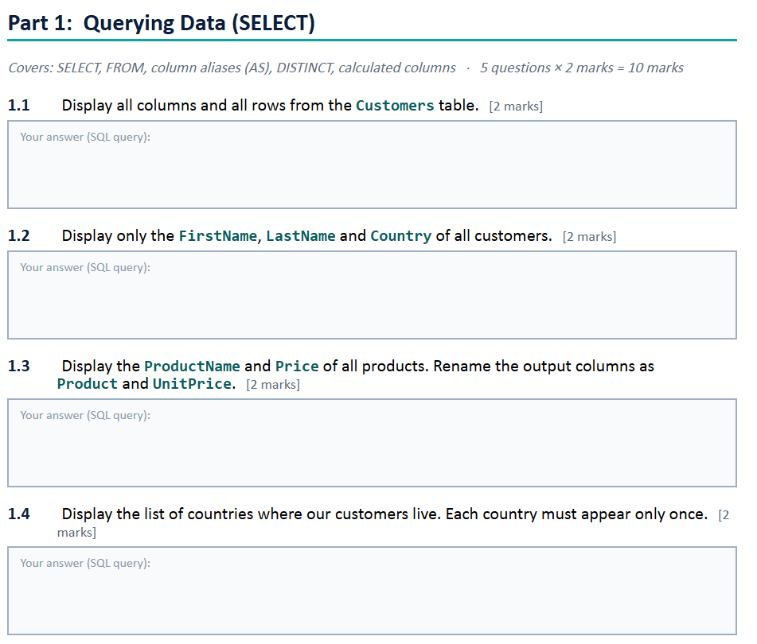
SELECT * FROM Customers;

SELECT FirstName, LastName, Country
FROM Customers;

SELECT ProductName AS PRODUCT, Price AS UnitPrice
FROM Products;

SELECT DISTINCT(Country)
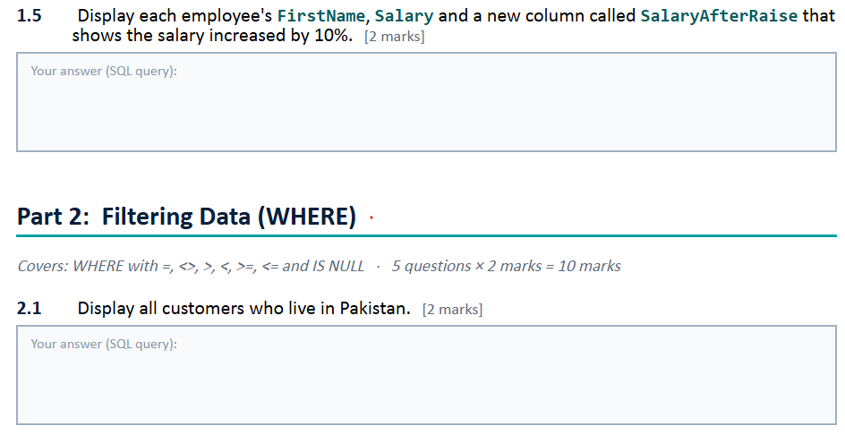
FROM Customers;

SELECT FirstName, LastName, Salary,
(Salary * 1.1 AS INT) AS SalaryAfterRaise
FROM Employees;

SELECT *
FROM Customers
WHERE Country = 'Pakistan';

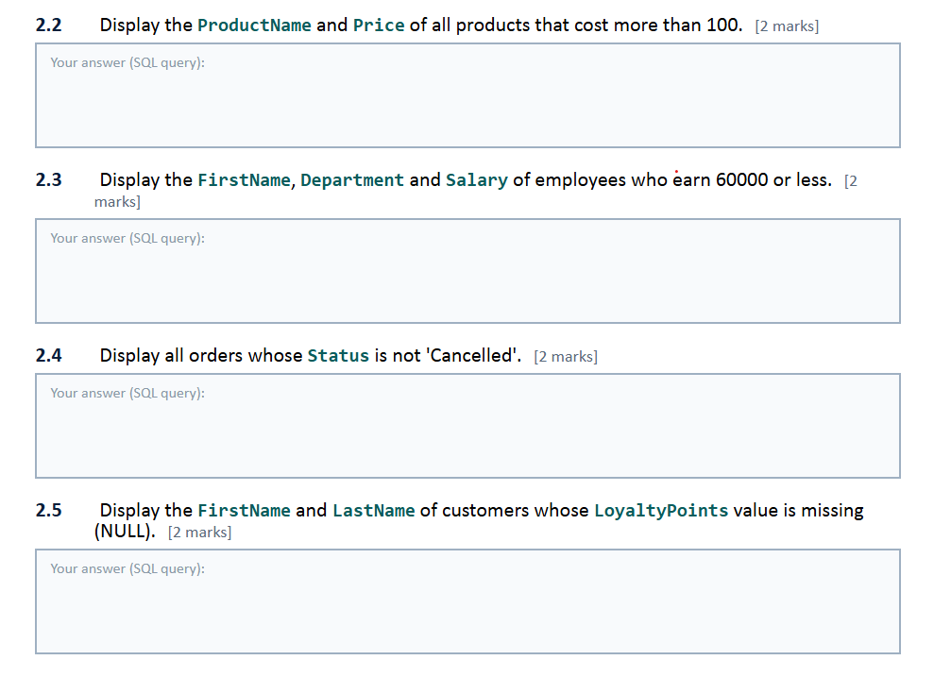
SELECT ProductName, Price
FROM Products
WHERE Price > 100;

SELECT FirstName, Department, Salary
FROM Employees
WHERE Salary >= 60000;

SELECT * FROM Orders
WHERE STATUS <> 'Cancelled';

SELECT FirstName, LastName, LoyaltyPoints
FROM Customers
WHERE LoyaltyPoints IS NULL;

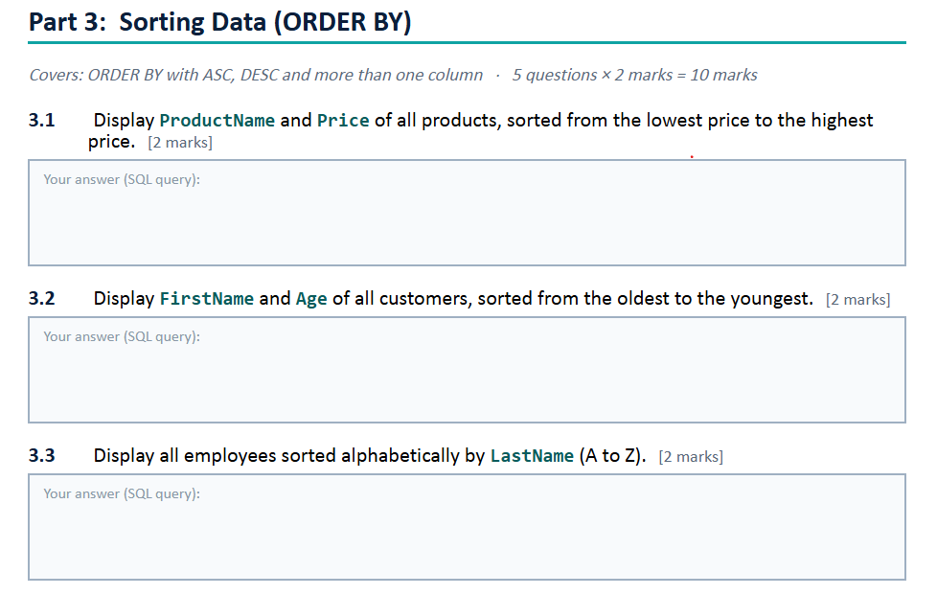

SELECT ProductName, Price
FROM Products
ORDER BY Price;

SELECT FirstName, Age
FROM Customers
ORDER BY Age DESC;

SELECT *
FROM Employees
ORDER BY LastName;

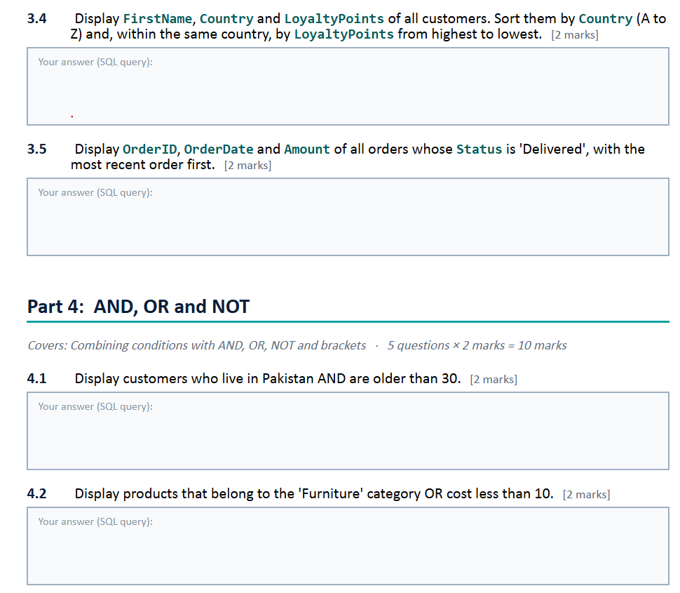

SELECT FirstName, Country, LoyaltyPoints
FROM Customers
ORDER BY COUNTRY,LoyaltyPoints DESC;

SELECT OrderID, OrderDate, Amount
FROM Orders
WHERE Status = 'Delivered'
ORDER BY OrderDate DESC;

SELECT *
FROM Customers
WHERE Country = 'Pakistan' AND Age > 30;

SELECT *
FROM Products
WHERE Category = 'Furniture' OR Price < 10;
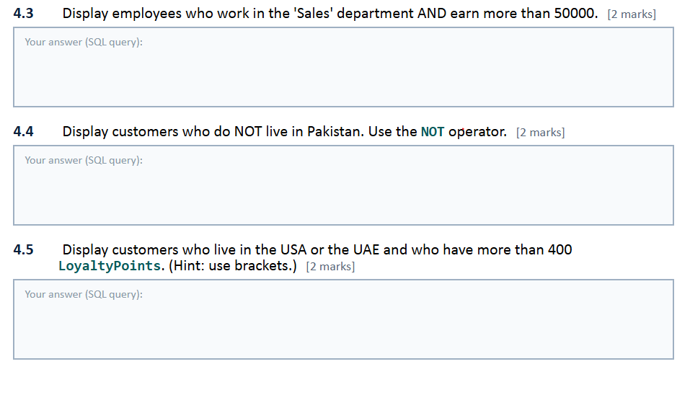

SELECT *
FROM Employees
WHERE Department = 'Sales' AND Salary > 50000;

SELECT *
FROM Customers
WHERE Country NOT IN ('PAKISTAN');

SELECT *
FROM Customers
WHERE COUNTRY IN ('USA', 'UAE') AND LoyaltyPoints > 400;

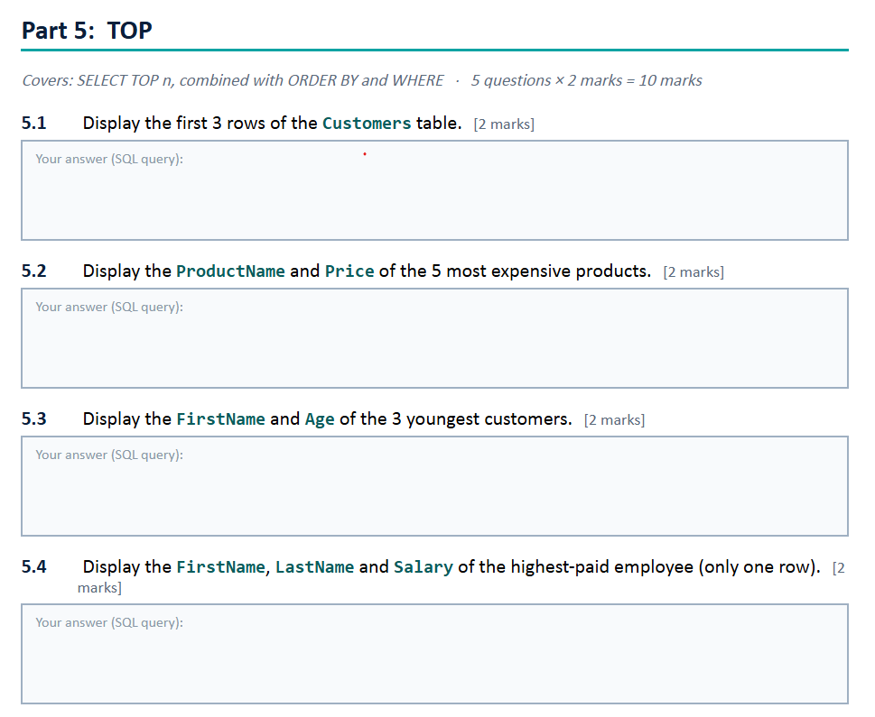

SELECT TOP(3) *
FROM Customers;

SELECT TOP(3) ProductName, Price
FROM Products
ORDER BY PRICE DESC;

SELECT TOP(3)FirstName, Age
FROM Customers
ORDER BY Age;

SELECT TOP(1)FirstName, LastName, Salary
FROM Employees
ORDER BY Salary DESC;

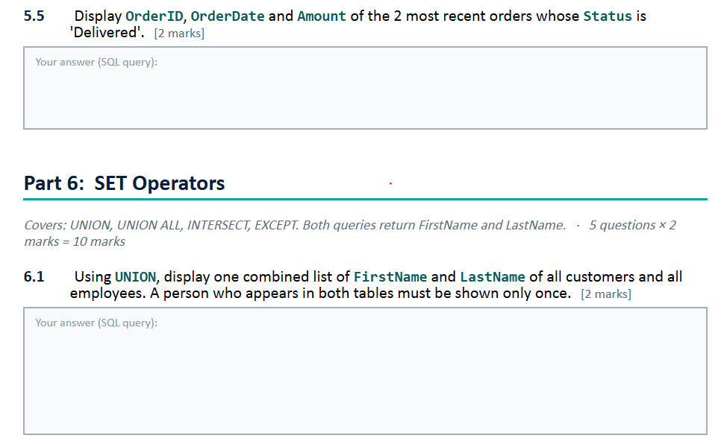
SELECT TOP(2) OrderID, OrderDate, Amount
FROM Orders
WHERE Status = 'Delivered'
ORDER BY OrderDate DESC;

SELECT FirstName, LastName
FROM Employees
UNION
SELECT FirstName, LastName
FROM Customers;
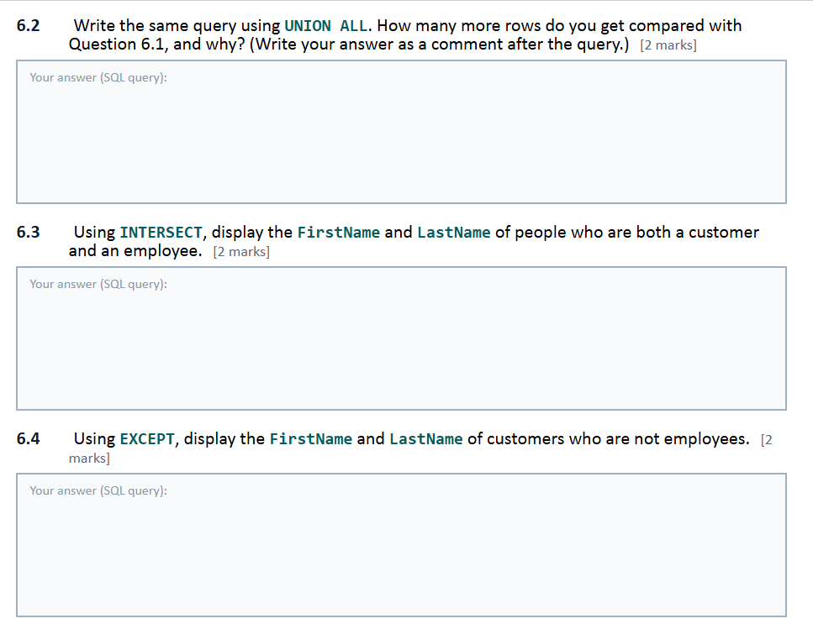
SELECT FirstName, LastName FROM Employees
UNION ALL
SELECT FirstName, LastName FROM Customers;
--Then there will be 22 rows, before there were 19 rows. Because UNION ALL select duplicates also

SELECT FirstName, LastName
FROM Customers
INTERSECT
SELECT FirstName, LastName
FROM Employees;

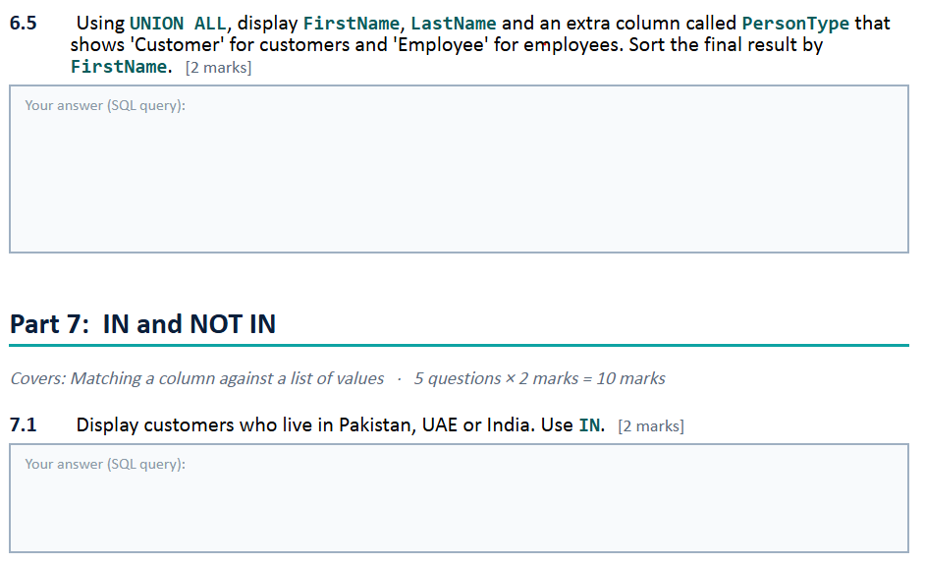
SELECT FirstName, LastName
FROM Customers
EXCEPT
SELECT FirstName, LastName
FROM Employees;

SELECT FirstName, LastName, 'Customer' AS PersonType
FROM Customers
UNION ALL
SELECT FirstName, LastName, 'Employee' AS PersonType
FROM Employees
ORDER BY FirstName;

SELECT *
FROM Customers
WHERE Country IN ('Pakistan', 'UAE', 'India');

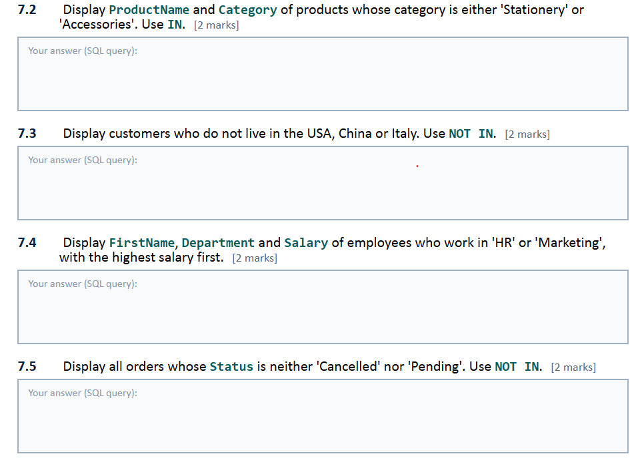
SELECT ProductName, Category
FROM Products
WHERE Category IN ('Stationery', 'Accessories');

SELECT *
FROM Customers
WHERE Country NOT IN ('USA', 'China', 'Italy');

SELECT FirstName, Department, Salary
FROM Employees
WHERE Department IN ('HR', 'Marketing')
ORDER BY Salary DESC;

SELECT *
FROM Orders
WHERE Status NOT IN ('Cancelled', 'Pending');

SELECT o.OrderID, c.FirstName, o.OrderDate
FROM Customers c
JOIN Orders o
ON c.CustomerID = o.CustomerID;

SELECT c.FirstName, o.OrderID
FROM Customers c
LEFT JOIN Orders o
ON c.CustomerID = o.CustomerID;
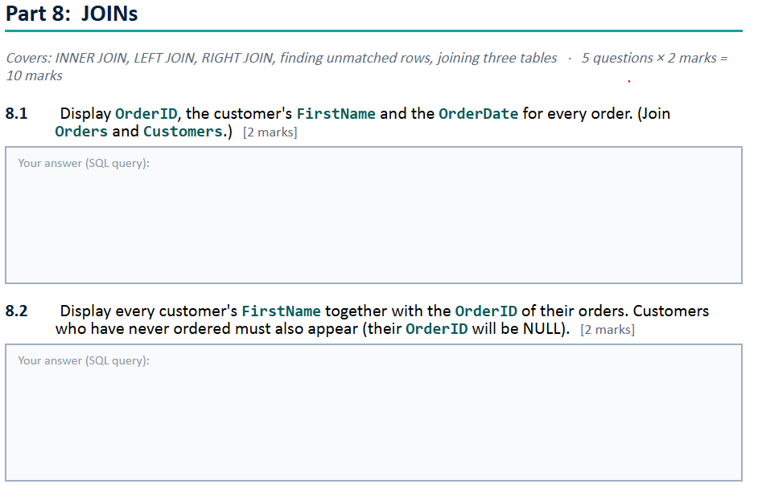

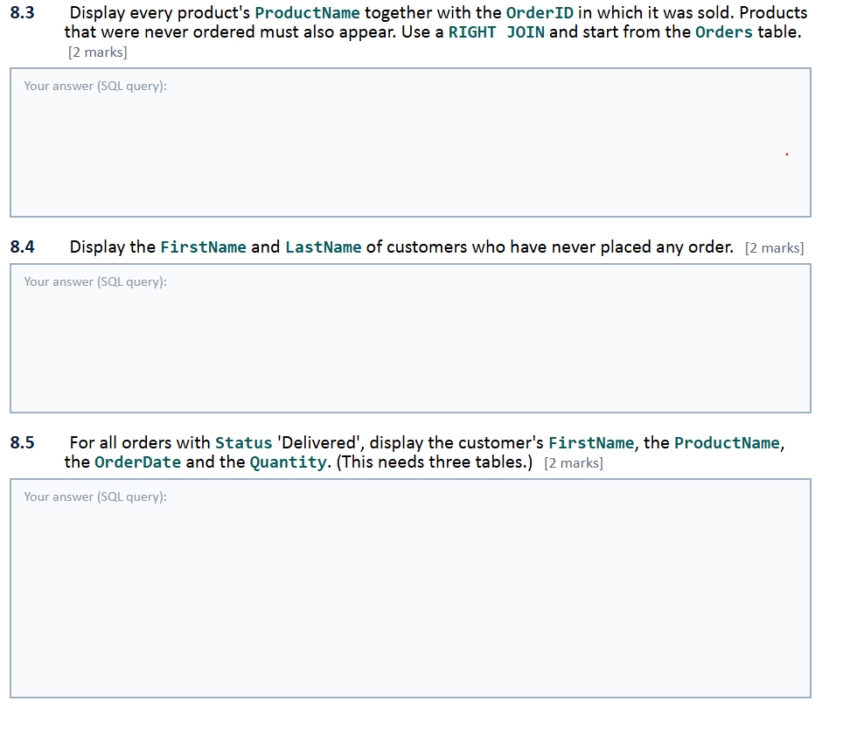

SELECT P.ProductName, O.OrderID
FROM Orders O
RIGHT JOIN Products P
ON O.ProductID= P.ProductID;

SELECT C.FirstName, C.LastName
FROM Customers C
LEFT JOIN Orders O
ON C.CustomerID = O.CustomerID
WHERE O.OrderID IS NULL;

SELECT O.Status, C.FirstName, P.ProductName, O.OrderDate, O.Quantity
FROM Customers C
JOIN Orders O
ON C.CustomerID = O.CustomerID
JOIN Products P
ON O.ProductID= P.ProductID
WHERE O.Status = 'Delivered';

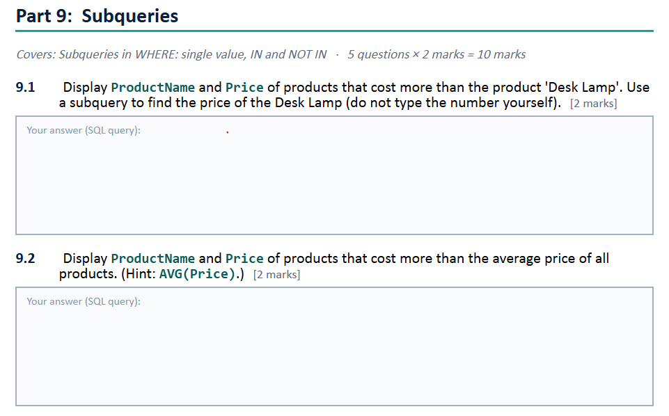

SELECT ProductName, Price FROM Products
WHERE Price > (
SELECT Price
FROM Products
WHERE ProductName = 'DESK LAMP');

SELECT ProductName, Price FROM Products
WHERE Price > (
SELECT AVG(Price) FROM Products);

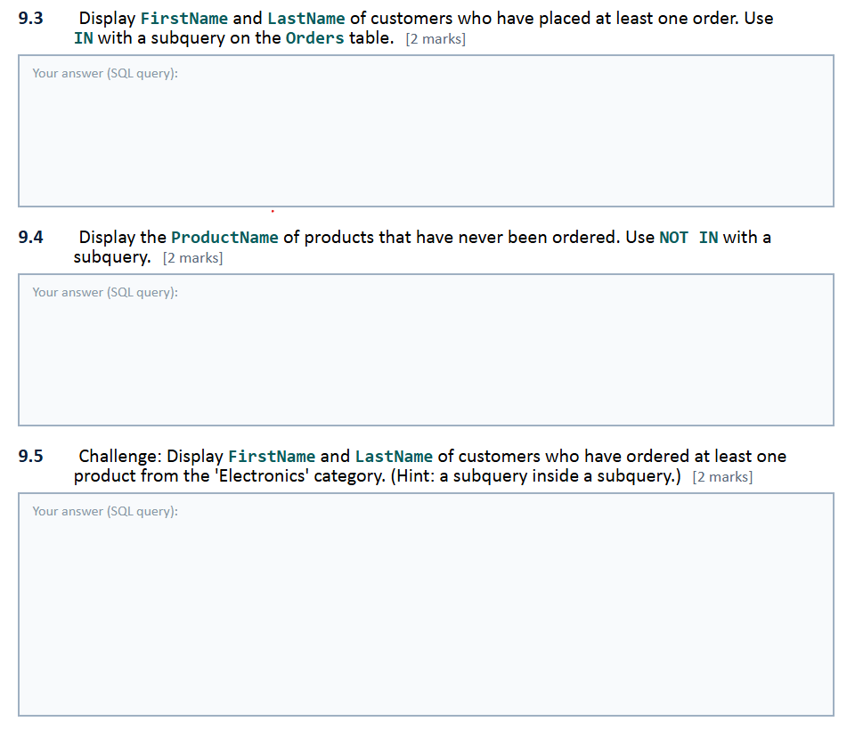
SELECT FirstName, LastName
FROM Customers
WHERE CustomerID IN (
SELECT CustomerID
FROM Orders);

SELECT FirstName, LastName
FROM Customers
WHERE CustomerID NOT IN (
SELECT CustomerID
FROM Orders);

SELECT FirstName, LastName
FROM Customers
WHERE CustomerID IN (
SELECT CustomerID
FROM Orders
WHERE ProductID IN (
SELECT ProductID
FROM Products
WHERE Category = 'Electronics')
);

