Chapter 3: Application

Chapter 3 presents the practical implementation of the proposed system. The chapter begins with a Use Case Diagram that provides a high-level overview of the system’s actors and their interactions, followed by a Business Process Model and Notation (BPMN) diagram that illustrates the underlying workflow and process flow. Each use case is then described in structured detail, specifying preconditions, post-conditions, and step-by-step scenarios. To demonstrate the system in operation, screenshots capturing both input and output are provided for every functional requirement derived from the use cases. The chapter concludes with a comprehensive set of test cases that validate each requirement against expected outcomes, confirming the system’s correctness and reliability

Project Features

3.1 Use Case
This diagram shows how a financial analyst uses an AI-powered system to analyze data, predict future performance, understand results and make better financial decisions.

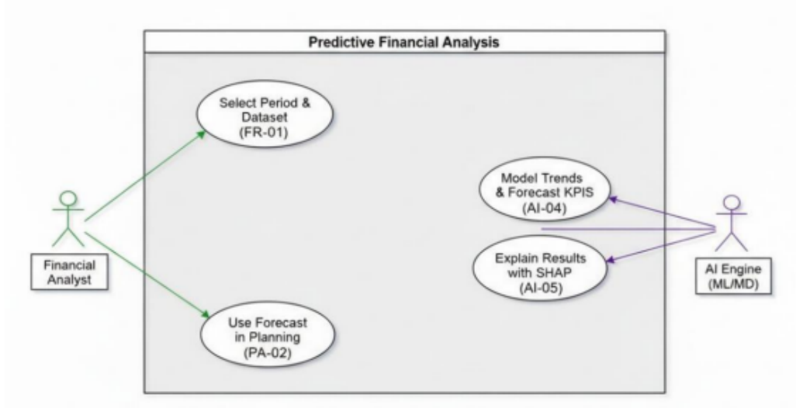
Figure 3.1: Use Case Diagram for Predictive Financial Analysis

3.2 Business Process Diagram (BPMN)
This BPMN model illustrates the collaborative workflow between the Financial Analyst, the AI Engine, and the Manager, detailing how manual data inputs trigger automated predictive modeling, visualization, and explainability features to support executive review and strategic financial planning.

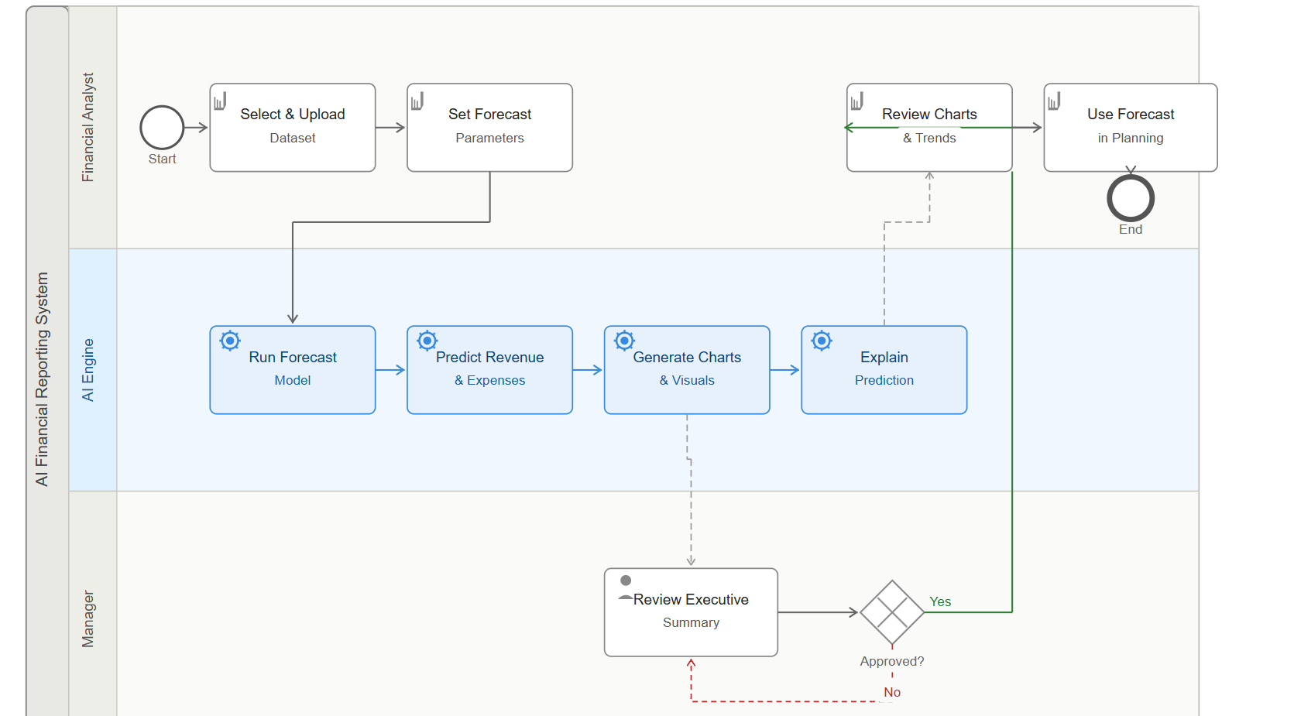
Figure 3.2: BPMN Diagram

As illustrated in the BPMN Figure, the process is structured into three distinct pools to separate manual administrative tasks from automated AI processing and management oversight. This vertical orientation ensures that every task, from the initial data upload to the final planning phase, is clearly visible for auditing and process analysis.

3.3 User Stories
The table below captures the user stories that define the functional requirements of the system, split across two epics: Predictive Financial Analysis and Automated Financial Report Generation.

Requirement ID | Epic | User Story Summary
Req-1 | Predictive Financial Analysis | As a financial analyst, I want time-series forecasting models (XGBoost and LSTM) to run forecasts using past data, so that I can plan future budgets.
Req-2 | Predictive Financial Analysis | As a financial analyst, I want supervised regression models, Random Forest and Linear Regression, to predict revenue and expenses, so that I understand future performance.
Req-3 | Predictive Financial Analysis | As a financial analyst, I want interactive data visualisation techniques, line charts, bar charts, and forecast overlay rendering, to display trends and anomalies, so that insights are easy to understand.
Req-4 | Predictive Financial Analysis | As a manager, I want an NLG module powered by a LLM to generate plain language summaries of predictions, so that I can make quick decisions without interpreting raw data.
Req-5 | Predictive Financial Analysis | As a financial analyst, I want SHAP to explain the contribution of each input variable to prediction results, so that I trust and can justify the forecasting model.
Req-6 | Predictive Financial Analysis | As a manager, I want ML feature importance analysis, using XGBoost gain scores, to highlight the key drivers behind performance changes, so that I know which factors to focus on.
Req-7 | Automated Financial Report Generation | As an accountant, I want a pattern memory module using historical template matching to learn past reporting structures, so that the reporting process becomes faster each period.
Req-8 | Automated Financial Report Generation | As an accountant, I want an intelligent automation pipeline, using RPA to update reports automatically when new data is uploaded, so that I do not need to restart the process manually.
Req-9 | Automated Financial Report Generation | As an accountant, I want an NLG module using transformer-based language generation to create clean financial report layouts with structured narratives, so that I can export reports without additional formatting.
Req-10 | Automated Financial Report Generation | As an accountant, I want an anomaly detection module using statistical outlier detection and rule-based validation to identify missing or inconsistent entries, so that the final report is complete and reliable.
Table 3.1: User Stories

3.4 Field Requirements and Business Rules
In this section, the input fields presented by the system interface for each functional requirement are described alongside the business rules that govern their behavior. These constraints ensure data integrity and prevent processing of invalid operations.

Field ID | Field Name | Req. | User Story | Business Rule
F-01 | Dataset Upload | Req-1 | As a financial analyst, I want time-series forecasting models to run forecasts using past data, so that I can plan future budgets. | Only .csv or .xlsx files are accepted. File must contain a minimum of 6 months of historical data. Empty or corrupted files are rejected and an error message is displayed.
F-02 | Forecast Period | Req-1 | As a financial analyst, I want time-series forecasting models to run forecasts using past data, so that I can plan future budgets. | User must select a forecast horizon between 1 and 24 months from a dropdown. No forecast can be generated without a valid period selection.
F-03 | Forecast Model Selector | Req-1 | As a financial analyst, I want time-series forecasting models to run forecasts using past data, so that I can plan future budgets. | User selects from XGBoost, LSTM, Random Forest, or Linear Regression. A model must be selected before the forecast can run. Defaults to XGBoost.
F-04 | Target Metrics | Req-2 | As a financial analyst, I want supervised regression models to predict revenue and expenses, so that I understand future performance. | At least one metric must be selected (Revenue or Expenses) before running a prediction. The system blocks execution if no metric is chosen.
F-05 | Confidence Interval | Req-2 | As a financial analyst, I want supervised regression models to predict revenue and expenses, so that I understand future performance. | Accepted values are 90%, 95%, and 99%. Defaults to 95% if no selection is made. Value must be set before prediction runs.
F-06 | Chart Type | Req-3 | As a financial analyst, I want interactive data visualization techniques to display trends and anomalies, so that insights are easy to understand. | At least one chart type (Line Chart or Bar Chart) must be selected. Forecast overlay toggle is only enabled after a completed forecast run.
F-07 | Forecast Overlay Toggle | Req-3 | As a financial analyst, I want interactive data visualisation techniques to display trends and anomalies, so that insights are easy to understand. | Can only be activated after a successful forecast run exists in the current session. Disabled by default.
F-08 | NLG Summary Language | Req-4 | As a manager, I want an NLG module powered by a LLM to generate plain-language summaries of predictions, so that I can make quick decisions. | Defaults to English. Summary generation is blocked if no forecast results exist in the current session.
F-09 | SHAP Explainability View | Req-5 | As a financial analyst, I want SHAP to explain the contribution of each input variable to prediction results, so that I trust and can justify the forecasting model. | Can only be enabled after a successful forecast run. Disabled if the selected model does not support SHAP output.
F-10 | Feature Importance Metric | Req-6 | As a manager, I want ML feature importance analysis using XGBoost gain scores to highlight key drivers behind performance changes, so that I know which factors to focus on. | Only available when XGBoost is the selected forecasting model. Blocked and greyed out for all other model selections.
F-11 | Pattern Memory Load | Req-7 | As an accountant, I want a pattern memory module using historical template matching to learn past reporting structures, so that the reporting process becomes faster each period. | Can only be activated if at least one prior report period has been completed and saved. Displays an informational message if no history is found.
F-12 | Auto-Update Toggle | Req-8 | As an accountant, I want an intelligent automation pipeline using RPA to update reports automatically when new data is uploaded, so that I do not need to restart the process manually. | Cannot be activated without a base report already generated in the current session. When enabled, any new data upload automatically triggers report regeneration.
F-13 | Report Template | Req-9 | As an accountant, I want an NLG module using transformer-based language generation to create clean financial report layouts, so that I can export reports without additional formatting. | User must select a template (Professional, Summary, or Detailed) before generating a report. Defaults to Professional. No report can be generated without a template selection.
F-14 | Page Size | Req-9 | As an accountant, I want an NLG module using transformer-based language generation to create clean financial report layouts, so that I can export reports without additional formatting. | Accepted values are A4 and Letter. Defaults to A4. Must be confirmed before report generation begins.
F-15 | Export Format | Req-9 | As an accountant, I want an NLG module using transformer-based language generation to create clean financial report layouts, so that I can export reports without additional formatting. | User must select PDF or XLSX before downloading. PDF export includes table of contents and page numbers by default. Export is blocked until report generation is complete.
F-16 | Anomaly Sensitivity | Req-10 | As an accountant, I want an anomaly detection module using statistical outlier detection and rule-based validation to identify missing or inconsistent entries, so that the final report is complete and reliable. | Range is Low, Medium, or High. Defaults to Medium. Reports cannot be finalised if critical-level anomalies remain unresolved.
Table 3.2: Field Requirements and Business Rules

3.5 User Stories UI
This section presents the graphical user interface for each user story, demonstrating the system inputs and outputs.

Req-1
As a financial analyst, I want ML to run forecasts using past data, so that I can plan future budgets.

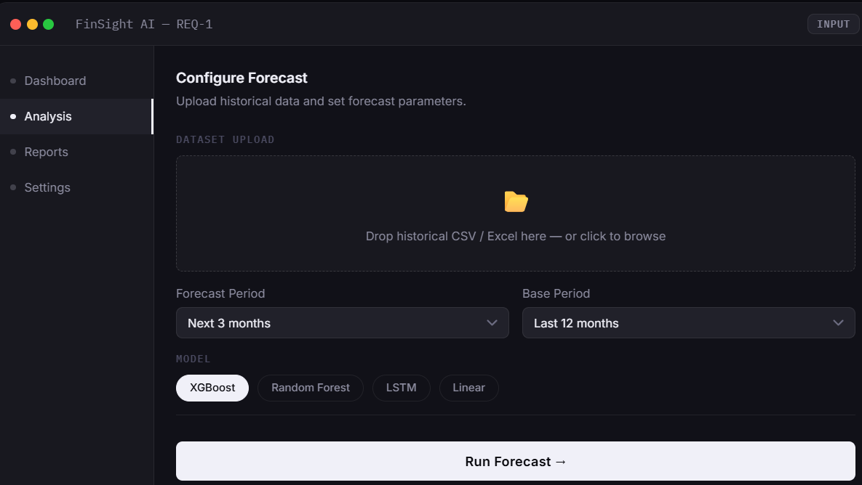
Figure: Req-1 Input Screen

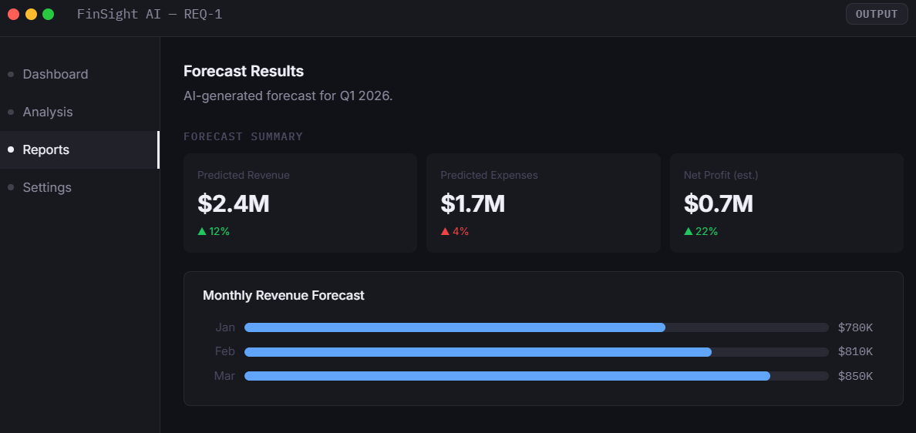
Figure: Req-1 Output Screen

Req-2
As a financial analyst, I want ML to predict revenue and expenses, so that I understand future performance.

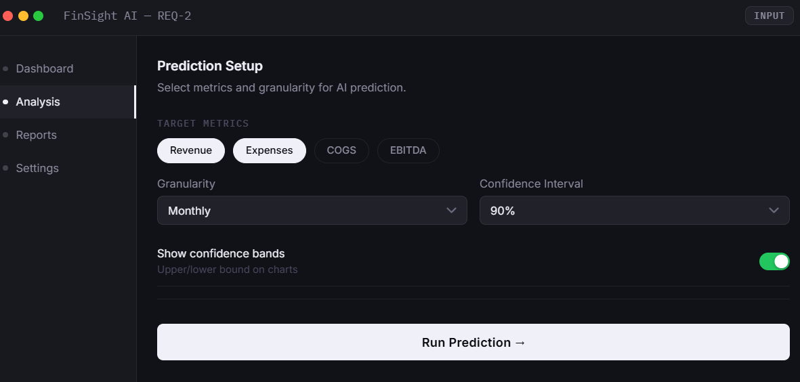
Figure: Req-2 Input Screen

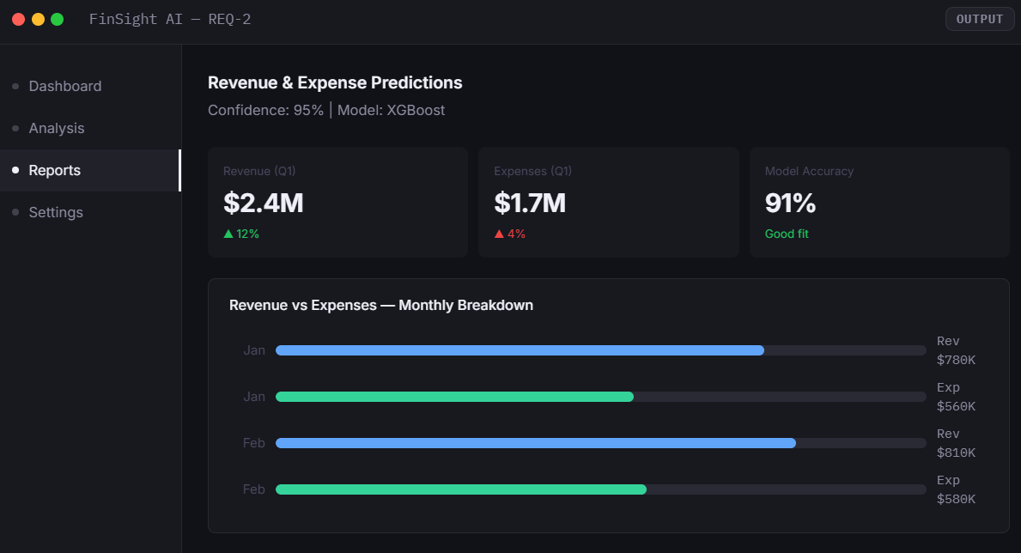
Figure: Req-2 Output Screen

Req-3
As a financial analyst, I want Data Visualization techniques to display charts and trends, so that insights are easy to understand.

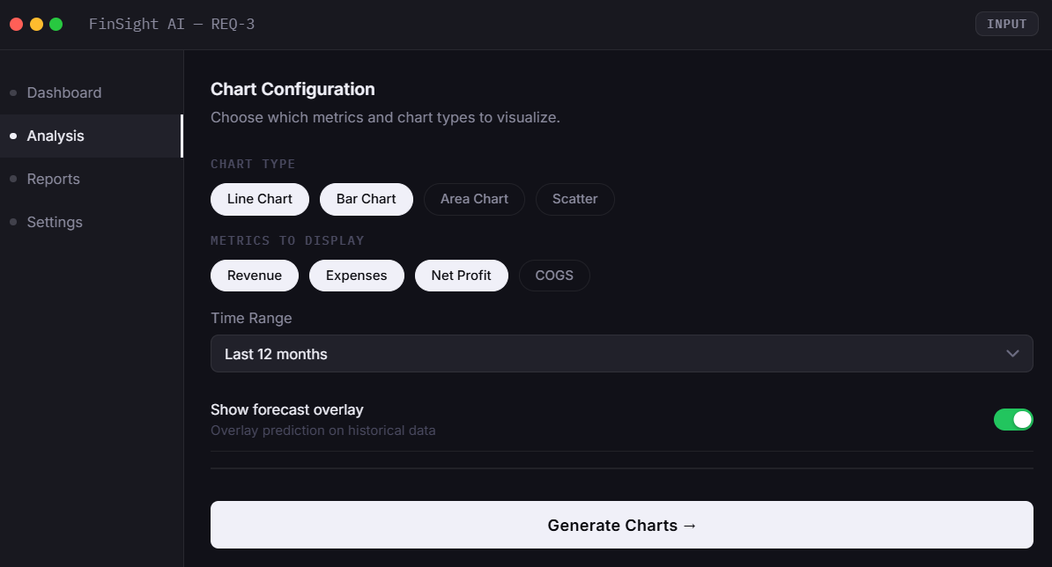
Figure: Req-3 Input Screen

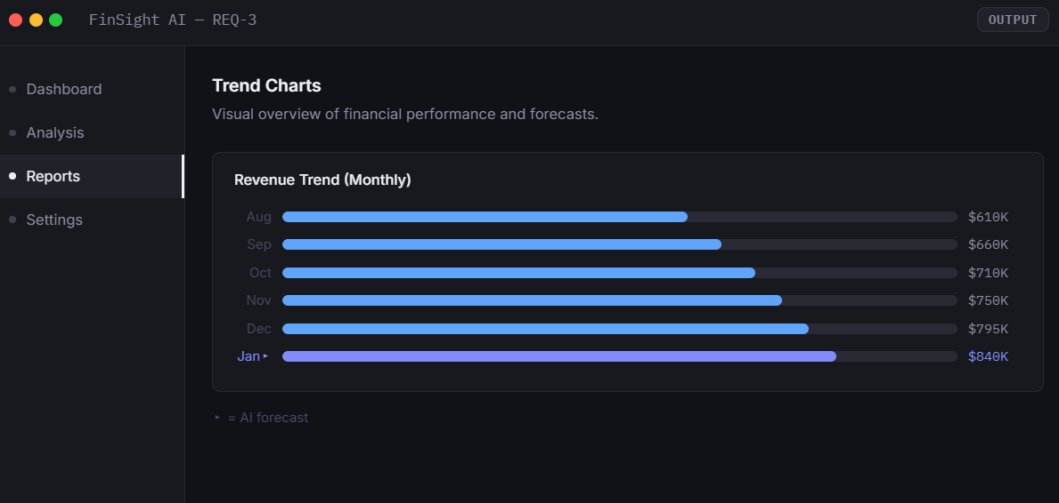
Figure: Req-3 Output Screen

Req-4
As a manager, I want NLP to generate simple summaries of predictions, so that I can make quick decisions.

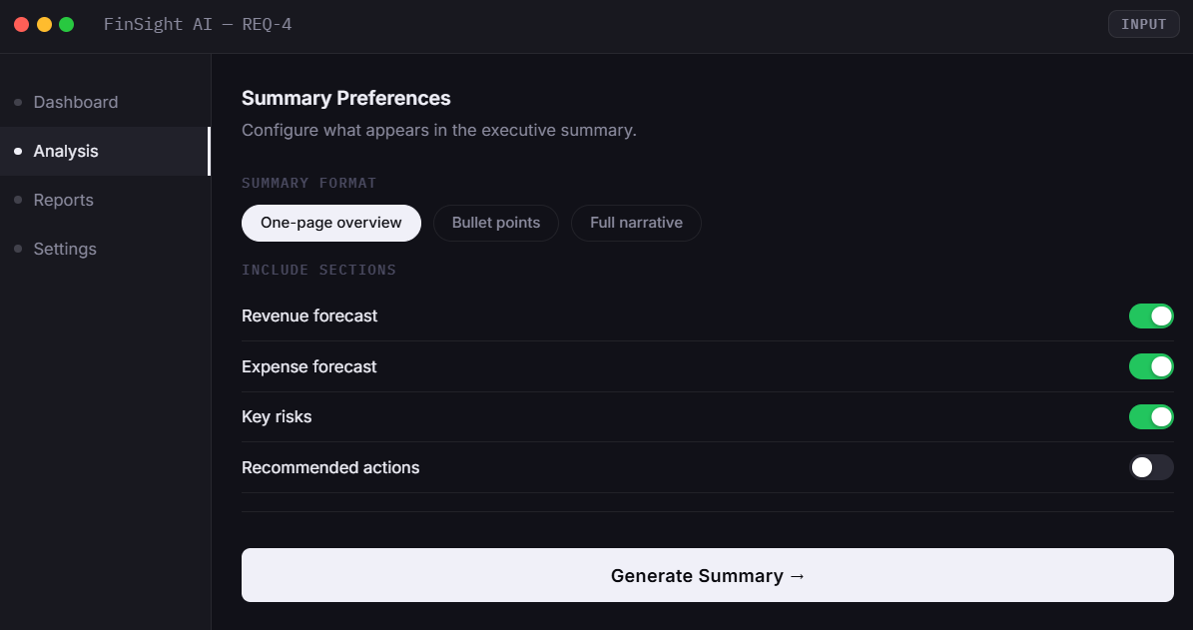
Figure: Req-4 Input Screen

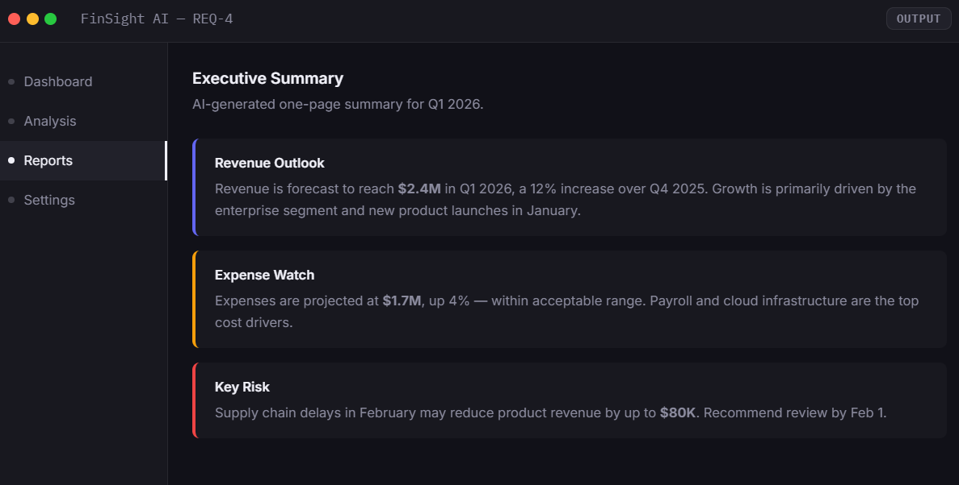
Figure: Req-4 Output Screen

Req-5
As a financial analyst, I want explainable AI methods to explain prediction results, so that I trust the forecasting model.

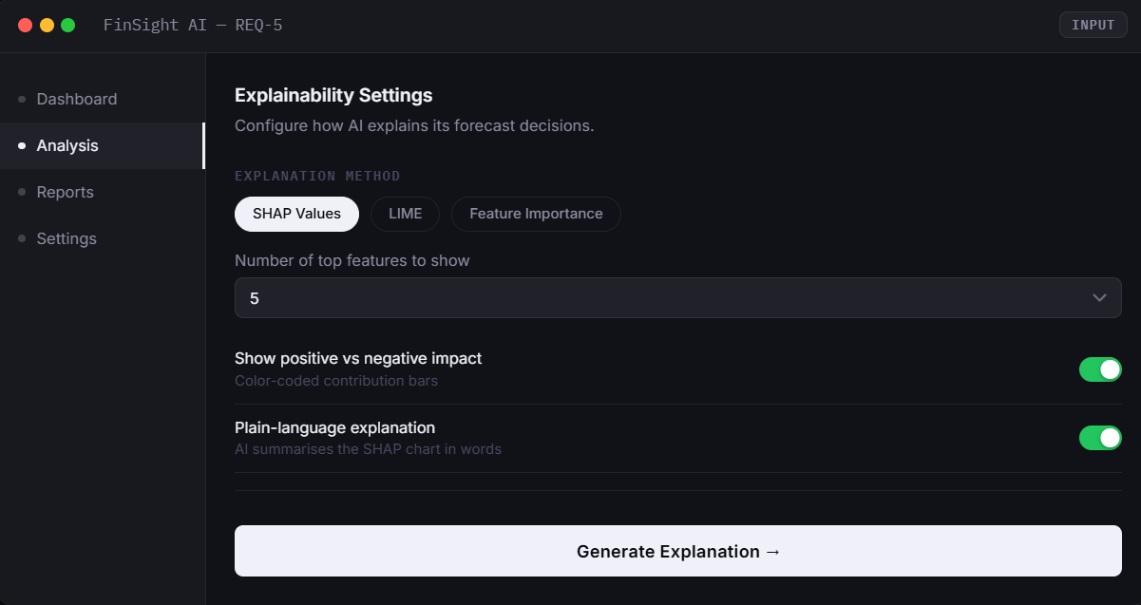
Figure: Req-5 Input Screen

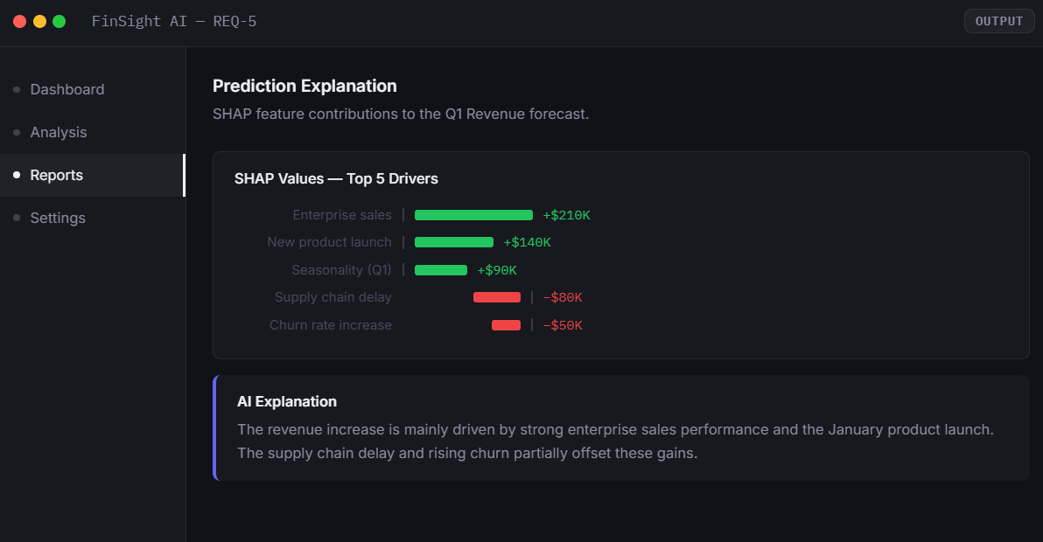
Figure: Req-5 Output Screen

Req-6
As a manager, I want ML feature analysis to highlight key drivers behind performance changes, so that I know which factors to focus on.

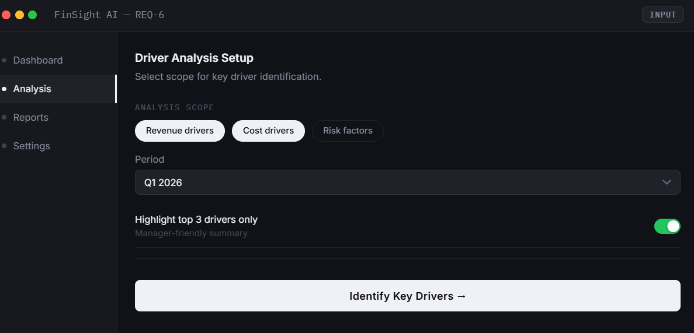
Figure: Req-6 Input Screen

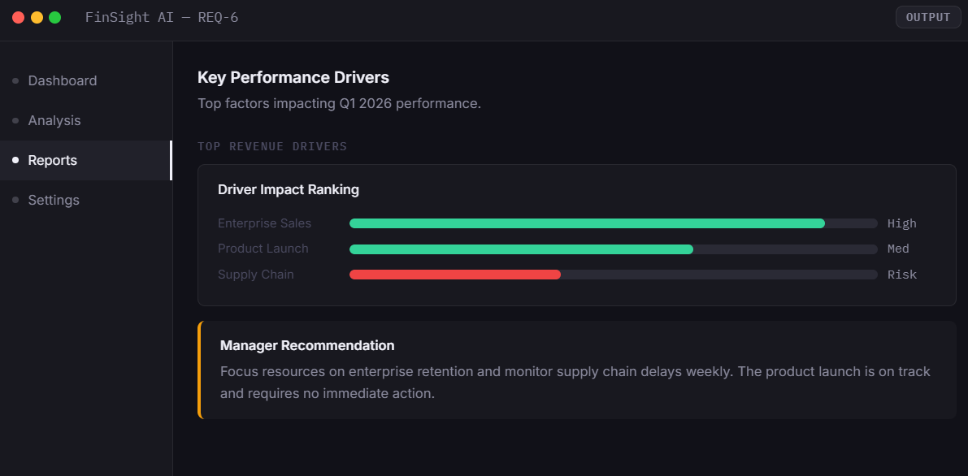
Figure: Req-6 Output Screen

Req-7
As an accountant, I want ML to learn past reporting patterns, so that the reporting process becomes faster each period.

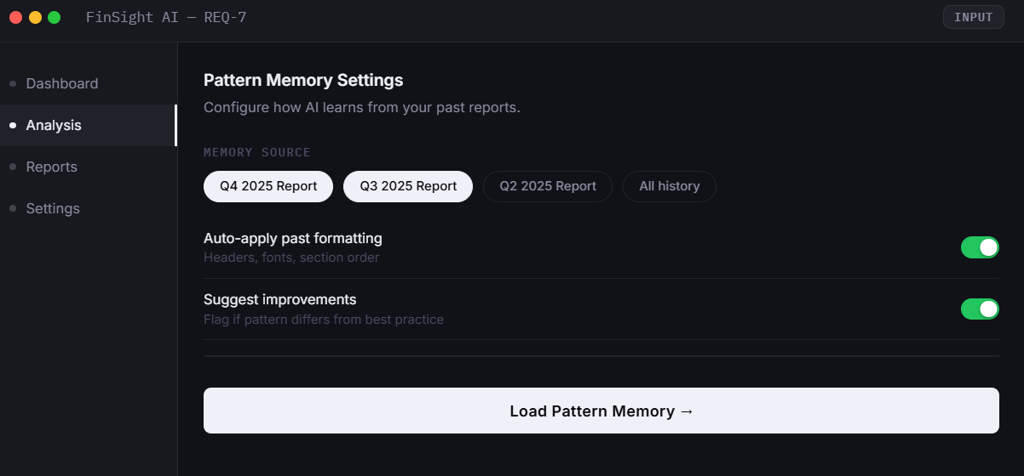
Figure: Req-7 Input Screen

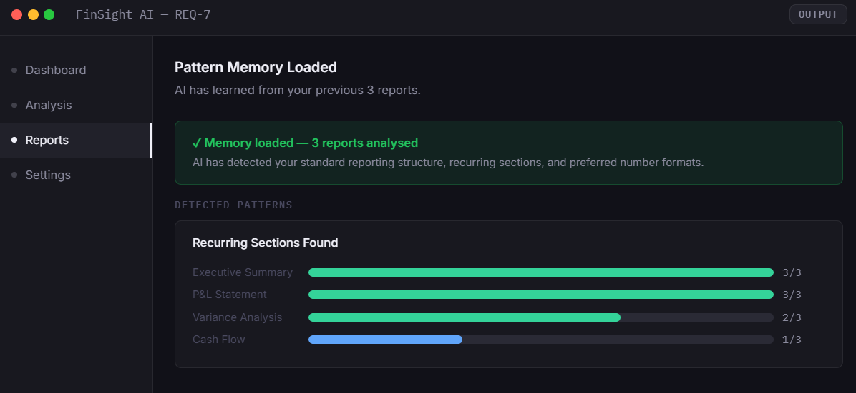
Figure: Req-7 Output Screen

Req-8
As an accountant, I want Intelligent Automation to update reports automatically when new data is uploaded, so that I don't restart the process manually.

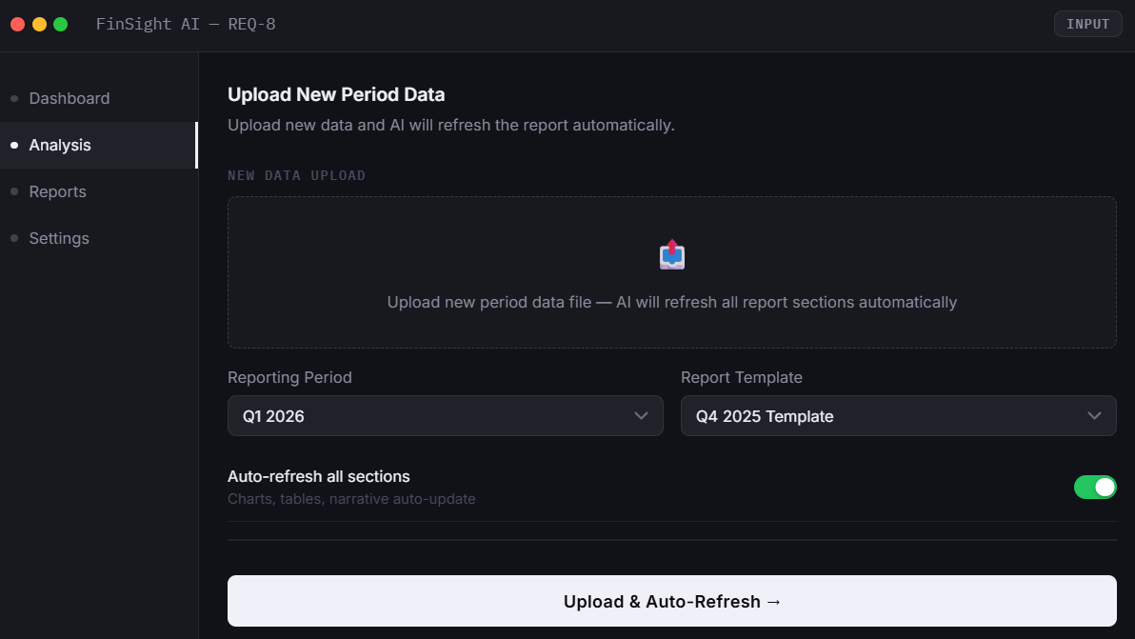
Figure: Req-8 Input Screen

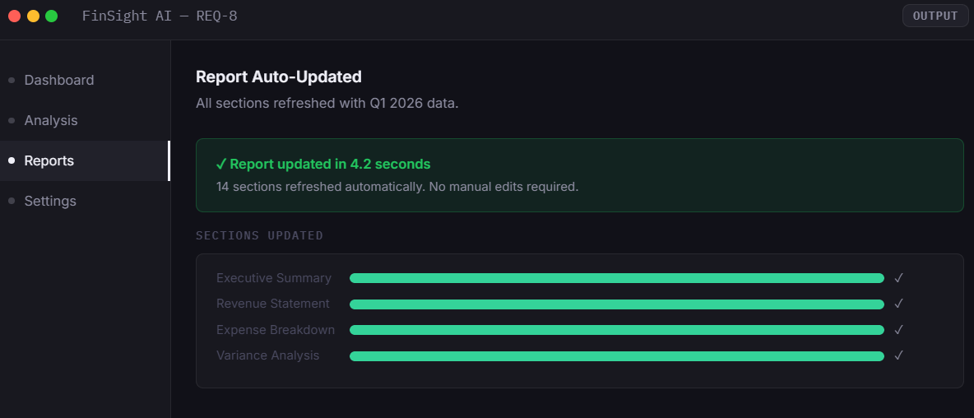
Figure: Req-8 Output Screen

Req-9
As an accountant, I want NLG to create clean financial report layouts, so that I can export reports without additional formatting.

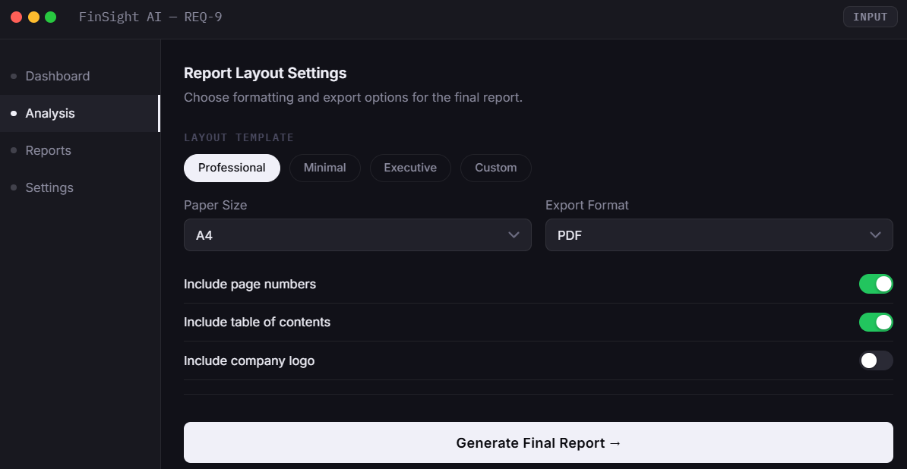
Figure: Req-9 Input Screen

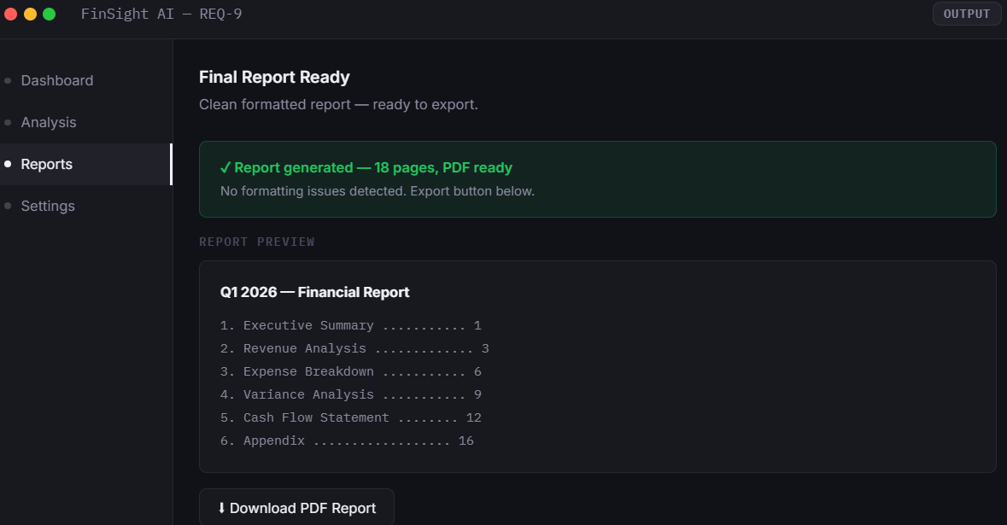
Figure: Req-9 Output Screen

Req-10
As an accountant, I want ML to detect missing or inconsistent entries, so that the final report is complete and reliable.

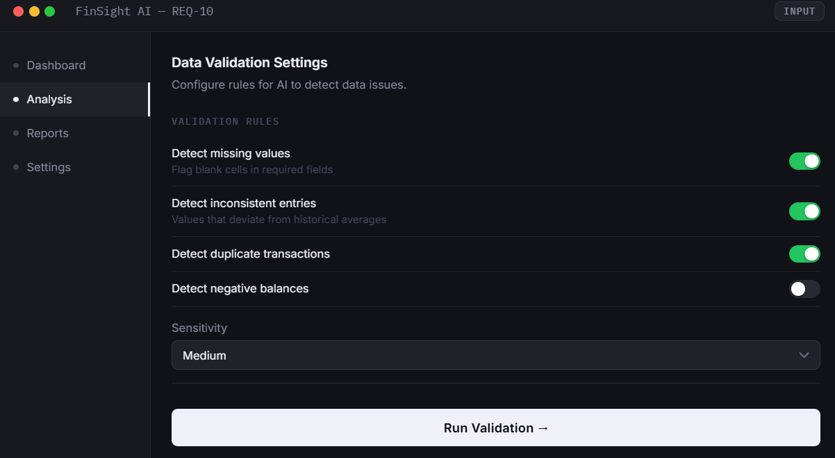
Figure: Req-10 Input Screen

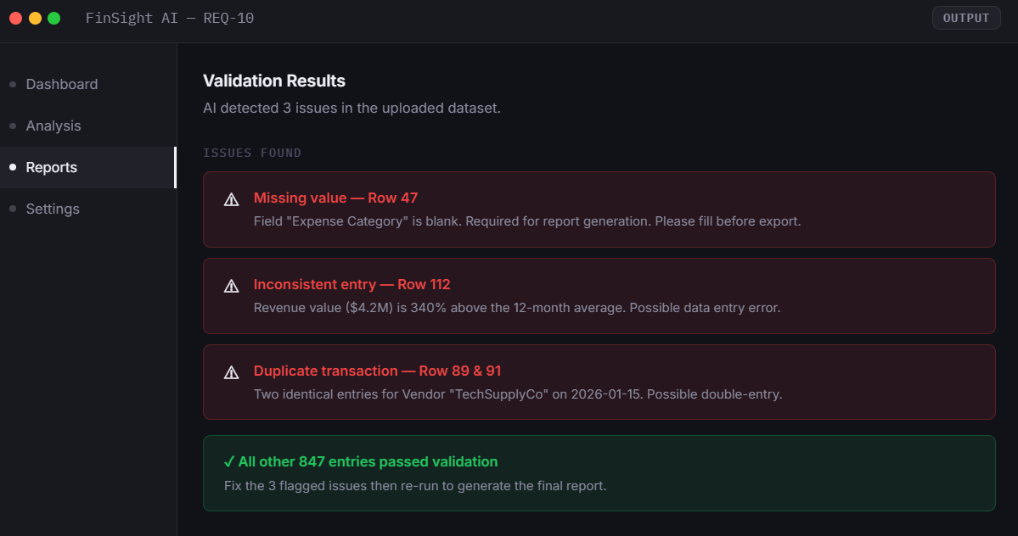
Figure: Req-10 Output Screen

3.6 Test Cases
The final section of this chapter presents a comprehensive set of test cases designed to validate the system's functional integrity and performance.

Test Case ID | Related User Story | Scenario | Test Steps | Expected Results
CFG-01 | Req-1, Req-2 | Analyst uploads a valid historical CSV file and runs a forecast | 1. Log in as Financial Analyst  2. Navigate to Predictive Analysis  3. Upload a valid .csv file with 12 months of data  4. Set forecast period to 'Next 6 months'  5. Click Run Forecast | System accepts the file, processes it, and displays forecast results within 10 seconds with no errors.
CFG-02 | Req-1, Req-2 | Analyst uploads an unsupported file format | 1. Log in as Financial Analyst  2. Navigate to Predictive Analysis  3. Upload a PDF file  4. Set forecast period to 'Next 6 months'  5. Click Run Forecast | System rejects the file and displays: 'Unsupported format. Please upload .csv or .xlsx.'
CFG-03 | Req-2, Req-6 | AI predicts revenue and expenses for the next quarter | 1. Upload valid historical data  2. Select 'Revenue' and 'Expenses' as target metrics  3. Set granularity to Monthly  4. Set confidence interval to 95%  5. Run prediction | System returns predicted values for Revenue and Expenses per month with upper/lower confidence bands displayed.
CFG-04 | Req-3 | Analyst views trend charts after forecast is generated | 1. Complete a successful forecast run  2. Navigate to the Charts & Trends tab  3. Enable 'Forecast overlay' toggle  4. Select Line Chart and Bar Chart | System renders both chart types with historical data and forecast overlay clearly distinguished. Charts are interactive.
CFG-05 | Req-7 | System has no previous reports in memory | 1. Log in as a new Accountant with no history  2. Navigate to Pattern Memory Settings  3. Click Load Pattern Memory | System displays: 'No previous reports found. Please complete at least one report period to enable pattern memory.'
CFG-06 | Req-9, Req-10 | Accountant generates and exports a clean final report as PDF | 1. Navigate to Report Layout Settings  2. Select Professional template and A4 size  3. Enable page numbers and table of contents  4. Select PDF as export format  5. Click Generate Final Report then Download | System generates a clean PDF with table of contents, page numbers, and correct layout. File downloads successfully with no formatting errors.
Table 3.3: Test Cases

