COUNTRY BRIEF
Climate Risk Profile
Burkina Faso | Drought & Agriculture Focus | 03 Oct 2026, 11:00

Key Findings
+25.4% | 33 / 190 | 28.9%
recent-decade rainfall vs 1985-2014 baseline | ND-GAIN vulnerability rank, 2024 (higher score = more ready) | of land area is arable (World Bank, 2023)

1. Observed trends
Mean annual temperature at the representative location (Ouagadougou) averaged 27.4 ºC over 1985-2024, with the warmest years concentrated in the 2000s; NASA's MERRA-2 record shows little net trend at this single point over the period (-0.04 ºC per decade).¹
Rainfall is strongly seasonal: nearly all precipitation falls between May and September, peaking in August (9.5 mm/day on average).¹ The recent decade (2015-2024) has been wetter than the 1985-2014 baseline - about 941 mm per year against 750 mm, a 25% increase - with the gain concentrated in the peak months of July to September (Figures 1-2).¹
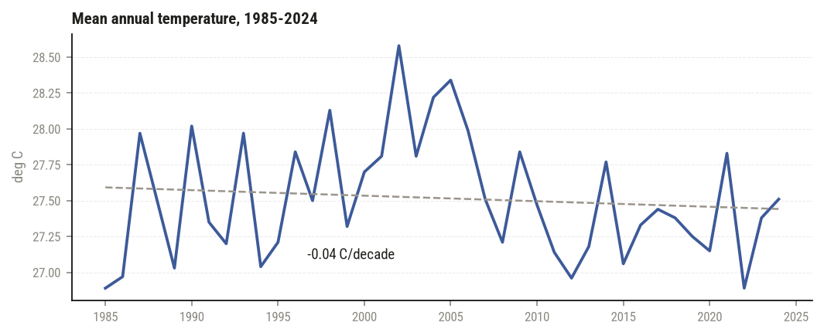
Figure 1. Mean annual temperature, 1985-2024. Dashed line: linear trend. Single grid point (MERRA-2).
2. Seasonal rainfall pattern
Baseline vs recent decade (Figure 2).
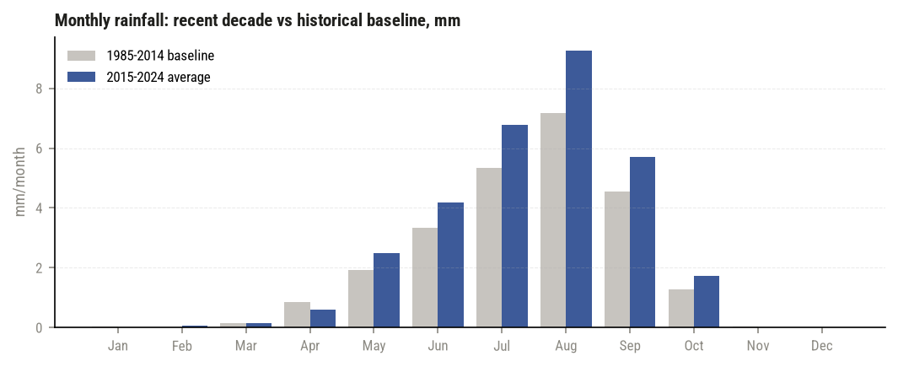
Figure 2. Monthly rainfall: 1985-2014 baseline vs 2015-2024 average.
3. Context and exposure
Burkina Faso's population is about 24.1 million (World Bank, 2025) and is growing 2.2% per year.² Roughly 71% of the population lives in rural areas and 28.9% of land is arable (2023), so livelihoods remain closely tied to rain-fed agriculture - which makes both the timing and the intensity of the June-September rains, rather than the annual total alone, a central food-security variable.²
4. Vulnerability standing
On the ND-GAIN Country Index (2024), Burkina Faso scores 37.4, placing it 33rd most vulnerable of 190 countries (a low score means high vulnerability).³
5. National response
Burkina Faso's updated Nationally Determined Contribution is available through the UNFCCC registry, which lists the country's mitigation and adaptation commitments.⁴ Adaptation priorities are detailed further in the country's National Adaptation Plan documents.
Sources (annex)
1. NASA POWER agroclimatology API, monthly point data (-1.5, 12.4), 1985-2024, retrieved 2026-10-03 05:44 UTC. power.larc.nasa.gov
2. World Bank Open Data API, indicators SP.POP.TOTL, SP.POP.GROW, SP.RUR.TOTL.ZS, AG.LND.ARBL.ZS, retrieved 2026-10-03 05:44 UTC. api.worldbank.org
3. ND-GAIN Country Index, 2024 scores, retrieved 2026-10-03 05:44 UTC. gain.nd.edu
4. UNFCCC NDC Registry, Burkina Faso submission. unfccc.int/NDCREG?country=BFA
Built by Omar Farooq | github.com/ahaomar/climate-profile-generator

