COUNTRY BRIEF
Climate Risk Profile
Senegal | Coastal & Agriculture Focus | 03 Oct 2026, 11:05

Key Findings
+27.7% | 62 / 190 | 18.9 m
recent-decade rainfall vs 1985-2014 baseline | ND-GAIN vulnerability rank, 2024 | population (World Bank, 2025)

1. Observed trends
Mean annual temperature at the representative location (Dakar) averaged 24.3 ºC over 1985-2024, with an observed warming trend of +0.13 ºC per decade at this single point.¹
Rainfall is confined to a June-September wet season peaking in August.¹ The recent decade averaged 636 mm per year against a 1985-2014 baseline of 498 mm - a +28% change - with the difference concentrated in the peak months (Figures 1-2).¹
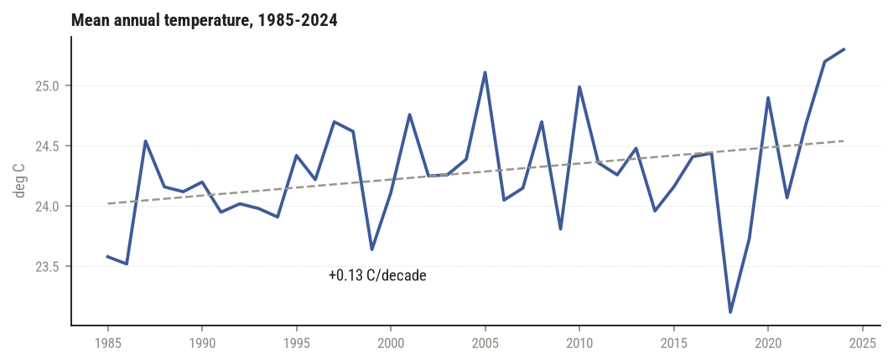
Figure 1. Mean annual temperature. Dashed line: linear trend. Single grid point (MERRA-2).
2. Seasonal rainfall pattern
Baseline vs recent decade (Figure 2).
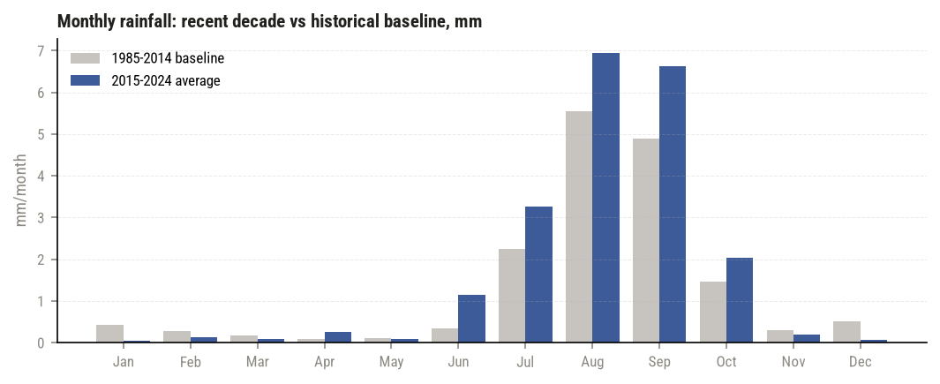
Figure 2. Monthly rainfall: baseline vs recent decade average.
3. Context and exposure
Senegal's population is about 18.9 million and growing 2.3% per year.² 44% of the population is rural and 20% of land is arable, keeping livelihoods tied to rain-fed agriculture and, on the coast, to fishing and urban infrastructure exposed to flooding.²
4. Vulnerability standing
On the ND-GAIN Country Index (2024), Senegal scores 42.3, placing it ranked 62 / 190 in vulnerability terms (a low score means high vulnerability).³
5. National response
Senegal's updated Nationally Determined Contribution is available through the UNFCCC registry, which lists the country's mitigation and adaptation commitments.⁴
Sources (annex)
1. NASA POWER agroclimatology API, monthly point data (-17.4, 14.7), 1985-2024, retrieved 2026-10-03 06:03 UTC. power.larc.nasa.gov
2. World Bank Open Data API, retrieved 2026-10-03 06:03 UTC. api.worldbank.org
3. ND-GAIN Country Index, 2024 scores, retrieved 2026-10-03 06:03 UTC. gain.nd.edu
4. UNFCCC NDC Registry, Senegal submission. unfccc.int/NDCREG?country=SEN
Built by Omar Farooq | github.com/ahaomar/climate-profile-generator

