COUNTRY BRIEF
Displacement Snapshot
Sudan | Cross-border movement into Chad Focus | 09 Oct 2026, 11:56

Key Findings
9.1M | 1.5M | 6.0M
people displaced within Sudan (UNHCR, 2025) | refugees hosted by Chad (UNHCR, 2025) | new internal displacements in 2023, the peak year (IDMC)

1. Displacement overview
Sudan faces one of the world's largest displacement crises. UNHCR recorded 9.1 million internally displaced people (IDPs) in Sudan in 2025, up from 2.6 million in 2020 - the sharpest single-year increase occurring in 2023, when the IDP stock rose from 3.6 to 9.1 million following the outbreak of armed conflict in April 2023.1
Sudan also hosts a refugee and asylum-seeker population of about 0.9 million (2025), and large-scale returns are underway: UNHCR recorded 2.9 million returned IDPs and 0.65 million returned refugees in 2025.1 Return figures reflect movements recorded in the year and may include people displaced again afterwards.
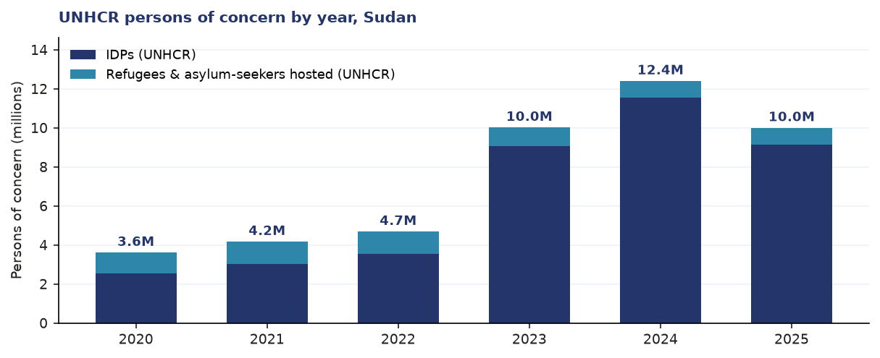
Figure 1. UNHCR persons of concern in Sudan by year, 2020-2025: IDPs, and refugees & asylum-seekers hosted.
2. Recent displacement pressure
IDMC recorded 6.0 million new internal displacements in Sudan in 2023 - the highest in the 2009-2025 series - followed by 3.8 million in 2024 and 1.7 million in 2025.2 New displacements measure movements during the year and include people displaced more than once; the IDP stock and the flow of new displacements therefore tell different parts of the same story.
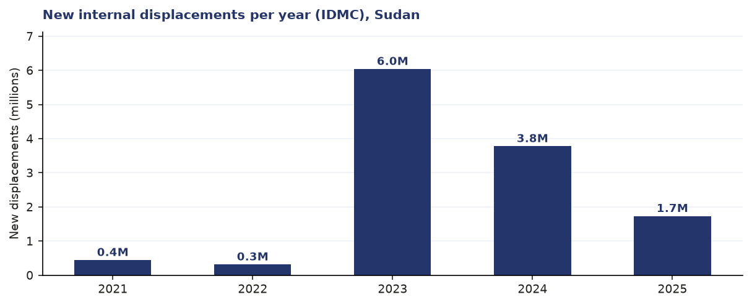
Figure 2. New internal displacements per year (IDMC), Sudan, 2015-2025.
3. Host-country context: Chad
Cross-border movement into Chad is the largest single displacement flow from Sudan. UNHCR recorded 1.5 million refugees hosted in Chad in 2025, roughly doubling from 0.6 million in 2022.3 Chad also manages its own internal displacement (0.2 million IDPs) and other populations of concern.3
- Refugees hosted by Chad: 1.5 million (2025) - up 154% since 2022 (3)
- Chad's own IDP stock: 0.2 million (2025) (3)
- Eastern Chad hosts the large majority of newly arrived Sudanese refugees
4. Response & frameworks
The international response is framed by the Global Compact on Refugees and, for mixed movements, the Global Compact for Migration; a regional refugee response plan coordinates country-level operations. Sudan's wider economic context is strained: GDP per capita stood at about US$1,165 in 2025.4 Current planning figures are set in the annual humanitarian programme cycle documents, linked in the annex.
Sources (annex)
1. UNHCR Population of Concern per country (ArcGIS FeatureServer), Sudan, 1967-2025. gis.unhcr.org / data.unhcr.org — retrieved 2026-10-09 06:51 UTC
2. IDMC Internal Displacements - country-year totals (HDX), Sudan, 2009-2025. data.humdata.org — retrieved 2026-10-09 06:51 UTC
3. UNHCR Population of Concern per country (ArcGIS FeatureServer), Chad. gis.unhcr.org / data.unhcr.org — retrieved 2026-10-09 06:51 UTC
4. World Bank Open Data API, indicators SP.POP.TOTL, NY.GDP.MKTP.CD, NY.GDP.PCAP.CD, SI.POV.DDAY. api.worldbank.org — retrieved 2026-10-09 06:51 UTC
Built by Omar Farooq | github.com/ahaomar/displacement-snapshot-generator

