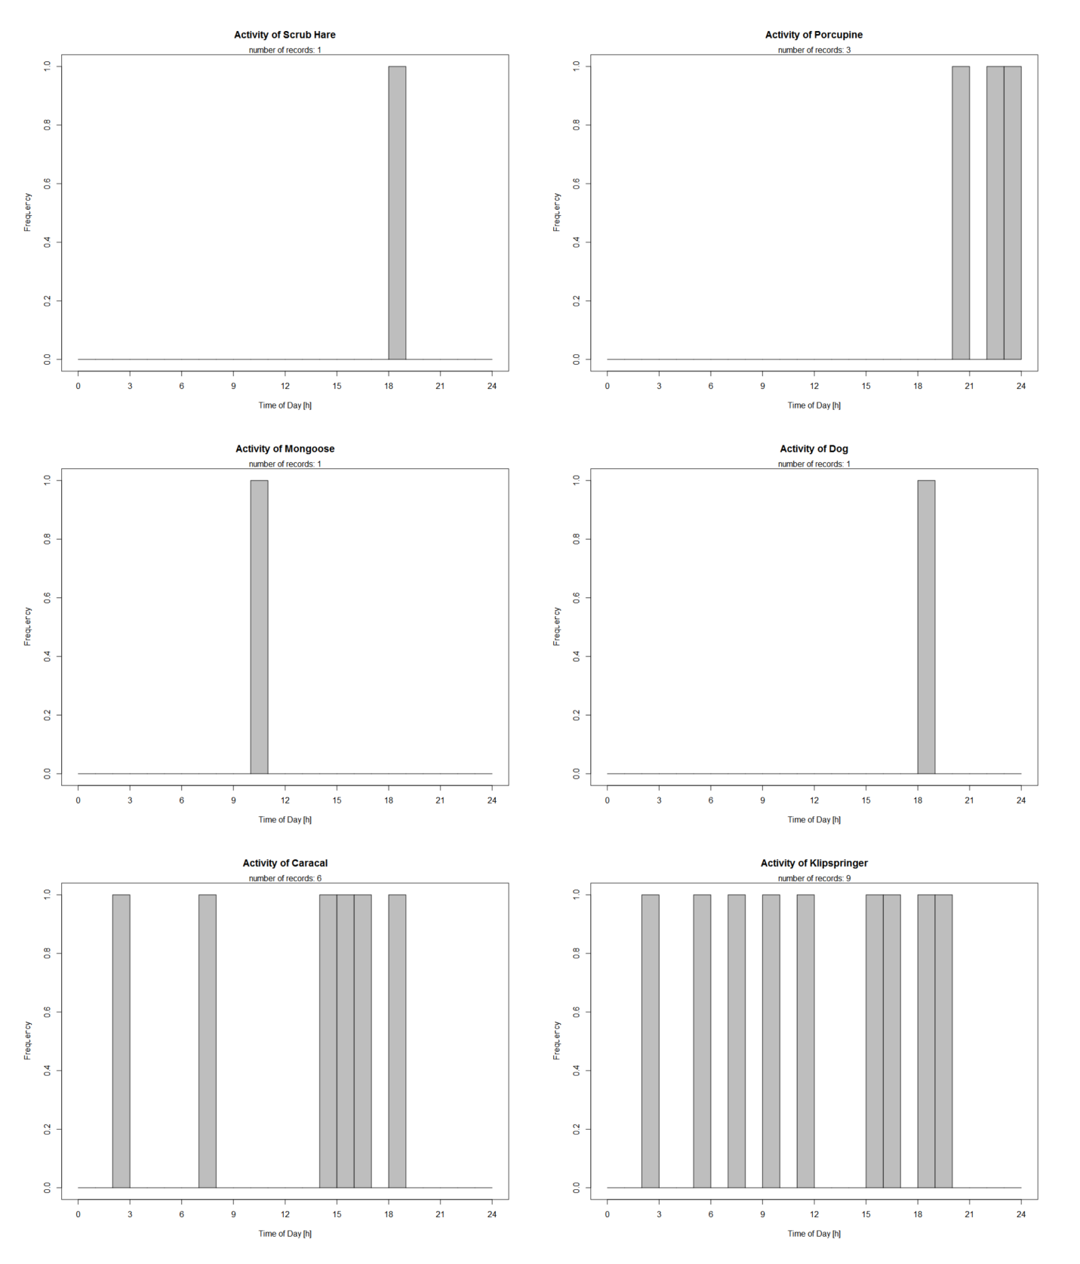

Figure X: Histogram displaying the time at which a particular species was detected, accumulated across all sites for species: scrub hare (*Lepus saxatilis*)*,* Cape porcupine (*Hystrix africaeaustralis*), Cape grey mongoose (*Galerella pulverulenta*), dog (*Canis lupus familiaris*), caracal (*Caracal caracal*) and klipspringer (*Oreotragus oreotragus*).

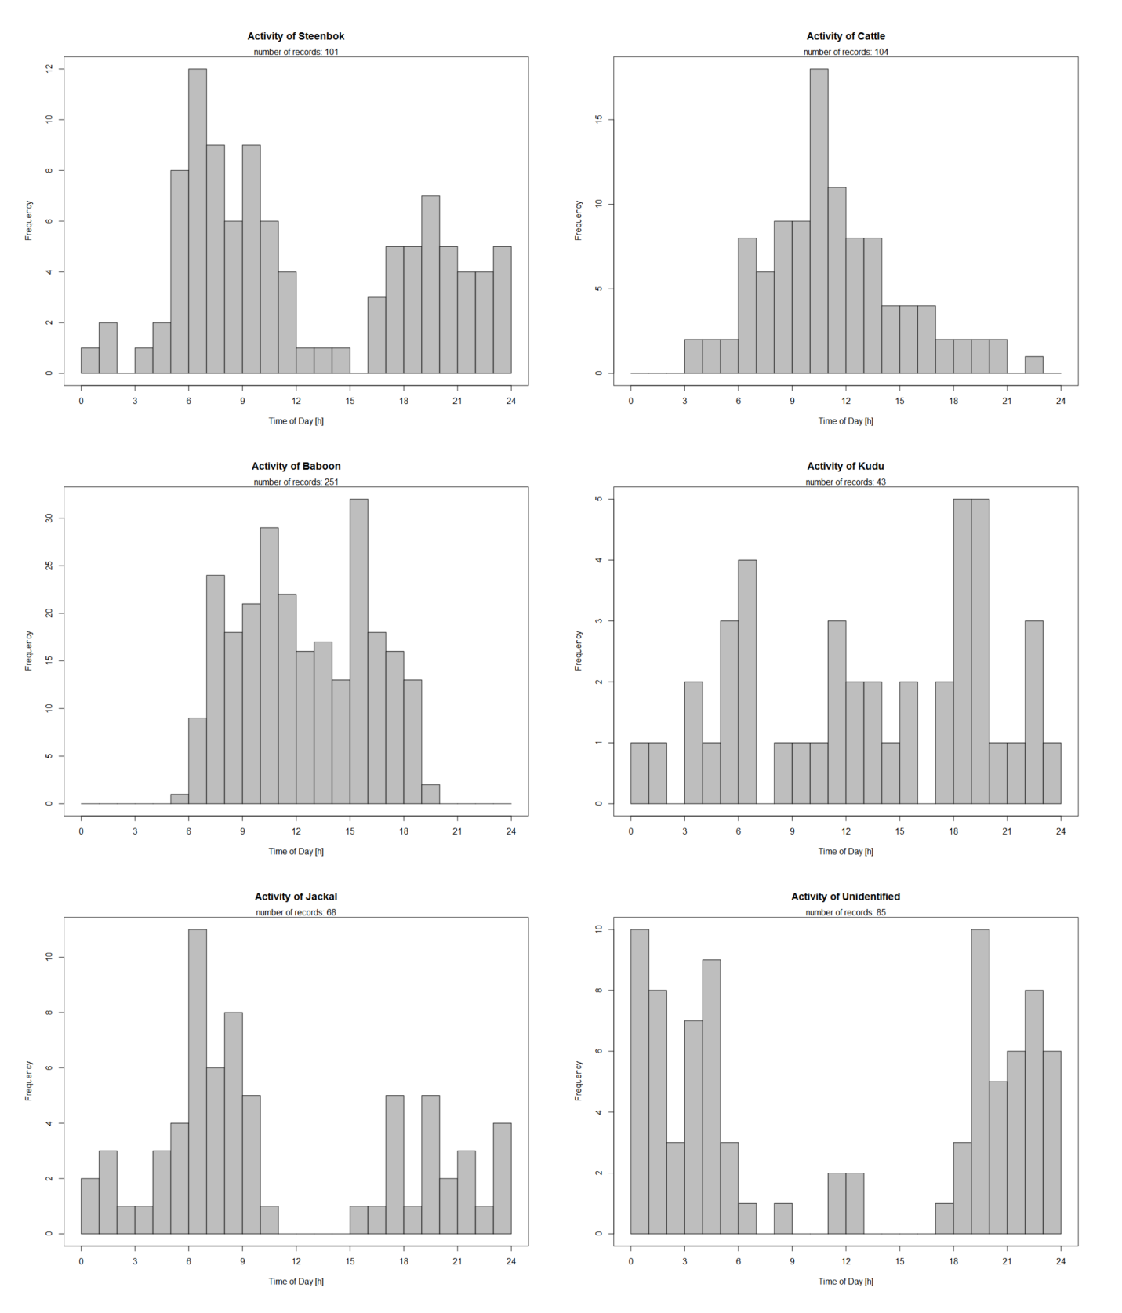Figure X: Histogram displaying the time at which a particular species was detected, accumulated across all sites for species: steenbok (*Raphicerus campestris*), cattle (*Bos taurus),* baboon (*Papio ursinus*), greater kudu (*Tragelaphus strepsiceros*), black-backed jackal (*Canis mesomelas*) and detections of species that could not be identified.

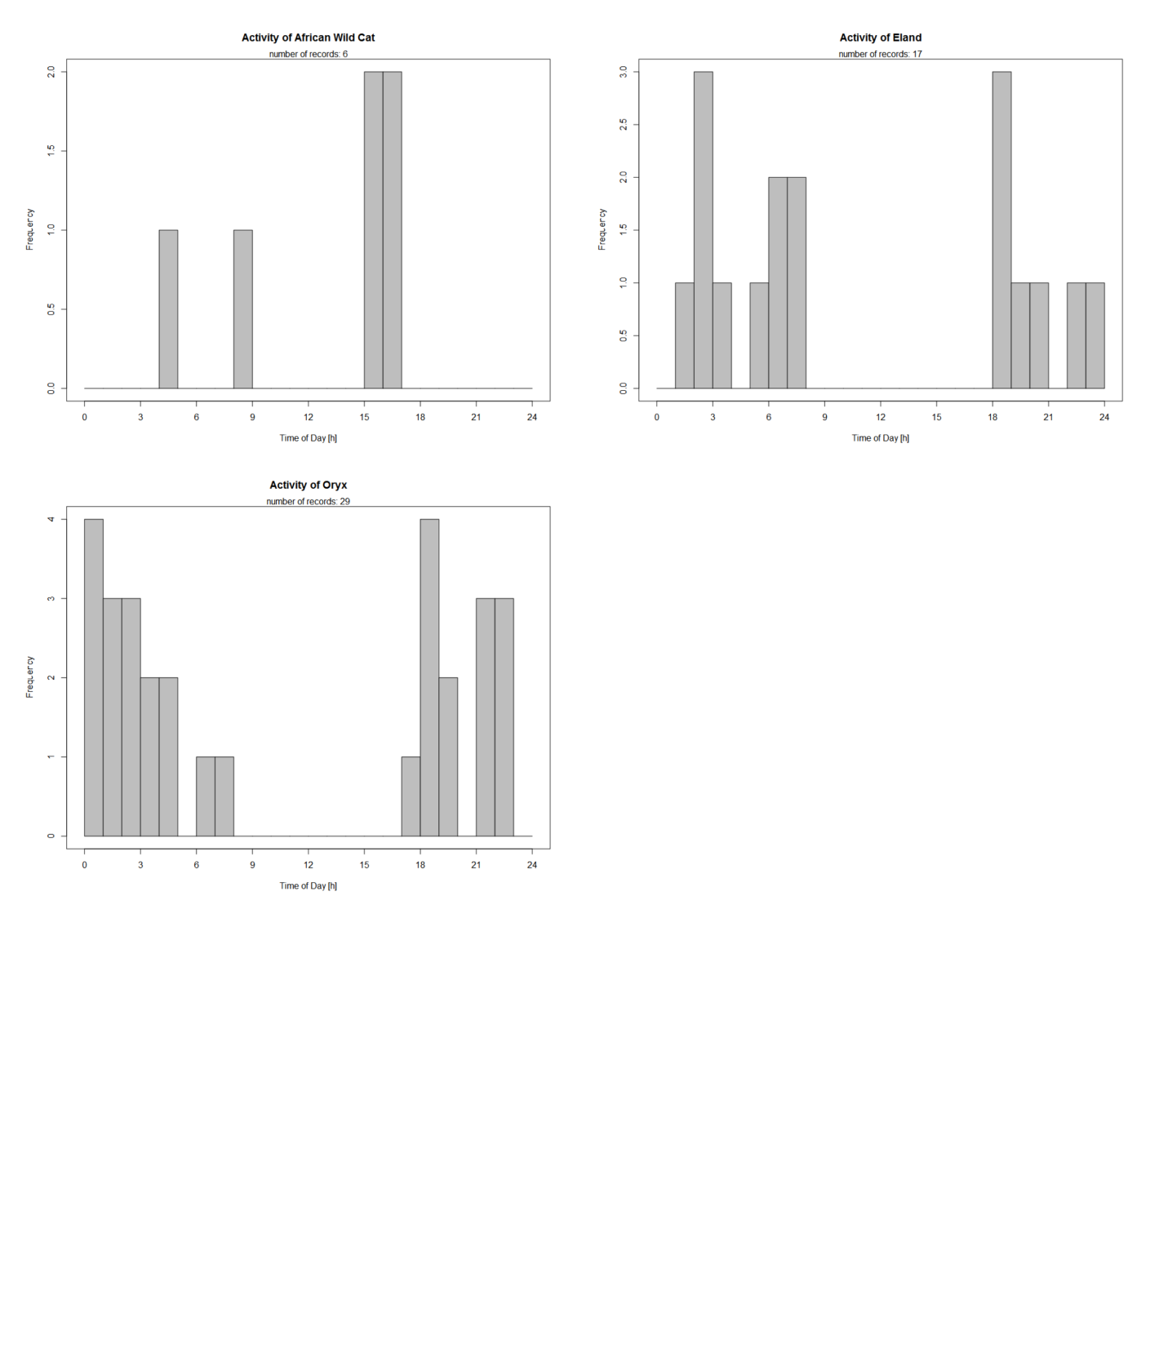

Figure X: Histogram displaying the time at which a particular species was detected, accumulated across all sites for species: African wild cat (*Felis silvestris cafra*), eland (*Taurotragus oryx*) and South African oryx (*Oryx gazelle*).

In order to assess the environment, a Jaccard similarity index was done. Species detection were compared for each site and simplified to a presence-absence matrix.

A Jaccard similarity index was done in order to quantify similarities in species composition among the environment. There was a high association between the scrub hare (*Lepus saxatilis*) and Cape grey mongoose (*Galerella pulverulenta*). Environments were highly similar, with most species being found in all three sites, with few exceptions. Species that were unique to one site include scrub hare (*Lepus saxatilis*)*,* Cape porcupine (*Hystrix africaeaustralis*), Cape grey mongoose (*Galerella pulverulenta*) and a dog (*Canis lupus familiaris*).

**Figure 4: Camera trapping in the non-perennial Prins River.** (I) Cows (*Bos taurus*) in the recharged river (J) A cow (*Bos taurus*), and baboon (*Papio ursinus*) drinking from the rapidly drying river (K) South African oryx (*Oryx gazella*) at night. (L) Juvenile greater kudu (*Tragelaphus strepsiceros*). (M) Scrub hare (*Lepus saxatilis*). (N) Klipspringer (*Oreotragus oreotragus*)(O) Black-backed jackal at the recharged river (*Canis mesomelas*).