**RAPIID Workflow Instructions**

Initial setup

* Turn on the power board and start the computer.
* Login details:
  + - 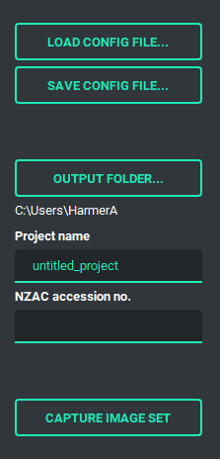User: rapiid
    - Password: image all the things
* Icon

  Description automatically generatedTurn on LED lights (check they are charging, should not say OK).
* Start the RAPIID app (shortcut on desktop or task bar).
* If continuing with an existing project:
  + - Load the config file from the **project** folder. It will be in the format: [project_name]_config.yaml
* If starting a new project:
  + - Set the output folder to D:\rapiid_capture
    - Set the project name e.g., species (with underscore between genus and species name),   
      or genus, or family if that is all that is available.
* Start LiveView on each camera.
* Place an exemplar specimen mounted on the removable stage in the device, aligning the red and blue markers on the removable and permanent stages.
* Check that each camera is aligned properly with the specimen and labels, and that each camera is in focus.
* Adjust the exposure of each camera, use the gain control for main adjustment.
* Remove the specimen and removeable stage from the device.

Calibration image

To allow label images to be deskewed and aligned, a calibration image must be taken at the beginning of each imaging session.

**\*Important:** If camera positions are changed during an imaging session, a new calibration image must be captured for the new positions. Start in a new folder if necessary to ensure calibration image is specific to that image set.

* Place the calibration grid on the stage, ensuring it is visible in all four label cameras (does not need to be present in dorsal or lateral camera).
* Name the calibration image cal_[project_name] in the NZAC accession no. field.
* A picture containing graphical user interface

  Description automatically generated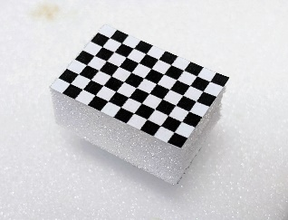Capture calibration image set.

Specimen capture

* Select a tray from a drawer and have an empty tray to the right.
* Graphical user interface, application, chat or text message

  Description automatically generatedTransfer the taxon header label (or add a new one if unlikely to finish in one session) to the new tray.
* Take a specimen from the working tray and add a barcode if not already present.
* Scan the barcode into the NZAC accession no. field.
* Mount the specimen on the removable stage, ensuring labels point towards the gripper handle and that the pin is as vertical as possible.
* Rotate and offset the point by ~80 degrees if working with tiny side mounted specimens.
* Place the specimen in the device, aligning the red and blue markers on the removable and permanent stages.
* Capture the image set.
* Remove the specimen from the device and return to the NEW tray.
* Repeat for all specimens in the tray.

\***Note**: If starting a new tray, check to see if it is a new taxon. Change the project name if necessary.

* When all trays in a drawer have been imaged, tick the ‘Imaged with RAPIID’ label on the outside of the drawer.

Shutdown the system

* When done imaging for the day:
  + - Save the config file
    - Stop LiveView on all cameras
    - Close the RAPIID app
    - Shutdown the computer
    - Switch off all lights
    - Switch off the power board