**Name: Aharneish Abburu Subject: MDSC-103 Optimization Techniques lab**

**Regd No: 22236 Date: 25th oct, 2022**

Question A:

Imagine a furniture company that makes tables and chairs. A table requires 40 board feet of wood and a chair requires 30 board feet of wood. Wood costs $1 per board foot and 40,000 board feet of wood are available. It takes 2 hours of skilled labour to make an unfinished table or an unfinished chair. Three more hours of labour will turn an unfinished table in to a finished table; two more hours of skilled labour will turn an unfinished chair into a finished chair. There are 6000 hours of skilled labour available. (Assume that you don’t need to pay for this labour.)

The prices of the output are given in the table below:

|  |  |
| --- | --- |
| Product | Price |
| Unfinished table | $70 |
| Finished table | $140 |
| Unfinished chair | $60 |
| Finished chair | $110 |

1. Formulate an LP that describes the production plans that the firm can use to maximize its profits.

Maximize

Z= 70 x1 + 140 x2 + 60 x3 + 110 x4

Subject to,

40 x1 + 0 x2 + 30 x3 + 0 x4 <= 40,000

2 x1 +5 x­2 +2 x3 + 4 x4 <= 6000

x1, x2, x3, x4 >= 0

x1 = no of tables unfinished

x2 = no of tables finished

x3 = no of unfinished chairs

x4 = no of finished chairs

1. What would happen if the prices of unfinished chairs went up?

If the prices of the unfinished chairs went up then the optimum value would also increase. This can be seen with the sensitivity analysis report generated that shows that the allowable increase is 6.5

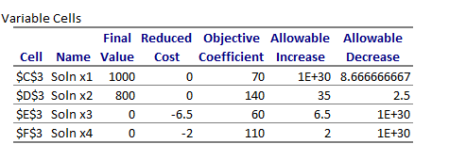

1. What would happen if the prices of the unfinished tables went up?

If the prices of the unfinished tables went up then the optimum value would also go up as seen in the sensitivity analysis report. The report shows that the allowable increase is 1E+30.

1. What would happen if the finished chairs fell to $100?

If the prices of the finished chairs fell to $100 from $110 it would not affect the optimum value hence there is no difference in the profit of the goods sold by the furniture company.

1. How would profit change if lumber supplies changed?

If the lumber prices are reduced the profits would also decrease. If the lumber prices are increased then the profit is also increased hence we can conclude that the wood prices determine the profit of the company.

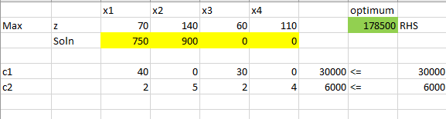

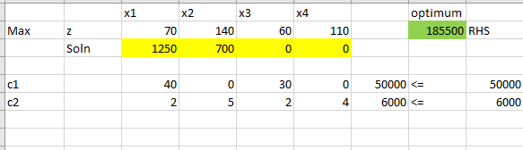

1. How much would you be willing to pay an additional carpenter?

If an additional carpenter is hired then the production will go up as the two carpenters would work parallely and hence it would take less time to finish the products hence would bring in more profits. Hence the carpenter can be paid the same amount or could be given more than the previous carpenter. Suppose the initial carpenter was earning $100 for every product he manufactures, then the additional carpenter can earn anywhere between $100 to $110 dollars.

1. Suppose that industrial regulations complicate the finishing process, so that it takes extra hour per chair or table to turn an unfinished product into a finished one. How would this change your plans?

If the industrial regulations complicate the finishing process and it takes extra hour per chair of table then the profits of the company decrease and the customer have to wait for much longer for the products to be made and delivered.

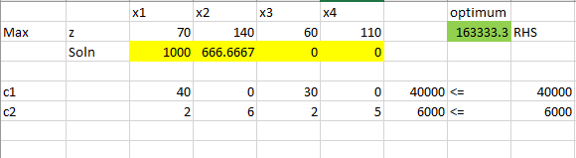

1. The owner of the firm comes up with a design for a beautiful hand-crafted cabinet. Each cabinet requires 250 hours of labour (this is 6 weeks of full-time work) and uses 50 board feet of lumber. Suppose that the company can sell a cabinet for $200, would it be worthwhile?

The problem then changes as

Maximize

Z= 70 x1 + 140 x2 + 60 x3 + 110 x4 + 0 x5 + 200 x6

Subject to,

40 x1 + 0 x2 + 30 x3 + 0 x4 + 50 x5 + 0 x6 <= 40,000

2 x1 +5 x­2 +2 x3 + 4 x4 + 0 x5 + 250 x6<= 6000

x1, x2, x3, x4, x5, x6>= 0

x1 = no of tables unfinished

x2 = no of tables finished

x3 = no of unfinished chairs

x4 = no of finished chairs

x5 = no of unfinished cabinets

x6 = no of finished cabinets

The introduction of cabinets doesn’t affect the profits as there is no increase or decrease in the profits of the company.

