LABMENTIX
Cybersecurity Training Program

CYBERSECURITY PROJECT REPORT
15-Day Hands-On Project Submission
Project Title | SIEM Dashboard Setup
Student Name | Aharnish Dhaw Kumar
Batch / Cohort | 15 – August 2026
Domain | SOC & SIEM
Trainer Name | Ganesh Kuche
Submission Date | 07/10/2026
Difficulty Level | Intermediate

SECTION 1 — PROJECT ABSTRACT

1. Project Abstract

This project demonstrates the deployment, configuration, and administration of an open-source Security Information and Event Management (SIEM) solution, Wazuh, within an isolated multi-VM home lab environment. It addresses the critical cybersecurity challenge of real-time endpoint visibility, log collection, and threat detection by ingesting logs from Ubuntu Server and Windows 10 endpoints. Throughout the project, Windows security audit policies and Linux authentication log tracking were configured, normalized, and integrated into customized SOC dashboards. Furthermore, custom correlation rules mapped to the MITRE ATT&CK framework (Technique T1110 - Brute Force) were implemented and successfully validated via controlled attack simulations, establishing an end-to-end telemetry and alerting pipeline.
SECTION 2 — INTRODUCTION

2. Introduction

2.1 Background
In modern cybersecurity, Security Operations Centers (SOCs) rely heavily on SIEM platforms to centralize log data, detect anomalies, and respond to incidents in real-time. Without centralized log management, detecting sophisticated attacks such as unauthorized access, credential stuffing, and brute-force attempts across distributed enterprise environments becomes nearly impossible. Open-source tools like Wazuh provide enterprise-grade capabilities—including log analysis, file integrity monitoring, vulnerability detection, and threat intelligence—making them foundational for practical security training and portfolio building.

2.2 Problem Statement
Organizations frequently struggle with visibility gaps across heterogenous operating systems (Windows and Linux), leading to delayed threat detection. Specifically, default system configurations often lack granular logging for authentication events, and unmonitored endpoints leave blind spots that attackers can exploit via repetitive brute-force credential attacks without triggering automated security alerts.

2.3 Objectives
- To set up and configure an open-source Wazuh SIEM server (manager, indexer, and dashboard) in a multi-virtual machine lab environment.
- To deploy and register Windows and Linux endpoint agents to stream live security telemetry.
- To enable advanced logging configurations, including Windows Security audit policies for logon tracking (Event IDs 4624/4625).
- To build customized SOC overview dashboards visualizing authentication trends, top source IPs, and event volumes.
- To write, test, and validate custom correlation rules mapped to MITRE ATT&CK T1110 for real-time brute-force detection.

SECTION 3 — TOOLS & ENVIRONMENT

3. Tools and Environment Setup
Tool / Software | Version / Platform | Purpose
Oracle VirtualBox | Latest (v7.x) | Virtualization platform hosting multi-VM lab infrastructure.
Ubuntu Server | 22.04 / 24.04 LTS | Host OS for the all-in-one Wazuh server (Manager, Indexer, Dashboard).
Windows 10 | Evaluation ISO | Target endpoint VM for security event log forwarding and agent testing.
Wazuh Agent & Manager | v4.14 / v4.x | Core SIEM platform for log ingestion, normalization, and alerting.
PowerShell & auditpol | Windows Built-in | Configuring advanced security audit subcategories and deploying agents.

3.1 Lab / Environment Description
The lab was constructed using Oracle VirtualBox with a Bridged Adapter network configuration, allowing all virtual machines to acquire IP addresses directly on the local subnet for seamless communication.
- Ubuntu VM: Assigned 4GB+ RAM, 4 CPUs, and a 75.46GB disk hosting the Wazuh Server (192.168.29.94).
- Windows 10 VM: Configured as the monitored endpoint agent (192.168.29.229).

SECTION 4 — METHODOLOGY / STEP-BY-STEP PROCESS

4. Methodology

Step 1 — Wazuh Server Installation
An Ubuntu Server VM was provisioned and updated. The all-in-one Wazuh installation script was executed to deploy the Wazuh manager, indexer, and web dashboard components concurrently.

sudo apt update && sudo apt upgrade -y
curl -sO https://packages.wazuh.com/4.14/wazuh-install.sh && sudo bash ./wazuh-install.sh -a

Figure 1: Terminal output verifying successful installation of the Wazuh indexer, manager, and dashboard components.

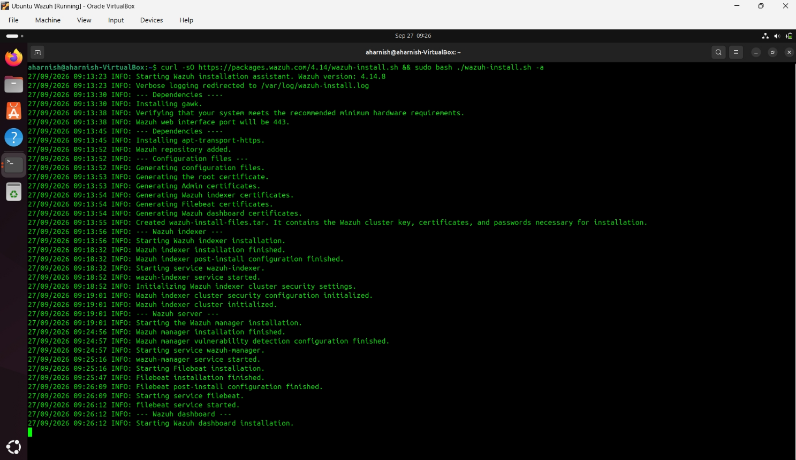
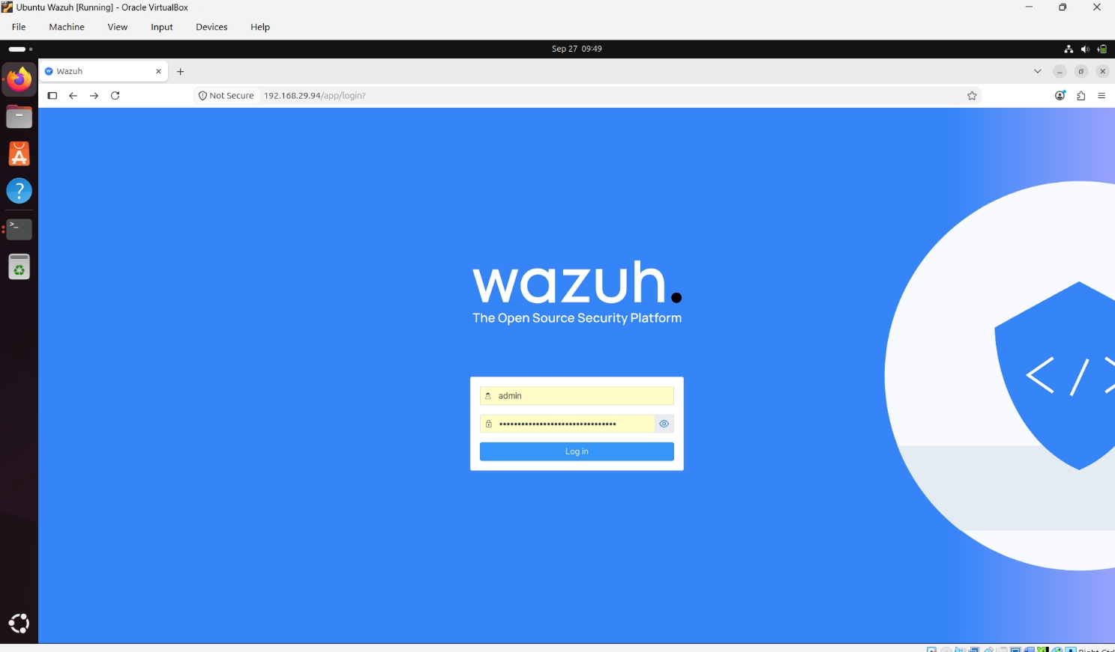

Step 2 — Agent Deployment & Registration
The Wazuh agent installer package was deployed onto the Windows 10 virtual machine via PowerShell, linking the endpoint securely to the Wazuh manager IP.

msiexec.exe /i wazuh-agent-4.14.4-1.msi /q WAZUH_MANAGER="192.168.29.94" WAZUH_AGENT_NAME="win10-agent"
NET START WazuhSvc

Figure 2: Wazuh Web UI confirming successful agent registration and active status for the Windows endpoint.

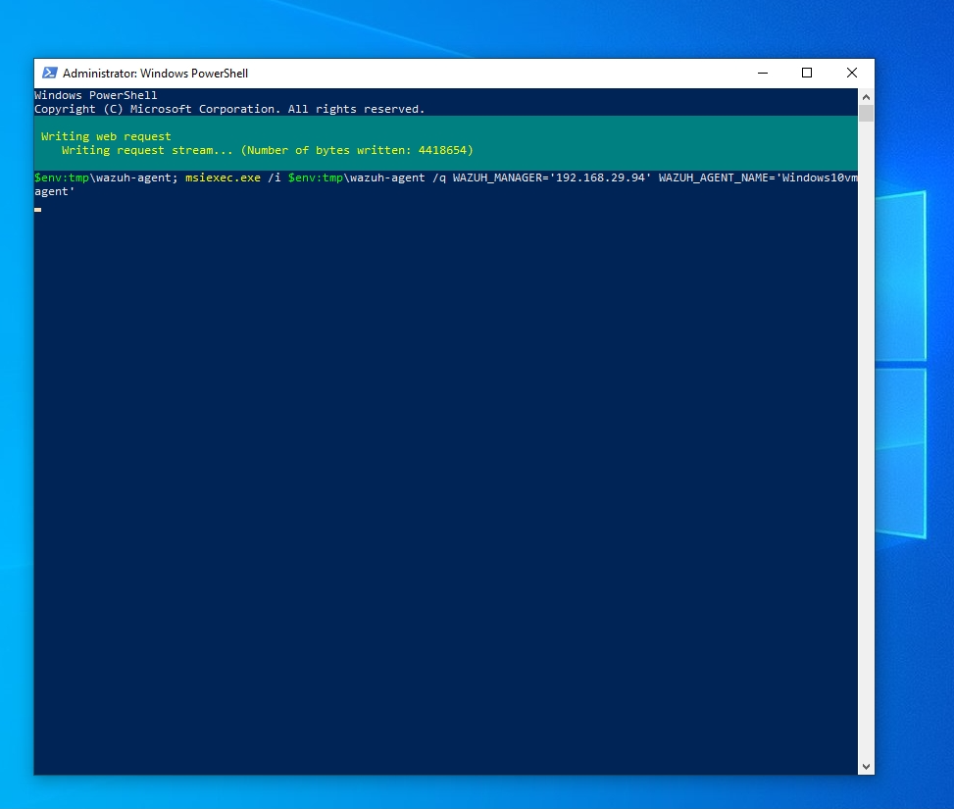
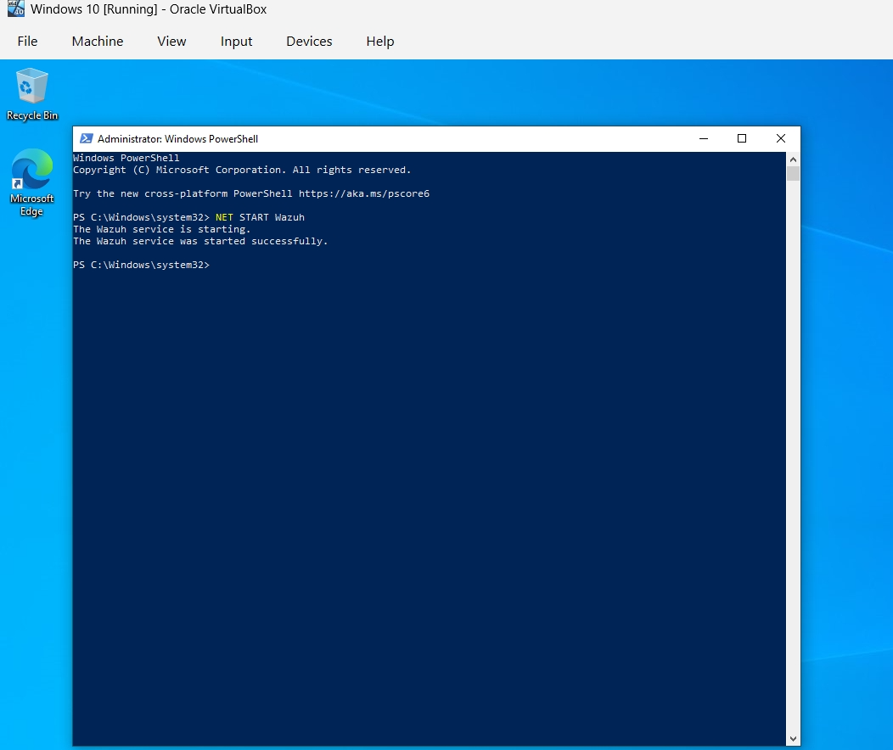
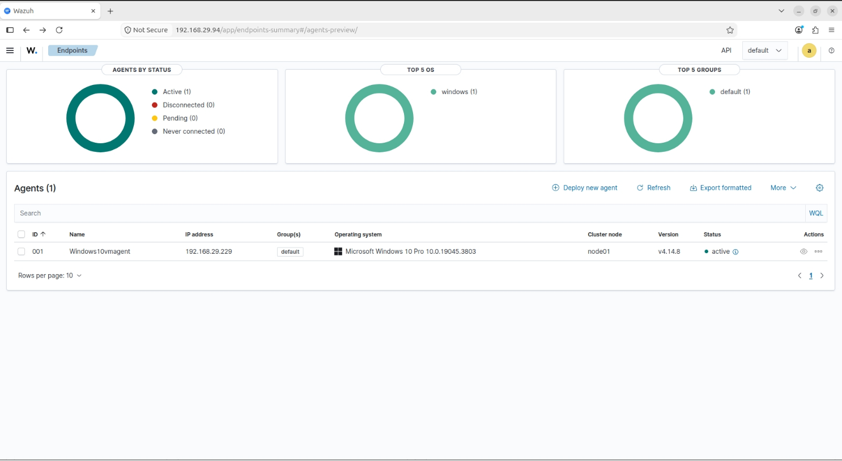

Step 3
Windows audit subcategories were updated using auditpol to ensure that successful and failed logon attempts (Event IDs 4624 and 4625) were recorded in the Windows Security Event Log for forwarding to Wazuh.
PowerShell

auditpol /set /subcategory:"Logon" /success:enable /failure:enable
auditpol /set /subcategory:"Logoff" /success:enable
auditpol /set /subcategory:"Account Lockout" /failure:enable

Figure 3: PowerShell window confirming successful execution of audit policy modifications[cite: 6, 7, 17, 18].
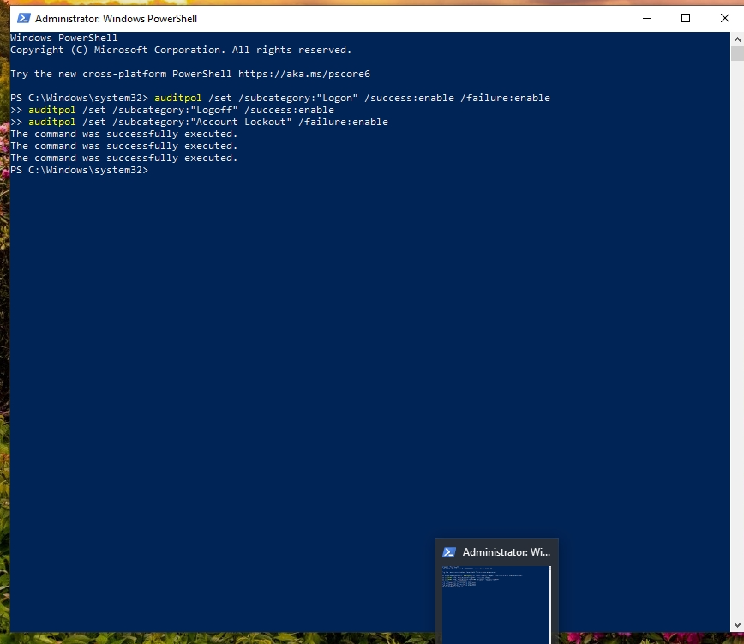
SECTION 5 — RESULTS & OBSERVATIONS

Step 4 — Dashboard Customization
Custom visualizations were built within the Wazuh dashboard via Dashboard Management, including failed logins over time, top source attacking IPs, and event distribution across hosts, saved collectively under the "SOC Overview" profile.
Figure 4: Final customized SOC Overview dashboard displaying real-time aggregated security metrics.
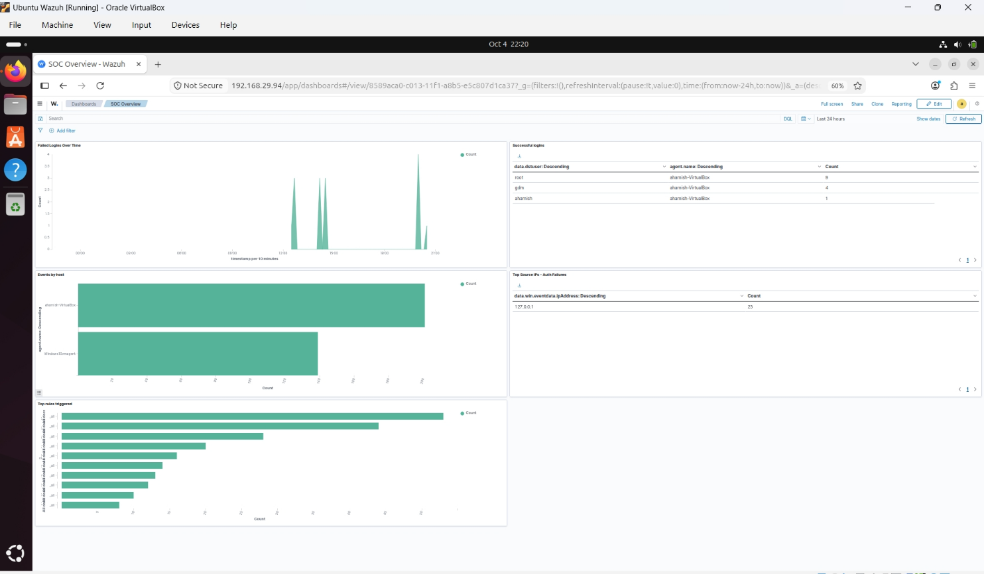
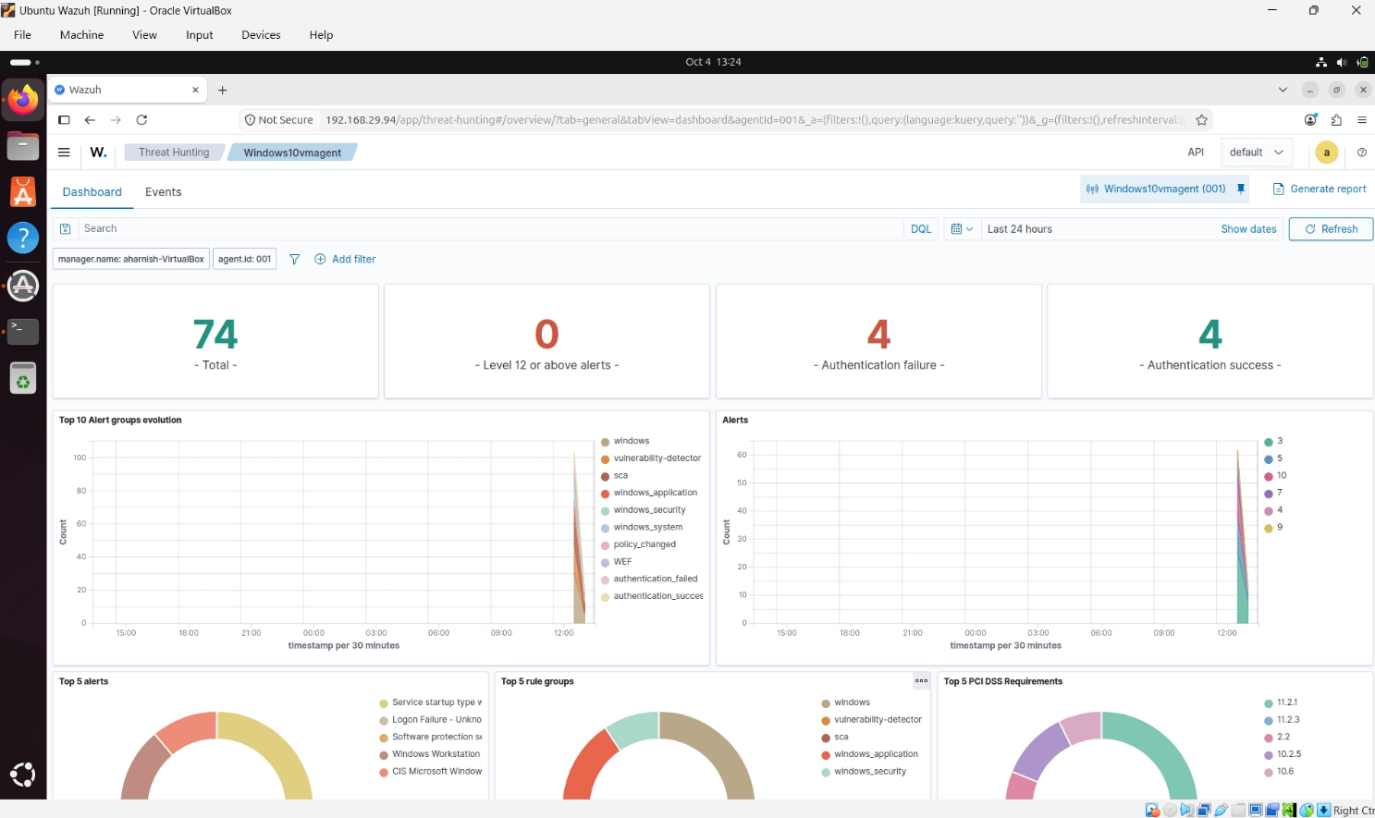

Step 5 — Custom Brute-Force Rule Engineering
Custom detection logic was introduced into /var/ossec/etc/rules/local_rules.xml on the Wazuh server to catch multiple failed authentication attempts within a tight timeframe, mapped directly to MITRE ATT&CK T1110.
<group name="windows,bruteforce">
<rule id="100200" level="12" frequency="5" timeframe="60" ignore="60">
<if_matched_sid>60122</if_matched_sid>
<same_field>data.srcip</same_field>
<description>Multiple failed Windows logons from same source (possible brute-force).</description>
<mitre><id>T1110</id></mitre>
</rule>
</group>

Step 6 — Attack Simulation & Validation
Controlled failure loops and simulated bad password attempts were executed on the endpoints to verify rule triggering, log parsing accuracy, and alert generation in alerts.json.

5. Results and Observations

5.1 Summary of Findings

# | Finding / Observation | Details | Severity / Impact
1 | Log Normalization Success | Raw Windows Event ID 4625 logs were successfully parsed into structured fields (data.srcip, data.dstuser). | Informational
2 | Authentication Tracking | Real-time tracking of Linux auth logs (auth.log) and Windows security channels confirmed active endpoint communication[cite: 8, 19]. | Low
3 | Brute-Force Detection Trigger | Simulated repetitive failed logons successfully tripped custom rule ID 100200, elevating alert severity to level 12. | High
4 | Dashboard Visualization | The "SOC Overview" dashboard dynamically updated top source IPs and event trends upon attack execution. | Medium

5.2 Analysis
The results confirm that out-of-the-box SIEM configurations require custom tuning and proper endpoint audit policy baselining to capture tactical security telemetry. By enforcing auditpol on Windows and writing customized threshold rules (frequency="5" timeframe="60"), noise was successfully filtered out, isolating genuine multi-attempt brute-force indicators mapped to MITRE ATT&CK T1110.
SECTION 6 — CHALLENGES FACED

6. Challenges Faced
Challenge Faced | How I Solved It
Agent Connection Timeout / "Never Connected" status | Verified VirtualBox network adapter settings were switched from NAT to Bridged Adapter to ensure proper LAN routing and adjusted firewall rules to allow TCP port 1514 traffic.
Missing Windows Event 4625 logs in Wazuh | Re-executed the auditpol command with elevated PowerShell privileges and verified the Windows Security Event viewer manually to ensure audit policies were actively recording failures.
Custom Rule Syntax Errors | Utilized sudo /var/ossec/bin/wazuh-logtest on the Wazuh server terminal to validate XML syntax and review rule parsing logic before restarting the manager service.

SECTION 7 — LEARNING OUTCOMES

7. Learning Outcomes
- Gained hands-on experience deploying, managing, and troubleshooting an enterprise-grade open-source SIEM (Wazuh) across a multi-VM architecture[cite: 1, 2, 3, 5, 12, 13, 14, 16].
- Learned how to configure Windows Advanced Audit Policies using auditpol to expose deep security logging channels (Event IDs 4624/4625).
- Mastered log normalization concepts, mapping raw unstructured text logs into structured fields like source IP (data.srcip) and target user (data.dstuser)[cite: 8, 19].
- Developed custom XML correlation rules with threshold frequency counters and integrated them with the MITRE ATT&CK framework (T1110 - Brute Force).
- Designed functional SOC dashboards to visualize real-time authentication metrics, threat telemetry, and host activity.

SECTION 8 — CONCLUSION & FUTURE SCOPE

8. Conclusion
This project successfully achieved its objectives by establishing a fully functional Home SOC lab centered around Wazuh SIEM. Through methodical VM deployment, audit policy tuning, custom rule writing, and attack simulation, practical insights into defensive security operations were gained. The resulting environment successfully captures, normalizes, and alerts on security threats in real-time, providing foundational evidence of SOC engineering capabilities.

8.1 Future Scope
If expanded, this project could incorporate automated incident response playboards using Wazuh active response scripts (e.g., automatically blocking malicious source IPs via firewall rules upon rule trigger). Additionally, integrating ticketing platforms like TheHive or Slack webhooks for automated alert notifications would simulate a more mature enterprise SOC workflow.

SECTION 9 — REFERENCES

9. References
[1] Wazuh Documentation — Wazuh Installation Guide — https://documentation.wazuh.com/
[2] Microsoft Learn — Audit Logon Events (Security Event ID 4625) — https://learn.microsoft.com/
[3] MITRE ATT&CK — Technique T1110: Brute Force — https://attack.mitre.org/techniques/T1110/
DECLARATION

Student Declaration

I hereby declare that this project report is my own original work, completed as part of the Labmentix Cybersecurity Training Program. The work presented in this report is genuine, and all external references have been duly acknowledged.

Aharnish Dhaw Kumar  Student Signature | 07/10/2026  Date of Submission

