Task 4 NMAP
Date of allotment: 09/10/2026
Date of completion: /10/2026
Deadline: 13/10/2026 (5days)

Tool: NMAP
  - What is nmap?
Nmap (Network Mapper) is a free, open-source tool used for network discovery and security auditing. It scans hosts and services by sending packets and analyzing responses, helping administrators and security professionals identify devices, open ports, running services, and potential vulnerabilities.

Key Features of Nmap
- Host Discovery: Detects which devices are active on a network.
- Port Scanning: Identifies open, closed, or filtered ports on target systems.
- Service & Version Detection: Determines what services are running and their versions (e.g., Apache, SSH, DNS).
- OS Fingerprinting: Estimates the operating system and device type based on TCP/IP stack behavior.
- Nmap Scripting Engine (NSE): Runs scripts (written in Lua) for advanced tasks like vulnerability detection, authentication checks, and protocol enumeration.
- Flexible Scan Types: Supports TCP SYN (stealth), TCP connect, UDP scans, and specialized probes (ACK, FIN, Xmas) to infer firewall rules.

Typical Uses:
- Security Auditing: Find exposed services and weak configurations.
- Network Inventory: Map devices and services across large address spaces.
- Troubleshooting: Distinguish between hosts that are down, filtered, or open but unresponsive.
- Penetration Testing: Identify attack surfaces and potential vulnerabilities.
- Firewall Testing: Verify which connections are allowed or blocked.

- Nmap Screenshot (nmap 104.21.77.200)
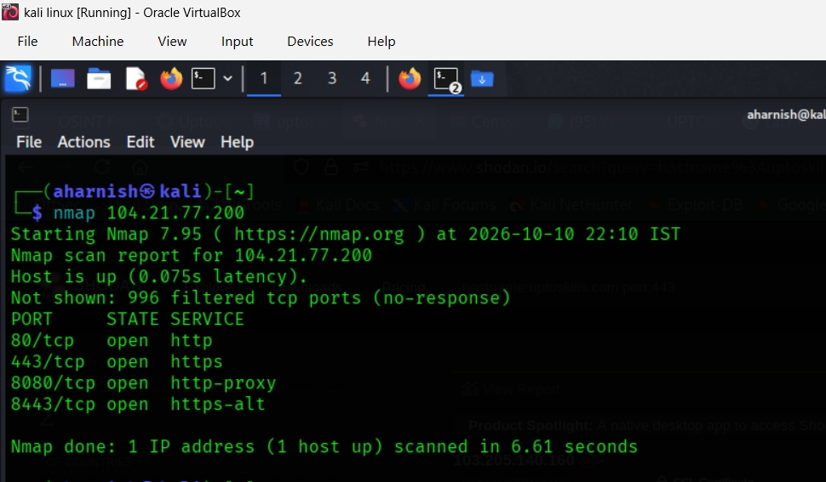
- In the following screenshot you can see the nmap is scanning the uptoskills ipv4 and the following output are shown.
- Command: Standard TCP scan of a single host.
- Output: Host is up. Ports 80, 443, 8080, 8443 are open. Remaining ports filtered.
- Summary: Basic connectivity confirmed, common web services detected.

- Scan Details.
- Command used: nmap 104.21.77.200
- Target: IP 104.21.77.200
- Scan type: Default TCP connect scan
- Latency: ~0.075 seconds
- Duration: ~6.61 seconds

- Findings
- Open ports detected:
  - 80/tcp → HTTP
  - 443/tcp → HTTPS
  - 8080/tcp → HTTP-proxy
  - 8443/tcp → HTTPS-alt
- Other ports: 996 filtered (no response).

- Nmap screenshot (nmap 172.67.211.113 104.21.77.200 2606:4700 :3036 :: 6815:4dc8 2606: 4700 : 3035 :: ac43 : d371)

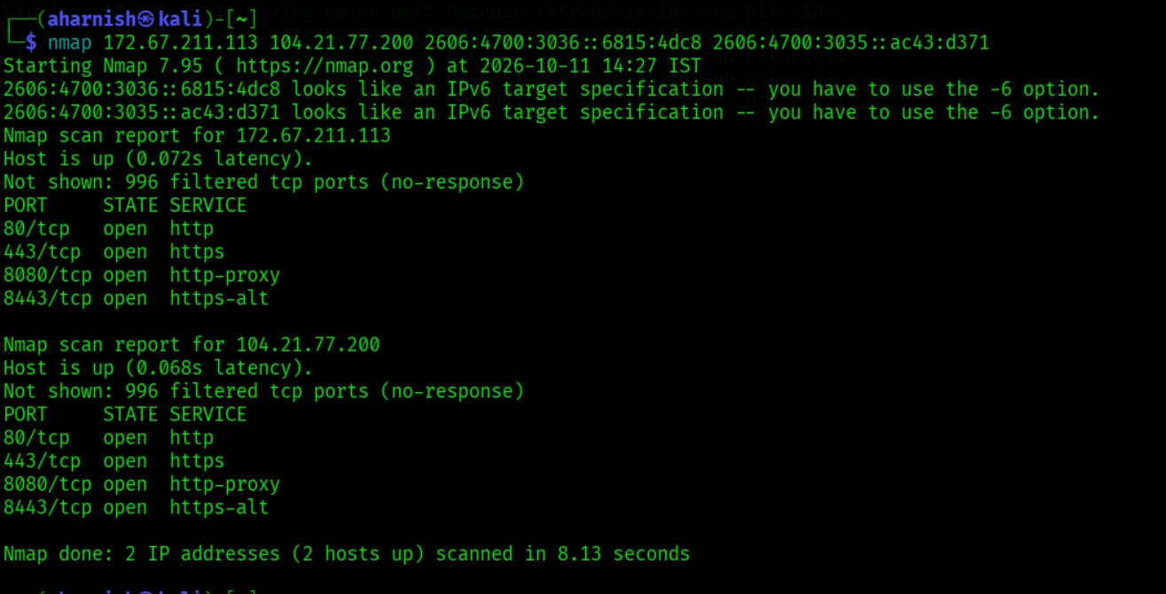
- In the following screenshot you can see the nmap is scanning the multiple ips in which ip4 and ipv5 are present.
- Command: Scan of multiple IPv4 and IPv6 addresses.
- Output: IPv6 targets require -6 option. IPv4 hosts responded, showing they are up.
- Summary: IPv6 scanning needs explicit -6. IPv4 hosts reachable.
- Findings
- Host: 172.67.211.113
- Status: Up (0.072s latency)
- Open ports:
- 80/tcp → HTTP
- 443/tcp → HTTPS
- 8080/tcp → HTTP-proxy
- 8443/tcp → HTTPS-alt
- Other ports: 996 filtered (no response).

- Host: 104.21.77.200
- Status: Up (0.068s latency)
- Open ports:
- 80/tcp → HTTP
- 443/tcp → HTTPS
- 8080/tcp → HTTP-proxy
- 8443/tcp → HTTPS-alt
- Other ports: 996 filtered.

- Nmap screenshot (nmap 104.21.77.0/24)
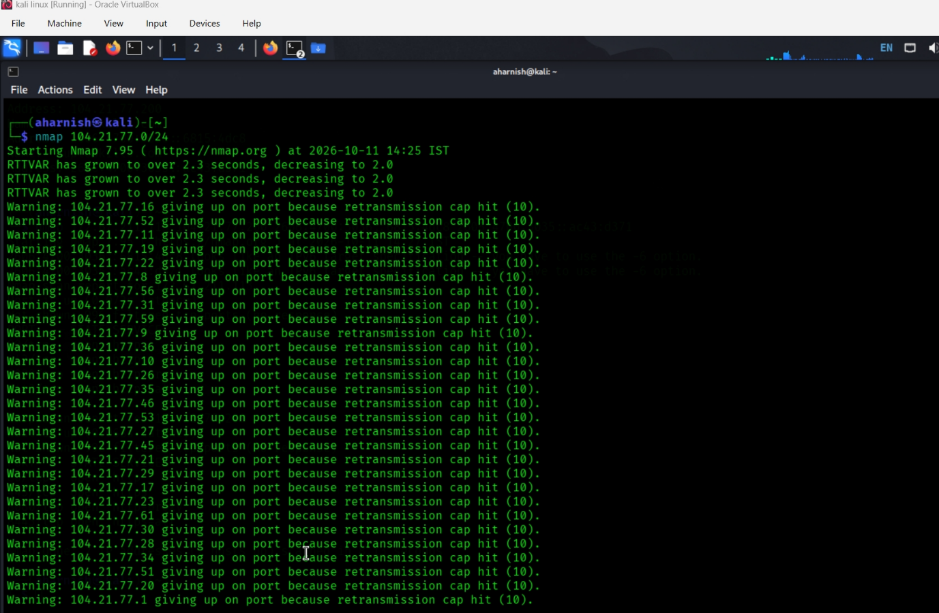

- In the following screenshot you can see the nmap is scanning an entire subnet.
- Purpose: Discovers hosts and scans common ports across the subnet. Use this only on networks you own or have permission to test.
- Command: Subnet scan.
- Output: Multiple warnings about retransmission caps due to latency. Some hosts responded with open ports 80 and 443.
- Summary: Subnet reachable, but latency issues caused incomplete results.
- Scan Details
- Command used: nmap 104.21.77.0/24
- Target: Entire /24 subnet (256 possible hosts).
- Scan type: Default TCP scan.
- Timestamp: 2026-10-11 14:25 IST

- Findings
- Diagnostic messages:
- RTTVAR (Round Trip Time Variance) grew above 2.3 seconds, showing network latency.
- Multiple warnings: “giving up on port because retransmission cap hit (10)” for many IPs. This means repeated probes failed, likely due to filtering or unreachable hosts.
- Hosts: Some IPs responded, but many did not, resulting in incomplete port data.
- Ports: Where responses were received, typical web ports (80, 443) were open.

- Nmap screenshot ( nmap -sn 104.21.77.200)
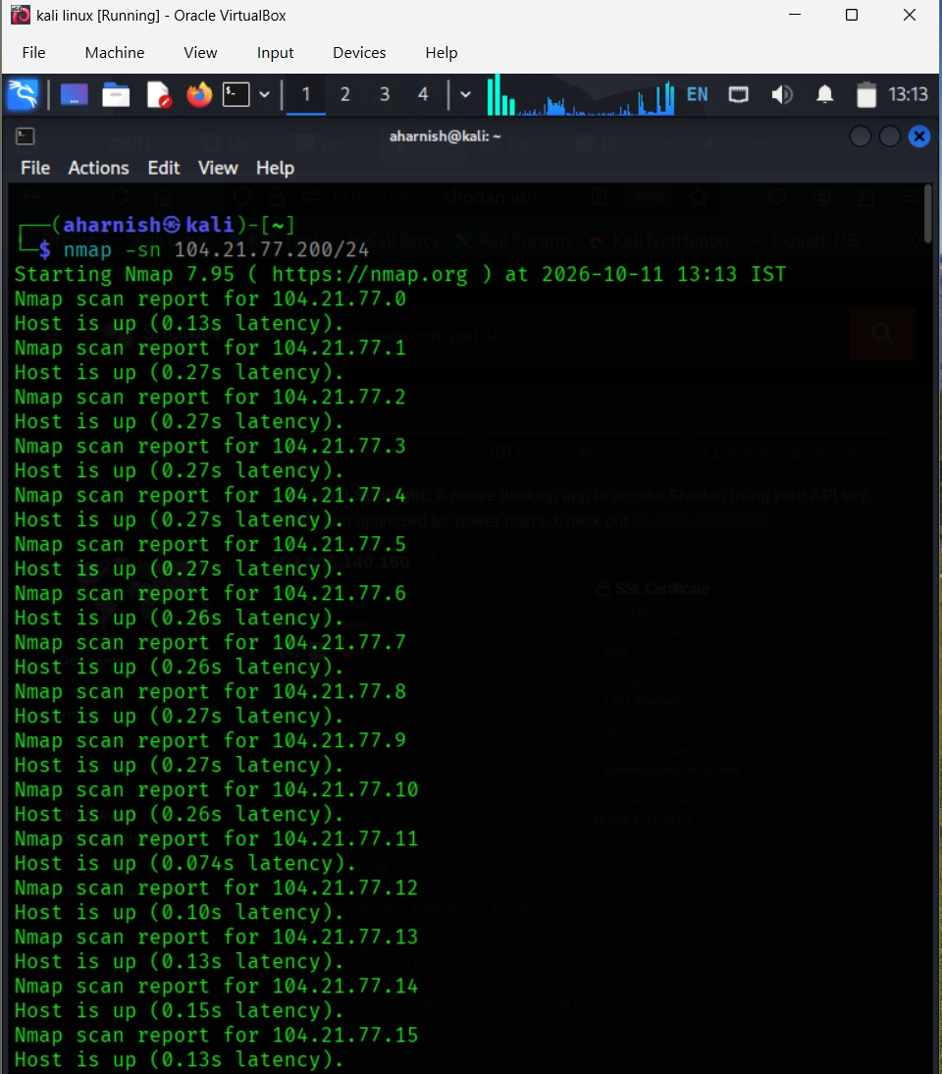
- In the following screenshot you can see the nmap is scanning Discover active hosts without a port scan.
- Purpose: Performs host discovery to identify potentially active devices.
- Command: Ping sweep (host discovery only).
- Output: Multiple IPs in the subnet reported “Host is up.”
- Summary: Confirms active hosts without port details.

- Scan Details
- Command used: nmap -sn 104.21.77.200/24
- Target: Entire /24 subnet (256 possible hosts).
- Scan type: Ping sweep (host discovery only, no port scan).
- Timestamp: 2026-10-11 13:13 IST

- Findings
- Multiple IPs in the range 104.21.77.0 through 104.21.77.15 responded as “Host is up”.
- Latency varied between ~0.10s and ~0.27s depending on the host.
- No port information was collected since -sn disables port scanning.

- Nmap screenshot (nmap -p 80 104.21.77.200)
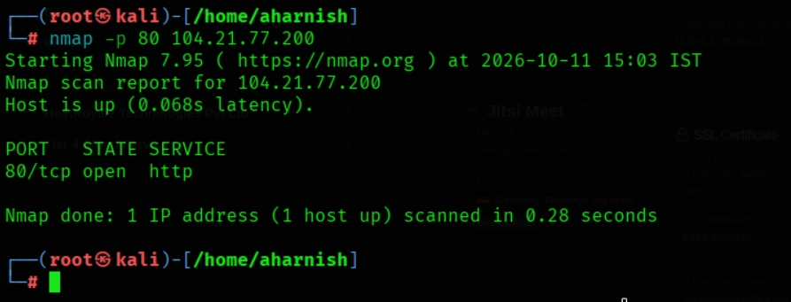
- In the following screenshot you can see that nmap is scanning the specific port using the (-p) and that port is http (80).
- Purpose: Checks port 80, commonly used for HTTP.
- Command: Scan only port 80.
- Output: Port 80/tcp open (HTTP).
- Summary: Confirms HTTP service is active.

- Scan Details
- Command used: nmap -p 80 104.21.77.200
- Target: IP 104.21.77.200
- Scan type: Single-port scan (HTTP).
- Timestamp: 2026-10-11 15:03 IST
- Latency: ~0.068 seconds
- Duration: ~0.28 seconds

- Findings
- Host status: Up and reachable.
- Port detected:
- 80/tcp → Open, running HTTP service.
- Other ports: Not scanned (only port 80 checked).

- Nmap screenshot (nmap -p 80, 443, 8080, 8443 104.21.77.200)
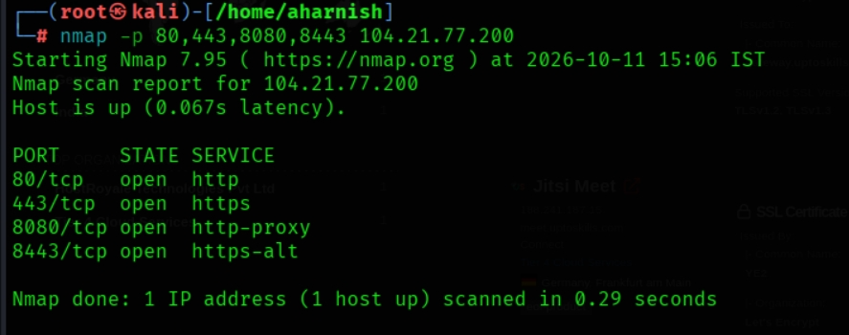
- In the following screenshot you can see the nmap is scanning multiple ports.
- Command: Scan selected ports.
- Output: All four ports open (http, https, http-proxy, https-alt).
- Summary: Confirms key web services are running.

- Scan Details
- Command used: nmap -p 80,443,8080,8443 104.21.77.200
- Target: IP 104.21.77.200
- Scan type: Specific port scan (four ports).
- Timestamp: 2026-10-11 15:06 IST
- Latency: ~0.067 seconds
- Duration: ~0.29 seconds

- Findings
- Host status: Up and reachable.
- Open ports detected:
- 80/tcp → HTTP
- 443/tcp → HTTPS
- 8080/tcp → HTTP-proxy
- 8443/tcp → HTTPS-alt.

- Nmap screenshot (nmap -p 1-1000 104.21.77.200)
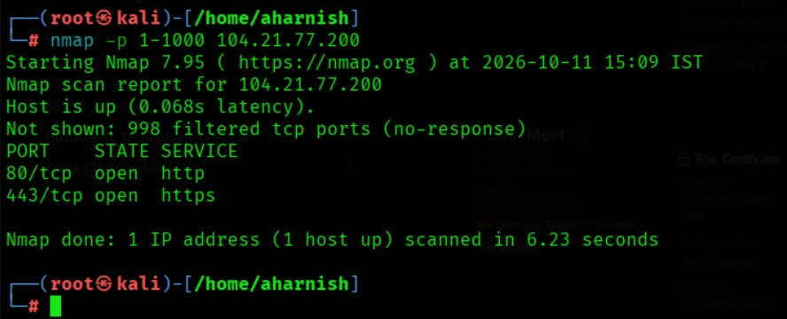
- In the following screenshot you can see nmap Scan a range of ports.
- Command: Scan first 1000 ports.
- Output: Only 80 and 443 open, rest filtered.
- Summary: Limited services detected in lower port range.

- Scan Details
- Command used: nmap -p 1-1000 104.21.77.200
- Target: IP 104.21.77.200
- Scan type: TCP scan of ports 1 through 1000
- Timestamp: 2026-10-11 15:09 IST
- Latency: ~0.068 seconds
- Duration: ~6.23 seconds

- Findings
- Host status: Up and reachable.
- Open ports detected:
- 80/tcp → HTTP
- 443/tcp → HTTPS
- Other ports: 998 filtered (no response).

- Nmap screenshot (nmap -p- 104.21.77.200)
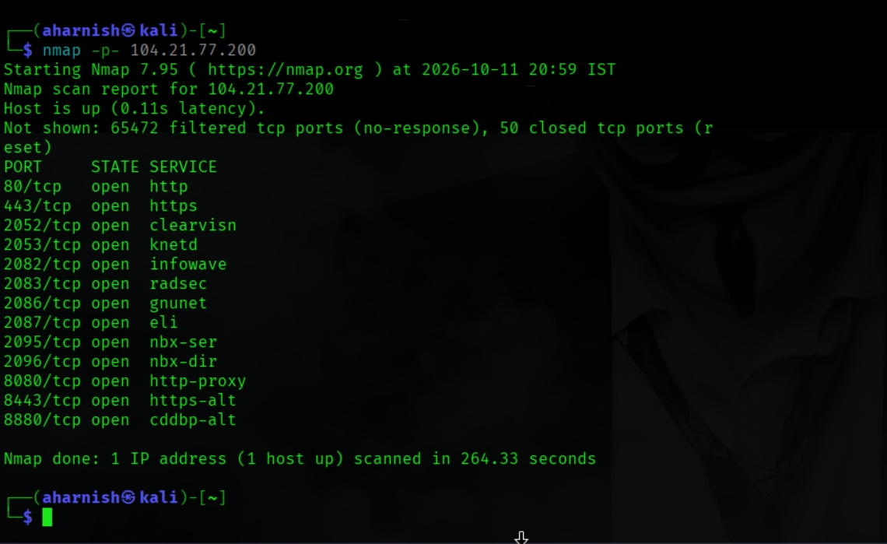
- In the following screenshot of nmap you can see that it is Scanning all TCP ports.
- Command: Scan first 1000 ports.
- Output: Only 80 and 443 open, rest filtered.
- Summary: Limited services detected in lower port range.
- Scan Details
- Command used: nmap -p- 104.21.77.200
- Target: IP 104.21.77.200
- Scan type: Full TCP port range (1–65535)
- Timestamp: 2026-10-11 20:59 IST
- Latency: ~0.11 seconds
- Duration: ~264.33 seconds

- Findings
- Host status: Up and reachable.
- Open ports detected:
- 80/tcp → HTTP
- 443/tcp → HTTPS
- 2052/tcp → clearvisn
- 2053/tcp → knetd
- 2082/tcp → infowave
- 2083/tcp → radsec
- 2086/tcp → gnunet
- 2087/tcp → eli
- 2095/tcp → nbx-ser
- 2096/tcp → nbx-dir
- 8080/tcp → HTTP-proxy
- 8443/tcp → HTTPS-alt
- 8880/tcp → cddbp-alt
- Other ports: 65,472 filtered (no response), 50 closed (reset).

- Nmap screenshot (nmap -sS 104.21.77.200)
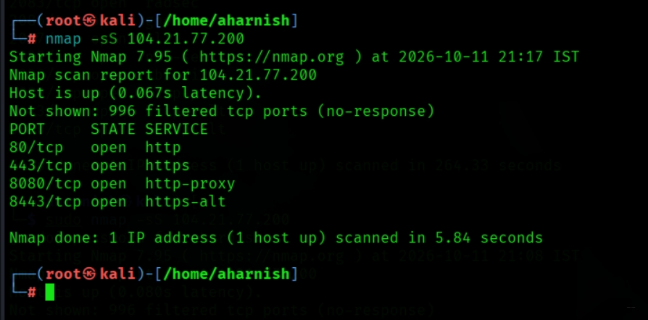
- In the following screenshot you can see the nmap is scanning only TCP ports using SYN scan.
- Purpose: Performs a TCP SYN scan, often called a half-open scan.
- Command: SYN scan.
- Output: Same open ports (80, 443, 8080, 8443).
- Summary: Confirms open ports using stealth scan.
- Scan Details
- Command used: nmap -sS 104.21.77.200
- Target: IP 104.21.77.200
- Scan type: TCP SYN (stealth) scan
- Timestamp: 2026-10-11 21:17 IST
- Latency: ~0.067 seconds
- Duration: ~5.84 seconds

- Findings
- Host status: Up and reachable.
- Open ports detected:
- 80/tcp → HTTP
- 443/tcp → HTTPS
- 8080/tcp → HTTP-proxy
- 8443/tcp → HTTPS-alt
- Other ports: 996 filtered (no response).

- Nmap screenshot (nmap -sU -p 53,67,123 104.21.77.200)
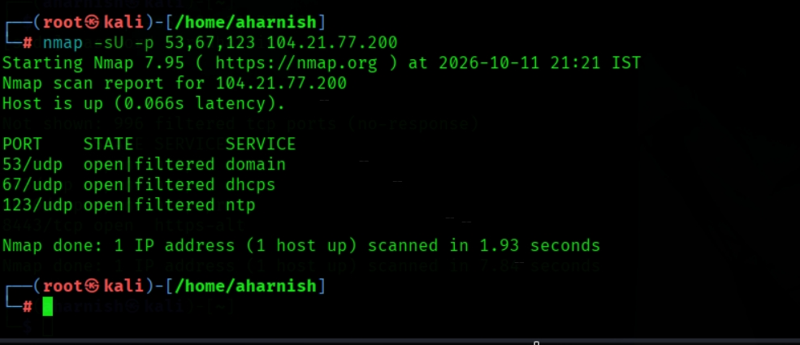
- In the following screen shot you can see the nmap is scanning the UDP ports.
- Purpose: Checks selected UDP ports, such as DNS (53), DHCP (67), and NTP (123).
- Command: UDP scan on selected ports.
- Output: Ports 53, 67, 123 reported as open|filtered.
- Summary: Possible DNS, DHCP, NTP services, but inconclusive.
- Scan Details
- Command used: nmap -sU -p 53,67,123 104.21.77.200
- Target: IP 104.21.77.200
- Scan type: UDP scan on selected ports (DNS, DHCP, NTP).
- Timestamp: 2026-10-11 21:21 IST
- Latency: ~0.066 seconds
- Duration: ~1.93 seconds

- Findings
- Host status: Up and reachable.
- UDP ports detected:
- 53/udp → open|filtered (Domain / DNS)
- 67/udp → open|filtered (DHCP server)
- 123/udp → open|filtered (NTP – Network Time Protocol)
- Interpretation: “open|filtered” means Nmap cannot confirm whether the port is truly open or just blocked by a firewall.

- Nmap screenshot (nmap -sU -p 53,67, 123, 68, 69, 161, 162, 500, 514, 1194, 4500 104.21.77.200).
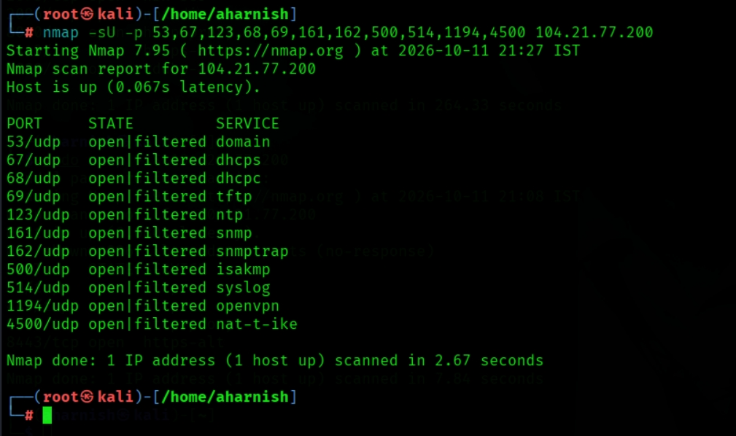
- In the following screen shot you can see the nmap is scanning the UDP ports.
- Command: UDP scan on common service ports.
- Output: All reported as open|filtered.
- Summary: Indicates potential UDP services, but firewall filtering prevents certainty.
- Scan Details
- Command used: nmap -sU -p 53,67,123,68,69,161,162,500,514,1194,4500 104.21.77.200
- Target: IP 104.21.77.200
- Scan type: UDP scan on multiple common service ports
- Timestamp: 2026-10-11 21:27 IST
- Latency: ~0.067 seconds
- Duration: ~2.67 seconds

- Findings
- Host status: Up and reachable.
- UDP ports reported as open|filtered:
- 53/udp → Domain (DNS)
- 67/udp → DHCP server
- 68/udp → DHCP client
- 69/udp → TFTP
- 123/udp → NTP (Network Time Protocol)
- 161/udp → SNMP
- 162/udp → SNMP trap
- 500/udp → ISAKMP (IPsec key management)
- 514/udp → Syslog
- 1194/udp → OpenVPN
- 4500/udp → NAT-T IKE (IPsec tunneling)

- Nmap screenshot (nmap -sV 104.21.77.200)
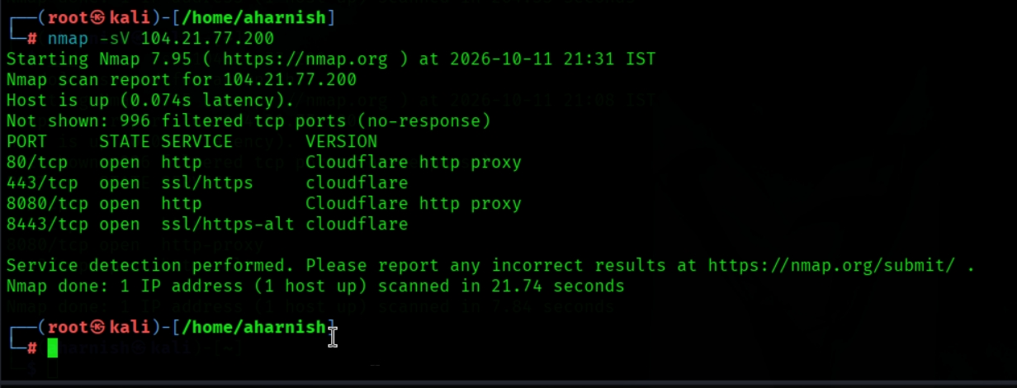
- In the following screenshot you can see the nmap is scanning service versions.
- Purpose: Attempts to identify services and their versions.
- Command: Service version detection.
- Output: Ports identified as Cloudflare proxies (http, https).
- Summary: Services run behind Cloudflare infrastructure.

- Scan Details
- Command used: nmap -sV 104.21.77.200
- Target: IP 104.21.77.200
- Scan type: Service version detection
- Timestamp: 2026-10-11 21:30 IST
- Latency: ~0.074 seconds
- Duration: ~21.74 seconds

- Findings
- Host status: Up and reachable.
- Open ports and detected services:
- 80/tcp → HTTP — Cloudflare http proxy
- 443/tcp → HTTPS — Cloudflare SSL proxy
- 8080/tcp → HTTP — Cloudflare http proxy
- 8443/tcp → HTTPS-alt — Cloudflare SSL proxy
- Other ports: 996 filtered (no response).

- Nmap screenshot (nmap -O 104.21.77.200).
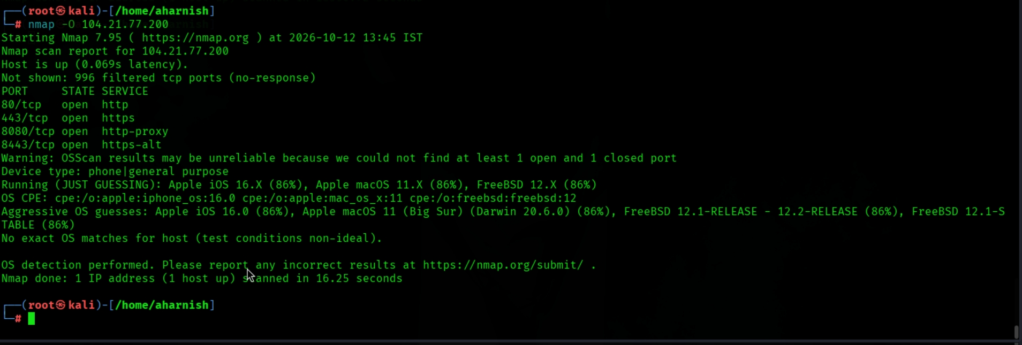
- In the following screen shot you can see nmap is scanning the operating system.
- Purpose: Attempts to identify the target operating system.
- Command: OS detection.
- Output: Guesses include FreeBSD, Apple iOS, macOS. Warning about unreliable results.
- Summary: OS fingerprinting inconclusive due to lack of closed ports.
- Scan Details
- Command used: nmap -O 104.21.77.200
- Target: IP 104.21.77.200
- Scan type: OS fingerprinting
- Timestamp: 2026-12-12 13:45 IST
- Latency: ~0.069 seconds
- Duration: ~16.25 seconds

- Findings
- Host status: Up and reachable.
- Open ports detected:
- 80/tcp → HTTP
- 443/tcp → HTTPS
- 8080/tcp → HTTP-proxy
- 8443/tcp → HTTPS-alt
- Other ports: 996 filtered (no response).
- OS detection results:
- Device type: phone | general purpose
- Guesses:
- Apple iOS 16.x (86%)
- FreeBSD 12.x (86%)
- Apple macOS 11 (Big Sur) (Darwin 20.6.0) (86%)
- Note: Results are unreliable because Nmap could not find both an open and a closed port (needed for accuracy).

- Nmap screenshot (nmap -A 104.21.77.200)
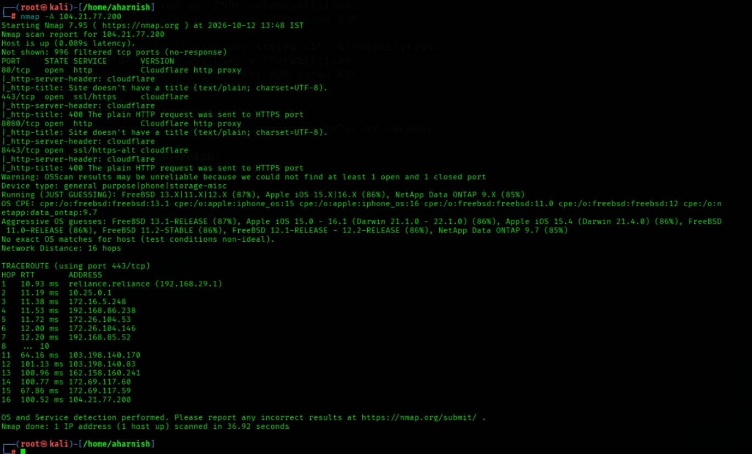
- In the following screenshot you can see that nmap is scanning an aggressive scan.
- Purpose: Enables OS detection, version detection, default scripts, and traceroute. This can generate more traffic and should be used only with authorization.
- Command: Aggressive scan (OS, version, scripts, traceroute).
- Output: Cloudflare proxy services, OS guesses (FreeBSD, iOS, NetApp). Traceroute shows ~16 hops.
- Summary: Detailed info, but OS detection still uncertain.

- Scan Details
- Command used: nmap -A 104.21.77.200
- Target: IP 104.21.77.200
- Scan type: Aggressive scan (includes OS detection, version detection, script scanning, traceroute)
- Timestamp: 2026-12-12 13:45 IST
- Network distance: ~16 hops

- Findings
- Host status: Up and reachable.
- Open ports and services:
- 80/tcp → HTTP (Cloudflare http proxy)
- 443/tcp → HTTPS (Cloudflare SSL proxy)
- 8080/tcp → HTTP (Cloudflare http proxy)

- Other ports: Majority filtered.

- Service details: Cloudflare proxies detected, meaning the real server is hidden behind Cloudflare’s infrastructure.

- OS guesses:
- FreeBSD 13.1-RELEASE
- Apple iOS 15.x
- NetApp Data ONTAP 9.x
- Accuracy limited due to filtering.

- Traceroute: Showed ~16 hops from your local network (192.168.x.x) to the target, confirming distance and routing path.

- Nmap screenshot (nmap -sC 104.21.77.200)
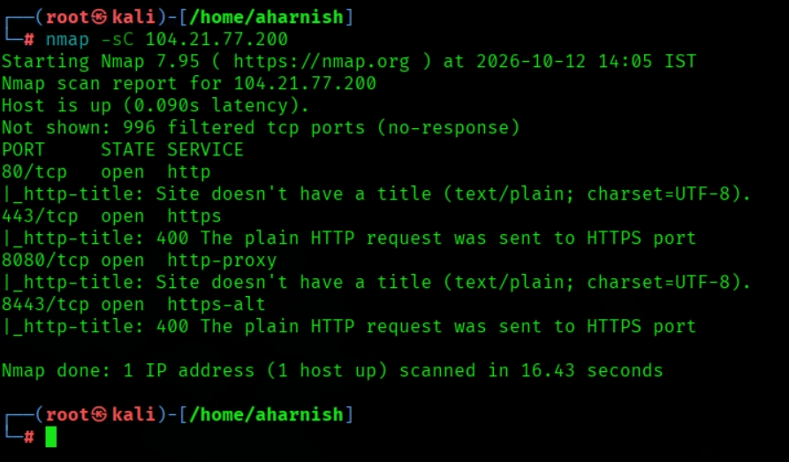
- In the following screenshot you can see that nmap is scanning default NSE scripts.
- Purpose: Runs Nmap's default script set to gather additional information.
- Command: Default script scan.
- Output: HTTP titles and Cloudflare responses.
- Summary: Confirms Cloudflare proxy behavior.
- Scan Details
- Command used: nmap -sC 104.21.77.200
- Target: IP 104.21.77.200
- Scan type: Default script scan (runs common NSE scripts)
- Timestamp: 2026-10-12 14:05 IST
- Latency: ~0.090 seconds
- Duration: ~16.43 seconds

- Findings
- Host status: Up and reachable.
- Open ports and script results:
- 80/tcp → HTTP
- Title: Site doesn’t have a title (text/plain; charset=UTF-8)
- 443/tcp → HTTPS
- Title: 400 The plain HTTP request was sent to HTTPS port
- 8080/tcp → HTTP-proxy
- Title: Site doesn’t have a title (text/plain; charset=UTF-8)
- 8443/tcp → HTTPS-alt
- Title: 400 The plain HTTP request was sent to HTTPS port
- Other ports: 996 filtered (no response).

- Nmap screenshot (nmap -- traceroute 104.21.77.200)
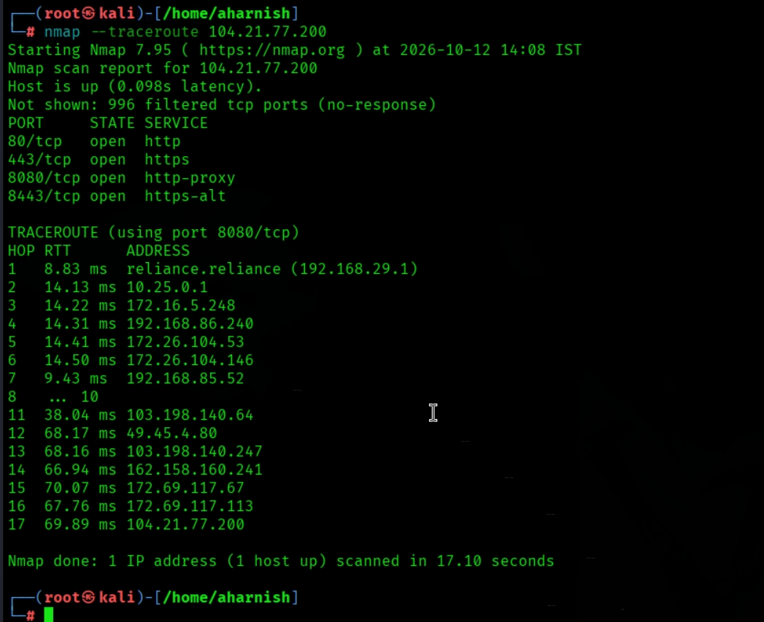
- In the following screenshot you can see the nmap is scanning to Trace the network route.
- Purpose: Attempts to show the network path to the target.
- Command: Traceroute with Nmap.
- Output: Shows hop sequence from local router through ISP to Cloudflare.
- Summary: Network path traced successfully.
- Scan Details
- Command used: nmap --traceroute 104.21.77.200
- Target: IP 104.21.77.200
- Scan type: Port scan with traceroute analysis
- Timestamp: 2026-10-12 14:08 IST
- Latency: ~0.098 seconds
- Duration: ~17.10 seconds

- Findings
- Host status: Up and reachable.
- Open ports detected:
- 80/tcp → HTTP
- 443/tcp → HTTPS
- 8080/tcp → HTTP-proxy
- 8443/tcp → HTTPS-alt
- Traceroute results (via port 8080/tcp):
- Hop 1 → Local router (192.168.29.1) ~8.83 ms
- Hop 2–7 → Private/internal IPs (10.x, 172.x, 192.168.x) ~14 ms range
- Hop 11 → Public ISP node (103.198.140.64) ~38 ms
- Hop 12–13 → Further ISP backbone nodes ~68 ms
- Hop 14–16 → Cloudflare edge nodes (162.158.x.x, 172.69.x.x) ~67–70 ms
- Hop 17 → Target host (104.21.77.200) ~69.89 ms

- Nmap screenshot (nmap -oN nmap_scan_results. txt 104.21.77.200)
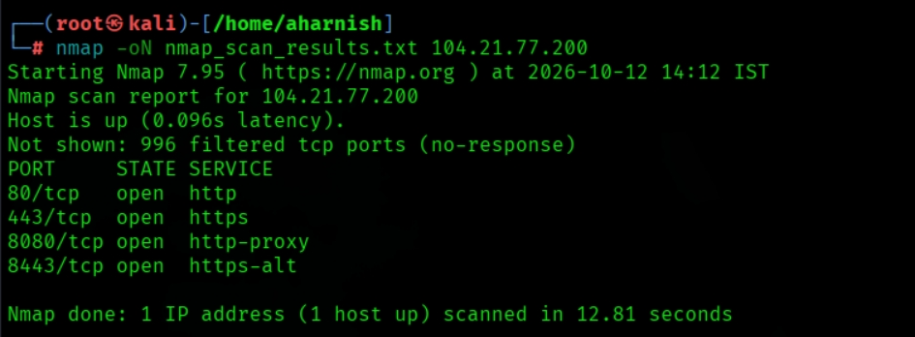
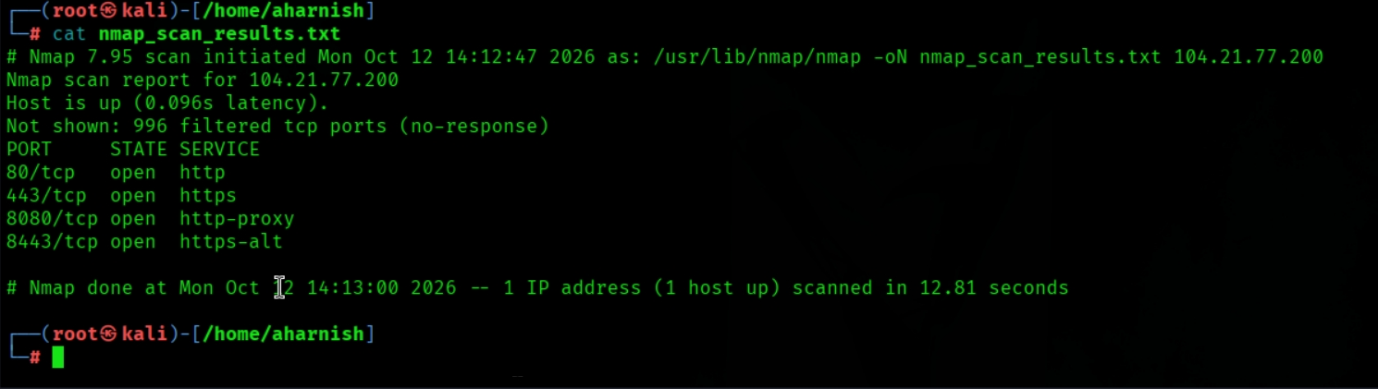
- In the following screenshot you can see that nmap is scanning to Save scan results to a text file.
- Purpose: Saves the scan results in normal text format.
- Command: Save results in normal text format.
- Output: Ports 80, 443, 8080, 8443 open.
- Summary: Results stored in text file.
- Scan Details
- Command used: nmap -oN nmap_scan_results.txt 104.21.77.200
- Target: IP 104.21.77.200
- Scan type: Standard TCP scan with results saved to file
- Timestamp: 2026-10-12 14:12 IST
- Latency: ~0.096 seconds
- Duration: ~12.81 seconds

- Findings
- Host status: Up and reachable.
- Open ports detected:
- 80/tcp → HTTP
- 443/tcp → HTTPS
- 8080/tcp → HTTP-proxy
- 8443/tcp → HTTPS-alt
- Other ports: 996 filtered (no response).

- Nmap screenshot (nmap -oX nmap_scan_results.xml 104.21.77.200)

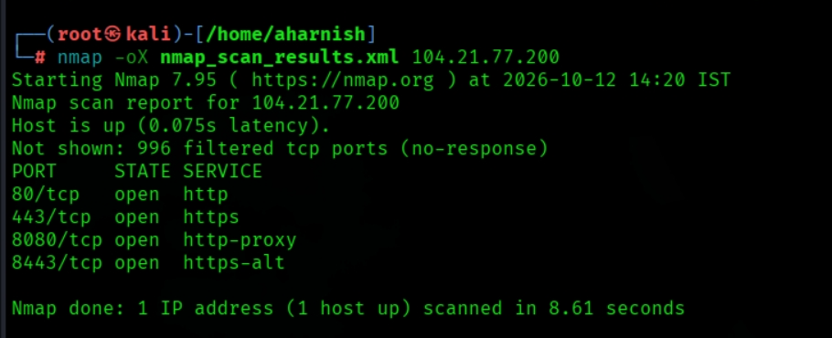
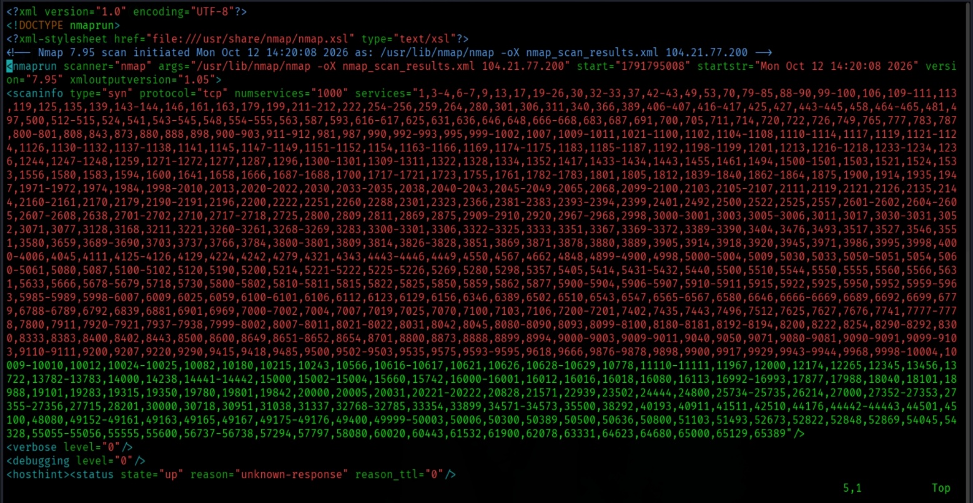
- In the following screenshot of the nmap you can see that it Save results in XML format.
- Purpose: Saves results in XML for later parsing and reporting.
- Command: Save results in XML format.
- Output: Same open ports.
- Summary: Results stored in XML for parsing.

- Scan Details
- Command used: nmap -oX nmap_scan_results.xml 104.21.77.200
- Target: IP 104.21.77.200
- Scan type: Standard TCP SYN scan with XML output
- Timestamp: 2026-10-12 14:20 IST
- Latency: ~0.075 seconds
- Duration: ~8.61 seconds

- Findings
- Host status: Up and reachable.
- Open ports detected:
- 80/tcp → HTTP
- 443/tcp → HTTPS
- 8080/tcp → HTTP-proxy
- 8443/tcp → HTTPS-alt

- Other ports: 996 filtered (no response).

- Output format: Results saved in XML, suitable for automated parsing, reporting, or integration with security tools.

- Nmap screenshot (nmap -v 104.21.77.200)
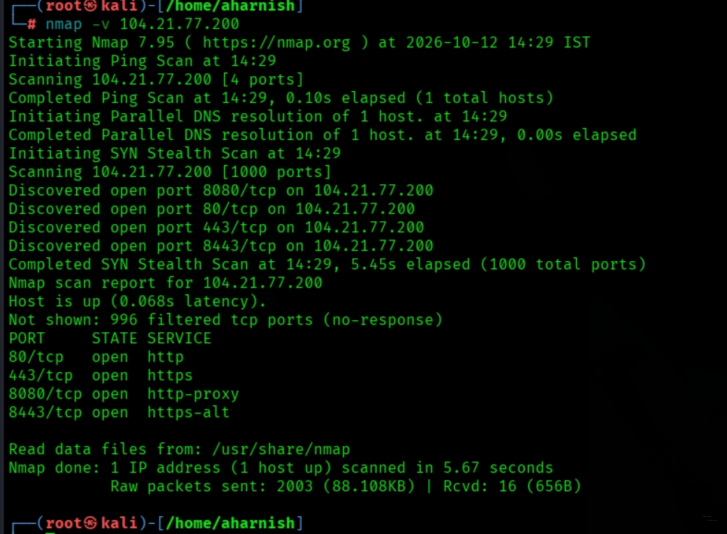
- In the following screenshot you can see that nmap is scanning to Enable verbose output.
- Purpose: Displays more information about the scan while it runs.

- Scan Details
- Command used: nmap -v 104.21.77.200
- Scan type: Verbose mode with SYN stealth scan.
- Target: IP 104.21.77.200
- Latency: ~0.068 seconds
- Duration: ~5.67 seconds

- Findings
- Host status: Up and reachable.
- Open ports detected:
  - 80/tcp → HTTP
  - 443/tcp → HTTPS
  - 8080/tcp → HTTP-proxy
  - 8443/tcp → HTTPS-alt
- Other ports: 996 filtered (no response).

- Nmap screenshot (nmap --script vuln 104.21.77.200)
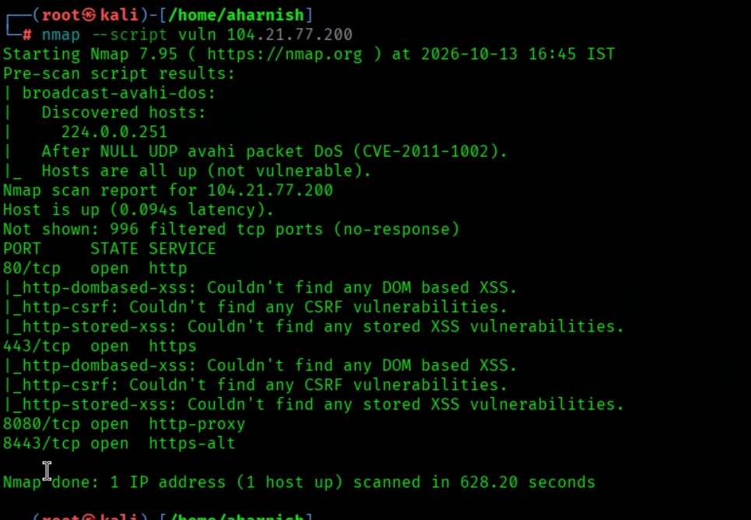
- In the following screenshot of the nmap you can see nmap is scanning the known vulnerabilities.
- Target IP: 104.21.77.200 Scan Tool: Nmap 7.95 Scan Date/Time: 13 October 2026, 16:45 IST Scan Type: --script vuln (Vulnerability Script Scan)

Host Status
- Host is up (latency: 0.094s)
- Discovered via broadcast-avahi-dos script: No Avahi DoS vulnerability detected.

- Open Ports & Services

Port | State | Service | Notes
80/tcp | Open | HTTP | No DOM-based XSS, CSRF, or stored XSS detected
443/tcp | Open | HTTPS | No DOM-based XSS, CSRF, or stored XSS detected
8080/tcp | Open | HTTP-Proxy | No DOM-based XSS, CSRF, or stored XSS detected
8443/tcp | Open | HTTPS-Alt | No DOM-based XSS, CSRF, or stored XSS detected
- Vulnerability Findings
- Web Application Security:
- No DOM-based XSS vulnerabilities found.
- No CSRF vulnerabilities detected.
- No stored XSS vulnerabilities detected.

- Network Exposure:
- Multiple web-facing services (HTTP/HTTPS on standard and alternate ports).
- Proxy service (8080) and alternate HTTPS (8443) may expand attack surface.

- Risk Assessment
- Severity: Low (no direct vulnerabilities detected in scan).
- Concerns:
- Multiple exposed web services increase potential attack vectors.
- Proxy and alternate HTTPS ports may require hardening and monitoring.

- 5. Recommendations
- Patch Management: Ensure all web services are updated with latest security patches.
- Configuration Review: Harden proxy (8080) and alternate HTTPS (8443) configurations.
- Web Security Testing: Conduct deeper application-level penetration tests (SQLi, RCE, authentication flaws).
- Monitoring: Implement intrusion detection/prevention for exposed ports.
- TLS/SSL Audit: Verify HTTPS configurations for strong cipher suites and certificate validity.

Scan Summary
- Total Ports Scanned: 4 (open)
- Total Vulnerabilities Detected: None (via Nmap vuln scripts)
- Scan Duration: 628.20 seconds

