Internship – 2026
By
Uptoskills

Duration :- 3 months
Start Date:- 24-09-2026
End Date:- 24-12-2026
Intern Code:- US/HR/2026/6WZML6

Name:- Aharnish Dhaw Kumar
Course:- Cyber Security Intern
Enroll No :- AUJ254692

Interview date: 22-09-2026
Offer letter date: 23-09-2026
Leader Assigned on: 26-09-2026
Project Handler: Rudrapratap Singh Bais
Asst Project Handler: Shamim Aftab Ansari
Project Name: Cyber Security
Project Briefed: 26-09-2026

Task 5 OWASP ZAP (Zet Attack Proxy)
Date of allotment: 13/10/2026
Date of completion: 16/10/2026
Deadline: 18/10/2026 (5days)

  - What is OWASP ZAP (Zet Attack Proxy)?
- OWASP ZAP (Zed Attack Proxy) is a free, open-source web application security testing tool used to find security vulnerabilities in websites and web applications.
- It is widely used by cybersecurity analysts, ethical hackers, and penetration testers to perform Vulnerability Assessment and Penetration Testing (VAPT).
- Vulnerability scanning: Identifies potential security weaknesses in web applications.
- Intercepting HTTP/HTTPS traffic: Lets you inspect requests and responses between your browser and a web application.
- Passive scanning: Analyzes traffic for potential issues without deliberately attacking the target.
- Active scanning: Sends specially crafted requests to test for certain vulnerabilities. Only use this on systems you own or have explicit permission to test.
- Security reporting: Generates reports containing findings, risk levels, and supporting evidence.

2. Examples of vulnerabilities ZAP can help identify
Vulnerability or issue | What it means
Cross-Site Scripting (XSS) | Untrusted input may execute JavaScript in a browser.
SQL injection | User input may interfere with database queries.
Missing security headers | Important browser security protections may be absent.
Cookie security issues | Cookies may lack protections such as Secure or HttpOnly.
Information disclosure | Responses may expose sensitive technical details.
Server configuration issues | The application may have insecure settings.

  - Screenshot of zap ui scan
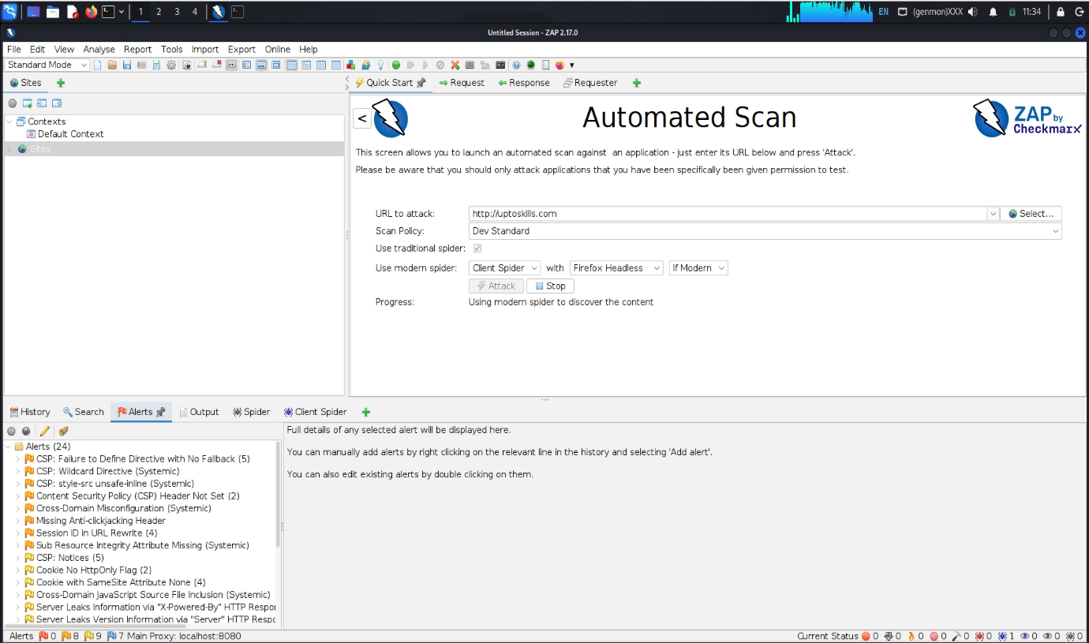
Vulnerability Assessment Report
Assessment Details
- Tool Used: OWASP ZAP 2.17.0
- Target URL: http://uptoskills.com
- Scan Type: Automated Scan
- Scan Policy: Dev Standard
- Spider Used: Traditional Spider + Modern Client Spider (Firefox Headless)
- Assessment Methodology: Automated Web Application Security Testing

Executive Summary
A vulnerability assessment was performed on the target web application using OWASP ZAP. The scan identified multiple security misconfigurations and missing security headers that could expose the application to attacks such as clickjacking, session hijacking, information disclosure, and content injection.
Several findings were categorized as medium-to-low risk security weaknesses. While no critical exploits are visible in the screenshot, remediation is recommended to improve the application's security posture.

Findings
1. Content Security Policy (CSP) Header Not Set
Description
The application does not define a Content Security Policy header.
Risk
Medium
Impact
- Increased exposure to Cross-Site Scripting (XSS).
- Malicious scripts may execute within the browser.
Recommendation
Implement a restrictive CSP header such as:
HTTP
Content-Security-Policy:
default-src 'self';
script-src 'self';
style-src 'self';
object-src 'none';

2. CSP: Wildcard Directive
Description
The CSP configuration contains wildcard (*) directives.
Risk
Low-Medium
Impact
- Allows content loading from untrusted domains.
- Weakens protection offered by CSP.
Recommendation
Replace wildcard domains with specific trusted sources.

3. CSP: style-src unsafe-inline
Description
The CSP permits inline CSS using 'unsafe-inline'.
Risk
Low
Impact
- Inline styles can potentially be abused during client-side attacks.
Recommendation
Use external CSS files and remove:
HTTP
style-src 'unsafe-inline'

4. Missing Anti-Clickjacking Header
Description
The website lacks clickjacking protection.
Risk
Medium
Impact
Attackers may embed the application within malicious iframes.
Recommendation
Configure:
HTTP
X-Frame-Options: DENY
or
HTTP
Content-Security-Policy: frame-ancestors 'none';

5. Session ID in URL Rewrite
Description
Session identifiers are exposed through URL parameters.
Risk
Medium
Impact
- Session Hijacking
- Session Fixation
- Leakage through browser history and logs
Recommendation
Store session identifiers in secure cookies:
HTTP
Set-Cookie:
HttpOnly;
Secure;
SameSite=Strict

6. Cookie Without HttpOnly Flag
Description
Cookies are missing the HttpOnly attribute.
Risk
Medium
Impact
Client-side scripts can access session cookies if an XSS vulnerability exists.
Recommendation
Enable:
HTTP
Set-Cookie: HttpOnly

7. Cookie with SameSite Attribute None
Description
Cookies are configured with SameSite=None.
Risk
Low-Medium
Impact
May increase exposure to Cross-Site Request Forgery (CSRF).
Recommendation
Use:
HTTP
SameSite=Lax
or
HTTP
SameSite=Strict
where appropriate.

8. Subresource Integrity Attribute Missing
Description
External scripts/styles do not use Subresource Integrity (SRI).
Risk
Low
Impact
Compromised third-party resources may execute malicious code.
Recommendation
Implement integrity checks:
HTML
example.jsscript>

9. Cross-Domain JavaScript Source File Inclusion
Description
JavaScript files are loaded from external domains.
Risk
Low
Impact
Trust is placed on third-party infrastructure.
Recommendation
- Use trusted CDN providers.
- Apply Subresource Integrity (SRI).

10. Information Disclosure via HTTP Headers
Description
Server information is disclosed through:
- Server Header
- X-Powered-By Header
Risk
Low
Impact
Attackers can identify technologies and versions used.
Recommendation
Remove or mask headers:
HTTP
Server:
X-Powered-By:

11. Cross-Domain Misconfiguration
Description
Improper cross-domain configuration detected.
Risk
Medium
Impact
Could enable unauthorized resource access from external domains.
Recommendation
Review CORS configuration:
HTTP
Access-Control-Allow-Origin:
Allow only trusted domains.

Risk Summary
Severity | Count
High | 0
Medium | 5
Low | 6
Informational | Multiple

Conclusion
The OWASP ZAP assessment identified several security header misconfigurations, cookie security issues, session management weaknesses, and information disclosure vulnerabilities. No critical vulnerabilities are visible from the screenshot; however, the discovered weaknesses could assist attackers during reconnaissance or facilitate further exploitation.
The highest priority remediation activities should focus on:
- Implementing a strong Content Security Policy.
- Enabling HttpOnly and Secure cookie flags.
- Eliminating session IDs from URLs.
- Adding clickjacking protection.
- Disabling server version disclosure.

  - Screenshot of Running OWASP ZAP in Daemon Mode

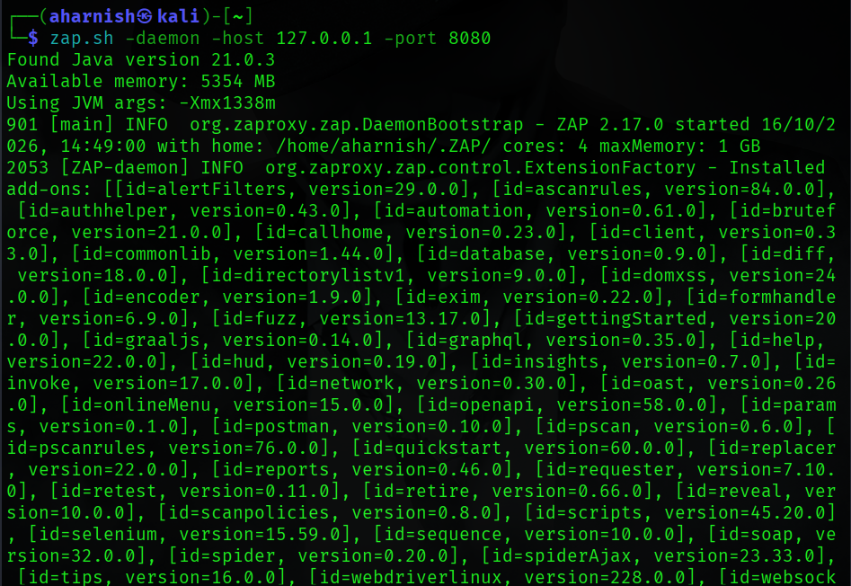
Practical Report: Running OWASP ZAP in Daemon Mode
Experiment Title
Running OWASP ZAP in Daemon Mode Using Command Line Interface (CLI)
Aim
To start OWASP ZAP in daemon mode on Kali Linux and configure it to listen on a local host and specified port for automated security testing.

Objective
- Launch OWASP ZAP without the graphical interface.
- Configure ZAP to run as a background service.
- Enable API-based and automated vulnerability scanning.
- Verify successful startup of the ZAP daemon.

Requirements
- Kali Linux
- Java Runtime Environment (JRE)
- OWASP ZAP Installed
- Terminal Access
- Sudo/User Privileges

Command Used
Shell
zap.sh -daemon -host 127.0.0.1 -port 8080
Command Explanation
Parameter | Description
zap.sh | Launches OWASP ZAP
-daemon | Starts ZAP without GUI in background mode
-host 127.0.0.1 | Binds the service to localhost
-port 8080 | Sets the listening port to 8080

Procedure
Step 1
Open the Kali Linux terminal.
Step 2
Execute the following command:
Shell
zap.sh -daemon -host 127.0.0.1 -port 8080
Step 3
Wait for ZAP initialization.
Step 4
Observe startup messages including:
- Java version detection
- Available memory allocation
- JVM settings
- ZAP version details
- Loaded add-ons/modules
Step 5
Confirm successful startup by checking the message indicating that the daemon is running and listening on the configured host and port.

Screenshot Analysis
Figure 2: Starting OWASP ZAP in Daemon Mode
The screenshot shows:
- Command execution:
Shell
zap.sh -daemon -host 127.0.0.1 -port 8080
- Java Version Detected:
Plain Text
Java version 21.0.3
- Available System Memory:
Plain Text
5354 MB
- JVM Memory Allocation:
Plain Text
-Xmx1338m
- ZAP Version Started:
Plain Text
OWASP ZAP 2.17.0
- Host Configuration:
Plain Text
127.0.0.1

- Port Configuration:
Plain Text
8080
- Numerous add-ons successfully loaded, including:
  - alertFilters
  - ascanrules
  - automation
  - bruteforce
  - database
  - fuzz
  - openapi
  - postman
  - reports
  - spider
  - spiderAjax
  - selenium
  - scripts
  - websocket

Observation
- OWASP ZAP started successfully in daemon mode.
- Java Runtime Environment was detected correctly.
- Memory allocation was configured automatically.
- ZAP loaded multiple security testing extensions and add-ons.
- The application initialized on localhost (127.0.0.1) and port 8080.
- No startup errors were observed during initialization.

Result
OWASP ZAP was successfully launched in daemon mode using the command:
Shell
zap.sh -daemon -host 127.0.0.1 -port 8080
The daemon initialized properly, detected Java 21.0.3, allocated memory resources, and loaded all required security testing modules. The system is now ready for automated vulnerability scanning, API integration, and web application security assessments.

Conclusion
The experiment successfully demonstrated how to start OWASP ZAP in daemon mode on Kali Linux. The tool initialized correctly, loaded essential security modules, and became available on localhost port 8080 for automated penetration testing and vulnerability assessment activities.

  - Screenshot of curl -x http://127.0.0.1:8080 -k https://uptoskills.com

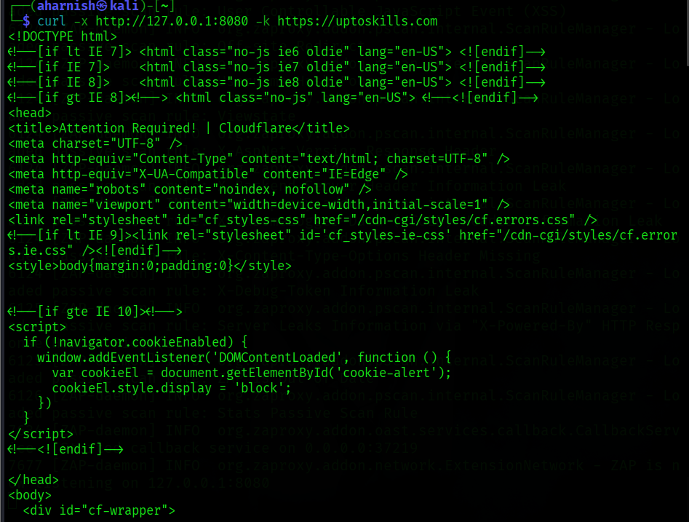

Practical Report: Testing Web Server Response Through OWASP ZAP Proxy
Experiment Title
Accessing a Target Website Through OWASP ZAP Proxy Using cURL
Aim
To verify that web traffic can be routed through the OWASP ZAP proxy and to observe the HTTP response received from a target website.

Objective
- Connect to a target website using the cURL tool.
- Route traffic through the OWASP ZAP proxy running on localhost.
- Examine the HTTP response returned by the web server.
- Validate that the proxy is intercepting and forwarding requests.

Requirements
- Kali Linux
- OWASP ZAP Running in Daemon Mode
- cURL Utility
- Internet Connectivity

Command Used
Shell
curl -x http://127.0.0.1:8080 -k https://uptoskills.com
``
Command Explanation
Parameter | Description
curl | Command-line tool for transferring data
-x http://127.0.0.1:8080 | Routes traffic through the OWASP ZAP proxy
-k | Ignores SSL certificate verification
https://uptoskills.com | Target website being accessed

Procedure
Step 1
Ensure OWASP ZAP is running in daemon mode on port 8080.
Step 2
Open a terminal window.
Step 3
Execute the command:
Shell
curl -x http://127.0.0.1:8080 -k https://uptoskills.com
Step 4
Observe the HTML content returned by the server.
Step 5
Verify that the request passes through the ZAP proxy and reaches the target website.

Screenshot Analysis
Figure 3: Accessing Target Website Through ZAP Proxy
The screenshot shows:
- Successful execution of:
Shell
curl -x http://127.0.0.1:8080 -k https://uptoskills.com
- The website returns an HTML response beginning with:
HTML
<!DOCTYPE html>
<html lang="en-US">
- Web page title displayed:
HTML
<title>Attention Required! | Cloudflare</title>
- Various HTML meta tags and stylesheet references were received from the server.
- The output confirms that an HTTP response was successfully delivered through the configured proxy.

Observation
- The cURL request was successfully sent through the OWASP ZAP proxy at 127.0.0.1:8080.
- The target website responded with HTML content.
- The response page displayed a Cloudflare "Attention Required!" page.
- Cloudflare protection likely identified the request as automated traffic and presented a security challenge.
- This confirms that the proxy is operational and capable of forwarding web requests.

Result
The website request was successfully forwarded through the OWASP ZAP proxy using cURL. The server returned an HTML response containing a Cloudflare protection page, demonstrating that:
- The proxy configuration is functioning correctly.
- Traffic is successfully passing through OWASP ZAP.
- The target server is reachable through the proxy.

Conclusion
- The experiment successfully demonstrated routing web traffic through OWASP ZAP using the cURL utility. The returned Cloudflare page confirmed that the request reached the target server via the proxy. This validates the proper operation of the OWASP ZAP daemon and establishes a foundation for web application security testing and traffic analysis.

  - Screenshot of Run a Quick Scan with Progress Bars
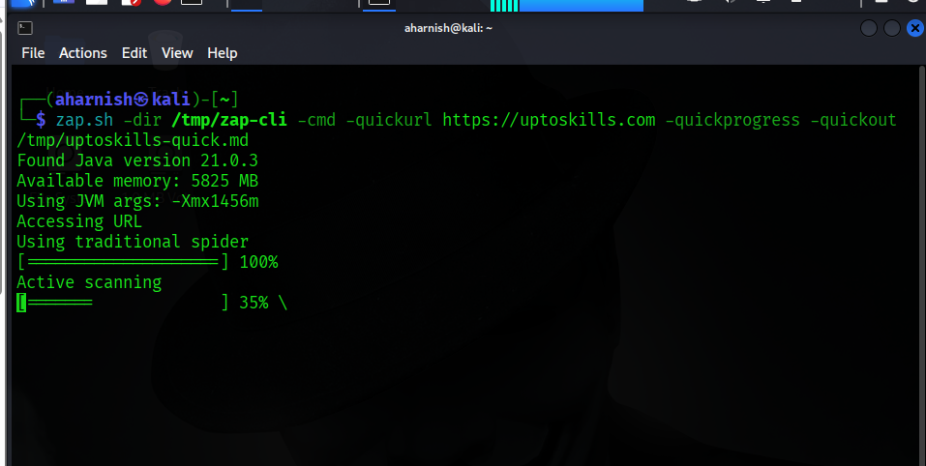
Practical Report: Quick Scan Using OWASP ZAP CLI
Aim
To perform a quick security scan on a target website using OWASP ZAP Command Line Interface.
Command Used
Shell
zap.sh -dir /tmp/zap-cli -cmd -quickurl https://uptoskills.com -quickprogress -quickout /tmp/uptoskills-quick.md
Procedure

- Open the terminal.
- Run the above command.
- Allow ZAP to crawl the target website.
- Monitor the scan progress displayed on the screen.
- Save the scan report to the specified output file.
Observation
- OWASP ZAP detected Java Version 21.0.3.
- The target URL was accessed successfully.
- Traditional spidering completed 100%.
- Active vulnerability scanning started and reached 35% at the time of the screenshot.
- Scan results were being saved to the specified report file.
Result
OWASP ZAP successfully initiated a quick scan of https://uptoskills.com, completed spidering, and began active security testing.
Conclusion

